**Potential for Artificial intelligence in health care system**

"In the modern world, artificial intelligence has significant role on human health, well-being and infection prevention and control."

Artificial intelligence (AI) refers to the way by which computerized system mimic the human intelligence.AI is not one technique but rather a collection of them. In today's world AI has simplified human lives in numerous ways. AI has potential to become extremely useful tool in a hand of any medical professional, scientist, researcher, Artificial intelligence ideas assist medical professionals to Save the lives, early detection of illness and other health problems even before they manifest. The key categories of applications involve diagnosis, treatment recommendations, patient engagement and adherence activities. Several studies have suggested that AI can perform as or better than humans at key healthcare tasks.

**Applications of AI in healthcare:**

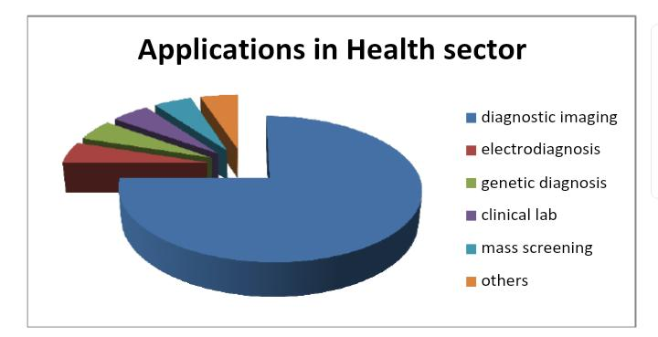

* Maintenance of Clinical Records: Al can an evaluate a patients information based collective data can bring outstanding issues to clinicians’ attention & save time.
* Advanced Consultation: Now days various Contraptions are by majority of population that can work rapidly and in time. For e.g. wrist watches, other wearable devices. This will screen data and related to wellbeing of individual and health danger aware in advance.
* Treatment planning: AI help to diagnose the diseases quickly & accurately and analyze medical images like X-rays. CT scan. This will reduce time and expenditure of treatment.
* Surgery with robot, Assistances: "Robotic surgery" mainly used to avoid invasive surgical operations. In this surgeon uses computer control robotic arms and one more advantage that surgeon need not to be present during surgery procedure.
* Cancer Treatment: Cure of cancer is one of the biggest challenges in health sector.AI helps to doctors to detect in early stage. This helps in prevention and treatment.

**Future Perspectives of Artificial intelligence**

AI could produce significantly quicker & accurate diagnosis. Due to early detection health care costs may decline.

Speech and text recognition may become more widely used in future for a variety of applications such as patient communication etc.

As the developments and research in artificial intelligence in health care system is taking place day by day So, more and more innovative solutions are coming out in every single day, and they have potential to solve number of complexities in health care system.

AI has simplified lives of number of people of health care chain. now days common man and women can detect diseases on their own with the help of AI powered various tools such as smart watches, bands, and variety of mobile applications, it will not only save time but also their money. So, the artificial intelligence is never ending concept, it will keep growing enormously to provide great help to mankind.