1.Prepare the documentation of all linux command covered in class.

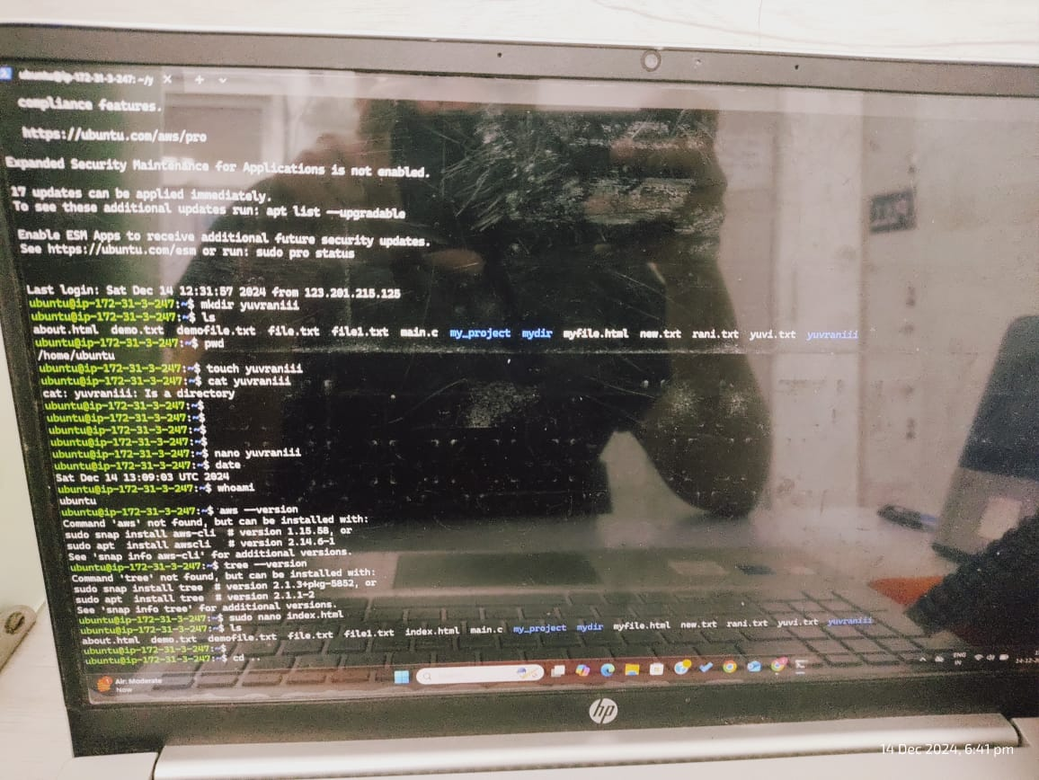

2. Perform following practical tasks and include the screen short of task in documentations.

a. Create a directory named my_project in your home directory.

b. Inside my project, create three subdirectories: src, bin, and docs.

c. In the src directory, create a file named main.c.

d. Create another file named README.md in the docs directory.

e. Copy the README.md file from docs to the src directory.

f. Move the main.c file from sre to bin.

g. Rename the README.md file in the src directory to README SRC.md.

h. Change the permissions of the my project directory to 755.

i. Change the permissions of the bin/main.c file to 644.

j. Change the ownership of the my project directory and its contents to a user named user1 and a group named group1.

k. Find all files in the my project directory and its subdirectories that have the .md extension.

I. Find all directories in the my project directory that were modified in the last 7 days.

m. Search for the word TODO in all files in the my project directory and its subdirectories.

n. Display the first 10 lines of the README SRC.md file.

o. Display the last 20 lines of the main.c file in the bin directory.

p. Display the last 15th lines of the main.c file in the bin directory.

q. Display the 12th to 18th lines of the main.c file in the bin directory.

