|  |
| --- |
| Carando Pre-Sliced Lunchmeat |

Overview

Introducing New Carando pre-sliced peperoni, genoa, and hard salami to our grab and go case. You will receive a 1 case allocation releasing Wednesday, 7/26. Carando is a well-known Italian deli company and the new items are sure to be a big hit with your customers. Get them on display right away upon arrival!

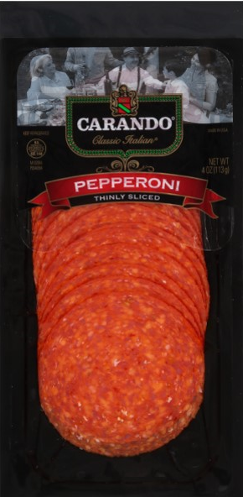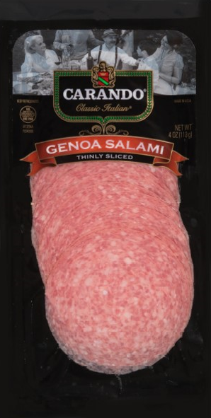Key Dates

|  |  |
| --- | --- |
| A 1 case per store allocation will release on fresh deliveries | Wednesday, 7/24 |

Product Information

|  |  |  |  |
| --- | --- | --- | --- |
| **Item** | **Code** | **Retail** | **TPR** |
| Carando P/S Pepperoni 4oz | 433258 | $4.99 | $3.99 |
| Carando P/S Hard Salami 4oz | 446568 |
| Carando P/S Genoa Salami 4oz | 449344 |

Store Actions

|  |  |  |  |
| --- | --- | --- | --- |
| **Action** | **When** | **Responsible** | **** |
| Receive new Carando pre-sliced items | Monday, 7/24 release based on delivery schedule | Deli Manager |  |
| Display in grab go case or peg section as applicable grouped together | Upon arrival |  |
| Print and hang shelf tags |  |