Homework #2
CS 429/529
Summer, 2009 (Due: July 22, 2009)

Each problem is worth 2.5 points.

1. Exercise 2.7, page 95 of your textbook.
Assuming that signals travel at the speed of light (186,000 miles per second), how much time does a signal require to travel from a ground station to a geosynchronous satellite? How much time is required if the satellite is in low earth orbit of 875 miles?

For the signal to travel to a geosynchronous satellite it takes 0.119s. For the same signal to reach a LEO satellite it takes 0.0047s.

2. Exercise 3.3, page 141 of your textbook.
What is the bit string associated with the following Manchester-encoded signal? What is the bit string if it is a differential Manchester-encoded signal?
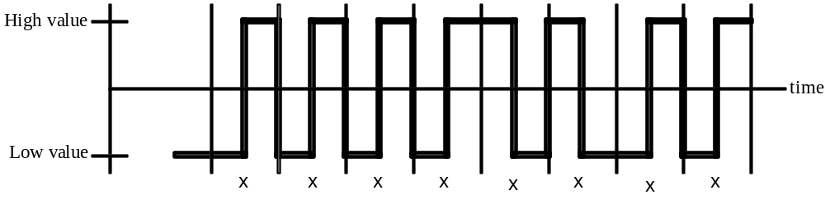

Manchester: 11110011
Differential Manchester: 00001010

3. Exercise 3.5, page 141 of your textbook.
Assume the maximum analog frequency of a medium is 6000 Hz. According to the Nyquist theorem, what are the maximum data rates for schemes that use one, two, three, and four bits per signal component?

1: 12000bps
2: 24000bps
3: 36000bps
4: 48000bps

4. Exercise 3.6, page 141 of your textbook.
According to Nyquist, what frequency is necessary to support a bit rate of 30,000 bps using
- Only one bit per signal component?
- Three bits per signal component?

To support a 30000bps max rate using one bit per signal component the frequency required is 15000Hz. If three bits per signal component are used then 5000Hz may be used.

5. Exercise 3.8, page 141 of your textbook.
What is the actual signal power (relative to the noise power) if the signal-to-noise ratio is given as 60 decibels?
S = 10^6 * N = 1000000N

6. Exercise 3.10, page 142 of your textbook.
Assume the maximum analog bandwidth of a medium is 6000 Hz. According to the Shannon result, what is the maximum data rate if the signal-to-noise ratio is 40 decibels? 60 decibels?

40dB: 6000 * log2(1+10^4) = 79727.14bps
60dB: 6000 * log2(1+10^6) = 119589.42bps

7. Exercise 3.12, page 142 of your textbook.
Suppose you want to achieve a data rate of 64,000 bps using a maximum bandwidth of 10,000 Hz. What is the minimum allowable signal-to-noise ratio?

64000 = 10000 * log2(1 + SN)
6.4 = log2(1 + SN)
2^6.4 - 1 = SN

The acceptable S/N ratio is 83.44bel or 8.344dB.

8. a. Exercise 3.18, page 143 of your textbook.
Design a QAM technique that uses up to eight phase shifts and two amplitudes. How many bits per baud are there?

There are 16 possible states for the signal to be in so there are log2(16) = 4 bits per baud.

b. Exercise 3.19, page 143 of your textbook.
Assume a QAM technique has up to m phase shifts and n amplitudes. How many bits per baud are there?
There are log2(m * n) bits per baud.

