Mark Randles

Homework #2
2009-05-27

CS6110 – Automata & Computability Theory

1)
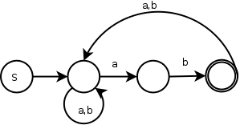

2)
The complement of a regular language is still a regular language. If we examine the definition of a regular language, “...a language is regular if and only if it can be accepted by a dfa.” To invert the string that a dfa accepts, all that needs to be done is to exchange all of the non-final states for final states and all the final states in the original dfa for non-final states. This creates the inverse dfa which also describes the inverse regular language.

3)

4)
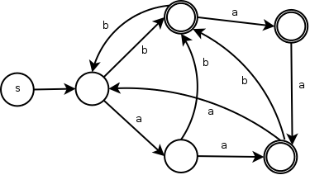

5)

