Homework #3

Mark Randles

CS6110
MW 6:15-9:20p

1a.

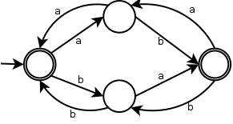
1b. λ + (aa+bb+(ab+ba)(ab+ba)*(aa+bb))*(ab+ba)(ab+ba)*
1c.

2a. (a + b)*ab
2b. (a+b)*(bb + a*)
2c. ((aa)*(bb)*)+(a(aa)*b(bb)*)

3.
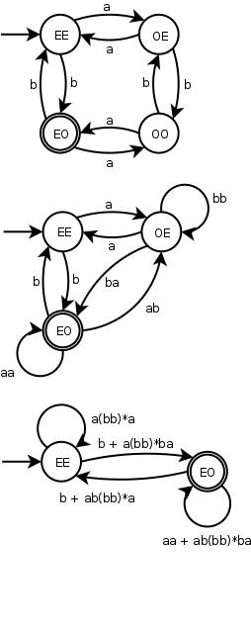
(a(bb)*a)*(b+a(bb)*ba) + ((a(bb)*a)*(b+a(bb)*ba)(aa+ab(bb)*ba)*(b+ab(bb)*a))*

4.
Proof:
(1) The opponent picks a number m.
(2) We chose a string w in L of w = a^{m}b^{m}a^{m-1} which is in L.
(3) The opponent chooses a decompisiton of xyz, subject to

.
(4) because xy is bound by m it will contain all a. It doesn't matter what value we pick for I since it will invalidate the constrain n = m and the constraing will never be fufilled, thus we get a contradiction.

5.
Proof:
(1) The opponent picks a number m.
(2) We chose a string w in L of which is in L.
(3) The opponent chooses a decompisiton of xyz, subject to

.
(4) We can derive a contradiction in the string w by pumping down with i=0. This will never be equal to a power of 3 because it will always reduce the string by at most m letters which will always be less then the next lower power of three.

Bonus.

