Homework #4
CS 612 Due: November 18, 2008
Fall, 2008 (20 points)

1. Exercise 16.3-2, page 392 of your text. (4 points)
What is an optimal Huffman code for the following set of frequencies, based on the first 8 Fibonacci numbers?
a:1 b:1 c:2 d:3 e:5 f:8 g:13 h:21
Can you generalize your answer to find the optimal code when the frequencies are the first n Fibonacci numbers?

2. (a) Exercise 22.2-1, page 538 of your text. (4 points)
Show the d and π values that result from running breadth-first search on the directed graph of Figure 22-2(a), using vertex 3 as the source.
(b) Exercise 22.2-2, page 538 of your text.
Show the d and π values that result from running breadth-first search on the undirected graph of Figure 22-3, using vertex u as the source.

3. Exercise 23.1-1, page 566 of your text. (3 points)
Let (u, v) be a minimum-weight edge in a Graph G. Show that (u, v) belongs to some minimum spanning tree of G.

4. Describe a sequence of connected weighted graphs G_{n} such that G_{n} has n vertices and the running time of the Minimum Spanning Tree Algorithm (Prim's Algorithm) for these graphs is linear in n. (3 points)

5. Use Prim’s Algorithm to find a Minimum Spanning Tree for the following graph. Show the actions step by step. (3 points)
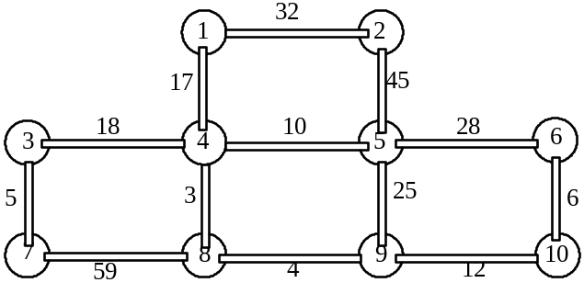

6. Use Kruskal’s Algorithm to find a Minimum Spanning Tree for the graph in the previous problem. Show the actions step by step. (3 points)

