Healthy Recipe Hub – A Personalised Nutrition Companion
Group Number: 07
Assignment: FIT5046 - Assignment 2: Android App Design Proposal and Skeleton Prototype

1 Introduction

1.1 Application Domain and SDG Goals
Healthy Recipe Hub is a mobile health and nutrition app that helps users discover healthy recipes, track nutritional information, and improve dietary habits. It aligns with SDG 3: Good Health and Well-being by promoting preventive health through accessible, evidence-based nutrition guidance.

1.2 Impact and Value
The app delivers practical value by simplifying healthy meal discovery through search and filtering, educational value through detailed nutrition breakdowns and visual charts, and convenience value through offline access and recipe sharing via Android intents.

1.3 User Group
Target users include young adults learning to cook, working professionals seeking quick healthy meals, and fitness enthusiasts tracking macronutrient intake. The app is designed with Material Design 3 guidelines to support users of varying technical abilities.

1.4 Context-Awareness
To make the app feel more relevant to users throughout the day, we built a simple time-based recommendation feature. The idea is straightforward: the app checks what time it is and suggests meals that make sense for that time of day. Morning opens with breakfast options, midday with lunch ideas, and evening with dinner suggestions. Late night shows lighter snacks instead.
This is handled by a TimeContextSimulator class that reads the device’s current hour and decides which meal category to show. On the Home screen, this appears as a greeting card — for example, at 8am the user sees a suggestion for Greek Yogurt Parfait, and at 7pm it switches to Grilled Salmon with Asparagus. A “View Details” button takes them straight to the full recipe list.

2 Android Components, App Functionalities, and Screens

2.1 Android Components
Android Component | Purpose in Healthy Recipe Hub
Room Database | Stores recipes locally, manages favourites, and caches data for offline access
Navigation Compose (NavHost) | Manages all screen routing with type-safe routes
Bottom Navigation Bar | Quick access to 4 primary screens: Home, Recipes, Favourites, Profile
Navigation Drawer | Access to secondary screens: Add Recipe, Charts, Map, AI Assistant, Settings
Retrofit | Fetches recipe data from remote APIs with offline-first repository pattern
Compose Canvas | Custom PieChart and BarChart for nutrition visualisation
LazyColumn | Efficient scrollable recipe lists in Recipes and Favourites screens
Expanded Dropdown Menu | Category, cuisine, and difficulty selection in Add Recipe screen
DatePicker | Used in Add Recipe screen for selecting recipe creation or planning dates
Progress Indicator | CircularProgressIndicator during loading and authentication

2.2 App Functionalities
App Functionality | Description
Login / Register | Email and password authentication with form validation. Mock mode enabled for offline demo.
Recipe Browsing | LazyColumn list of recipe cards with title, calories, and favourite toggle
Search & Filter | Real-time keyword search filtering recipes by name or description
Recipe Detail | Full view with nutrition breakdown (calories, protein, carbs, fat, fibre), ingredients, instructions, and PieChart
Favourites | Save recipes locally via Room database; accessible from Favourites screen
Add Recipe | Form with fields for name, description, ingredients, instructions, and calories
Nutrition Charts | PieChart for macronutrient distribution and BarChart for calorie comparison, drawn with Compose Canvas
Recipe Sharing | Share recipe content via Android ACTION_SEND intent

2.3 Screens
Screen | Description | Access
Login / Register | Authentication with email, password, and form validation | App entry point
Home | Welcome message and context-aware recipe recommendation | Bottom Navigation
Recipes | Searchable recipe list; tap card to open detail view | Bottom Navigation
Recipe Detail | Full recipe with nutrition PieChart, ingredients, instructions | From Recipes / Favourites
Favourites | User’s saved recipes | Bottom Navigation
Add Recipe | Form to create and save a new recipe | Navigation Drawer
Profile | User account information | Bottom Navigation
Charts | Nutrition PieChart and calorie BarChart | Navigation Drawer
Map / AI Assistant / Settings | Placeholder screens for future features | Navigation Drawer

3 The UI Design and Android Prototype (Jetpack Compose)
The app uses a single-Activity architecture. On launch, AuthActivity handles login/register. After authentication, MainActivity hosts all main screens via Jetpack Compose Navigation, with a Bottom Navigation Bar (Home, Recipes, Favourites, Profile) and a Navigation Drawer (Add Recipe, Charts, Map, AI Assistant, Settings). Recipe Detail is accessed from Recipes or Favourites screens.
All screens are built with Jetpack Compose and Material Design 3. The primary colour is green (#4CAF50) representing health, with orange (#FF9800) as an accent.

Figure 1: Navigation Flow Diagram
[Insert one diagram here showing all screens as boxes connected by arrows indicating navigation flow — Login → MainActivity, Bottom Navigation 4 items, Drawer 5 items, Recipe Detail from Recipes/Favourites]

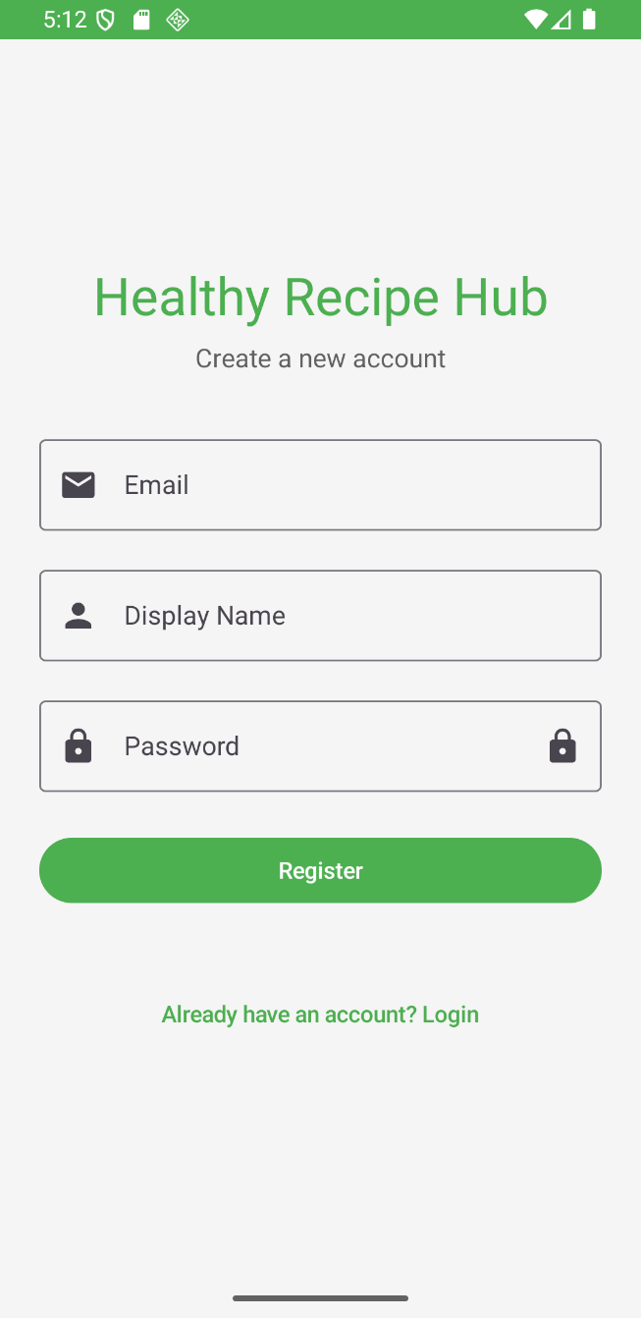
Figure 2: Authentication and Home Screens 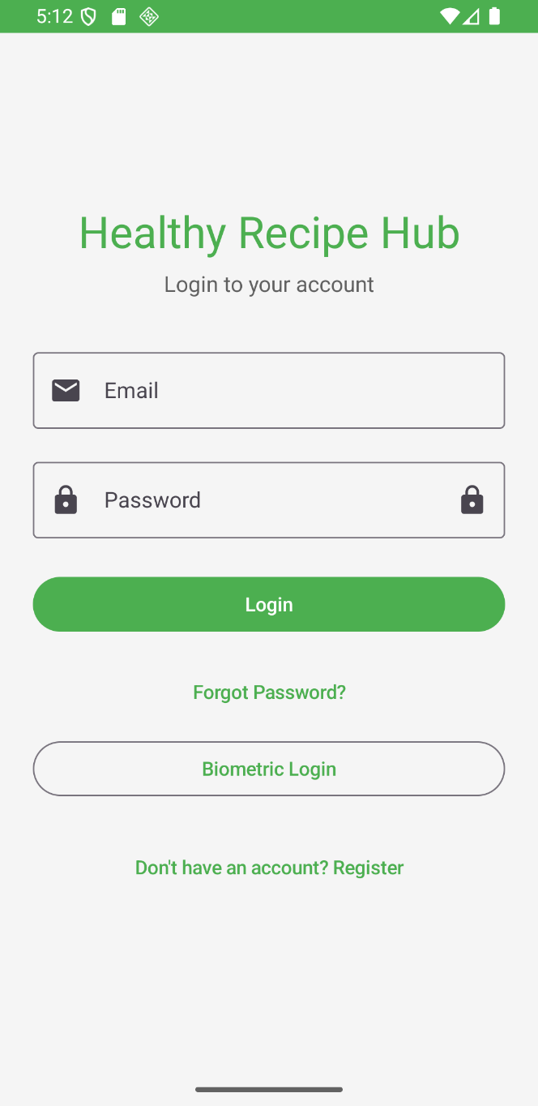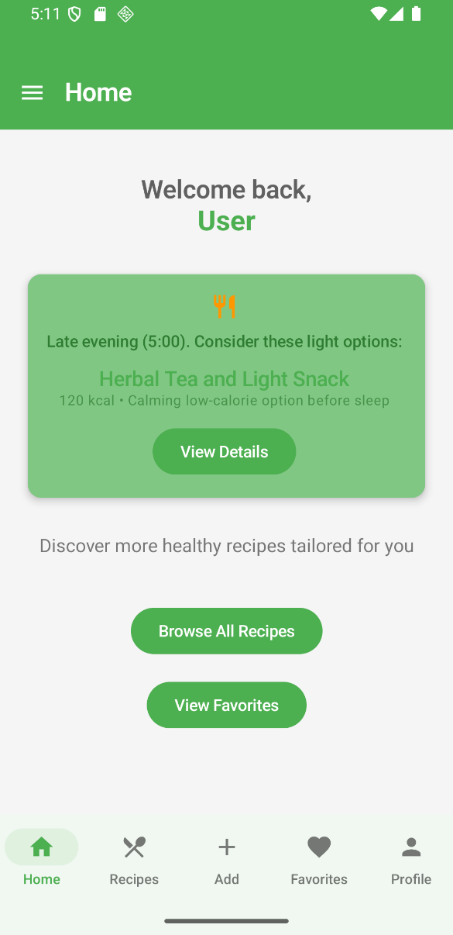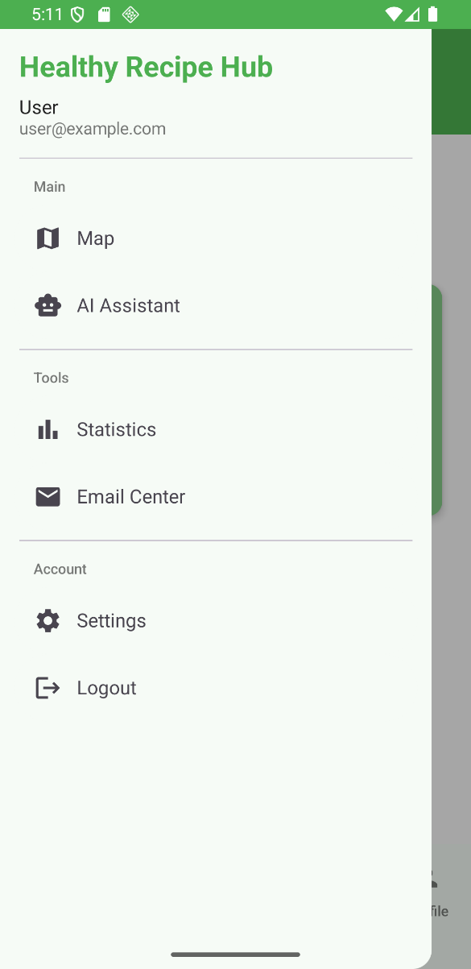
Screen | Description
Login Screen | Email and password fields with visibility toggle, login button, and link to Register
Register Screen | Registration form with display name, email, password fields and inline validation
Home Screen | Welcome card with time-based meal recommendation and “View Details” button
Navigation Drawer | Open drawer showing all menu items: Add Recipe, Charts, Map, AI Assistant, Settings

Figure 3: Recipe Screens
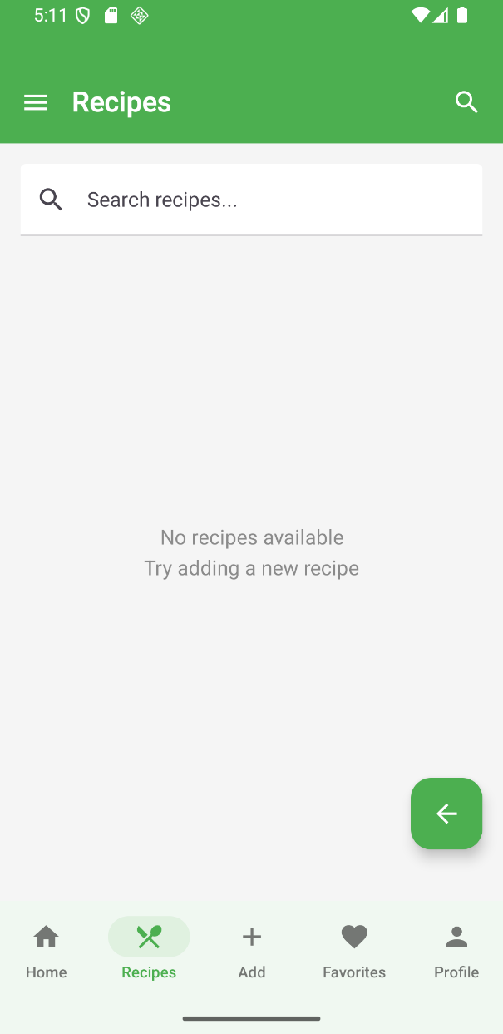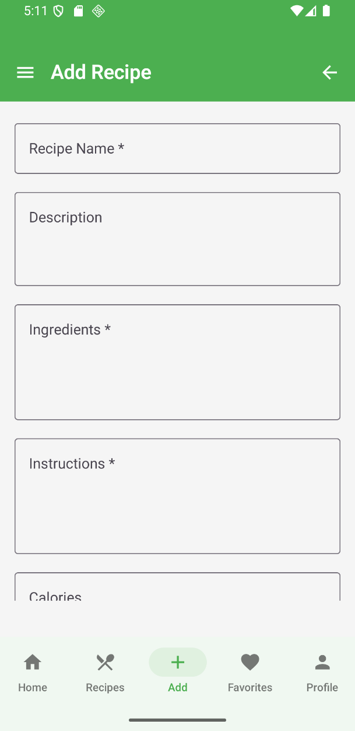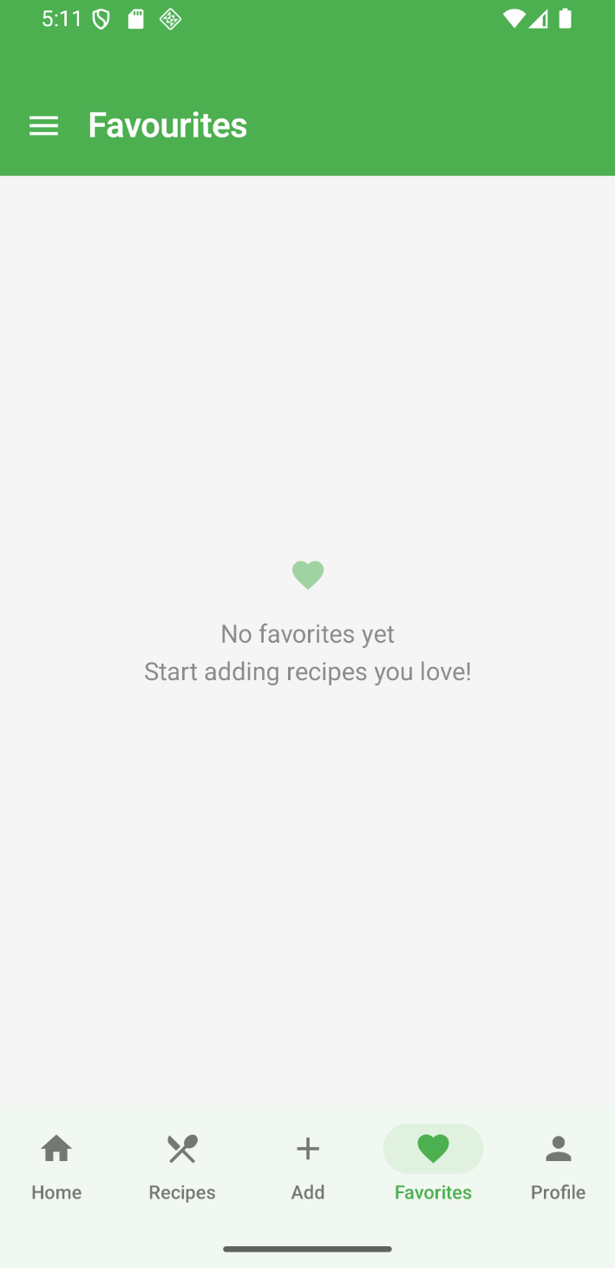
Screen | Description
Recipes Screen | Scrollable LazyColumn list of recipe cards showing title, calories, and favourite toggle
Favourites Screen | Grid of recipes saved by the user, stored locally in Room database
Add Recipe Screen | Form with fields for name, description, ingredients, instructions, calories, and DatePicker for plan date

Figure 4: Profile and Charts Screens
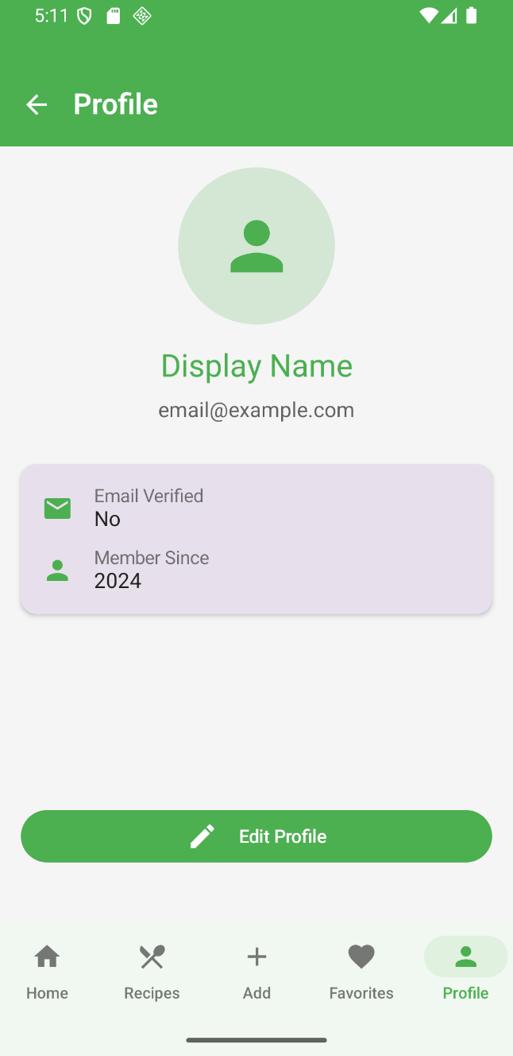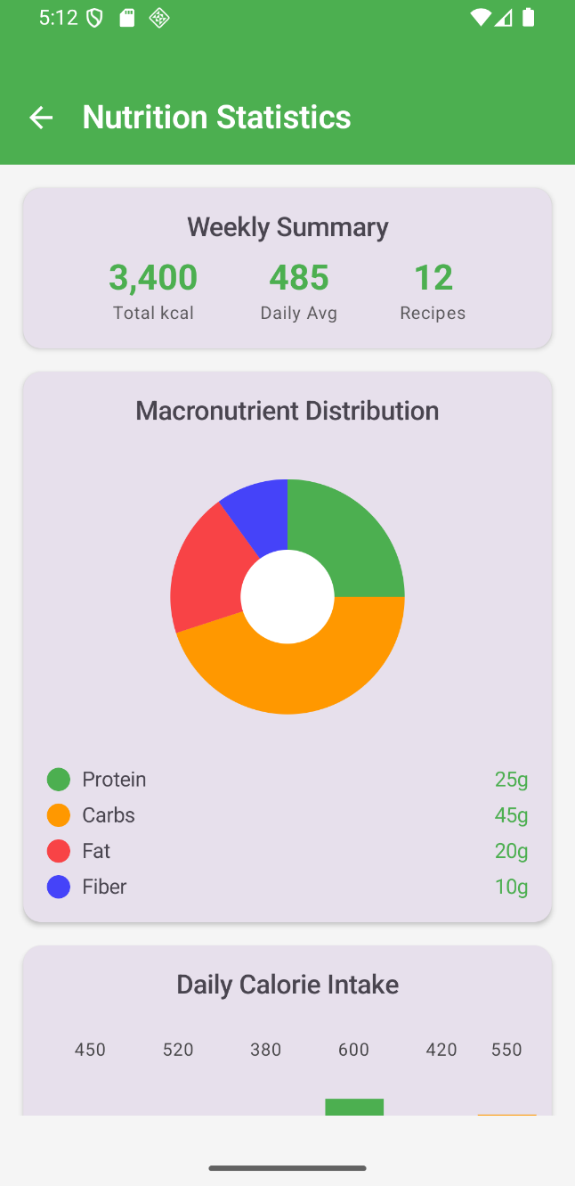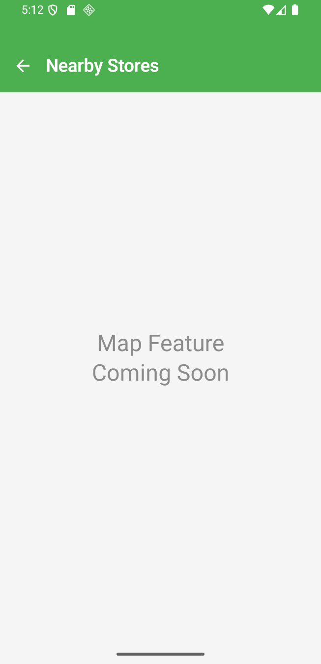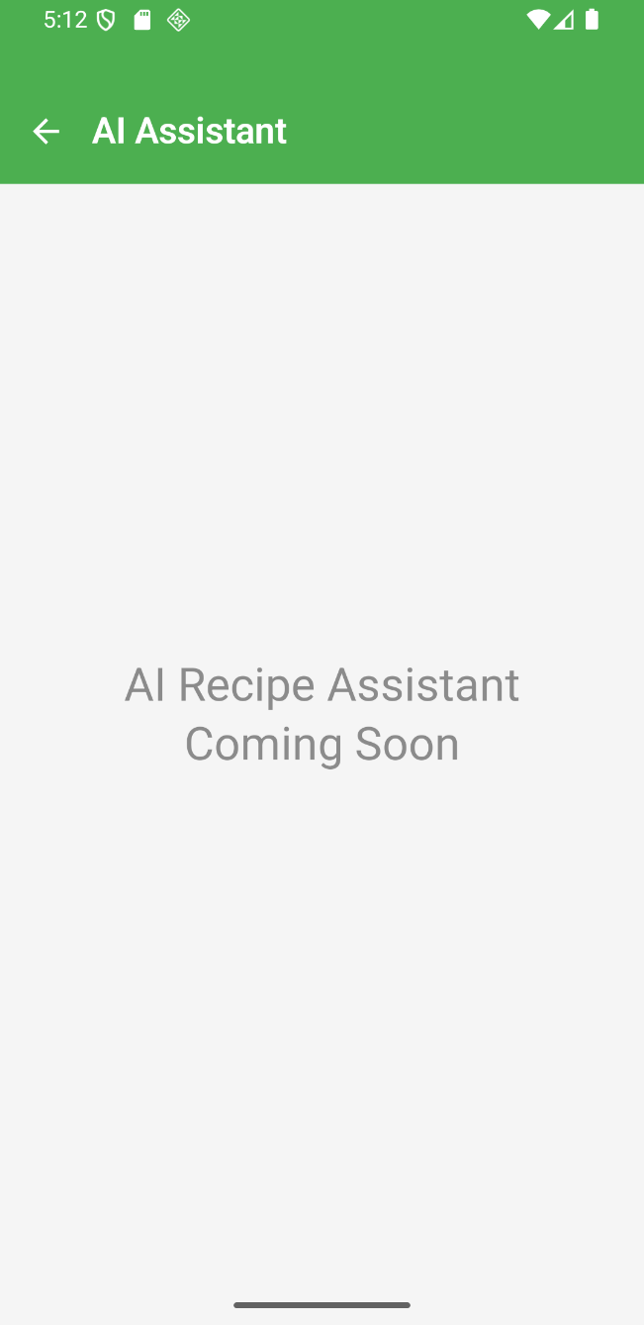
Screen | Description
Profile Screen | Displays user account information including display name and email
Charts Screen | Nutrition PieChart showing macronutrient distribution and BarChart for calorie comparison
Map Screen | Placeholder screen for future healthy store locator feature
AI Assistant Screen | Placeholder screen for future AI-powered recipe recommendation feature

4 Design Guidelines
Guideline 1 – Password masking with visibility toggle: Password fields use PasswordVisualTransformation() by default. A trailing eye icon in AuthScreen.kt lets users toggle visibility. A “Forgot Password?” button is also provided on the Login screen.
Guideline 2 – Vertical form layout: All form screens (Login, Register, Add Recipe) use a scrollable Column with 16dp spacing between fields, following natural top-to-bottom reading flow.
Guideline 3 – Reduce typing with selection controls: The Add Recipe screen uses ExposedDropdownMenuBox for category, cuisine type, and difficulty level to prevent invalid input and speed up form completion.
Guideline 4 – Inline validation: Login validates email format and minimum password length (6 characters). Error messages appear inline below the relevant field using supportingText and isError parameters of OutlinedTextField.

5 Advanced Features

Feature 1: AlarmManager for Meal Reminders
The app uses Android’s AlarmManager to schedule daily meal reminders at breakfast (8:00 AM), lunch (12:30 PM), and dinner (6:00 PM). Each alarm triggers a BroadcastReceiver via PendingIntent, which displays a notification suggesting a relevant recipe. Alarms use RTC_WAKEUP to ensure delivery even in Doze mode and are compatible with Android 12+ exact alarm permissions. This promotes regular eating habits and increases user engagement with the app.
References: Atitienei (2024); Pirim (n.d.); Android Developers – AlarmManager

Feature 2: Google ML Kit Text Recognition
The app integrates Google ML Kit’s on-device text recognition to allow users to scan printed recipes using their camera. The TextRecognition API processes the image locally (no network required), extracts text blocks, and parses them into title, ingredients, and instructions, which are then auto-populated into the Add Recipe form. This significantly reduces manual data entry and supports multi-language recipes.
References: Google Developers – ML Kit Text Recognition v2; Kodeco ML Kit Tutorial

6 Generative AI Use Declaration
Generative AI tools were used in the preparation of this document for the purposes of formatting consistency and document presentation. Specifically, AI assistance was used to standardise table layouts, unify heading styles, and improve the overall readability and presentation of the written content. All technical descriptions, design decisions, and implementation details reflect the actual work completed by the group and were reviewed and verified by all members prior to submission.

7 References
Android Developers. (n.d.). Jetpack Compose. Google. https://developer.android.com/jetpack/compose
Android Developers. (n.d.). Room persistence library. Google. https://developer.android.com/training/data-storage/room
Android Developers. (n.d.). AlarmManager. Google. https://developer.android.com/reference/android/app/AlarmManager
Atitienei, D. (2024, January 15). Schedule notifications on Android with AlarmManager. Medium. https://medium.com/@daniel.atitienei/schedule-notifications-on-android-with-alarmmanager-8983b2fd4ff0
Google Developers. (n.d.). Recognize text in images with ML Kit on Android. Google. https://developers.google.com/ml-kit/vision/text-recognition/v2/android
Kodeco. (n.d.). Text recognition with ML Kit for Android: Getting started. https://www.kodeco.com/47836688-text-recognition-with-ml-kit-for-android-getting-started
Pirim, T. (n.d.). Send notifications at a specific time with Alarm Manager on Android. Medium. https://medium.com/@tolgapirim25/send-notifications-at-a-specific-time-with-alarm-manager-on-android-13c7cc9d8e7a

