HANDOVER PACKAGE — SUPPORT DOCUMENT
HandMirror
Version 2.2 · 15 October 2026 (living document -- updated each iteration) | Team TE38 · BitDance | FIT5120, Monash University
1. Purpose & audience
This document is for whoever operationally runs and supports the live HandMirror product once a sponsor has taken it on: what every feature does (so support staff can help learners), day-to-day operation, data loading, backups, security, and what to do when something breaks. It assumes no prior familiarity with the codebase -- that is the companion Maintenance Document.
Reading order: Section 2 for the features, Sections 3-6 to run the system, Section 7 for security and the standards it follows, Section 9 when something goes wrong, and Section 10 for the handover plan itself.
2. Using HandMirror -- feature guide
HandMirror needs no account: every feature works as soon as the site opens. A learner's To Learn and Learnt lists are kept in their own browser, so they are tied to that browser and device.
2.1 Look up a sign (Library)
- Type any English word in the search bar; results match the sign's name, its topics, search keywords and definitions.
- Narrow the list with the topic index on the left, the All levels / Beginner / Intermediate / Advanced switch, and Sort by (A-Z, difficulty or popularity).
- The camera icon in the search bar is sign-to-search: sign at the webcam and pick from the four closest matches.
- Each card plays its demonstration video, shows the estimated level (top-left), and has two buttons at the bottom-right: + adds the sign to To Learn, ✓ marks it learnt. A blue “To Learn” or green “Learnt” stamp shows its state.
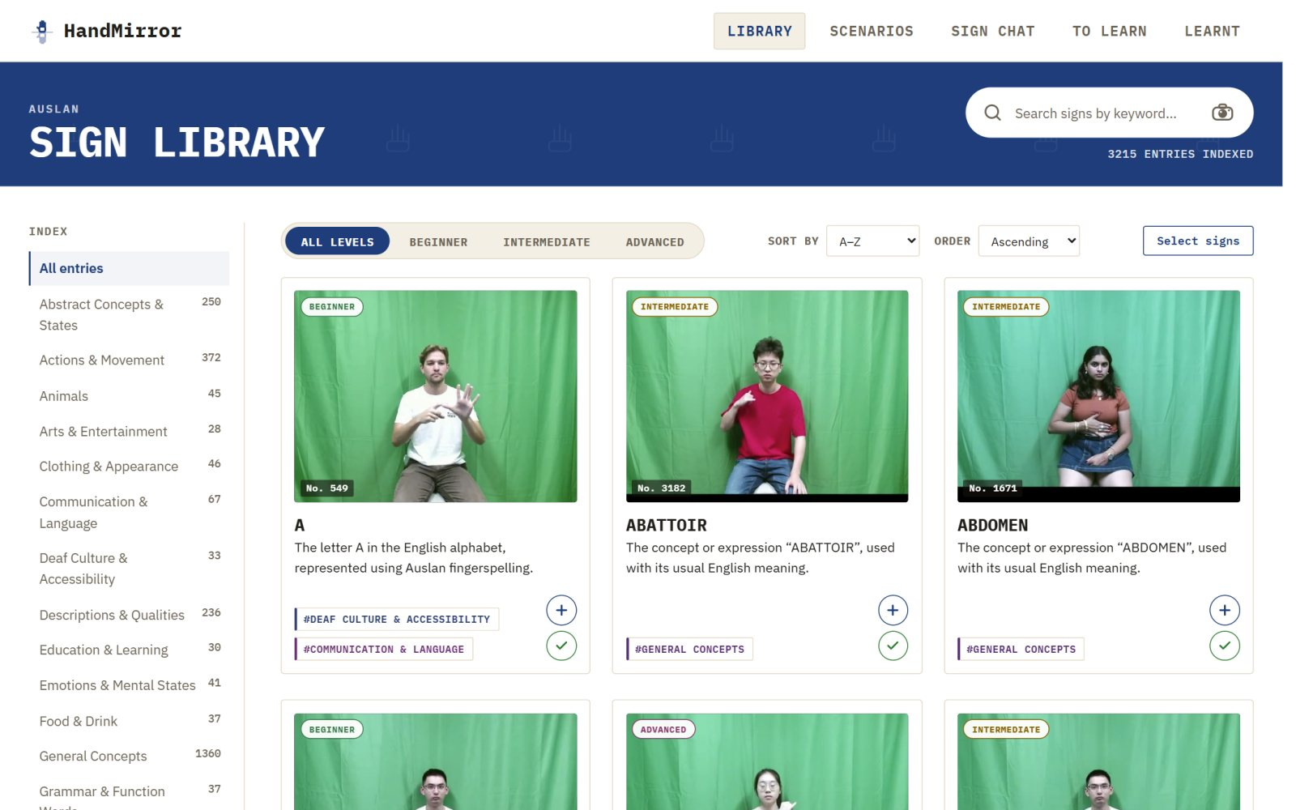
Figure 1. The Sign Library: search, topic index, level filter and sort, with the + / ✓ buttons on each card.
2.2 Save several signs at once
Select signs (above the cards in the Library, To Learn and Learnt) turns the grid into a multi-select: click cards to tick them, then use the bar at the bottom of the screen. The Library offers Add to To Learn and Mark as learnt; To Learn offers Mark as learnt and Remove; Learnt offers Move to To Learn and Remove. A sign is never on both lists -- adding it to one takes it off the other. Done leaves selection mode.
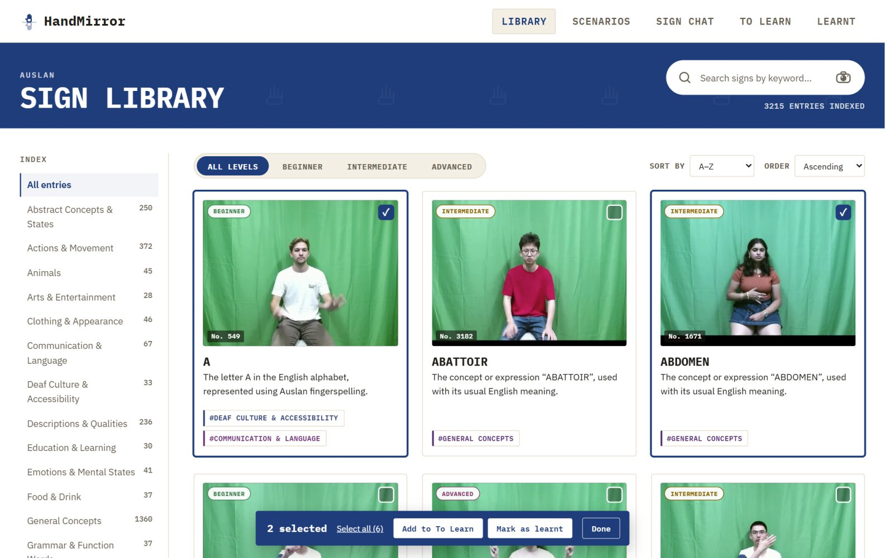
Figure 2. Two signs selected, with the bulk-action bar at the bottom of the screen.
2.3 Learn a sign
- The sign page opens on Learn: the demonstration video (with a choice of versions where there are several, replay, and 0.5×-2× speed), the definition, and “How it's formed” -- the movement step by step.
- Video / 3D avatar switches the stage to an avatar performing the same sign. Drag to turn it to any angle; Reset view puts it back. The avatar shows the overall movement -- exact handshapes come from the video.
- Add to to-learn list and Mark as learnt save the sign; the arrows at the sides step to the previous and next sign in the list the learner came from.
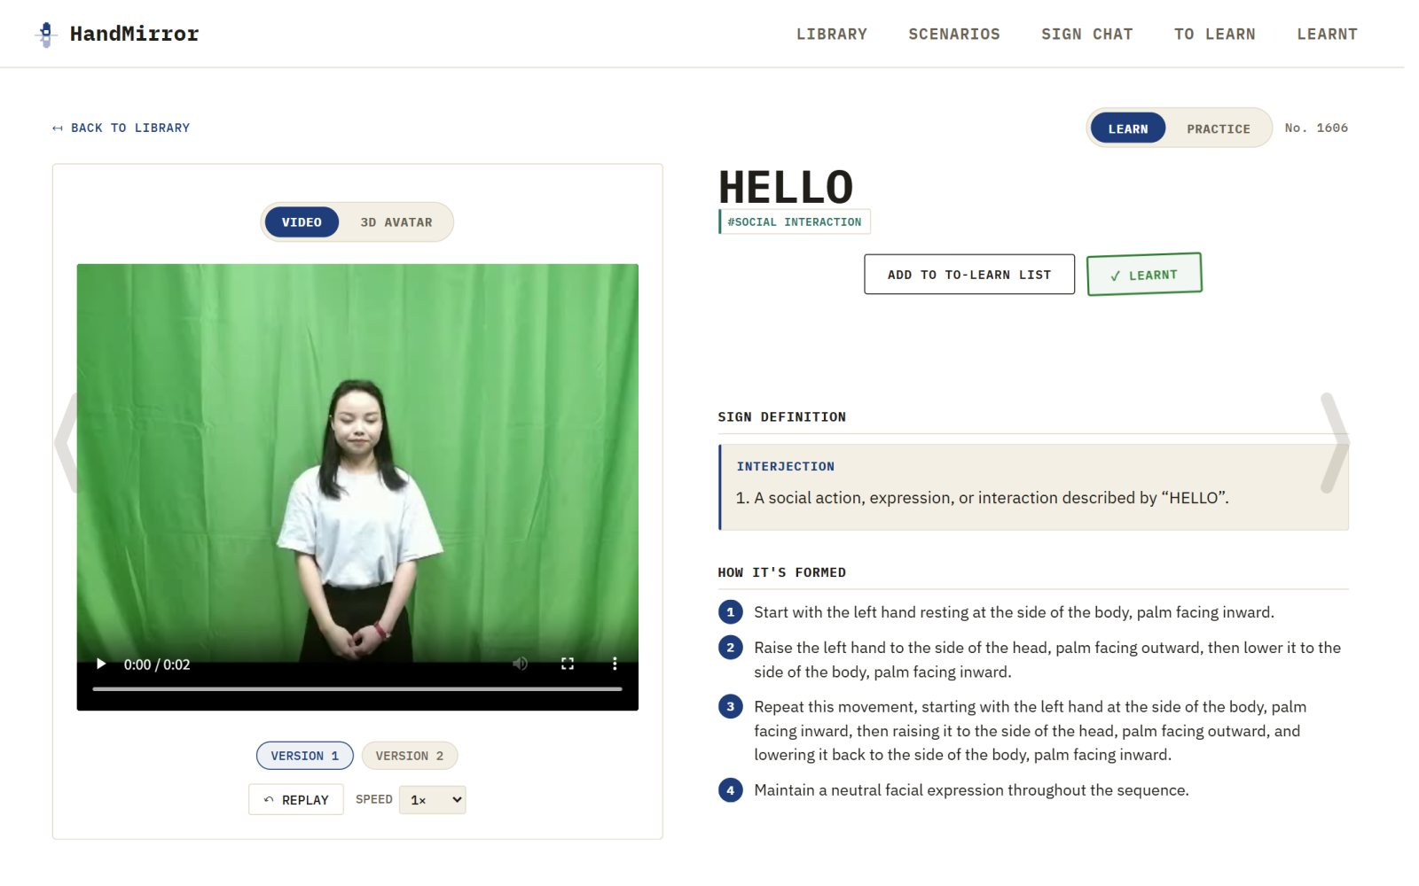
Figure 3. A sign page in Learn mode with the demonstration video.
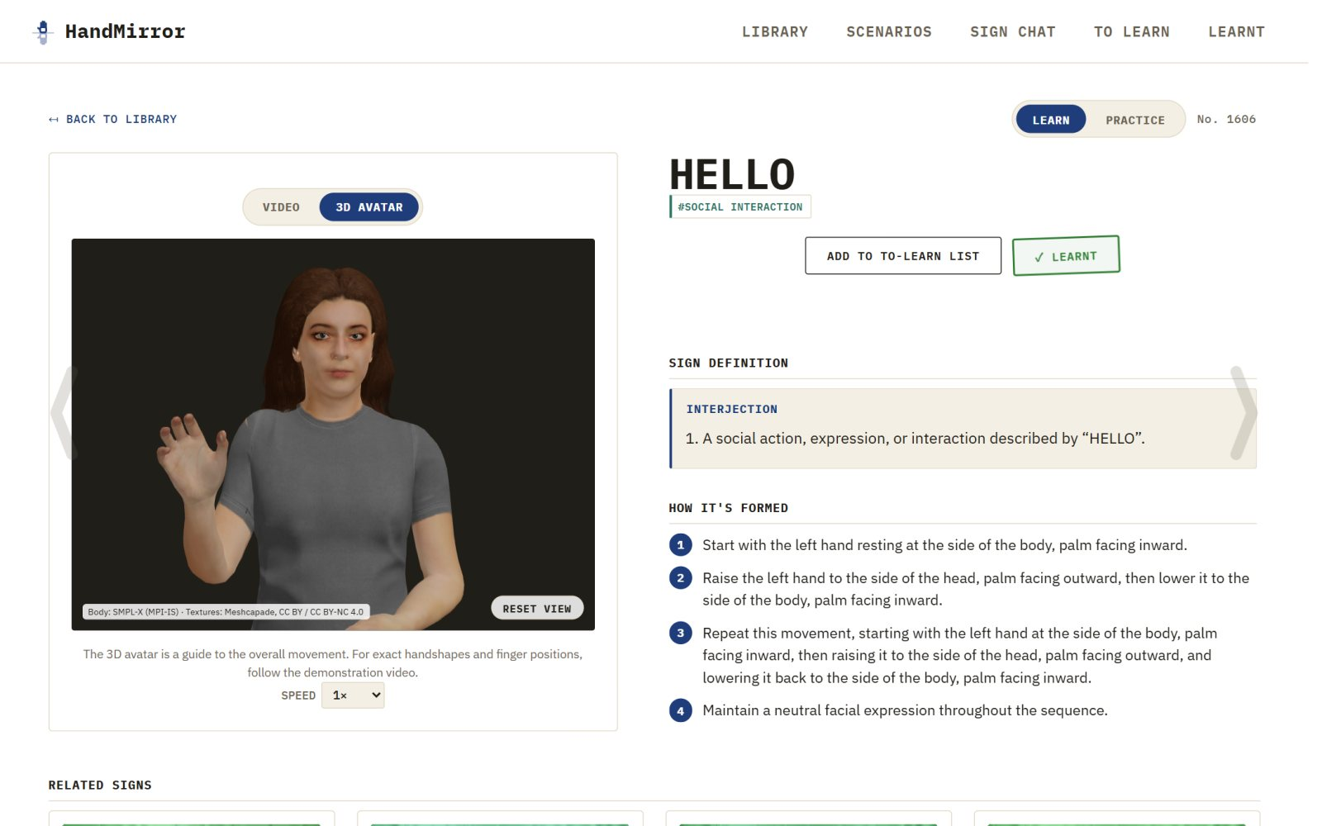
Figure 4. The same sign on the 3D avatar.
2.4 Practise a sign
Practice (top-right of the sign page) is shown for the signs the recognition model knows. Read the note above Start practice: follow the hand orientation in the video. After a short countdown the learner signs at the webcam; the capture stops by itself when the hands come to rest. The result is Excellent (80+), Almost there (60-79) or Keep practicing (under 60), with a tip and Try again. The camera picture never leaves the browser (Section 7).
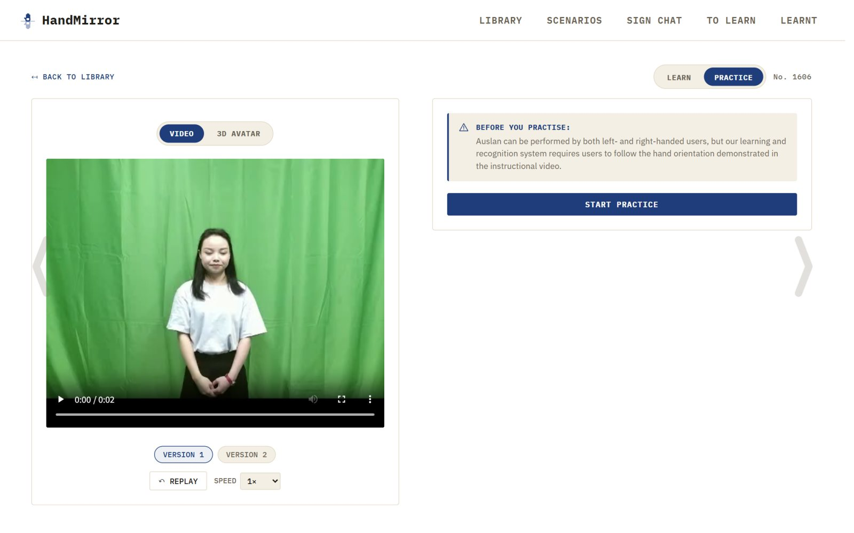
Figure 5. Practice mode, before the camera starts.
2.5 To Learn and the personalise wizard
To Learn lists the saved signs grouped by when they were added (Day / Week / Month / Year). Personalize your learning opens a two-step wizard: pick topics, then set how many signs in total and how they split across the topics (drag the pie chart or type numbers). The wizard adds signs the learner has not saved or learnt yet.
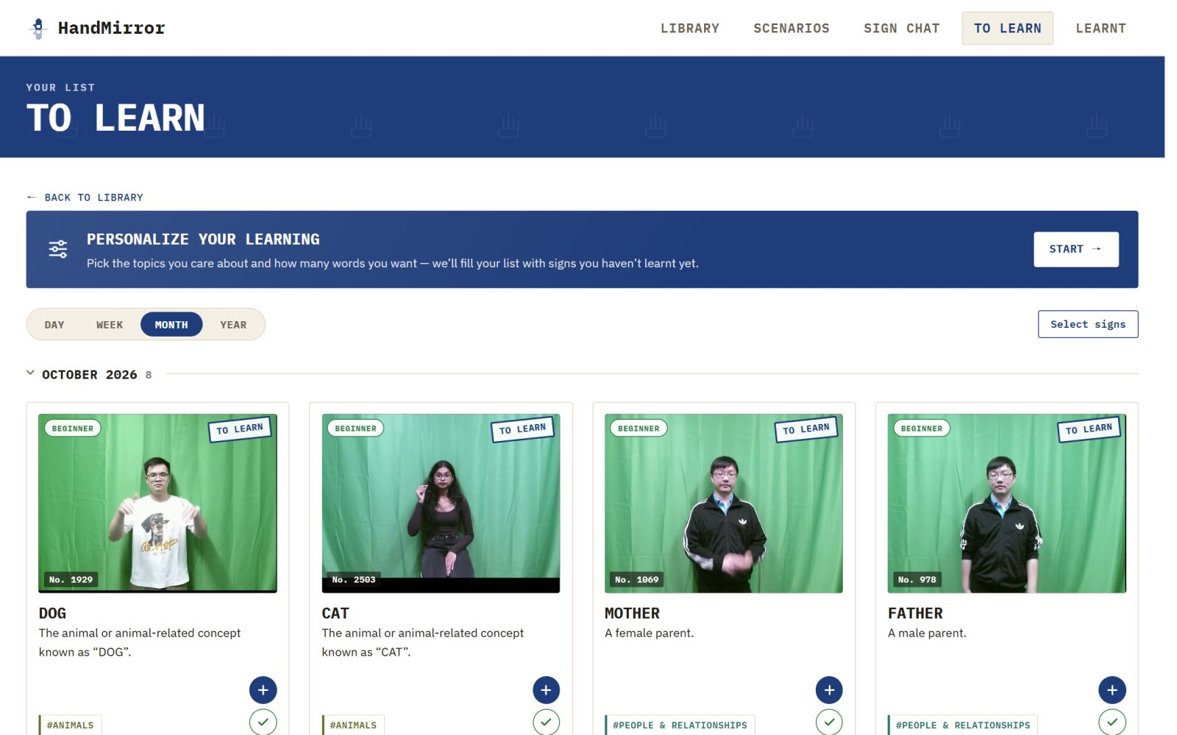
Figure 6. The To Learn list, with the personalise card above it.
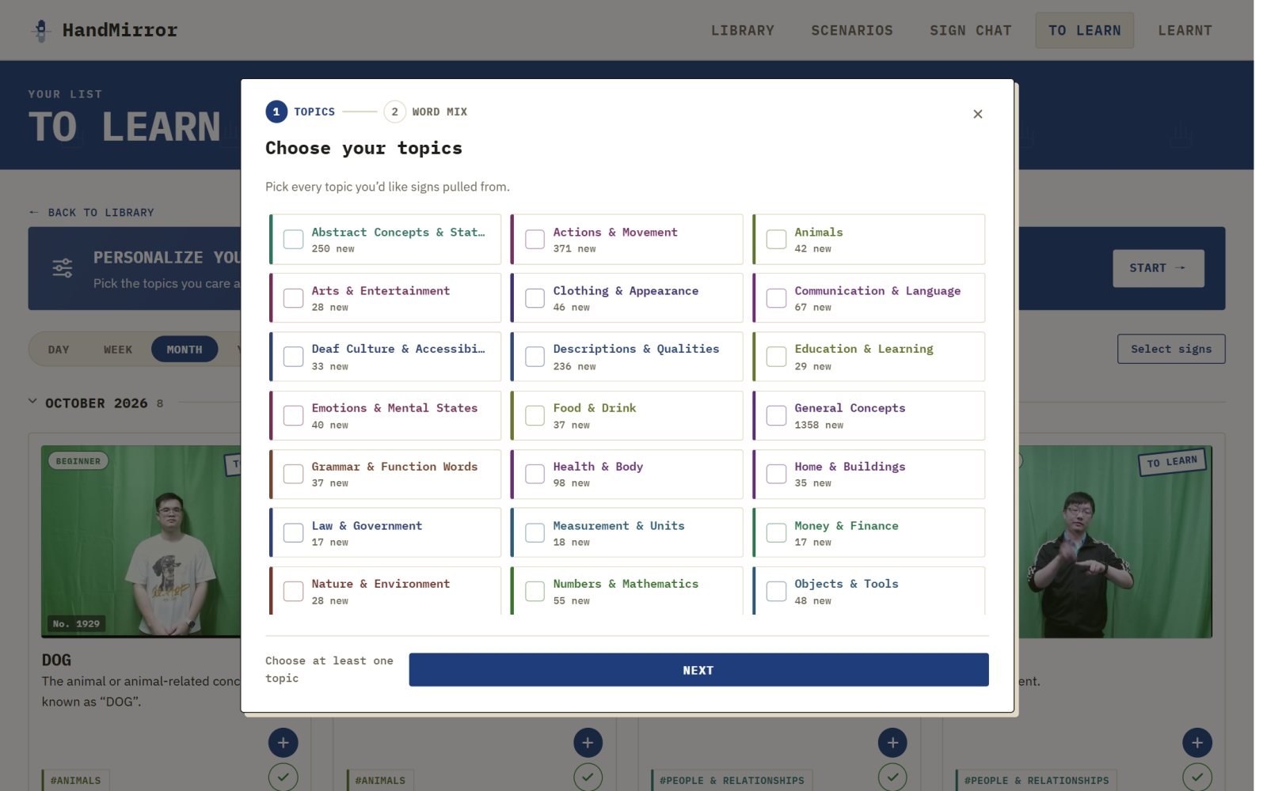
Figure 7. Step 1 of the personalise wizard: choosing topics.
2.6 Learnt
Learnt shows every sign marked learnt, grouped the same way, and progress against the whole dictionary.
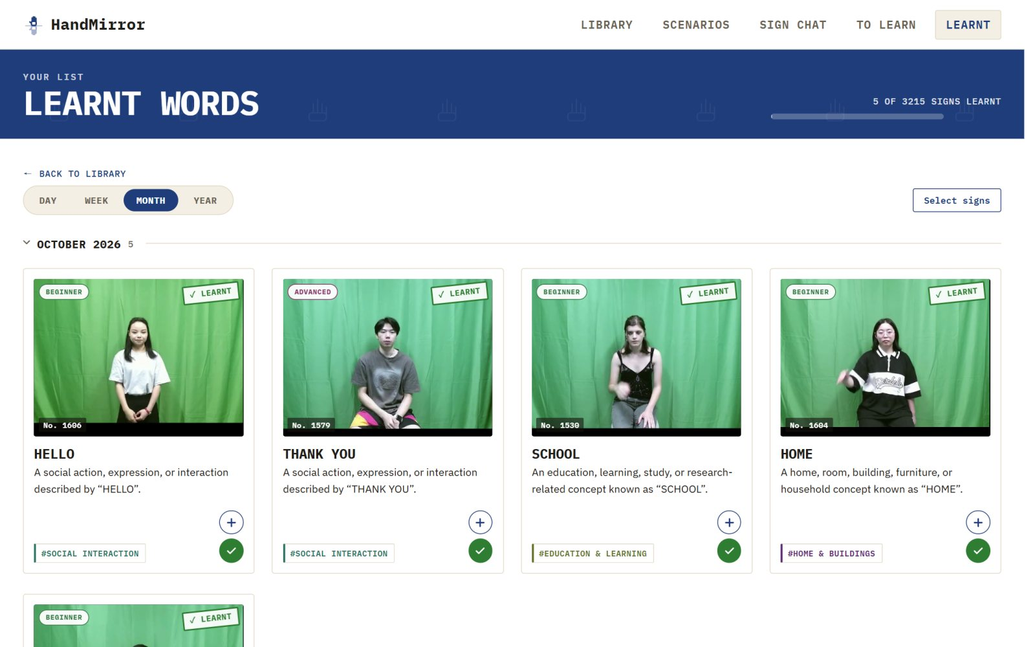
Figure 8. The Learnt list and its progress bar.
2.7 Scenario journeys
Scenarios groups signs by real situations -- ordering a coffee, a doctor's visit, family -- in three directions (Daily Life, Professional, Language Basics) that open and close with the arrow on the left. Each journey is a route of short stops. Hovering over a word shows its video with three buttons: Practise this sign, Add to To Learn and Mark as learnt. Next stop moves along the route.
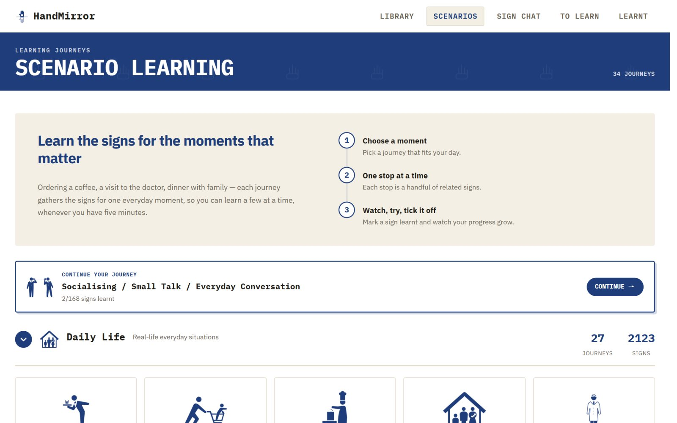
Figure 9. The Scenarios page: how a journey works, and the first direction opened.
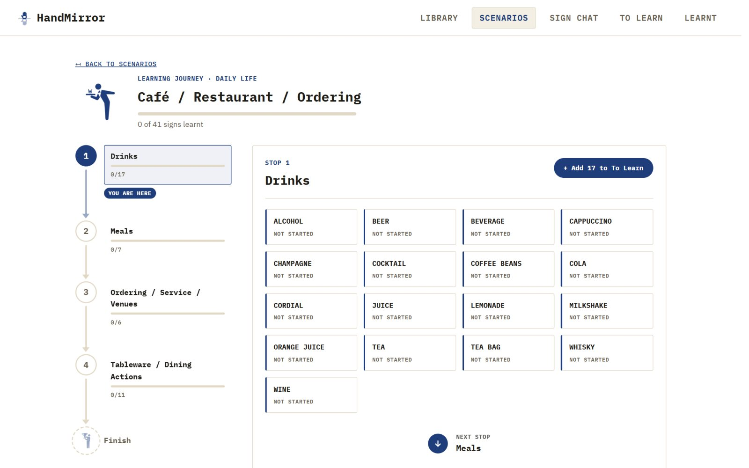
Figure 10. One journey: the route of stops on the left, the current stop's signs on the right.
2.8 Sign Chat
Type a short English sentence (or press the record button to sign it on camera) and the avatar replies in Auslan with subtitles; click a reply to watch it again, and New chat to start over. Sign Chat depends on the GPU model service in Section 4 -- when that is not running, the page shows an error instead of a reply.
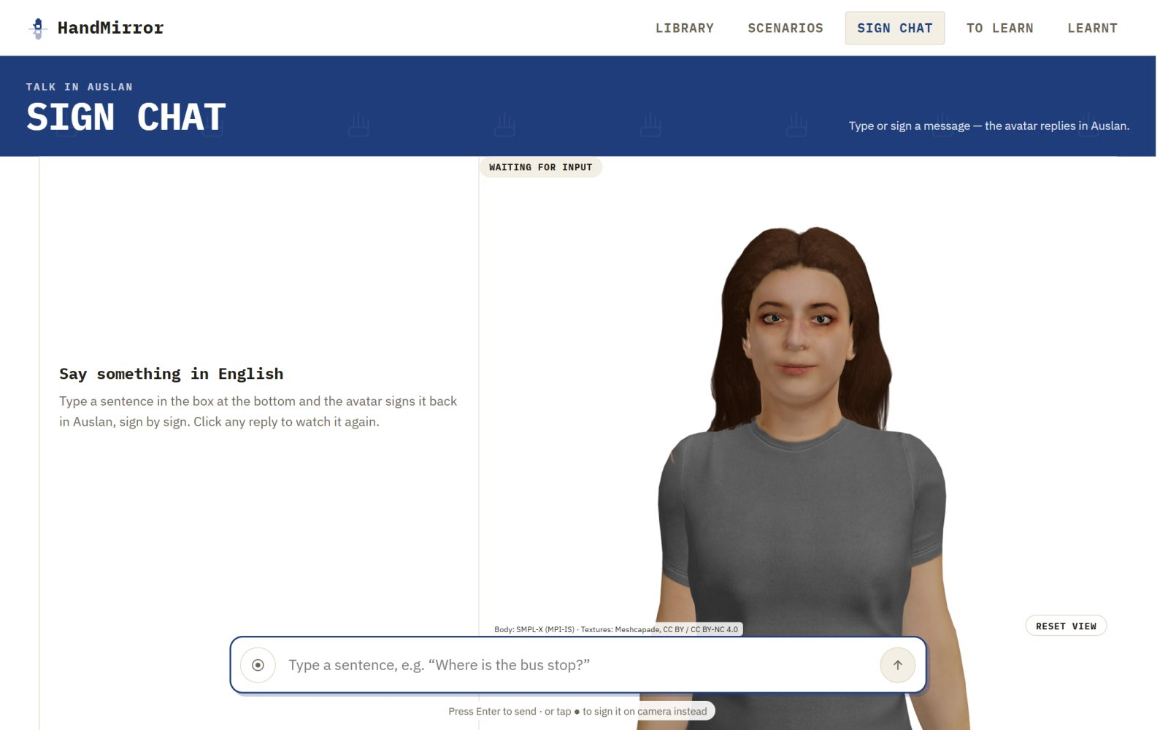
Figure 11. Sign Chat waiting for a message.
3. System summary
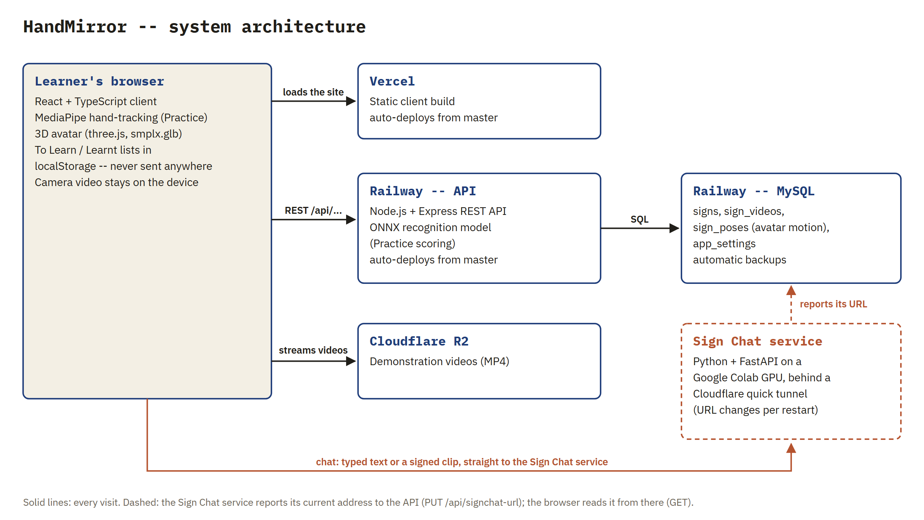
Figure 12. How the parts connect. The browser talks to four services; only the Sign Chat service is not permanently hosted.
Component | Technology | Where it runs
Web client | React 19 + TypeScript (Vite); three.js for the 3D avatar; MediaPipe for in-browser hand-tracking | Vercel
API | Node.js + Express; ONNX Runtime for the Practice recognition model | Railway
Database | MySQL (signs, sign_videos, sign_poses, app_settings) | Railway
Demonstration videos | MP4 files | Cloudflare R2
Sign Chat service | Python + FastAPI; sign-to-text, text-to-sign and dialogue models; needs a GPU | Google Colab (Section 4)

4. Environments & access
Environment | Component | Address
Production | Client (Vercel) | https://handmirror.vercel.app (public, no login)
Production | API (Railway) | https://fit5120-te38-signlanguage-production.up.railway.app
Production | Database | MySQL on Railway (shared with the API service)
Production | Sign Chat service | Google Colab GPU runtime behind a temporary trycloudflare.com URL (below)
Preview | Client | Vercel builds a preview for every non-master branch (e.g. staging)
Local dev | Client + API | cd website && npm run install:all && npm run seed && npm run dev (client :5173, API :4000)
Local dev | Sign Chat (no GPU) | cd sign_chat/sign_chat_backend && SIGNCHAT_MOCK=1 SIGNCHAT_DIALOGUE=echo uvicorn signchat.server:app --port 8000

Sign Chat hosting
Sign Chat has no permanent host yet. It runs from sign_chat/sign_chat_backend/colab_server.ipynb on a Colab A100 (an L4 with High-RAM also works; peak GPU memory is about 15 GB). Run sections 1-4; section 4 has finished when it prints “models loaded”. Section 3b (a 10-minute precision check) may be skipped, and section 6 must not be run while the site is in use: it restarts the server, leaving Sign Chat down for about two minutes.
- The URL is handed over automatically. Each time section 3 opens a tunnel, it reports the new URL to the API (PUT /api/signchat-url, authorised by the SIGNCHAT_UPDATE_TOKEN secret), and the website reads it whenever Sign Chat is opened. Restarting Colab needs no code change and no redeploy. Section 3 prints “website updated: 200” when the hand-off worked.
- One-time setup: the same secret value is stored as the Railway variable SIGNCHAT_UPDATE_TOKEN and as a Colab secret of the same name (key icon in Colab's left sidebar, with Notebook access switched on).
- Model weights (about 13 GB) are in the Google Drive of ruizisong11@gmail.com, folders auslan_work/ and smplx_models/. The notebook mounts the Drive of the account running it, so either run it from that account or share both folders and add them as shortcuts at the top of My Drive. They are not in the repository -- copy them to storage the sponsor owns at handover.
- While the runtime is up, anyone with the URL can call the service. Stop the runtime when it is not needed.
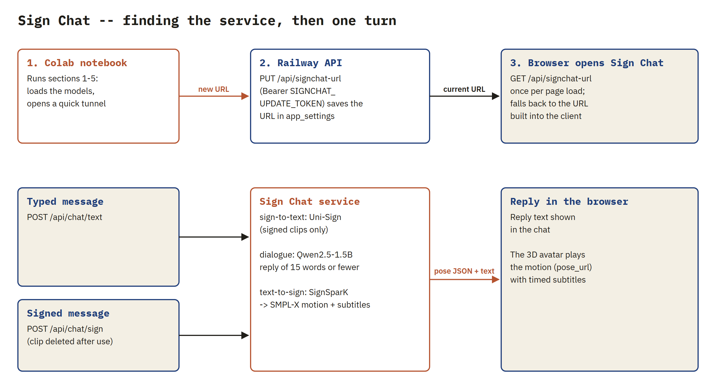
Figure 13. Top: how the website finds the Sign Chat service after a restart. Bottom: one conversation turn.
Deployment triggers
Both platforms deploy from the master branch automatically: Vercel builds the client, and Railway (project “pure-kindness”, service at https://fit5120-te38-signlanguage-production.up.railway.app) redeploys the API. Pushes to other branches produce Vercel previews only.
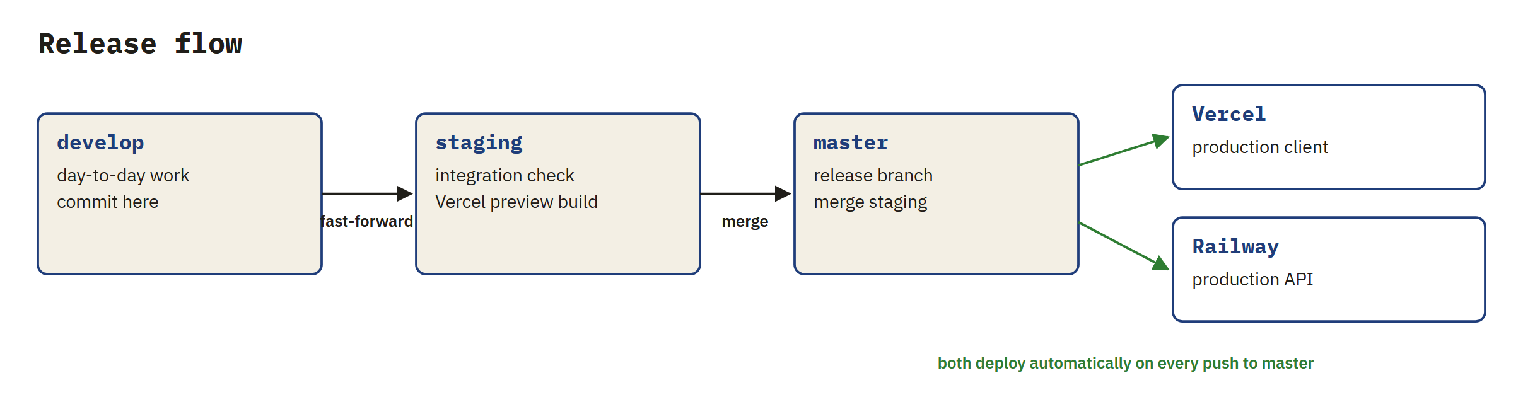
Figure 14. The release flow: work moves develop → staging → master, and master deploys itself.
5. Running & operating the product
Client: a static Vite build, auto-deployed by Vercel on every push to the master branch. API: a long-running Node process on Railway, started with npm start and restarted automatically on crash; GET /api/health returns {"status":"ok"} when it is up. The Practice model files (recognition/models, about 14 MB) are committed to the repository, so nothing needs fetching at deploy time. The 3D avatar (client/public/smplx.glb, 6.2 MB) and the home page cover clips (client/public/hero) are static files deployed with the client.
Required environment variables
Variable | Where | Purpose
PORT | Server | Port the Express server listens on (default 4000).
DB_HOST / DB_PORT | Server | MySQL host and port.
DB_USER / DB_PASSWORD | Server | MySQL credentials -- never commit real values.
DB_NAME | Server | Database name (auslan_learning).
CORS_ORIGIN | Server | The exact origin allowed to call the API. If unset it defaults to “*” (any origin) -- always set it in production.
VIDEO_BASE_URL | Server | Base URL used to resolve a sign's demonstration video when its row has no explicit video_url.
RECOGNITION_MODELS | Server | Optional path to the recognition model folder; defaults to the repository's recognition/models.
SIGNCHAT_UPDATE_TOKEN | Server | Shared secret the Colab notebook uses to report Sign Chat's URL (same value as the Colab secret). If unset, reporting is switched off (503).
VITE_API_BASE_URL | Client | Base URL the client calls for the API, including /api (e.g. https://fit5120-te38-signlanguage-production.up.railway.app/api).
VITE_SIGNCHAT_API_BASE_URL | Client | Fallback Sign Chat URL, used only when the API has none on record (website/client/.env.production).

Secret values live only in each platform's project settings (Vercel / Railway environment variables, Colab secrets), never in source control; the local .env files are git-ignored and .env.example lists the keys with no values.
6. Data management
The database has four tables: signs (one row per sign -- gloss, definitions, usage notes, tags, keywords and a source provenance string, several columns stored as native JSON), sign_videos (one or more demonstration videos per sign), sign_poses (one gzipped avatar motion clip per sign; a sign without a row simply has no 3D avatar) and app_settings (small key/value settings -- today only the current Sign Chat URL; created automatically the first time the notebook reports one).
Loading data
- npm run seed -- loads a small set of clearly-labelled placeholder demo signs (local development only).
- npm run import:real -- imports the real dataset from server/data/signs.json and server/data/sign_videos.json.
- Avatar motion: python scripts/convert_poses.py <npz dir> <out dir> turns fitted SMPL-X .npz files into .json.gz, then node scripts/importPoses.js <out dir> upserts them into sign_poses, matched by gloss (run from website/server; it writes to whichever database the server's .env points at).
Backup & restore
Railway backs up the production MySQL volume automatically. To restore, open the MySQL service in the Railway dashboard, go to its Backups tab, pick a backup and choose Restore; the API reconnects on its own once the database is back. For a copy outside Railway (e.g. before a risky data import), take a manual dump:
mysqldump -h <DB_HOST> -P <DB_PORT> -u <DB_USER> -p auslan_learning > backup.sql
mysql -h <DB_HOST> -P <DB_PORT> -u <DB_USER> -p auslan_learning < backup.sql
7. Security, privacy & standards
There are no end-user accounts. The sign endpoints are read-only; the Practice endpoints score landmark data without storing it. The only endpoint that writes is PUT /api/signchat-url, which requires the SIGNCHAT_UPDATE_TOKEN secret (compared in constant time) and accepts only an https URL. Secrets exist only as platform environment variables and Colab secrets.
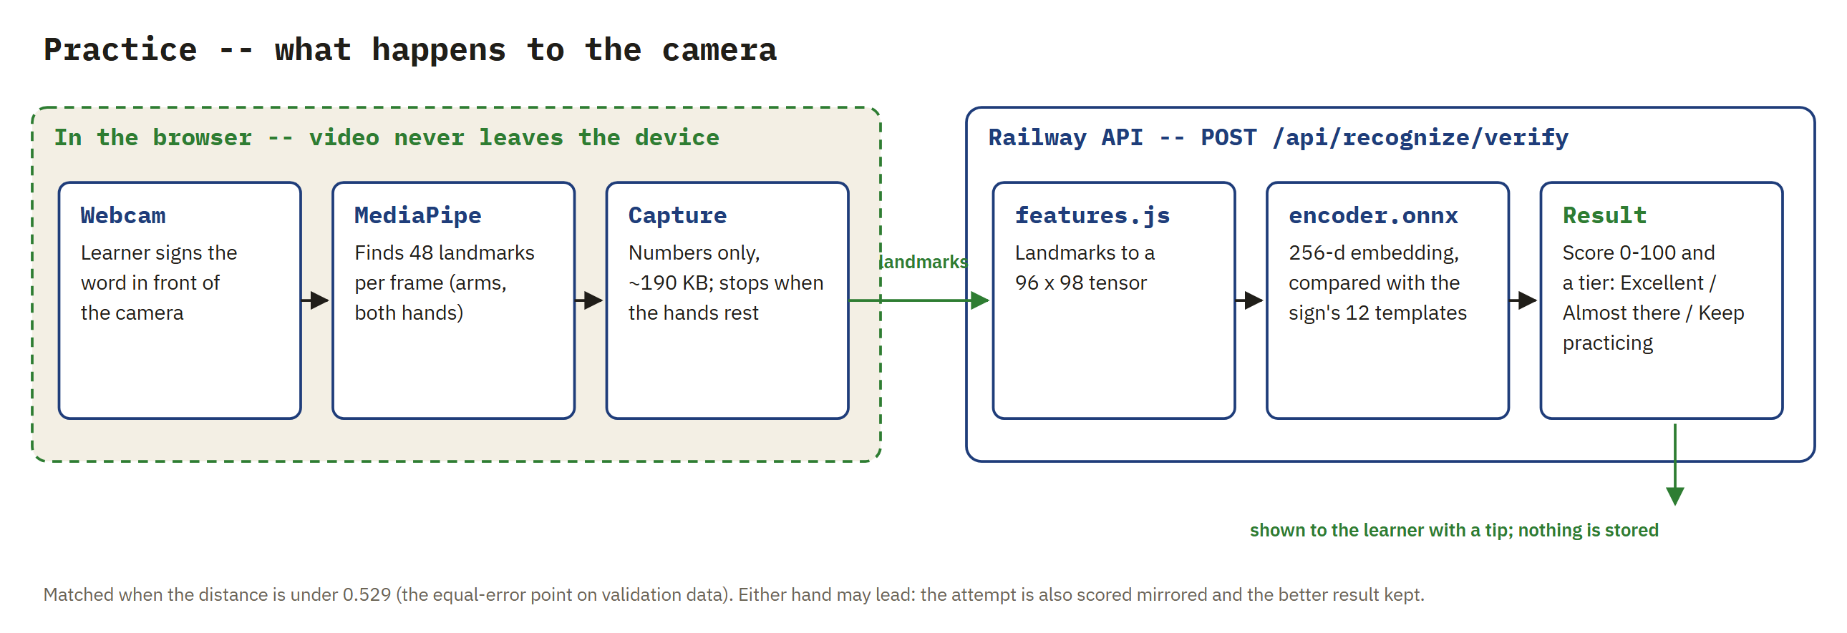
Figure 15. Practice keeps the camera picture on the learner's device: only landmark numbers reach the API, and nothing is stored.
Privacy -- Australian Privacy Principles (Privacy Act 1988)
Principle | How HandMirror complies
APP 1 -- open and transparent management | This document and the Product Document describe exactly what each feature sends and keeps. Recommended: a short privacy notice in the site footer.
APP 3 -- collection | Only what a feature needs: landmark numbers for Practice, the message for Sign Chat. No names, emails, accounts or tracking cookies.
APP 5 -- notice of collection | Practice and Sign Chat run only after the learner starts them. Recommended: one line on Sign Chat saying messages go to the model service.
APP 6 -- use and disclosure | Data is used only to produce the score or the reply, and is not shared with anyone else.
APP 11 -- security of personal information | HTTPS everywhere; Practice data is not stored; uploaded Sign Chat clips are deleted when the request ends; conversation text is held in memory for the session only.
APP 12 / 13 -- access and correction | Nothing is stored about an identifiable learner; saved lists live in the learner's own browser and can be cleared there.

Security -- OWASP Top 10 (2021)
Risk | Status in HandMirror
A01 Broken access control | No accounts or private data. The one write endpoint (PUT /api/signchat-url) requires a secret token.
A02 Cryptographic failures | All traffic is HTTPS (Vercel, Railway, Cloudflare tunnel). No secrets in the repository.
A03 Injection | Every SQL query uses mysql2 parameter placeholders; the reported Sign Chat URL is parsed and reduced to its https origin.
A04 Insecure design | Data minimisation by design: Practice sends landmarks, never video.
A05 Security misconfiguration | Open items: CORS falls back to “*” when CORS_ORIGIN is unset, and there is no security-headers middleware (helmet). Set CORS_ORIGIN and add helmet before wider use.
A06 Vulnerable and outdated components | Run npm audit on client and server regularly; dependencies are pinned in package-lock.json.
A07 Identification and authentication failures | Not applicable (no logins). Rotate SIGNCHAT_UPDATE_TOKEN if it is ever exposed.
A09 Logging and monitoring | Railway and Vercel keep request and error logs; GET /api/health supports uptime monitoring.
A10 Server-side request forgery | The API never fetches a URL supplied by a user; the Sign Chat URL is only stored and handed to browsers.

Accessibility -- WCAG 2.1 Level AA
Every page was checked with axe-core against WCAG 2.0-2.2 A/AA rules (Maintenance Document, Section 10). Keep new pages at the same level.
Known limitations
- No rate-limiting middleware: each POST /api/recognize call runs model inference on the API server's CPU, so a flood of requests could slow the whole API. Add express-rate-limit (tighter on /api/recognize).
- Request bodies up to 5 MB are accepted (a Practice capture is about 190 KB).
- While Colab is running, the Sign Chat tunnel URL is public and unauthenticated.
- The Practice score threshold was calibrated on studio (green-screen) footage; home webcams, lighting and framing can lower scores.
- Sign Chat's sign-to-text and text-to-sign models have not been validated by fluent signers; they do best on short, everyday sentences.
8. API reference summary
Endpoint | Notes
GET /api/health | Liveness check; returns {"status":"ok"}.
GET /api/signs | Search/list signs. Optional: query (search across gloss, tags, keywords, definitions), tag, level (beginner / intermediate / advanced), sort, page, pageSize (default 6, max 50).
GET /api/signs/tags | Topic categories with counts. Optional exclude (comma-separated sign ids) so counts reflect what is still left to learn.
GET /api/signs/sample | Random signs from one topic for the personalise wizard: tag, count (max 50), exclude.
GET /api/signs/:id | Single sign with its demonstration videos and estimated level. 404 if the id doesn't exist.
GET /api/signs/:id/pose | The sign's avatar motion clip (SMPL-X joint rotations per frame). 404 if the sign has none.
POST /api/recognize/verify | Practice scoring. Body {word, capture}; returns matched, a 0–100 score, a tier (excellent / close / needs_practice) and a feedback sentence.
POST /api/recognize/identify | Sign-to-search. Body {capture}; returns the four closest signs with a calibrated confidence.
GET /api/recognize/vocabulary | Which signs the recognition model knows (?detail=1 adds the Signbank cross-reference).
GET /api/signchat-url | The Sign Chat service's current URL and when it was reported; 404 if none yet.
PUT /api/signchat-url | Header Authorization: Bearer <SIGNCHAT_UPDATE_TOKEN>, body {url}. 401 wrong token, 400 not an https URL, 503 token not configured.
Sign Chat service | POST /api/chat/text, POST /api/chat/sign (multipart video upload), DELETE /api/session/:id -- see sign_chat/sign_chat_backend/README.md.

The landmark “capture” format and error codes (400 unusable_capture, 404 unknown_word, 503 model_unavailable) are specified in recognition/API.md.
9. Troubleshooting guide
Symptom | Likely cause / fix
Server won't start | Check DB_HOST/DB_PORT/DB_USER/DB_PASSWORD/DB_NAME point to a reachable MySQL instance.
CORS error in the browser console | CORS_ORIGIN on the server doesn't match the client's actual deployed origin.
Videos don't play / show black | VIDEO_BASE_URL isn't set, or the Cloudflare R2 bucket it points to is unreachable.
Search returns zero results | The database hasn't been seeded or imported yet -- run npm run seed or npm run import:real.
Practice says “isn't switched on for this site yet” | The API returned 503 model_unavailable: recognition/models is missing from the deployment, or RECOGNITION_MODELS points at the wrong folder.
Practice says “Didn't catch enough movement” | 400 unusable_capture: both hands weren't in frame, or the capture was too short. Ask the learner to step back so both shoulders are visible.
“There's no 3D avatar for this sign yet” | The sign has no sign_poses row -- import its motion clip (Section 6).
3D avatar panel stays blank | smplx.glb failed to load, or the browser has WebGL disabled; check the browser console.
Sign Chat shows an error instead of a reply | The Colab runtime is not running, or the models are still loading (about two minutes after a restart). Start the notebook (sections 1-4), then reload the Sign Chat page.
Section 3 prints “website NOT updated: Secret SIGNCHAT_UPDATE_TOKEN does not exist” | Add the Colab secret (key icon, Notebook access on), then re-run the report line or section 3.
Section 3 prints 503 “SIGNCHAT_UPDATE_TOKEN is not set on the server” / 401 “Bad token” | Set the Railway variable, or make the Railway and Colab values identical.
Section 3 shows a URL of https://api.trycloudflare.com | Cloudflare refused the tunnel (usually rate limiting). The notebook retries automatically; if all attempts fail, wait 10-15 minutes and run section 3 again.
Sign Chat repeats your text back and the avatar barely moves | The client is talking to a mock server (SIGNCHAT_MOCK=1, echo dialogue), not the real models.

10. Knowledge transfer plan
The handover is designed so a sponsor's staff can run and change HandMirror without the original team. It happens in four steps, each led by the team members below and backed by these documents.
Step | Audience | Content | Material
1. Product walkthrough (1 hour) | Sponsor's product owner, support staff | Live demo of every feature in Section 2; who the product serves; licence and privacy position | Product Document; this document, Section 2
2. Operations session (1.5 hours) | Support staff | Deploying, environment variables, starting Sign Chat on Colab, backups and restore, the troubleshooting table | This document, Sections 3-9
3. Code walkthrough (2 hours) | Technical team | Codebase map, the recognition and avatar pipelines, the release flow, how to add signs and journeys | Maintenance Document; repository READMEs
4. Account transfer | Sponsor's administrator | Ownership or admin rights moved to the sponsor (list below); secrets rotated afterwards | Checklist below

Accounts and assets to transfer:
- GitHub repository https://github.com/randlyoyo/FIT5120-TE38-SignLanguage (transfer ownership or add the sponsor as admin).
- Vercel project “handmirror” (team te-38) and Railway project “pure-kindness” (API and MySQL).
- Cloudflare R2 bucket with the demonstration videos.
- Google Drive folders with the Sign Chat model weights (auslan_work/, smplx_models/) and the Colab notebook.
- The Project Governance Portfolio on Google Drive (https://drive.google.com/drive/folders/1u6BIRZyPxSSnvfm3VgOKKIQmPg2BWyyp).
- After transfer: rotate DB_PASSWORD and SIGNCHAT_UPDATE_TOKEN so the team's copies stop working.
11. Support contacts
Name | Role | Contact
Dingao Wang | Lead developer -- first contact for any issue | wangdingao5337@gmail.com
Ruizi Song | Holds the Sign Chat model weights (Google Drive) | ruizisong11@gmail.com

HandMirror — Support Document · Team TE38 (BitDance) · FIT5120

