HANDOVER PACKAGE — PRODUCT DOCUMENT
HandMirror
Version 2.2 · 15 October 2026 (living document -- updated each iteration) | Team TE38 · BitDance | FIT5120, Monash University
1. Overview
HandMirror is a free, web-based Auslan (Australian Sign Language) learning assistant for families. This version delivers the full learning loop the team planned: look up a sign; learn it three ways (a real signer on video, a step-by-step breakdown, and a 3D avatar you can turn to any angle); practise it on camera with instant feedback; organise learning with personalised To Learn lists and real-life scenario journeys; and hold a short conversation with a signing avatar (Sign Chat).
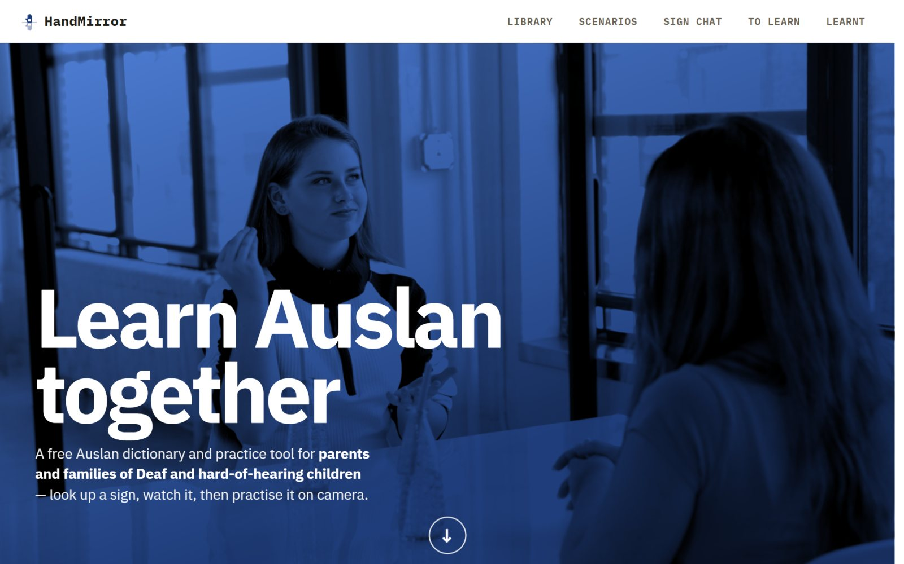
Figure 1. The home page states what HandMirror is and who it is for within the first screen.
The problem
Parents and caregivers of young Deaf or hard-of-hearing children in Australia often have limited Auslan knowledge and struggle to find practical, trustworthy learning support for everyday family communication. Australian news coverage (ABC News, 2022) documented a family that secured NDIS funding but still could not find a suitable Auslan tutor -- funding does not always create access. Existing online resources are scattered, often move too fast for a beginner, and cannot confirm whether a learner is practising a sign correctly.
The audience
Primary audience: parents and caregivers of young Deaf or hard-of-hearing children in Australia, with limited Auslan knowledge and a need for flexible, family-friendly support. Primary persona: “Sarah Thompson”, 38, a parent and primary-school teacher who needs short, flexible learning sessions with progress tracking. Secondary audiences: Auslan beginners generally, and accessibility-focused learners (students, teachers).
Why it's important
The project addresses UN Sustainable Development Goal 4 (Quality Education) and Goal 10 (Reduced Inequalities) -- giving families a flexible, low-cost way to build practical Auslan at home, rather than depending on scarce tutor availability.
2. What's built so far
Epic | Status | What it does today
Epic 1 -- Sign library search & browse | Delivered | Keyword search across gloss, tags, keywords and definitions; topic browsing; difficulty-level filter and sort; pagination; sign-to-search (sign at the webcam and pick from the four closest signs); select several signs at once and add them to To Learn or mark them learnt.
Epic 2 -- Sign demonstration & learning | Delivered | Real signer video for every sign (0.5×–2× speed), a step-by-step movement description, a rotatable 3D avatar playing the sign, Mark as learnt, and + / ✓ buttons on every sign card for one-click saving.
Epic 3 -- Basic quiz / self-check | Not built | Remains open for a future iteration.
Epic 4 -- AI sign recognition & webcam feedback | Delivered | Practice tab: the learner signs at the webcam and gets one of three results -- Excellent (score 80+), Almost there (60–79) or Keep practicing (under 60) -- with a tip. Either hand may lead.
Epic 5 -- Personalised learning | Delivered | To Learn list (grouped by when signs were added), a personalise wizard (pick topics, a word count and its split; it fills the list with signs not yet learnt), and a Learnt list with progress.
Epic 6 -- Family mode | Not built | Remains open for a future iteration.
Epic 7 -- Real-life conversation practice | Delivered | Scenario Learning: 34 journeys (e.g. café, doctor, family) split into short stops, with a guided route and progress. Sign Chat: type or sign a sentence and a 3D avatar replies in Auslan.

3. How it works (high level)
A React + TypeScript client (hosted on Vercel) calls a Node.js + Express REST API (hosted on Railway), backed by a MySQL database (also on Railway). Demonstration videos are served from Cloudflare R2. Practice runs the hand-tracking in the learner's browser and scores the attempt with a small recognition model inside the Express API. Sign Chat uses a separate Python model service that needs a GPU. Full technical detail is in the Support and Maintenance Documents.
Live product: https://handmirror.vercel.app (public -- no account, login or password is needed) | Source code: https://github.com/randlyoyo/FIT5120-TE38-SignLanguage
4. Ethics & responsible design
Data provenance and licensing
Every sign record carries a source field recording where its content came from, so the product never silently presents unverified content as confirmed Auslan. The third-party assets in the product, and the terms they come under, are:
Asset | Source | Licence / terms
Sign records & demonstration videos | MM-WLAuslan word-level dataset (UQ CV Lab); dictionary cross-reference to Auslan Signbank | Research dataset terms; Signbank is CC BY-NC-ND 4.0
Practice recognition model | Trained by the team on MM-WLAuslan | Inherits the dataset's terms
3D avatar body | SMPL-X neutral model (Max Planck Institute for Intelligent Systems) | Non-commercial use only; the model may not be redistributed
Avatar motion | SMPL-X parameters fitted by the team to the MM-WLAuslan signers | Inherits the dataset's terms
Avatar skin | BEDLAM body textures by Meshcapade | CC BY-NC 4.0
Avatar clothing | Meshcapade SMPL texture samples | CC BY 4.0
Avatar hair | Exported from an Avaturn avatar | CC BY-NC 4.0 -- non-commercial use only
Scenario pictograms | Human Pictogram 2.0 by TopeconHeroes (recoloured) | Free to use as part of a design; files may not be redistributed or sold on their own
Sign Chat models | Uni-Sign (sign-to-text) and SignSparK (text-to-sign), fine-tuned on Auslan-Daily; Qwen2.5-1.5B-Instruct for dialogue | Per each upstream project's licence
Home page cover footage | Four clips of people signing from Pexels, video IDs 10373883, 10374296, 10374298, 10373841 (client/public/hero) | Pexels licence: free to use, attribution not required

Licence position: the restricted assets above -- Auslan Signbank, the research datasets and everything derived from them, SMPL-X, the BEDLAM skin and the avatar hair -- are licensed under Creative Commons 4.0 non-commercial terms (CC BY-NC 4.0; CC BY-NC-ND 4.0 for Signbank) or an equivalent non-commercial research licence. HandMirror may therefore be run free of charge, as it is today, for non-commercial use only. Any commercial use requires a separate licence from each rights holder first.
Content safety
The dictionary covers the full Auslan vocabulary of its source dataset, which includes adult and crude signs -- appropriate for a reference, but not for a family homepage. The home page's sign strip therefore draws only from a fixed list of 16 family-friendly signs (HELLO, THANK YOU, DOG, MOTHER and so on), never from a random catalogue pick. The cover footage behind the home page title is stock video of people signing, chosen for mood; it is not presented as a lesson.
Privacy
- No user accounts. Learnt and To Learn lists are stored only in the visitor's own browser (localStorage) and are never sent to the server.
- Practice: camera video never leaves the browser. Hand-tracking runs locally; only numeric landmark coordinates are posted for scoring, and they are not stored.
- Sign Chat: typed messages are sent to the Sign Chat service. When a learner chooses to sign a message instead, the recorded clip is uploaded to that service so it can be recognised.
What the Sign Chat service keeps (checked in sign_chat_backend/signchat, 13 October 2026):
- Uploaded video clips: written to a temporary file for recognition and deleted as soon as the request finishes, whether it succeeds or fails.
- Conversation text: the last 6 exchanges of each session, in memory only (at most 1,000 sessions). Lost when the service restarts; DELETE /api/session/:id clears one sooner.
- Generated replies: each reply's motion file, skeleton video and subtitles (which contain the reply text) are saved under media/ and are not cleaned up automatically. On Colab they disappear when the runtime ends; a permanent host should delete them after a set period.
- No accounts, names or IP addresses are recorded by the service itself.
Personal information is handled in line with the Australian Privacy Principles (Privacy Act 1988, Cth): nothing is collected that the feature does not need, camera video is not stored, and no learner is identified. The mapping to each principle is in the Support Document, Section 7. Recommendation: tell users on the Sign Chat page that their messages are processed by the service and not kept beyond the session.
Honesty about limits
The interface tells learners that the 3D avatar shows the overall movement and that exact handshapes should be taken from the demonstration video. The Practice score threshold was calibrated on studio footage, and Sign Chat's replies have not yet been checked by fluent signers -- see the Support Document's known limitations.
ACS Code of Conduct mapping
ACS value | How HandMirror addresses it
The public interest | Targets a documented, real accessibility gap for Deaf/hard-of-hearing families rather than a purely commercial idea.
Quality of life | Free to use, no account required, reduces dependence on scarce and costly in-person tutoring.
Honesty | Source fields disclose provenance; the avatar is labelled as a guide; adult signs are kept off the family-facing home page.
Competence | Recognition has a parity test against the training pipeline; the APIs and data paths are documented for safe extension.
Professional development | The recognition contract (recognition/API.md) and Sign Chat README let future contributors retrain or replace models without redesigning the product.
Professionalism | Known limitations and licence restrictions (non-commercial use only) are disclosed rather than hidden.

The full Ethics Canvas is in the Project Governance Portfolio: https://drive.google.com/drive/folders/1u6BIRZyPxSSnvfm3VgOKKIQmPg2BWyyp
5. Team
Name | Role | Email | LinkedIn
Dingao Wang | Lead developer; support contact | dwan0104@student.monash.edu | www.linkedin.com/in/dingaowang
Ziyang Wang | Team member | zwan0637@student.monash.edu | www.linkedin.com/in/ziyang-wang-2b4700197
Minshu Ye | Team member | myee0023@student.monash.edu | www.linkedin.com/in/minshu-ye-24887b428
Xinyue Mao | Team member | xmao0020@student.monash.edu | www.linkedin.com/in/xinyue-mao-236877428
Yan Zhuang | Team member | yzhu0233@student.monash.edu | www.linkedin.com/in/yan-zhuang-b4b80b3a3
Ruizi Song | Team member; holds the Sign Chat model weights | rson0034@student.monash.edu | www.linkedin.com/in/ruizi-song-12a8a8392

Team TE38 · “BitDance” · FIT5120, Monash University · Studio mentors: Afsana and Ted.
6. Potential sponsors
Organisation | Why they fit
Deaf Children Australia | Runs family programs and Auslan resources; could validate family needs and test the platform directly with parents and caregivers.
Expression Australia | Provides Auslan education and services (incl. Auslan in the Home, Auslan Storytime); could advise on Auslan accuracy, accessibility and culturally appropriate design.

7. Links
Item | Link
Live product | https://handmirror.vercel.app -- public, no login or password
Source code (GitHub) | https://github.com/randlyoyo/FIT5120-TE38-SignLanguage
System architecture | Current diagram: Support Document, Section 3 (and Maintenance Document, Section 2); earlier write-up in website/docs/system-architecture.docx
Product demo video | Project Governance Portfolio → Project Support folder
Team LinkedIn | Each member's profile is listed in Section 5
Project Governance Portfolio (Google Drive) | https://drive.google.com/drive/folders/1u6BIRZyPxSSnvfm3VgOKKIQmPg2BWyyp

HandMirror — Product Document · Team TE38 (BitDance) · FIT5120

