Databridge

Integrantes:
Randoll Emanuel Urbina Mendez
Victoria Valeria Espinoza Mayorga
Oscar Antonio Lara Ordoñes
Genesis Michelle Eugarrios Mendoza

Inicio de sesión:
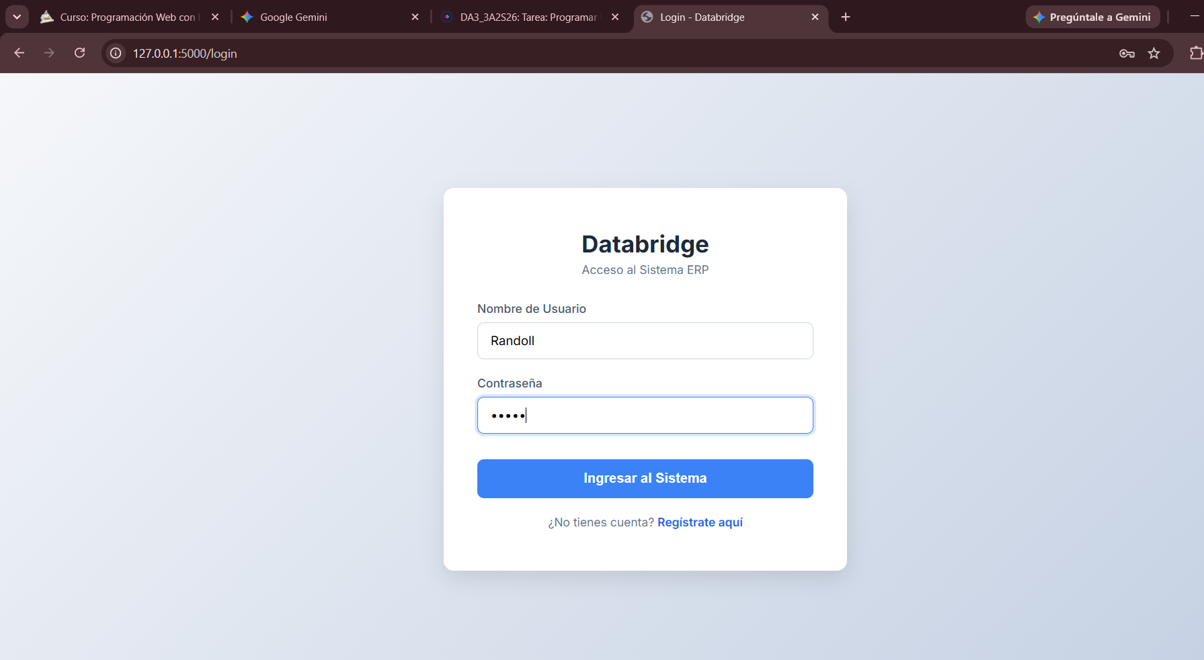
Código:
<!DOCTYPE html>
<html lang="es">
<head>
<meta charset="UTF-8">
<title>Login - Databridge</title>
<link href="https://fonts.googleapis.com/css2?family=Inter:wght@400;500;600;700&display=swap" rel="stylesheet">
<style>
body { font-family: 'Inter', sans-serif; background: linear-gradient(135deg, #f5f7fa 0%, #c3cfe2 100%); display: flex; justify-content: center; align-items: center; height: 100vh; margin: 0; }
.login-container { background: white; padding: 50px 40px; border-radius: 12px; box-shadow: 0 10px 25px rgba(0,0,0,0.1); width: 100%; max-width: 400px; }
.logo-text { text-align: center; color: #1e293b; font-size: 28px; font-weight: 700; margin-bottom: 5px; }
.subtitle { text-align: center; color: #64748b; font-size: 14px; margin-bottom: 30px; }
.form-group { margin-bottom: 20px; }
label { display: block; margin-bottom: 8px; color: #475569; font-weight: 500; font-size: 14px; }
input[type="text"], input[type="password"] { width: 100%; padding: 12px 15px; border: 1px solid #cbd5e1; border-radius: 8px; box-sizing: border-box; font-size: 15px; font-family: 'Inter', sans-serif;}
input:focus { border-color: #3b82f6; outline: none; box-shadow: 0 0 0 3px rgba(59,130,246,0.2); }
.btn-login { width: 100%; padding: 14px; background-color: #3b82f6; color: white; border: none; border-radius: 8px; cursor: pointer; font-size: 16px; font-weight: 600; margin-top: 10px; transition: background-color 0.2s;}
.btn-login:hover { background-color: #2563eb; }
.flash-msg { padding: 10px; text-align: center; margin-bottom: 20px; border-radius: 4px; font-size: 14px; border-left: 4px solid; }
.error { color: #b91c1c; background-color: #fef2f2; border-left-color: #ef4444; }
.success { color: #065f46; background-color: #d1fae5; border-left-color: #10b981; }
.register-link { text-align: center; margin-top: 20px; font-size: 14px; color: #64748b;}
.register-link a { color: #2563eb; text-decoration: none; font-weight: 600;}
</style>
</head>
<body>
<div class="login-container">
<div class="logo-text">Databridge</div>
<div class="subtitle">Acceso al Sistema ERP</div>

{% with messages = get_flashed_messages(with_categories=true) %}
{% if messages %}
{% for category, message in messages %}
<div class="flash-msg {{ category }}">{{ message }}</div>
{% endfor %}
{% endif %}
{% endwith %}

<form method="POST" action="{{ url_for('login') }}">
<div class="form-group">
<label>Nombre de Usuario</label>
<input type="text" name="username" placeholder="Ej. jperez" required autocomplete="off">
</div>
<div class="form-group">
<label>Contraseña</label>
<input type="password" name="password" placeholder="••••••••" required>
</div>
<button type="submit" class="btn-login">Ingresar al Sistema</button>
</form>

<div class="register-link">
¿No tienes cuenta? <a href="{{ url_for('registro') }}">Regístrate aquí</a>
</div>
</div>
</body>
</html>

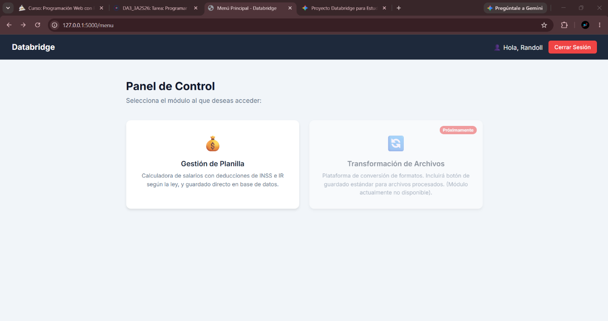
Menú:

Código:
<!DOCTYPE html>
<html lang="es">
<head>
<meta charset="UTF-8">
<title>Menú Principal - Databridge</title>
<link href="https://fonts.googleapis.com/css2?family=Inter:wght@400;500;600;700&display=swap" rel="stylesheet">
<style>
body { font-family: 'Inter', sans-serif; background-color: #f1f5f9; margin: 0; padding: 0; }
.navbar { background-color: #1e293b; padding: 15px 30px; display: flex; justify-content: space-between; align-items: center; color: white; }
.logo { font-size: 20px; font-weight: 700; }
.user-info { display: flex; align-items: center; gap: 15px; }
.btn-logout { background-color: #ef4444; color: white; border: none; padding: 8px 15px; border-radius: 6px; cursor: pointer; text-decoration: none; font-size: 14px; font-weight: 500; transition: background-color 0.2s;}
.btn-logout:hover { background-color: #dc2626; }

.container { max-width: 900px; margin: 50px auto; padding: 0 20px; }
.welcome-text { font-size: 28px; font-weight: 700; color: #0f172a; margin-bottom: 10px; }
.subtitle-text { font-size: 16px; color: #64748b; margin-bottom: 40px; }

.modules-grid { display: grid; grid-template-columns: repeat(auto-fit, minmax(300px, 1fr)); gap: 25px; justify-content: center;}

.module-card { background: white; border-radius: 12px; padding: 30px 20px; text-align: center; box-shadow: 0 4px 6px -1px rgba(0, 0, 0, 0.1); text-decoration: none; color: inherit; transition: transform 0.2s, box-shadow 0.2s; display: flex; flex-direction: column; align-items: center;}
.module-card:hover { transform: translateY(-5px); box-shadow: 0 10px 15px -3px rgba(0, 0, 0, 0.1); border-bottom: 4px solid #3b82f6; }

.icon { font-size: 40px; margin-bottom: 15px; }
.module-title { font-size: 18px; font-weight: 600; color: #1e293b; margin-bottom: 10px; }
.module-desc { font-size: 14px; color: #64748b; line-height: 1.5; }

/* Estilo para tarjetas deshabilitadas */
.disabled-card { opacity: 0.5; cursor: not-allowed; position: relative; }
.disabled-card:hover { transform: none; box-shadow: 0 4px 6px -1px rgba(0, 0, 0, 0.1); border-bottom: none; }
.badge { background-color: #ef4444; color: white; font-size: 11px; padding: 4px 8px; border-radius: 12px; position: absolute; top: 15px; right: 15px; font-weight: bold;}
</style>
</head>
<body>

<div class="navbar">
<div class="logo">Databridge</div>
<div class="user-info">
<span>👤 Hola, {{ username }}</span>
<a href="{{ url_for('logout') }}" class="btn-logout">Cerrar Sesión</a>
</div>
</div>

<div class="container">
<div class="welcome-text">Panel de Control</div>
<div class="subtitle-text">Selecciona el módulo al que deseas acceder:</div>

<div class="modules-grid">

<!-- Módulo 1: Planilla (ACTIVO) -->
<a href="{{ url_for('planilla') }}" class="module-card">
<div class="icon">💰</div>
<div class="module-title">Gestión de Planilla</div>
<div class="module-desc">Calculadora de salarios con deducciones de INSS e IR según la ley, y guardado directo en base de datos.</div>
</a>

<!-- Módulo 2: Transformación (INACTIVO) -->
<a href="#" class="module-card disabled-card" onclick="return false;">
<span class="badge">Próximamente</span>
<div class="icon">🔄</div>
<div class="module-title">Transformación de Archivos</div>
<div class="module-desc">Plataforma de conversión de formatos. Incluirá botón de guardado estándar para archivos procesados. (Módulo actualmente no disponible).</div>
</a>

</div>
</div>

</body>
</html>
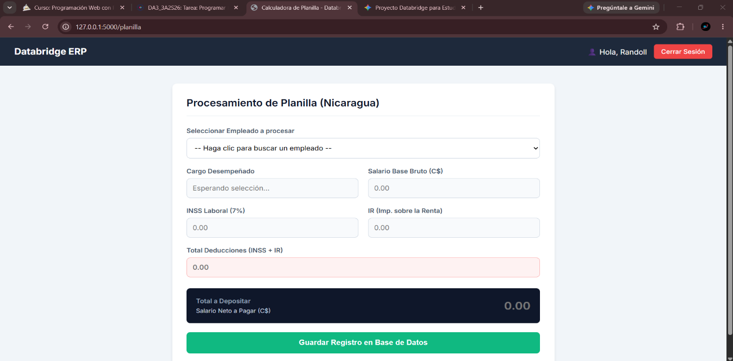
Planilla:

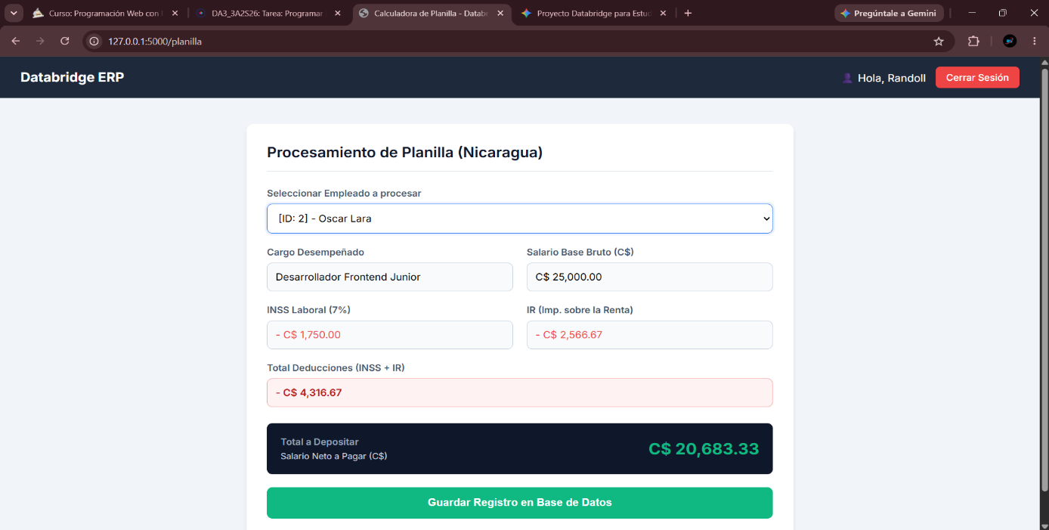
Código:
<!DOCTYPE html>
<html lang="es">
<head>
<meta charset="UTF-8">
<title>Calculadora de Planilla - Databridge</title>
<link href="https://fonts.googleapis.com/css2?family=Inter:wght@400;500;600;700&display=swap" rel="stylesheet">
<style>
body { font-family: 'Inter', sans-serif; background-color: #f1f5f9; margin: 0; padding: 0; }
.navbar { background-color: #1e293b; padding: 15px 30px; display: flex; justify-content: space-between; align-items: center; color: white; }
.logo { font-size: 20px; font-weight: 700; }
.user-info { display: flex; align-items: center; gap: 15px; }
.btn-logout { background-color: #ef4444; color: white; border: none; padding: 8px 15px; border-radius: 6px; cursor: pointer; text-decoration: none; font-size: 14px; font-weight: 500; transition: background-color 0.2s;}
.btn-logout:hover { background-color: #dc2626; }
.container { max-width: 800px; margin: 40px auto; padding: 0 20px; }
.card { background: white; border-radius: 10px; box-shadow: 0 4px 6px -1px rgba(0, 0, 0, 0.1); padding: 30px; }
.card-title { font-size: 22px; font-weight: 600; color: #0f172a; margin-bottom: 25px; border-bottom: 1px solid #e2e8f0; padding-bottom: 15px;}
.form-grid { display: grid; grid-template-columns: 1fr 1fr; gap: 20px; margin-bottom: 20px; }
.form-group { display: flex; flex-direction: column; }
.full-width { grid-column: span 2; margin-bottom: 20px;}
label { font-size: 14px; font-weight: 600; color: #475569; margin-bottom: 8px; }
input, select { padding: 12px; border: 1px solid #cbd5e1; border-radius: 8px; font-size: 15px; font-family: 'Inter', sans-serif; background-color: #f8fafc;}
select { background-color: white; cursor: pointer; }
input:focus, select:focus { outline: none; border-color: #3b82f6; box-shadow: 0 0 0 3px rgba(59, 130, 246, 0.1); }
.result-box { background-color: #0f172a; color: white; padding: 20px; border-radius: 8px; display: flex; justify-content: space-between; align-items: center; margin-top: 25px; }
.result-box input { background: transparent; border: none; color: #10b981; font-size: 24px; font-weight: 700; text-align: right; padding: 0; box-shadow: none; width: 250px;}
.btn-save { background-color: #10b981; color: white; border: none; padding: 15px; width: 100%; border-radius: 8px; font-size: 16px; font-weight: 600; cursor: pointer; margin-top: 20px; transition: background-color 0.2s;}
.btn-save:hover { background-color: #059669; }
.flash-msg { padding: 15px; border-radius: 8px; margin-bottom: 20px; font-weight: 500; text-align: center; }
.flash-success { background-color: #d1fae5; color: #065f46; border: 1px solid #a7f3d0; }
.flash-error { background-color: #fee2e2; color: #991b1b; border: 1px solid #fecaca; }
</style>
</head>
<body>

<!-- Barra de Navegación -->
<div class="navbar">
<div class="logo">Databridge ERP</div>
<div class="user-info">
<span>👤 Hola, {{ username }}</span>
<a href="{{ url_for('logout') }}" class="btn-logout">Cerrar Sesión</a>
</div>
</div>

<!-- Contenedor Principal -->
<div class="container">

{% with messages = get_flashed_messages(with_categories=true) %}
{% if messages %}
{% for category, message in messages %}
<div class="flash-msg flash-{{ category }}">{{ message }}</div>
{% endfor %}
{% endif %}
{% endwith %}

<div class="card">
<div class="card-title">Procesamiento de Planilla (Nicaragua)</div>

<form method="POST" action="{{ url_for('planilla') }}">

<!-- Campos ocultos para enviar los números limpios a SQL Server -->
<input type="hidden" name="salario_bruto" id="hdnSalarioBruto">
<input type="hidden" name="inss" id="hdnINSS">
<input type="hidden" name="ir" id="hdnIR">
<input type="hidden" name="total_deducciones" id="hdnTotalDeducciones">
<input type="hidden" name="salario_neto" id="hdnSalarioNeto">

<div class="form-group full-width">
<label>Seleccionar Empleado a procesar</label>
<select id="empleadoSelect" name="id_empleado" onchange="calcularPlanilla()" required>
<option value="">-- Haga clic para buscar un empleado --</option>
{% for emp in empleados %}
<option value="{{ emp.id }}" data-cargo="{{ emp.cargo }}" data-salario="{{ emp.salario }}">
[ID: {{ emp.id }}] - {{ emp.nombre }}
</option>
{% endfor %}
</select>
</div>

<div class="form-grid">
<div class="form-group">
<label>Cargo Desempeñado</label>
<input type="text" id="txtCargo" readonly placeholder="Esperando selección...">
</div>

<div class="form-group">
<label>Salario Base Bruto (C$)</label>
<input type="text" id="txtSalarioBruto" readonly placeholder="0.00">
</div>
</div>

<div class="form-grid">
<div class="form-group">
<label>INSS Laboral (7%)</label>
<input type="text" id="txtINSS" readonly placeholder="0.00" style="color: #ef4444;">
</div>

<div class="form-group">
<label>IR (Imp. sobre la Renta)</label>
<input type="text" id="txtIR" readonly placeholder="0.00" style="color: #ef4444;">
</div>
</div>

<div class="form-group full-width">
<label>Total Deducciones (INSS + IR)</label>
<input type="text" id="txtTotalDeducciones" readonly placeholder="0.00" style="color: #b91c1c; font-weight: 600; background-color: #fef2f2; border-color: #fca5a5;">
</div>

<div class="result-box">
<div>
<label style="color:#94a3b8; display: block; margin-bottom: 5px;">Total a Depositar</label>
<div style="font-size: 13px; color: #cbd5e1;">Salario Neto a Pagar (C$)</div>
</div>
<div>
<input type="text" id="txtSalarioNeto" readonly placeholder="0.00">
</div>
</div>

<button type="submit" class="btn-save">Guardar Registro en Base de Datos</button>
</form>
</div>
</div>

<!-- Script de Cálculo -->
<script>
function calcularPlanilla() {
var select = document.getElementById("empleadoSelect");
var option = select.options[select.selectedIndex];

if (option.value === "") {
document.getElementById("txtCargo").value = "";
document.getElementById("txtSalarioBruto").value = "";
document.getElementById("txtINSS").value = "";
document.getElementById("txtIR").value = "";
document.getElementById("txtTotalDeducciones").value = "";
document.getElementById("txtSalarioNeto").value = "";
return;
}

var cargo = option.getAttribute("data-cargo");
var salarioBruto = parseFloat(option.getAttribute("data-salario"));

// 1. Cálculo de INSS Laboral (7%)
var inss = salarioBruto * 0.07;

// 2. Cálculo del IR
var salarioBaseIR = salarioBruto - inss;
var salarioAnual = salarioBaseIR * 12;
var irAnual = 0;

if (salarioAnual > 500000) { irAnual = ((salarioAnual - 500000) * 0.30) + 82500; }
else if (salarioAnual > 350000) { irAnual = ((salarioAnual - 350000) * 0.25) + 45000; }
else if (salarioAnual > 200000) { irAnual = ((salarioAnual - 200000) * 0.20) + 15000; }
else if (salarioAnual > 100000) { irAnual = ((salarioAnual - 100000) * 0.15); }

var irMensual = irAnual / 12;

// 3. Totales
var deduccionesTotales = inss + irMensual;
var salarioNeto = salarioBruto - deduccionesTotales;

// Formateo para la vista (con "C$" y comas)
const formatMoney = (monto) => "C$ " + monto.toLocaleString('es-NI', {minimumFractionDigits: 2, maximumFractionDigits: 2});

document.getElementById("txtCargo").value = cargo;
document.getElementById("txtSalarioBruto").value = formatMoney(salarioBruto);
document.getElementById("txtINSS").value = "- " + formatMoney(inss);
document.getElementById("txtIR").value = "- " + formatMoney(irMensual);
document.getElementById("txtTotalDeducciones").value = "- " + formatMoney(deduccionesTotales);
document.getElementById("txtSalarioNeto").value = formatMoney(salarioNeto);

// Guardado para el backend (números puros para SQL)
document.getElementById("hdnSalarioBruto").value = salarioBruto.toFixed(2);
document.getElementById("hdnINSS").value = inss.toFixed(2);
document.getElementById("hdnIR").value = irMensual.toFixed(2);
document.getElementById("hdnTotalDeducciones").value = deduccionesTotales.toFixed(2);
document.getElementById("hdnSalarioNeto").value = salarioNeto.toFixed(2);
}
</script>
</body>
</html>
Codigo Backend:
from flask import Flask, render_template, request, redirect, url_for, flash, session
import pyodbc
from werkzeug.security import generate_password_hash, check_password_hash

app = Flask(__name__)
app.secret_key = 'databridge_super_secreta' # Necesario para mostrar alertas y usar sesiones

# --- CONFIGURACIÓN DE BASE DE DATOS ---
DB_SERVER = r'.\SQLDEV'
DB_NAME = 'Databridge'

def get_connection():
return pyodbc.connect(
f'DRIVER={{ODBC Driver 17 for SQL Server}};'
f'SERVER={DB_SERVER};'
f'DATABASE={DB_NAME};'
f'Trusted_Connection=yes;'
)

# --- RUTA RAÍZ ---
@app.route('/')
def home():
return redirect(url_for('login'))

# --- REGISTRO DE USUARIO ---
@app.route('/registro', methods=['GET', 'POST'])
def registro():
if request.method == 'POST':
username = request.form['username']
correo = request.form['correo']
password = request.form['password']

hashed_pw = generate_password_hash(password)

conn = get_connection()
cursor = conn.cursor()

try:
cursor.execute("""
INSERT INTO Usuario (Nombre_Usuario, Correo_Empresarial, Contrasena_Hash)
VALUES (?, ?, ?)
""", (username, correo, hashed_pw))
conn.commit()
flash('Usuario registrado exitosamente. Ahora puedes iniciar sesión.', 'success')
return redirect(url_for('login'))
except Exception as e:
flash('Error al registrar: El nombre de usuario o correo ya está en uso.', 'error')

return render_template('registro.html')

# --- LOGIN ---
@app.route('/login', methods=['GET', 'POST'])
def login():
if request.method == 'POST':
username = request.form['username']
password = request.form['password']

conn = get_connection()
cursor = conn.cursor()

cursor.execute("SELECT Id_Usuario, Contrasena_Hash FROM Usuario WHERE Nombre_Usuario = ?", (username,))
user = cursor.fetchone()

if user and check_password_hash(user.Contrasena_Hash, password):
session['user_id'] = user.Id_Usuario
session['username'] = username
return redirect(url_for('menu'))
else:
flash('Usuario o contraseña incorrectos', 'error')

return render_template('login.html')

# --- MENÚ PRINCIPAL ---
@app.route('/menu')
def menu():
# Si no hay sesión iniciada, lo regresamos al login
if 'user_id' not in session:
return redirect(url_for('login'))
return render_template('menu.html', username=session['username'])

# --- CERRAR SESIÓN ---
@app.route('/logout')
def logout():
session.clear()
return redirect(url_for('login'))

# --- MÓDULO DE PLANILLA ---
@app.route('/planilla', methods=['GET', 'POST'])
def planilla():
if 'user_id' not in session:
return redirect(url_for('login'))

conn = get_connection()
cursor = conn.cursor()

if request.method == 'POST':
id_empleado = request.form['id_empleado']
salario_bruto = request.form['salario_bruto']
inss = request.form['inss']
ir = request.form['ir']
total_deducciones = request.form['total_deducciones']
salario_neto = request.form['salario_neto']

try:
cursor.execute("""
INSERT INTO Registro_Planilla
(Id_Empleado, Salario_Bruto, INSS, IR, Total_Deducciones, Salario_Neto)
VALUES (?, ?, ?, ?, ?, ?)
""", (id_empleado, salario_bruto, inss, ir, total_deducciones, salario_neto))
conn.commit()
flash('✅ Planilla guardada exitosamente en la base de datos.', 'success')
except Exception as e:
flash(f'❌ Error al guardar en base de datos: {str(e)}', 'error')

return redirect(url_for('planilla'))

# Cargar empleados para el menú desplegable
query = """
SELECT E.Id_Empleado, P.PNombre_Persona, P.PApellido_Persona, C.Nombre_Cargo, C.Salario_Cargo
FROM Empleado E
JOIN Persona P ON E.Id_persona = P.Id_Persona
JOIN Cargo C ON E.Id_Cargo = C.Id_Cargo
"""
cursor.execute(query)

empleados = []
for row in cursor.fetchall():
empleados.append({
'id': row.Id_Empleado,
'nombre': f"{row.PNombre_Persona} {row.PApellido_Persona}",
'cargo': row.Nombre_Cargo,
'salario': float(row.Salario_Cargo)
})

return render_template('planilla.html', empleados=empleados, username=session['username'])

if __name__ == '__main__':
app.run(debug=True)

