**Answer 1:**

**Code:**

using System;

namespace q1

{

class Program

{

static void Main(string[] args)

{

Console.WriteLine("Enter your decimals:");

string s0 = Console.ReadLine();

string s1 = Console.ReadLine();

double n0, n1, ans = 0.0;

Double.TryParse(s0, out n0);

Double.TryParse(s1, out n1);

Console.WriteLine("Choose among + or - or / *: ");

char op = Console.ReadLine()[0];

switch (op)

{

case '+':

ans = n0 + n1;

break;

case '-':

ans = n0 - n1;

break;

case '*':

ans = n0 * n1;

break;

case '/':

ans = n0 / n1;

break;

default:

Console.WriteLine("Invalid operator entered.");

break;

}

Console.WriteLine("Answer is {0}.",ans);

}

}

}

**IO:**

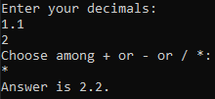

**Answer 2:**

**Code:**

using System;

namespace q2

{

class Program

{

static int getIntFromStrDate(string inputDate, int a, int b)

{

string temp = "" + inputDate[a] + inputDate[b];

int ans = 0;

int.TryParse(temp, out ans);

return ans;

}

static long convertStrDateToSeconds(string inputDate)

{

int DD = getIntFromStrDate(inputDate, 0,1);

int MM = getIntFromStrDate(inputDate, 3, 4);

int YY = getIntFromStrDate(inputDate, 6, 7);

int hh = getIntFromStrDate(inputDate, 9, 10);

int mm = getIntFromStrDate(inputDate, 12, 13);

int ss = getIntFromStrDate(inputDate, 15, 16);

long ans = 0;

ans = ss;

ans += mm * 60;

ans += hh * 60 * 60;

ans += DD * 24 * 60 * 60;

ans += MM * 30 * 24 * 60 * 60;

ans += YY * 12 * 30 * 24 * 60 * 60;

return ans;

}

static string convertSecDateToStr(long ansInSec)

{

long DD, MM, YY, hh, mm, ss;

YY = ansInSec / (12 * 30 * 24 * 60 * 60);

ansInSec = ansInSec % (12 * 30 * 24 * 60 * 60);

MM = ansInSec / (30 * 24 * 60 * 60);

ansInSec = ansInSec % (30 * 24 * 60 * 60);

DD = ansInSec / (24 * 60 * 60);

ansInSec = ansInSec % (24 * 60 * 60);

hh = ansInSec / (60 * 60);

ansInSec = ansInSec % (60 * 60);

mm = ansInSec / (60);

ansInSec = ansInSec % (60);

ss = ansInSec;

return DD.ToString()+ ":" + MM.ToString() + ":" + YY.ToString() + ":" + hh.ToString() + ":" + mm.ToString() + ":" + ss.ToString();

}

static string addSeconds(string inputDate, long secondsToBeAdded)

{

long inputDateInSec = convertStrDateToSeconds(inputDate);

long ansInSec = inputDateInSec + secondsToBeAdded;

string ans = "";

ans = convertSecDateToStr(ansInSec);

return ans;

}

static void Main(string[] args)

{

Console.WriteLine("Enter date in 'DD:MM:YY:hh:mm:ss' format.");

string inputDate = Console.ReadLine();

Console.WriteLine("Enter the number of ticks.");

string inputTickStr = Console.ReadLine();

long inputTickCount = 0;

long.TryParse(inputTickStr, out inputTickCount);

long secondsToBeAdded = (inputTickCount / 10000000); // assuming secondsToBeAdded is a whole number

string ans = addSeconds(inputDate, secondsToBeAdded);

Console.WriteLine("Answer is {0}.",ans);

}

}

}

**IO:**

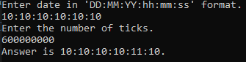

**Answer 3:**

**Code:**

using System;

using System.Collections.Generic;

using System.ComponentModel;

using System.Data;

using System.Drawing;

using System.Linq;

using System.Text;

using System.Threading.Tasks;

using System.Windows.Forms;

namespace q3

{

public partial class Form1 : Form

{

public Form1()

{

InitializeComponent();

}

private void button1_Click(object sender, EventArgs e)

{

double currentSalary = 0;

double.TryParse(salaryTextBox.Text, out currentSalary);

int selectedLevel = salaryLevelsComboBox.SelectedIndex + 1; // index will start from 0

double bonusFactor = 0;

if (selectedLevel == 1)

bonusFactor = 0.1;

else if (selectedLevel <= 4)

bonusFactor = 0.09;

else if (selectedLevel <= 7)

bonusFactor = 0.07;

else //(selectedLevel <= 10)

bonusFactor = 0.05;

// set the text

bonusTextBox.Text = (currentSalary * bonusFactor).ToString();

}

}

}

****

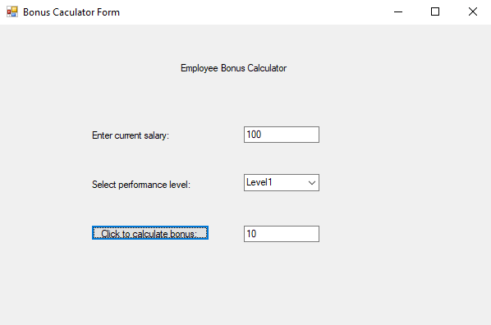

**Answer 4:**

**Code:**

using System;

using System.Collections.Generic;

using System.ComponentModel;

using System.Data;

using System.Drawing;

using System.Linq;

using System.Text;

using System.Threading.Tasks;

using System.Windows.Forms;

namespace q4

{

public partial class carPurchaserForm : Form

{

public carPurchaserForm()

{

InitializeComponent();

}

private void purchaseButton_Click(object sender, EventArgs e)

{

string name = this.nameComboBox.GetItemText(this.nameComboBox.SelectedItem);

string colour = this.colourComboBox.GetItemText(this.colourComboBox.SelectedItem);

string model = this.modelListBox.GetItemText(modelListBox.SelectedItem);

string price = this.priceTextBox.Text;

string message = "Thank you for purchasing a " + colour + " " + name + " (" + model + " model) for " + price + " INR.";

MessageBox.Show(message);

}

private void cancelButton_Click(object sender, EventArgs e)

{

nameComboBox.Text = "";

colourComboBox.Text = "";

modelListBox.ClearSelected();

priceTextBox.Text = "";

}

}

}

**IO: Clicking Purchase Button:**

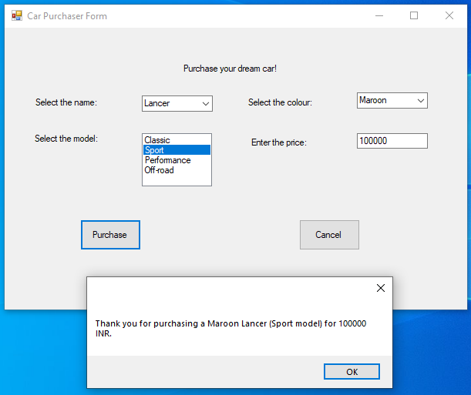

**Clicking Cancel Button:**

