**Answer 1:**

**Code:**

**.aspx file:**

<%@ Page Language="C#" AutoEventWireup="True" CodeBehind="WebForm1.aspx.cs"

Inherits="q1.WebForm1" %>

<!DOCTYPE html>

<html xmlns="http://www.w3.org/1999/xhtml">

<head runat="server">

<title></title>

</head>

<body>

<form id="form1" runat="server">

<div>

<div style="BORDER-RIGHT: thin ridge;

PADDING-RIGHT: 20px;

BORDER-TOP: thin ridge;

PADDING-LEFT: 20px;

FONT-SIZE: x-small;

PADDING-BOTTOM: 20px;

BORDER-LEFT: thin ridge;

WIDTH: 293px;

PADDING-TOP: 20px;

BORDER-BOTTOM: thin ridge;

FONT-FAMILY: Verdana;

HEIGHT: 486px; BACKGROUND-COLOR: lightblue">

Choose a background color:

<br /><br />

<asp:DropDownList ID="backList" runat="server">

</asp:DropDownList>

<br /> <br />

Select Image:

<asp:DropDownList ID="imageList" runat="server">

</asp:DropDownList>

<br /><br />

Enter Heading Font size:

<asp:TextBox ID="headingSize" runat="server"></asp:TextBox>

<br /><br />

Enter Heading Font Family:

<asp:DropDownList ID="headingFamily"

runat="server"></asp:DropDownList>

<br /><br />

Enter Heading Font Color:

<asp:TextBox ID="headingColor" runat="server"></asp:TextBox>

<br /><br />

Enter Heading Text:

<asp:TextBox ID="headingText" runat="server"></asp:TextBox>

<br /><br />

Enter Body Font size:

<asp:TextBox ID="bodySize" runat="server"></asp:TextBox>

<br /><br />

Enter Body Font Family:

<asp:DropDownList ID="bodyFamily" runat="server"></asp:DropDownList>

<br /><br />

Enter Body Font Color:

<asp:TextBox ID="bodyColor" runat="server"></asp:TextBox>

<br /><br />

Enter Body Text:

<asp:TextBox ID="bodyText" runat="server"></asp:TextBox>

<br /><br />

<asp:Button ID="update" runat="server" Text="Update"

OnClick="update_Click" />

</div>

<asp:panel ID="pnlMag" style="LEFT: 350px; POSITION: absolute; TOP:

16px" runat="server"

Height="507px" Width="339px" HorizontalAlign="Center" >

<br />&nbsp;

<asp:Label ID="heading" runat="server" Text=""></asp:Label>

<br /><br />

<asp:Image ID="dp" runat="server" ImageUrl="" ImageAlign="Middle" />

<br /><br /><br />

<asp:Label ID="body" runat="server" Text=""></asp:Label>

</asp:panel>

</div>

</form>

</body>

</html>

**.cs file:**

using System;

using System.Collections.Generic;

using System.Linq;

using System.Web;

using System.Web.UI;

using System.Web.UI.WebControls;

using System.Drawing;

namespace q1

{

public partial class WebForm1 : System.Web.UI.Page

{

protected void Page_Load(object sender, EventArgs e)

{

if (!this.IsPostBack)

{

backList.Items.Add("White");

backList.Items.Add("Red");

backList.Items.Add("Blue");

backList.Items.Add("Yellow");

imageList.Items.Add(new ListItem("Santro", "Santro.png"));

imageList.Items.Add(new ListItem("Ikon", "Ikon.png"));

imageList.Items.Add(new ListItem("Lancer", "Lancer.png"));

imageList.Items.Add(new ListItem("Cruz", "Cruz.png"));

headingFamily.Items.Add("Arial");

headingFamily.Items.Add("Times New Roman");

headingFamily.Items.Add("Georgia");

headingFamily.Items.Add("Helvetica");

bodyFamily.Items.Add("Arial");

bodyFamily.Items.Add("Times New Roman");

bodyFamily.Items.Add("Georgia");

bodyFamily.Items.Add("Helvetica");

}

}

protected void update_Click(object sender, EventArgs e)

{

pnlMag.BackColor = ColorTranslator.FromHtml(backList.SelectedItem.Text);

dp.ImageUrl = imageList.SelectedItem.Value;

heading.Font.Name = headingFamily.SelectedItem.Text;

heading.Font.Size = FontUnit.Parse(headingSize.Text);

heading.ForeColor = ColorTranslator.FromHtml(headingColor.Text);

heading.Text = headingText.Text;

body.Font.Name = bodyFamily.SelectedItem.Text;

body.Font.Size = FontUnit.Parse(bodySize.Text);

body.ForeColor = ColorTranslator.FromHtml(bodyColor.Text);

body.Text = bodyText.Text;

dp.Visible = true;

}

}

}

IO in next page:-

**IO:**

**Initial landing page:**

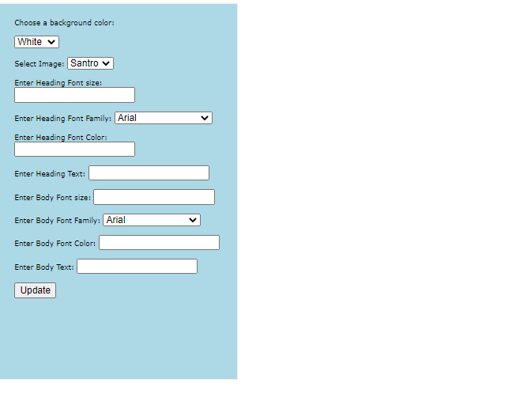

**After entering details and clicking submit:**

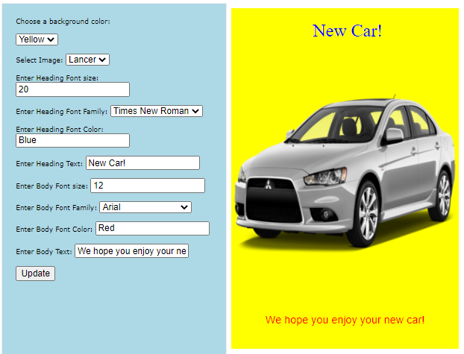

**Answer 2:**

**Code:**

**.aspx file:**

<%@ Page Language="C#" AutoEventWireup="true" CodeBehind="WebForm1.aspx.cs"

Inherits="Lab3q2.Employee" %>

<!DOCTYPE html>

<html xmlns="http://www.w3.org/1999/xhtml">

<head runat="server">

<title></title>

</head>

<body>

<form id="form1" runat="server">

<div>

Choose Employee:

<asp:DropDownList ID="employeeList" runat="server" OnSelectedIndexChanged="empChanged" AutoPostBack="true"></asp:DropDownList>

<br /><br />

<asp:Image ID="empImage" ImageUrl="1.png" runat="server" />

<br /><br />

Name of the employee:

<asp:TextBox ID="name" runat="server"></asp:TextBox>

<br /><br />

Date of joining:

<asp:TextBox ID="doj" TextMode="Date" runat="server"></asp:TextBox>

<br /><br />

<asp:Button ID="promotion" runat="server" Text="Am I Eligible for

promotion?" OnClick="promotion_Click" />

<br /><br />

<asp:Label ID="output" runat="server" Text=""></asp:Label>

</div>

</form>

</body>

</html>

**.cs file:**

using System;

using System.Collections.Generic;

using System.Linq;

using System.Web;

using System.Web.UI;

using System.Web.UI.WebControls;

namespace Lab3q2

{

public partial class Employee : System.Web.UI.Page

{

protected void Page_Load(object sender, EventArgs e)

{

if (!IsPostBack)

{

employeeList.Items.Add(new ListItem("001", "1.png"));

employeeList.Items.Add(new ListItem("002", "2.png"));

employeeList.Items.Add(new ListItem("003", "3.png"));

employeeList.Items.Add(new ListItem("004", "4.png"));

}

}

protected void promotion_Click(object sender, EventArgs e)

{

empImage.ImageUrl = employeeList.SelectedItem.Value;

DateTime datejoin = Convert.ToDateTime(doj.Text);

DateTime now = DateTime.Now;

int days = (now - datejoin).Days;

int years = days / 365;

if (years >= 5)

{

output.Text = "Congrats,you are eligible.";

}

else

{

output.Text = "Sorry, you are not eligible.";

}

}

protected void empChanged(object sender, EventArgs e)

{

empImage.ImageUrl = employeeList.SelectedItem.Value;

}

}

}

**IO:**

**Initial landing page:**

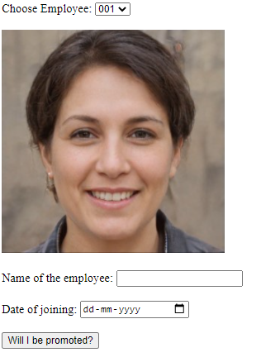

**If the employee’s experience is less than 5 years:**

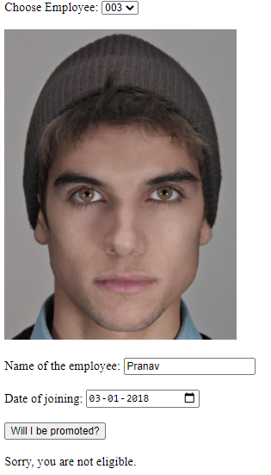

**If the employee’s experience is greater than 5 years:**

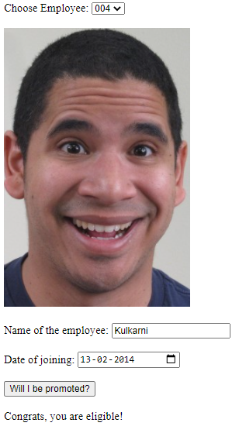

**Answer 3:**

**Code:**

**.aspx file:**

<%@ Page Language="C#" AutoEventWireup="true" CodeBehind="WebForm1.aspx.cs"

Inherits="Lab3q3.Card" %>

<!DOCTYPE html>

<html xmlns="http://www.w3.org/1999/xhtml">

<head runat="server">

<title></title>

</head>

<body>

<form id="form1" runat="server">

<div>

<div style="BORDER-RIGHT: thin ridge; PADDING-RIGHT: 20px; BORDER-TOP: thin ridge;

PADDING-LEFT: 20px;

FONT-SIZE: x-small; PADDING-BOTTOM: 20px; BORDER-LEFT: thin ridge; WIDTH: 293px;

PADDING-TOP: 20px;

BORDER-BOTTOM: thin ridge; FONT-FAMILY: Verdana; HEIGHT: 486px; BACKGROUND-

COLOR: lightyellow">

Choose background color

<br />

<asp:DropDownList ID="backColor" runat="server"></asp:DropDownList>

<br /><br />

Choose font family

<br />

<asp:DropDownList ID="fontFamily" runat="server"></asp:DropDownList>

<br /><br />

Enter font size

<br />

<asp:TextBox ID="fontSize" runat="server"></asp:TextBox>

<br /><br />

Enter input message

<br />

<asp:TextBox ID="message" runat="server"></asp:TextBox>

<br /><br />

Choose image

<br />

<asp:DropDownList ID="imageList" runat="server"></asp:DropDownList>

<br /><br />

<asp:Button ID="submit" runat="server" Text="Create"

OnClick="submit_Click" />

<asp:Button ID="clear" runat="server" Text="Clear"

OnClick="clear_Click" />

</div>

<asp:panel ID="pnlCard" style="LEFT: 350px; POSITION: absolute; TOP: 16px"

runat="server"

Height="507px" Width="339px" HorizontalAlign="Center" >

<br />&nbsp;

<asp:Label ID="display" runat="server" Text=""></asp:Label>

<br /><br />

<asp:Image ID="dp" runat="server" ImageUrl="default.jpg"

ImageAlign="Middle" />

<br /><br /><br />

</asp:panel>

</div>

</form>

</body>

</html>

**.cs file:**

using System;

using System.Collections.Generic;

using System.Linq;

using System.Web;

using System.Web.UI;

using System.Web.UI.WebControls;

using System.Drawing;

namespace Lab3q3

{

public partial class Card : System.Web.UI.Page

{

protected void Page_Load(object sender, EventArgs e)

{

if (!IsPostBack)

{

backColor.Items.Add("Blue");

backColor.Items.Add("Green");

backColor.Items.Add("Yellow");

backColor.Items.Add("Red");

fontFamily.Items.Add("Times New Roman");

fontFamily.Items.Add("Arial");

fontFamily.Items.Add("Calibri");

fontFamily.Items.Add("Georgia");

imageList.Items.Add(new ListItem("Scenery 1", "c1.jpg"));

imageList.Items.Add(new ListItem("Scenery 2", "c2.jpg"));

}

}

protected void submit_Click(object sender, EventArgs e)

{

pnlCard.BackColor = Color.FromName(backColor.SelectedValue.ToString());

pnlCard.Font.Name = fontFamily.SelectedValue.ToString();

int a = 0;

int.TryParse(fontSize.Text, out a);

display.Font.Size = a;

dp.ImageUrl = imageList.SelectedItem.Value;

dp.Visible = true;

display.Text = message.Text;

}

protected void clear_Click(object sender, EventArgs e)

{

display.Text = "";

dp.ImageUrl = "default.jpg";

pnlCard.BackColor = Color.FromName("White");

message.Text = " ";

fontSize.Text = " ";

}

}

}

**IO:**

**Initial landing page:**

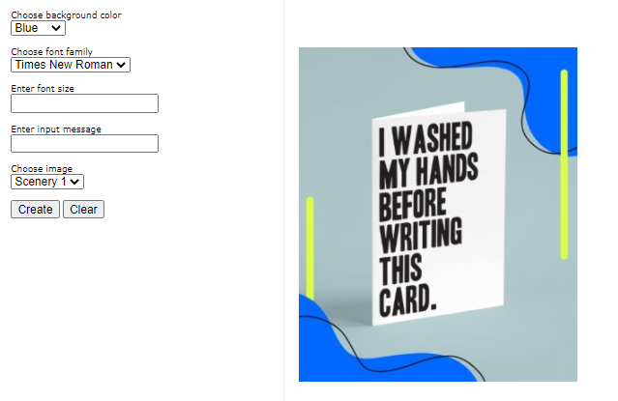

**After entering details and clicking on the button:**

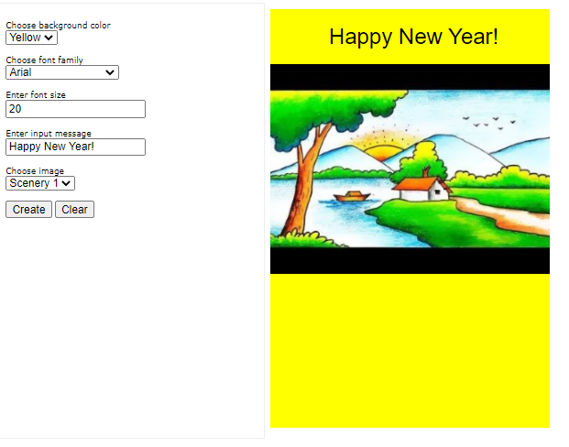

**Using the Clear button:**

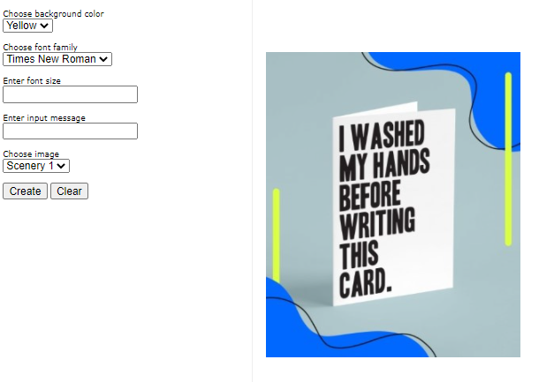

**Answer 4:**

**Code:**

**.aspx file:**

<%@ Page Language="C#" AutoEventWireup="true" CodeBehind="WebForm1.aspx.cs" Inherits="q4.Captcha" %>

<!DOCTYPE html>

<html xmlns="http://www.w3.org/1999/xhtml">

<head runat="server">

<title></title>

</head>

<body>

<form id="form1" runat="server">

<div>

<asp:Image ID="captcha" ImageUrl="~/captcha.png" runat="server" />

<br />

<br />

<asp:TextBox ID="input" runat="server"></asp:TextBox>

<br />

<br />

<asp:Button ID="submit" runat="server" Text="Submit" OnClick="submit_Click" />

<br />

<br />

<asp:Label

ID="output"

runat="server"

Text="You have 3 trials left"

></asp:Label>

</div>

</form>

</body>

</html>

**.cs file:**

using System;

using System.Collections.Generic;

using System.Linq;

using System.Web;

using System.Web.UI;

using System.Web.UI.WebControls;

namespace q4

{

public partial class Captcha : System.Web.UI.Page

{

protected void Page_Load(object sender, EventArgs e) { }

protected void submit_Click(object sender, EventArgs e)

{

if (String.Equals(input.Text, "qGphJD"))

{

output.Text = "Success!";

}

else

{

int counter;

if (ViewState["count"] == null)

{

counter = 2;

}

else

{

counter = (int)ViewState["count"] - 1;

if (counter == 0)

{

input.Enabled = false;

}

}

ViewState["count"] = counter;

if (counter >= 0) output.Text = "You have " + counter + " trials left";

else output.Text = "You have 0 trials left.";

}

}

}

}

IO in next page:-

**IO:**

**Initial landing page:**

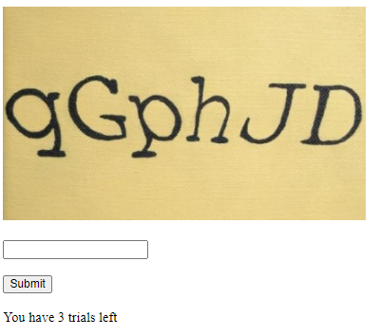

**Entering the correct text to match the CAPTCHA:**

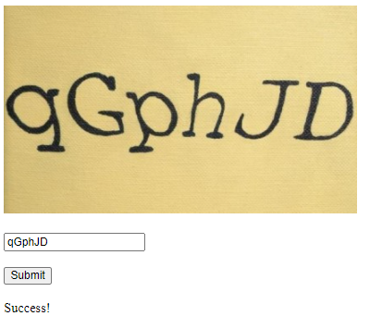

**Entering the wrong text three times (Input TextBox gets greyed out):**

