**Answer 1:**

**.aspx file:**

<%@ Page Language="C#" AutoEventWireup="true" CodeFile="Default.aspx.cs" Inherits="_Default" %>

<!DOCTYPE html>

<html xmlns="http://www.w3.org/1999/xhtml">

<head runat="server">

<title></title>

</head>

<body>

<form id="form1" runat="server">

<div style="height: 562px">

&nbsp;&nbsp;&nbsp;&nbsp;&nbsp;

<br />

&nbsp;&nbsp;&nbsp;

<asp:Label ID="Label1" runat="server" Text="Choose Candidate"></asp:Label>

<br />

&nbsp;&nbsp;&nbsp;

<br />

&nbsp;&nbsp;&nbsp;

<asp:DropDownList ID="DropDownList1" runat="server">

</asp:DropDownList>

&nbsp;&nbsp;&nbsp;

<asp:RequiredFieldValidator ID="RequiredFieldValidator1" runat="server" ErrorMessage="Please choose a candidate" ControlToValidate="DropDownList1" EnableClientScript="false" Display="None"></asp:RequiredFieldValidator>

<br />

<br />

&nbsp;&nbsp;&nbsp;

<asp:Label ID="Label2" runat="server" Text="Choose House"></asp:Label>

&nbsp;&nbsp;&nbsp;&nbsp;

<asp:RequiredFieldValidator ID="RequiredFieldValidator2" runat="server" ErrorMessage="Please choose a house" ControlToValidate="RadioButtonList1" EnableClientScript="false" Display="None"></asp:RequiredFieldValidator>

<br />

&nbsp;&nbsp;&nbsp;

<asp:RadioButtonList ID="RadioButtonList1" runat="server" OnSelectedIndexChanged="RadioButtonList1_SelectedIndexChanged">

</asp:RadioButtonList>

<br />

&nbsp;&nbsp;&nbsp;

<asp:Label ID="Label3" runat="server" Text="Class"></asp:Label>

&nbsp;&nbsp;&nbsp;

<asp:TextBox ID="TextBox1" runat="server"></asp:TextBox>

&nbsp;&nbsp;&nbsp;

<asp:RequiredFieldValidator Display="None" ID="RequiredFieldValidator3" runat="server" ErrorMessage="Class is required" ControlToValidate="TextBox1" EnableClientScript="false"></asp:RequiredFieldValidator>

&nbsp;&nbsp;&nbsp;

<asp:RangeValidator Display="None" ID="RangeValidator1" runat="server" ErrorMessage="Value of class should be between 6 and 12" ControlToValidate="TextBox1" EnableClientScript="false" MinimumValue="6" MaximumValue="12" Type="Integer"></asp:RangeValidator>

<br />

<br />

&nbsp;&nbsp;&nbsp;

<asp:Label ID="Label4" runat="server" Text="Email"></asp:Label>

&nbsp;&nbsp;&nbsp;

<asp:TextBox ID="TextBox2" runat="server"></asp:TextBox>

&nbsp;&nbsp;&nbsp;

<asp:RequiredFieldValidator Display="None" ID="RequiredFieldValidator4" runat="server" ErrorMessage="Email is required" ControlToValidate="TextBox2" EnableClientScript="false"></asp:RequiredFieldValidator>

&nbsp;&nbsp;&nbsp;

<asp:RegularExpressionValidator Display="None" ID="RegularExpressionValidator1" runat="server" ErrorMessage="Email format is not valid" ControlToValidate="TextBox2" EnableClientScript="false" ValidationExpression="\S+@\S+\.\S+"></asp:RegularExpressionValidator>

<br />

<br />

&nbsp;&nbsp;&nbsp;

<asp:Label ID="Label5" runat="server" Text="Parent Contact"></asp:Label>

&nbsp;&nbsp;&nbsp;

<asp:TextBox ID="TextBox3" runat="server"></asp:TextBox>

&nbsp;&nbsp;&nbsp;

<asp:CustomValidator Display="None" ID="CustomValidator1" runat="server" ErrorMessage="Number should be 10 digits long" OnServerValidate="CustomValidator1_ServerValidate" ControlToValidate="TextBox3" EnableClientScript="false"></asp:CustomValidator>

<br />

<br />

&nbsp;&nbsp;&nbsp;

<asp:Button ID="Button1" runat="server" Text="Submit" OnClick="Button1_Click" />

<br />

<asp:ValidationSummary ID="ValidationSummary1" runat="server" ForeColor="Red" />

<br />

&nbsp;&nbsp;&nbsp;

<asp:Label ID="Label6" runat="server"></asp:Label>

<br />

<br />

&nbsp;&nbsp;&nbsp;

<br />

</div>

</form>

</body>

</html>

**.cs file:**

using System;

using System.Collections.Generic;

using System.Linq;

using System.Web;

using System.Web.UI;

using System.Web.UI.WebControls;

public partial class _Default : System.Web.UI.Page

{

protected void Page_Load(object sender, EventArgs e)

{

if(!this.IsPostBack)

{

DropDownList1.Items.Add("Yash");

DropDownList1.Items.Add("Aksh");

DropDownList1.Items.Add("Harsh");

RadioButtonList1.Items.Add("Yellow");

RadioButtonList1.Items.Add("Blue");

RadioButtonList1.Items.Add("Green");

RadioButtonList1.Items.Add("Red");

}

}

protected void CustomValidator1_ServerValidate(object source, ServerValidateEventArgs e)

{

string contact = TextBox3.Text;

if(contact.Length!=10)

{

e.IsValid = false;

}

else

{

e.IsValid = true;

}

}

protected void Button1_Click(object sender, EventArgs e)

{

if(Page.IsValid)

{

Label6.Text = "Successfully submitted";

}

else

{

Label6.Text = "";

}

}

protected void RadioButtonList1_SelectedIndexChanged(object sender, EventArgs e)

{

}

}

**IO:**

**Landing Page:**

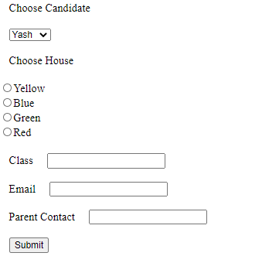

**Empty field validation:**

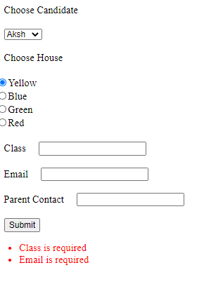

**After filling all data:**

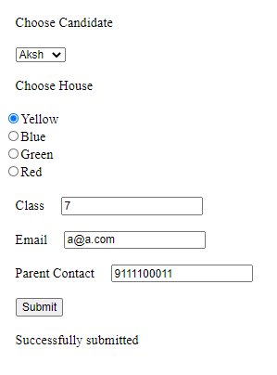

**Answer 2:**

**Master.aspx file:**

<%@ Master Language="C#" AutoEventWireup="true" CodeFile="MasterPage.master.cs" Inherits="MasterPage" %>

<!DOCTYPE html>

<html>

<head runat="server">

<title></title>

<asp:ContentPlaceHolder id="head" runat="server">

</asp:ContentPlaceHolder>

</head>

<body>

<form id="form1" runat="server">

<div style="height: 600px; background-color:antiquewhite;">

<asp:Image ID="Image1" runat="server" ImageUrl="Images/logo.png" Height="75px" Width="104px"/>

&nbsp;&nbsp;&nbsp;&nbsp;&nbsp;

<asp:Label ID="Label1" runat="server">Shoppify</asp:Label>

<br />

<br />

<br />

<asp:Hyperlink ID="HyperLink1" runat="server" NavigateUrl="Electronics.aspx">Electronics</asp:Hyperlink>

&nbsp;

&nbsp;

<asp:Hyperlink ID="HyperLink2" runat="server" NavigateUrl="Baggages.aspx">Baggages</asp:Hyperlink>

&nbsp;

&nbsp;

<asp:Hyperlink ID="HyperLink3" runat="server" NavigateUrl="Offers.aspx">Offers</asp:Hyperlink>

<br />

<br />

<asp:ContentPlaceHolder id="ContentPlaceHolder1" runat="server">

</asp:ContentPlaceHolder>

<br />

<br />

<asp:Label ID="Label2" runat="server" Font-Bold="True" >Contact us at : shoppify@customercare.com</asp:Label>

</div>

</form>

</body>

</html>

**Baggage.aspx file:**

<%@ Page Title="" Language="C#" MasterPageFile="~/MasterPage.master" AutoEventWireup="true" CodeFile="Baggages.aspx.cs" Inherits="Baggages" %>

<asp:Content ID="Content1" ContentPlaceHolderID="head" Runat="Server">

</asp:Content>

<asp:Content ID="Content2" ContentPlaceHolderID="ContentPlaceHolder1" Runat="Server">

<br />

<asp:Label ID="Label1" runat="server" Text="Laptop bags"></asp:Label>

<asp:Image ID="Image1" runat="server" Height="100px" Width="100px" />

<br />

<asp:Label ID="Label2" runat="server" Text="Trolley bags"></asp:Label>

<asp:Image ID="Image2" runat="server" Height="100px" Width="100px" />

<br />

<asp:Label ID="Label3" runat="server" Text="Backpacks"></asp:Label>

<asp:Image ID="Image3" runat="server" Height="100px" Width="100px" />

<br />

</asp:Content>

**Electronics.aspx file:**

<%@ Page Title="" Language="C#" MasterPageFile="~/MasterPage.master" AutoEventWireup="true" CodeFile="Electronics.aspx.cs" Inherits="Electronics" %>

<asp:Content ID="Content1" ContentPlaceHolderID="head" Runat="Server">

</asp:Content>

<asp:Content ID="Content2" ContentPlaceHolderID="ContentPlaceHolder1" Runat="Server">

<p>

<br />

<asp:Label ID="Label3" runat="server" Text="Mobiles"></asp:Label>

&nbsp;&nbsp;&nbsp;

<asp:DropDownList ID="DropDownList1" runat="server">

</asp:DropDownList>

</p>

<p>

<asp:Label ID="Label4" runat="server" Text="Laptops"></asp:Label>

&nbsp;&nbsp;&nbsp;

<asp:DropDownList ID="DropDownList2" runat="server">

</asp:DropDownList>

</p>

<p>

<asp:Label ID="Label5" runat="server" Text="Printers"></asp:Label>

&nbsp;&nbsp;&nbsp;

<asp:DropDownList ID="DropDownList3" runat="server">

</asp:DropDownList>

</p>

<p>

</p>

</asp:Content>

**Offers.aspx file:**

<%@ Page Title="" Language="C#" MasterPageFile="~/MasterPage.master" AutoEventWireup="true" CodeFile="Offers.aspx.cs" Inherits="Offers" %>

<asp:Content ID="Content1" ContentPlaceHolderID="head" Runat="Server">

</asp:Content>

<asp:Content ID="Content2" ContentPlaceHolderID="ContentPlaceHolder1" Runat="Server">

<br />

<asp:Label ID="Label1" runat="server" Text="Offer 1"></asp:Label>

&nbsp;

&nbsp;

<asp:Image ID="Image1" runat="server" Height="100px" Width="100px"></asp:Image>

<br />

<asp:Label ID="Label2" runat="server" Text="Offer 2"></asp:Label>

&nbsp;

&nbsp;

<asp:Image ID="Image2" runat="server" Height="100px" Width="100px"></asp:Image>

<br />

</asp:Content>

**IO:**

**Electronics page:**

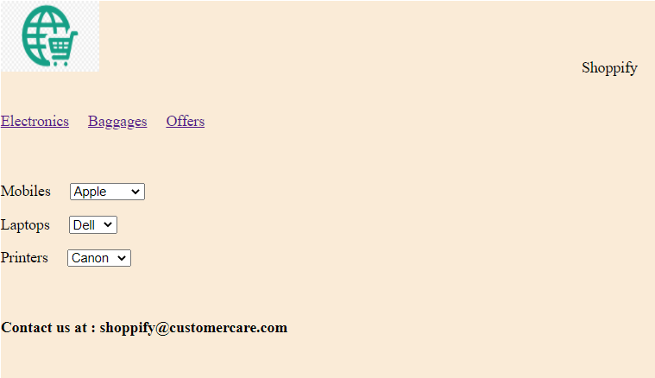

**Offers page:**

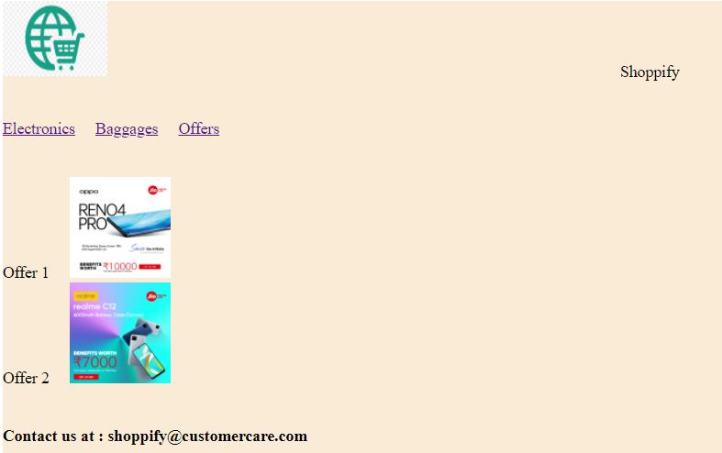

**Baggage page:**

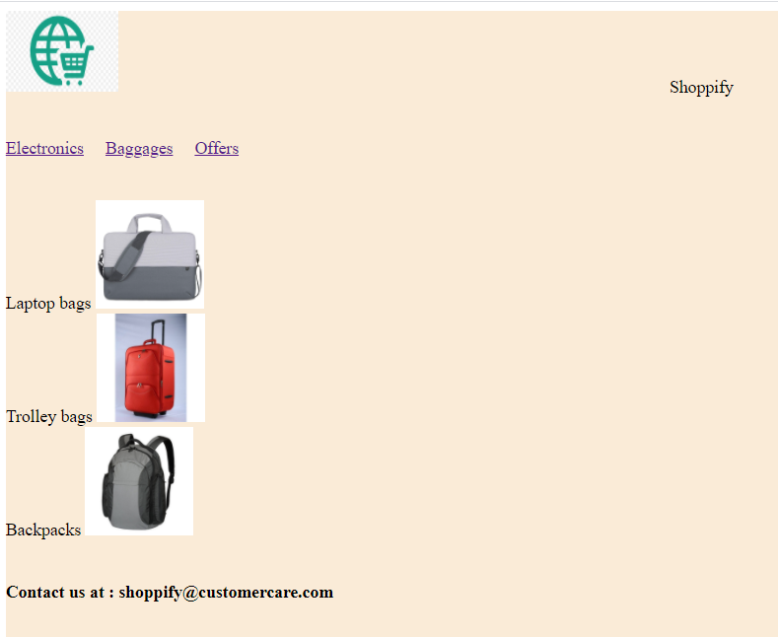

**Answer 3:**

**.aspx file:**

<%@ Page Language="C#" AutoEventWireup="true" CodeFile="Default.aspx.cs" Inherits="_Default" Theme="Summer" %>

<!DOCTYPE html>

<html xmlns="http://www.w3.org/1999/xhtml">

<head runat="server">

<title></title>

</head>

<body>

<form id="form1" runat="server">

<div style="height: 391px">

<asp:DropDownList ID="DropDownList1" runat="server">

</asp:DropDownList>

<br />

<br />

<asp:Button ID="Button1" runat="server" OnClick="Button1_Click" Text="Change Theme" />

<br />

<br />

<asp:Button ID="Button2" runat="server" Text="Sample button" />

</div>

</form>

</body>

</html>

**.cs file:**

using System;

using System.Collections.Generic;

using System.Linq;

using System.Web;

using System.Web.UI;

using System.Web.UI.WebControls;

public partial class _Default : System.Web.UI.Page

{

protected void Page_Load(object sender, EventArgs e)

{

if(!this.IsPostBack)

{

DropDownList1.Items.Add("Summer");

DropDownList1.Items.Add("Monsoon");

}

}

protected void Page_PreInit(object sender,EventArgs e)

{

if(Session["theme"]!=null)

{

this.Theme = (string)Session["theme"];

}

}

protected void Button1_Click(object sender, EventArgs e)

{

string theme = DropDownList1.SelectedValue;

Session["theme"] = theme;

Server.Transfer(Request.FilePath);

}

}

**Summer.css:**

body {

background-image: url('summer.jfif');

background-repeat: no-repeat;

}

**Summer.skin:**

<asp:Button runat="server" BackColor="Orange" />

**Monsoon.css:**

body {

background-image: url('monsoon.jfif');

background-repeat: no-repeat;

}

**Monsoon.skin:**

<asp:Button runat="server" BackColor="Blue" />

**IO:**

**Summer:**

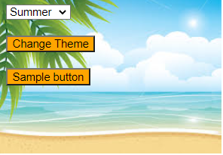

**Monsoon:**

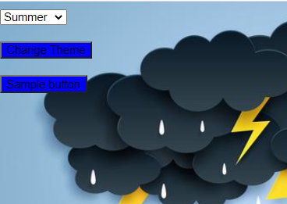

**Answer 4:**

**Masterpage.Master file:**

<%@ Master Language="C#" AutoEventWireup="true" CodeFile="MasterPage.master.cs" Inherits="MasterPage" %>

<!DOCTYPE html>

<html>

<head runat="server">

<title></title>

<asp:ContentPlaceHolder id="head" runat="server">

</asp:ContentPlaceHolder>

</head>

<body>

<form id="form1" runat="server">

<div>

<asp:Label ID="Label1" runat="server" Text="Welcome to mobile world"></asp:Label>

<br />

<br />

<asp:Label ID="Label3" runat="server" Text=""></asp:Label>

<br />

<br />

<asp:ContentPlaceHolder id="ContentPlaceHolder1" runat="server">

</asp:ContentPlaceHolder>

<br />

<br />

<asp:Label ID="Label2" runat="server" Text="Contact us at mobile@customer.com"></asp:Label>

</div>

</form>

</body>

</html>

**First.aspx file:**

<%@ Page Title="" Language="C#" MasterPageFile="~/MasterPage.master" AutoEventWireup="true" CodeFile="First.aspx.cs" Inherits="First" %>

<asp:Content ID="Content1" ContentPlaceHolderID="head" Runat="Server">

</asp:Content>

<asp:Content ID="Content2" ContentPlaceHolderID="ContentPlaceHolder1" Runat="Server">

<asp:DropDownList ID="DropDownList1" runat="server" OnSelectedIndexChanged="DropDownList1_SelectedIndexChanged" AutoPostBack="true">

</asp:DropDownList>

<br />

<br />

<asp:Button ID="Button1" runat="server" Text="Submit" OnClick="Button1_Click" />

</asp:Content>

**First.aspx.cs file:**

using System;

using System.Collections.Generic;

using System.Linq;

using System.Web;

using System.Web.UI;

using System.Web.UI.WebControls;

public partial class First : System.Web.UI.Page

{

protected void Page_Load(object sender, EventArgs e)

{

if(!this.IsPostBack)

{

DropDownList1.Items.Add(new ListItem("Apple Iphone XR","Screen:828x1792 pixels,Memory:3GB RAM,Camera:12MP,Battery:2942 mAh"));

DropDownList1.Items.Add(new ListItem("Samsung Galaxy S10", "Screen:700x1792 pixels,Memory:4GB RAM,Camera:10MP,Battery:1942 mAh"));

DropDownList1.Items.Add(new ListItem("Sony Xperia XZ2", "Screen:828x1792 pixels,Memory:3GB RAM,Camera:13MP,Battery:2742 mAh"));

DropDownList1.Items.Add(new ListItem("Nokia 7.2", "Screen:828x1792 pixels,Memory:3GB RAM,Camera:12MP,Battery:2942 mAh"));

}

}

protected void Button1_Click(object sender, EventArgs e)

{

Session["info"] = DropDownList1.SelectedValue;

Response.Redirect("Second.aspx");

}

protected void DropDownList1_SelectedIndexChanged(object sender, EventArgs e)

{

Label Label3 = (Label)this.Master.FindControl("Label3");

Label3.Text = DropDownList1.SelectedItem.Text;

}

}

**Second.aspx file:**

<%@ Page Title="" Language="C#" MasterPageFile="~/MasterPage.master" AutoEventWireup="true" CodeFile="Second.aspx.cs" Inherits="Second" %>

<asp:Content ID="Content1" ContentPlaceHolderID="head" Runat="Server">

</asp:Content>

<asp:Content ID="Content2" ContentPlaceHolderID="ContentPlaceHolder1" Runat="Server">

<asp:Label ID="Label1" runat="server" Text="Label"></asp:Label>

<br />

<br />

<asp:Label ID="Label2" runat="server" Text="Label"></asp:Label>

<br />

<br />

<asp:Label ID="Label3" runat="server" Text="Label"></asp:Label>

<br />

<br />

<asp:Label ID="Label4" runat="server" Text="Label"></asp:Label>

<br />

<br />

<asp:Button ID="Button1" runat="server" Text="Go Back" OnClick="Button1_Click" />

</asp:Content>

**Second.aspx.cs file:**

using System;

using System.Collections.Generic;

using System.Linq;

using System.Web;

using System.Web.UI;

using System.Web.UI.WebControls;

public partial class Second : System.Web.UI.Page

{

protected void Page_Load(object sender, EventArgs e)

{

string info = (string)Session["info"];

string[] list = info.Split(',');

Label1.Text = list[0];

Label2.Text = list[1];

Label3.Text = list[2];

Label4.Text = list[3];

}

protected void Button1_Click(object sender, EventArgs e)

{

Response.Redirect("First.aspx");

}

}

**IO:**

**Screenshot of the first page:**

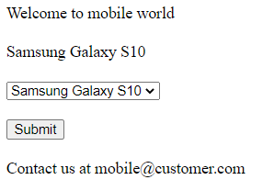

**Screenshot of the second page:**

