**Answer 1:**

**.aspx file:**

<%@ Page Language="C#" AutoEventWireup="true" CodeFile="Default.aspx.cs" Inherits="_Default" %>

<!DOCTYPE html>

<html xmlns="http://www.w3.org/1999/xhtml">

<head runat="server">

<title></title>

</head>

<body>

<form id="form1" runat="server">

<div style="height: 202px">

<asp:GridView ID="GridView1" runat="server" DataSourceID="SqlDataSource1" AutoGenerateColumns="false" AllowSorting="true" OnRowDataBound="GridView1_RowDataBound">

<Columns>

<asp:TemplateField HeaderText="Details" SortExpression="name">

<ItemTemplate>

<b>Name:</b>

<%# Eval("name") %>

<br />

<b>Age:</b>

<%# Eval("age") %>

</ItemTemplate>

</asp:TemplateField>

<asp:BoundField DataField="designation" HeaderText="Designation"/>

<asp:BoundField DataField="salary" HeaderText="Salary"/>

</Columns>

</asp:GridView>

</div>

<asp:SqlDataSource ID="SqlDataSource1" runat="server" ConnectionString="Data Source=(localdb)\MSSQLLocalDB;Initial Catalog=Test;Integrated Security=SSPI" SelectCommand="SELECT name,age,designation,salary FROM Staff"></asp:SqlDataSource>

</form>

</body>

</html>

**.cs file:**

using System;

using System.Collections.Generic;

using System.Linq;

using System.Web;

using System.Web.UI;

using System.Web.UI.WebControls;

public partial class _Default : System.Web.UI.Page

{

protected void Page_Load(object sender, EventArgs e)

{

}

protected void GridView1_RowDataBound(object sender,GridViewRowEventArgs e)

{

if(e.Row.RowType == DataControlRowType.DataRow)

{

int age = (int)DataBinder.Eval(e.Row.DataItem, "age");

if(age>35)

{

e.Row.BackColor = System.Drawing.Color.DarkGray;

e.Row.ForeColor = System.Drawing.Color.White;

}

}

}

}

**Dbo.Staff:**

CREATE TABLE [dbo].Staff

(

[Name] VARCHAR(50) NOT NULL PRIMARY KEY,

[Age] INT NOT NULL,

[Designation] VARCHAR(50) NOT NULL,

[Salary] INT NOT NULL

)

**IO:**

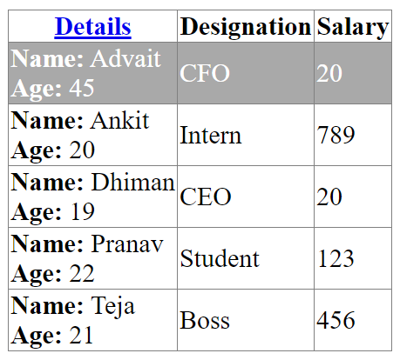

**Answer 2:**

**.aspx file:**

<%@ Page Language="C#" AutoEventWireup="true" CodeFile="Default.aspx.cs" Inherits="_Default" %>

<!DOCTYPE html>

<html xmlns="http://www.w3.org/1999/xhtml">

<head runat="server">

<title></title>

</head>

<body>

<form id="form1" runat="server">

<div style="height: 325px">

<asp:GridView ID="GridView1" runat="server" DataSourceID="SqlDataSource1" AutoGenerateColumns="false" AllowPaging="true" PageSize="3" DataKeyNames="id">

<HeaderStyle BackColor="Green" ForeColor="Red" Font-Bold="true"/>

<Columns>

<asp:CommandField ShowEditButton="true"/>

<asp:BoundField DataField="id" HeaderText="Id" ReadOnly="true"/>

<asp:TemplateField HeaderText="Name">

<ItemTemplate>

<b>First Name:</b>

<%# Eval("first_name") %>

<br />

<b>Last Name:</b>

<%# Eval("last_name") %>

</ItemTemplate>

<EditItemTemplate>

<b>First Name:</b>

<asp:TextBox runat="server" ID="TextBox1" Text='<%# Bind("first_name") %>'></asp:TextBox>

<br />

<b>Last Name:</b>

<%# Eval("last_name") %>

</EditItemTemplate>

</asp:TemplateField>

<asp:BoundField DataField="book_title" HeaderText="Book Title" ReadOnly="true"/>

<asp:BoundField DataField="genre" HeaderText="Genre" ReadOnly="true"/>

<asp:BoundField DataField="copies_sold" HeaderText="Copies Sold"/>

</Columns>

</asp:GridView>

</div>

<asp:SqlDataSource ID="SqlDataSource1" runat="server" ConnectionString="Data Source=(localdb)\MSSQLLocalDB;Initial Catalog=Test;Integrated Security=SSPI" SelectCommand="SELECT * FROM Authors" UpdateCommand="UPDATE Authors SET copies_sold=@copies_sold,first_name=@first_name WHERE id=@id">

</asp:SqlDataSource>

</form>

</body>

</html>

**.cs file:**

using System;

using System.Collections.Generic;

using System.Linq;

using System.Web;

using System.Web.UI;

using System.Web.UI.WebControls;

public partial class _Default : System.Web.UI.Page

{

protected void Page_Load(object sender, EventArgs e)

{

}

}

**Db.Authors:**

CREATE TABLE [dbo].Authors

(

[Id] INT NOT NULL PRIMARY KEY,

[First_name] VARCHAR(50) NOT NULL,

[Last_name] VARCHAR(50) NOT NULL,

[Book_title] VARCHAR(50) NOT NULL,

[Genre] VARCHAR(50) NULL,

[Copies_sold] INT NOT NULL

)

**IO:**

**Landing page:**

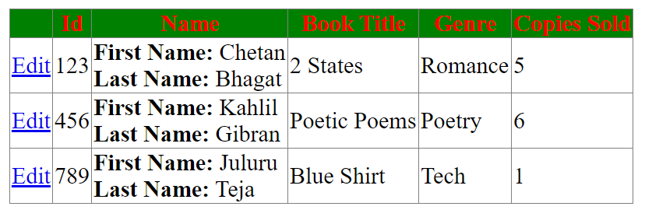

**Updating the number of copies sold:**

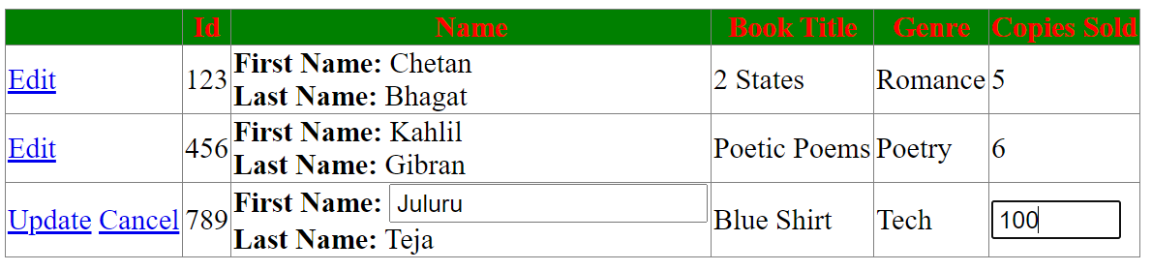

**After clicking on Update:**

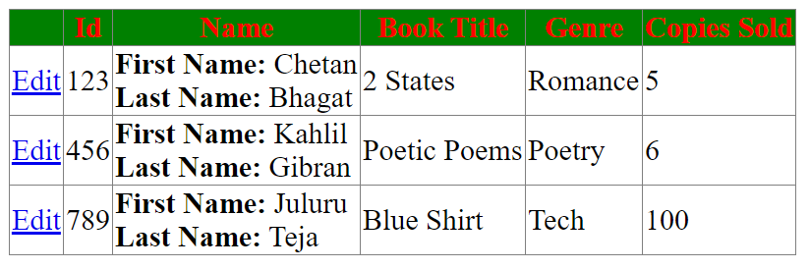

**Answer 3:**

**.aspx file:**

<%@ Page Language="C#" AutoEventWireup="true" CodeFile="Default.aspx.cs" Inherits="_Default" %>

<!DOCTYPE html>

<html xmlns="http://www.w3.org/1999/xhtml">

<head runat="server">

<title></title>

</head>

<body>

<form id="form1" runat="server">

<div>

</div>

</form>

</body>

</html>

**.cs file:**

using System;

using System.Collections.Generic;

using System.Linq;

using System.Web;

using System.Web.UI;

using System.Web.UI.WebControls;

using System.IO;

using System.Xml.Linq;

public partial class _Default : System.Web.UI.Page

{

protected void Page_Load(object sender, EventArgs e)

{

if(!this.IsPostBack)

{

string file = Path.Combine(Request.PhysicalApplicationPath, @"App_Data\Cars.xml");

XDocument doc = new XDocument(

new XDeclaration("1.0", null, "yes"),

new XElement("Cars",

new XElement("Detail", new XElement("Name", "I20"), new XElement("Make", "Hyundai"), new XElement("Price", "700000")),

new XElement("Detail", new XElement("Name", "I10"), new XElement("Make", "Hyundai"), new XElement("Price", "600000"))));

doc.Save(file);

}

}

}

**Cars.Xml file:**

<?xml version="1.0" encoding="utf-8" standalone="yes"?>

<Cars>

<Detail>

<Name>Ikon</Name>

<Make>Hyundai</Make>

<Price>50000</Price>

</Detail>

<Detail>

<Name>Fiesta</Name>

<Make>Ford</Make>

<Price>123</Price>

</Detail>

</Cars>

**Answer Additional 1:**

**.aspx file:**

<%@ Page Language="C#" AutoEventWireup="true" CodeFile="Default.aspx.cs" Inherits="_Default" %>

<!DOCTYPE html>

<html xmlns="http://www.w3.org/1999/xhtml">

<head runat="server">

<title></title>

</head>

<body>

<form id="form1" runat="server">

<div style="height: 319px">

<asp:GridView ID="GridView1" runat="server" DataSourceID="SqlDataSource1" AutoGenerateColumns="false" AllowSorting="true" DataKeyNames="id">

<Columns>

<asp:BoundField DataField="id" HeaderText="Id" ReadOnly="true" SortExpression="id"/>

<asp:TemplateField HeaderText="Name" SortExpression="name">

<ItemTemplate>

<b>Name:</b>

<%# Eval("name") %>

</ItemTemplate>

<EditItemTemplate>

<b>Name:</b>

<asp:TextBox ID="TextBox2" runat="server" Text='<%# Bind("name") %>'></asp:TextBox>

<asp:RequiredFieldValidator ID="RequiredFieldValidator1" runat="server" ErrorMessage="Name is required" EnableClientScript="false" ControlToValidate="TextBox2"></asp:RequiredFieldValidator>

</EditItemTemplate>

</asp:TemplateField>

<asp:TemplateField HeaderText="Details">

<ItemTemplate>

<b>Price:</b>

<%# Eval("price") %>

<br />

<br />

<b>Quantity:</b>

<%# Eval("quantity") %>

</ItemTemplate>

<EditItemTemplate>

<b>Price:</b>

<%# Eval("price") %>

<br />

<br />

<b>Quantity</b>

<asp:TextBox ID="TextBox1" runat="server" Text='<%# Bind("quantity") %>'></asp:TextBox>

<asp:RangeValidator ID="RangeValidator1" runat="server" ErrorMessage="Quantity should be between 1 and 20" ControlToValidate="TextBox1" EnableClientScript="false" Type="Integer" MinimumValue="1" MaximumValue="20"></asp:RangeValidator>

</EditItemTemplate>

</asp:TemplateField>

<asp:CommandField ShowEditButton="true"/>

</Columns>

</asp:GridView>

<asp:SqlDataSource ID="SqlDataSource1" runat="server" ConnectionString="Data Source=(localdb)\MSSQLLocalDB;Initial Catalog=Test;Integrated Security=SSPI" SelectCommand="SELECT * FROM Product" UpdateCommand="UPDATE Product SET quantity=@quantity,name=@name WHERE id=@id"></asp:SqlDataSource>

</div>

</form>

</body>

</html>

**.cs file:**

using System;

using System.Collections.Generic;

using System.Linq;

using System.Web;

using System.Web.UI;

using System.Web.UI.WebControls;

public partial class _Default : System.Web.UI.Page

{

protected void Page_Load(object sender, EventArgs e)

{

}

}

**Dbo.Product:**

CREATE TABLE [dbo].Product

(

[Id] INT NOT NULL PRIMARY KEY,

[name] VARCHAR(50) NOT NULL,

[price] INT NOT NULL,

[quantity] INT NOT NULL

)

**IO:**

**Landing Page:**

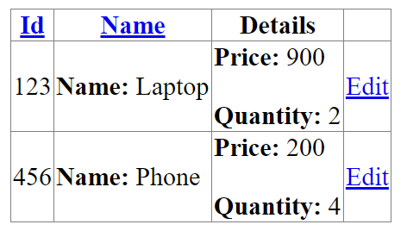

**Only name and quantity can be edited:**

