**PRACTICAL 3**

**Border Gateway Protocol (BGP)**

**Aim –** Create a network with three routers with BGP. Show connectivity.

**Theory –**

*Border Gateway Protocol:*

Border Gateway Protocol (BGP) is used to Exchange routing information for the internet and is the protocol used between ISP which are different ASes.

The protocol can connect together any internetwork of autonomous system using an arbitrary topology. The only requirement is that each AS have at least one router that is able to run BGP and that is router connect to at least one other AS’s BGP router. BGP’s main function is to exchange network reach-ability information with other BGP systems. Border Gateway Protocol constructs an autonomous systems’ graph based on the information exchanged between BGP routers.

*Characteristics of Border Gateway Protocol (BGP):*

* **Inter-Autonomous System Configuration:** The main role of BGP is to provide communication between two autonomous systems.
* BGP supports Next-Hop Paradigm.
* Coordination among multiple BGP speakers within the AS (Autonomous System).
* **Path Information:** BGP advertisement also include path information, along with the reachable destination and next destination pair.
* **Policy Support:** BGP can implement policies that can be configured by the administrator. For ex:- a router running BGP can be configured to distinguish between the routes that are known within the AS and that which are known from outside the AS.
* Runs Over TCP.
* BGP conserve network Bandwidth.
* BGP supports CIDR.
* BGP also supports Security.

**Topology –**

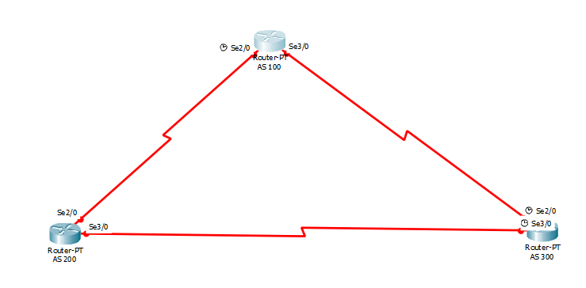

**Steps –**

*Step 1: Create Topology as shown above and assign the IP address to the PC.*

*Step 2: Start CLI for Router 1 and assign IP address for all devices connected to the router.*

**Syntax for adding IP address:**

**int link_port**

**ip add [ip_address] [subnet_mask]**

**no sh**

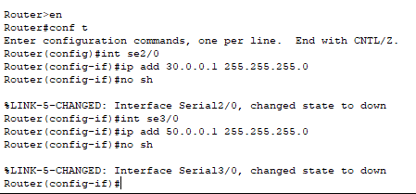

*Step 3: Repeat step 2 for router 2 and router 3*

**Router 2:**

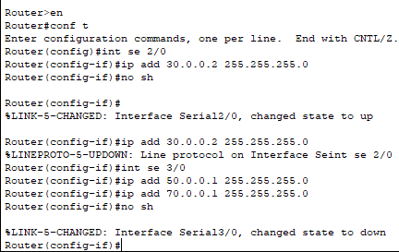

**Router 3:**

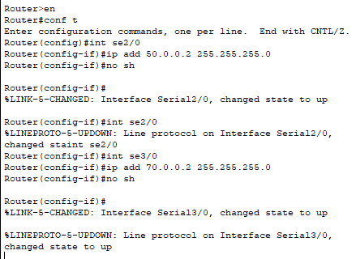

*Step 4: After all IP address are set,configure the BGP protocol on every router as follows*

**Syntax:**

Router bgp bgp_id

Neighbor1 [ip_address] remote-as [neighbor_id]

network1 [network_address]

**BGP configration for router 1:**

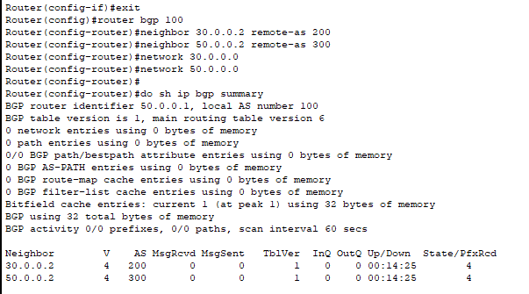

**BGP configration for router 2:**

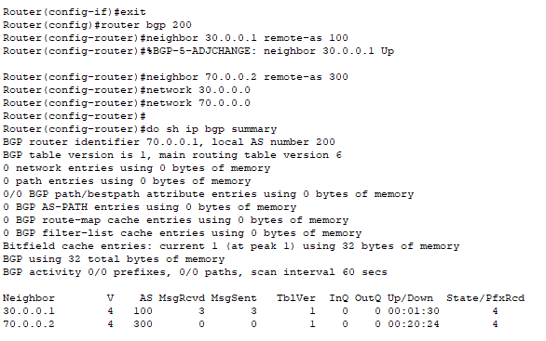

**BGP configration for router 3:**

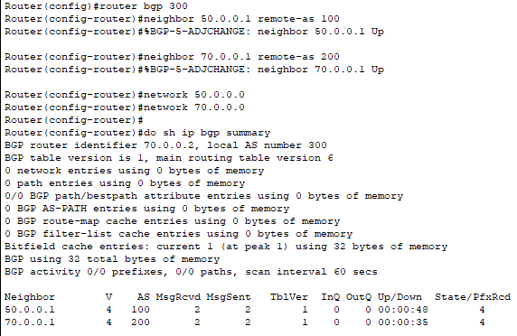

**Outputs for routers 1,2,3 are as follows:**

