**PRACTICAL 2**

**Open Shortest Path First (OSPF)**

**Aim –** Create a network with three routers with OSPF and each router associated network will have minimum three PC. Show connectivity.

**Theory –**

*Open Shortest Path First Protocol:*

Open Shortest Path First (OSPF) is a link-state routing protocol which is used to find the best path between the source and the destination router using its own Shortest Path First). OSPF is developed by Internet Engineering Task Force (IETF) as one of the Interior Gateway Protocol (IGP), i.e, the protocol which aims at moving the packet within a large autonomous system or routing domain. It is a network layer protocol which works on the protocol number 89 and uses AD value 110. OSPF uses multicast address 224.0.0.5 for normal communication and 224.0.0.6 for update to designated router(DR)/Backup Designated Router (BDR).

*OSPF supports/provides/advantages:*

* Both IPv4 and IPv6 routed protocols
* Load balancing with equal cost routes for same destination
* VLSM and route summarization
* Unlimited hop counts
* Trigger updates for fast convergence
* A loop free topology using SPF algorithm
* Run on most routers
* Classless protocol

**Topology –**

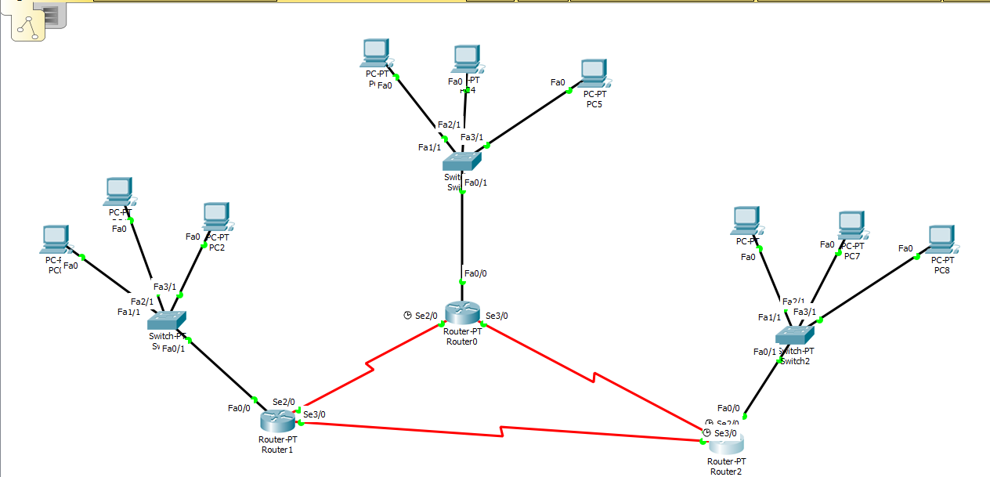

**Steps –**

*Step 1: Create Topology as shown above and assign the IP address to the PC.*

*Step 2: Start CLI for Router 1 and assign IP address for all devices connected to the router.*

**Syntax for adding IP address:**

**int link_port**

**ip add [ip_address] [subnet_mask]**

**no sh**

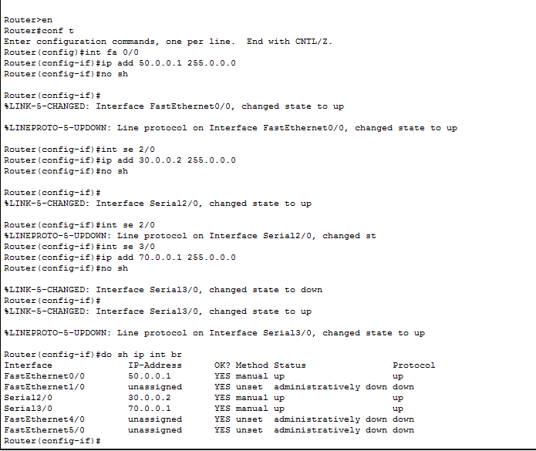

*Step 3: Repeat step 2 for router 2 and router 3*

**Router 2:**

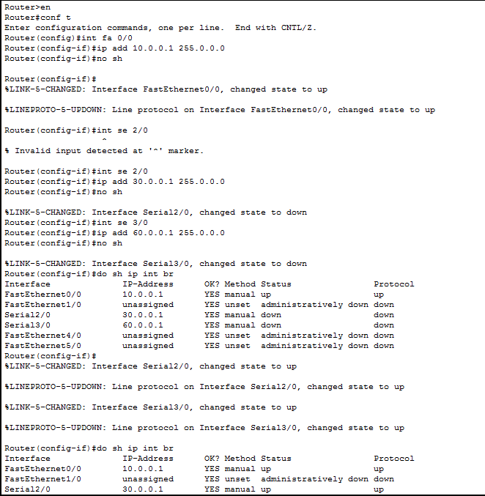

**Router 3:**

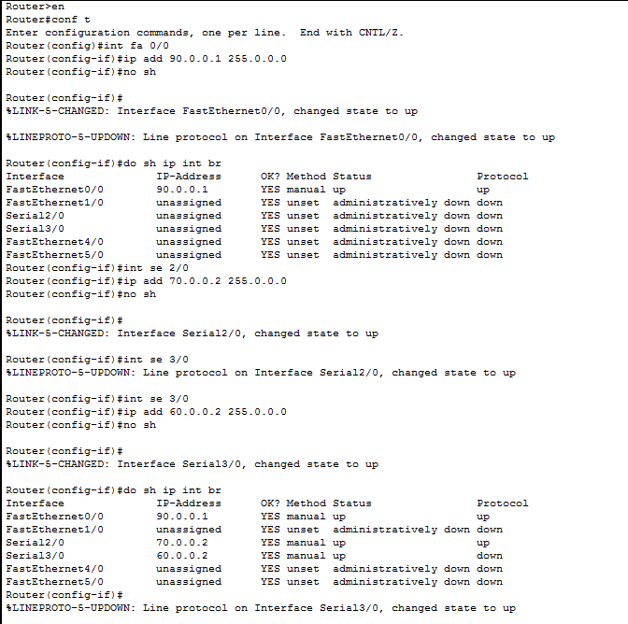

*Step 4: After all IP address are set,configure the ospf protocol on every router as follows*

**Syntax:**

Router ospf 1

network1 [network_address] [subnet_mask] area 0

network2 [network_address] [subnet_mask] area 0

network3 [network_address] [subnet_mask] area 0

**OSPF configration for router 1:**

Router(config)#router ospf 1

Router(config-router)#network 10.0.0.0 0.255.255.255 area 0

Router(config-router)#network 30.0.0.0 0.255.255.255 area 0

Router(config-router)#network 60.0.0.0 0.255.255.255 area 0

Router(config-router)#exit

**OSPF configration for router 2:**

Router(config)#router ospf 1

Router(config-router)#network 30.0.0.0 0.255.255.255 area 0

Router(config-router)#network 50.0.0.0 0.255.255.255 area 0

Router(config-router)#network 70.0.0.0 0.255.255.255 area 0

Router(config-router)#exit

**OSPF configration for router 3:**

Router(config)#router ospf 1

Router(config-router)#network 70.0.0.0 0.255.255.255 area 0

Router(config-router)#network 90.0.0.0 0.255.255.255 area 0

Router(config-router)#network 60.0.0.0 0.255.255.255 area 0

Router(config-router)#exit