**PRACTICAL 1**

**Routing Information Protocol (RIP)**

**Aim –** Create a network with three routers with RIPv2 and each router associated network will have minimum three PC. Show connectivity.

**Theory –**

*Routing Information Protocol:*

**Routing Information Protocol** (RIP) is a dynamic routing protocol which uses hop count as a routing metric to find the best path between the source and the destination network. It is a distance vector routing protocol which has AD value 120 and works on the application layer of OSI model. RIP uses port number 520.

*Features of RIP :*

1. Updates of the network are exchanged periodically.
2. Updates (routing information) are always broadcast.
3. Full routing tables are sent in updates.
4. Routers always trust on routing information received from neighbor routers. This is also known as *Routing on rumours*.

**Topology –**

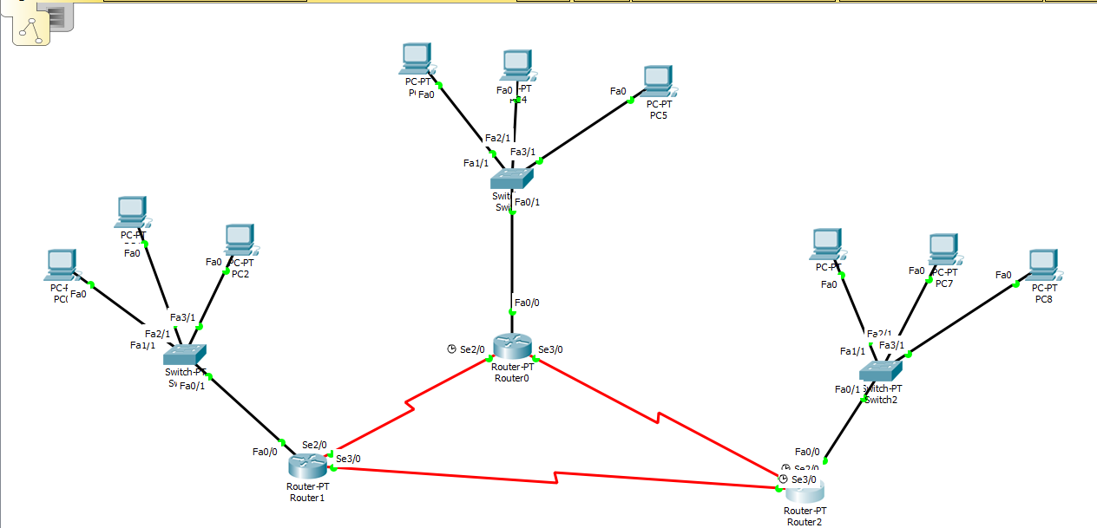

**Steps –**

*Step 1: Create Topology as shown above and assign IP to PC’s*

*Step 2: Start CLI for Router 1 and assign IP address for all devices connected to the router.*

**Syntax for adding IP address:**

**int link_port**

**ip add [ip_address] [subnet_mask]**

**no sh**

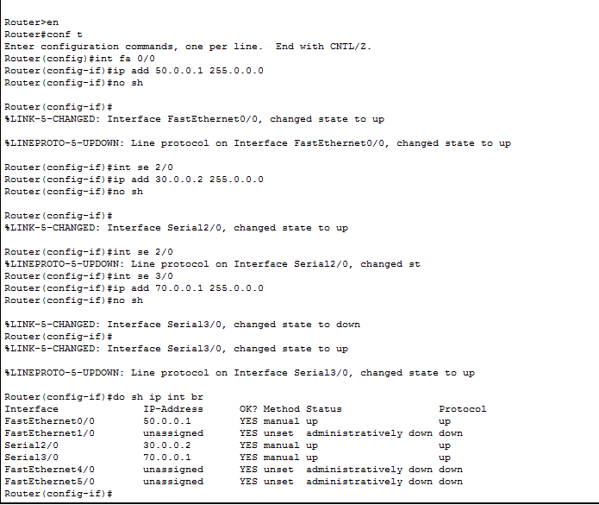

*Step 3: Repeat step 2 for router 2 and router 3*

**Router 2:**

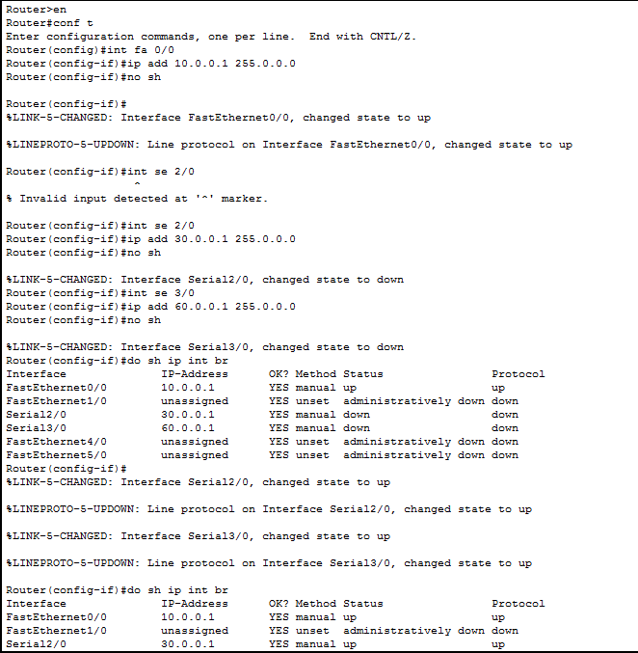

**Router 3:**

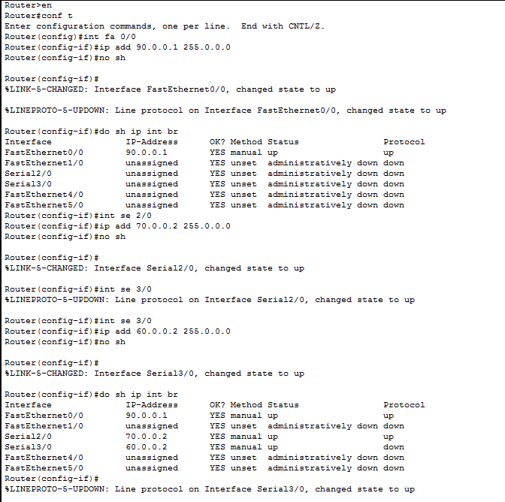

*Step 4: After all IP address are set,configure the rip protocol on every router as follows*

**Syntax:**

Router rip

Version 2

network1 [network_address]

network2 [network_address]

network3 [network_address]

RIP configration for router 1:

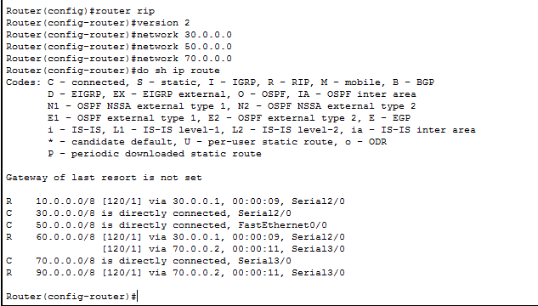

RIP configration for router 2:

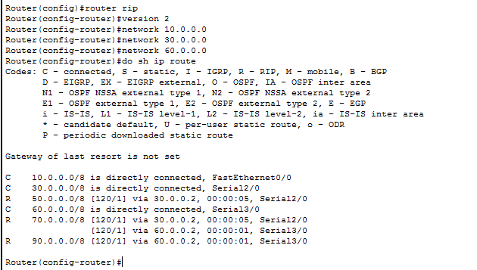

RIP configration for router 3:

