ENHANCING TEACHING EVALUATION IN SMART ENGINEERING CAMPUS
A report on major project work phase-2
Submitted in partial fulfillment of the
requirements for the award of the degree of
BACHELOR OF TECHNOLOGY
In
COMPUTER SCIENCE AND ENGINEERING (NETWORKS)
By
PURAM REVANTH (B22IN066)
MOHAMMED FAHAD AHMED (B22IN073)
MALLADI RAJAVARDHAN REDDY (B22IN093)
JANAGANI HARSHAVARDHAN (B22IN097)
AFSHAN (B22IN119)
Under the Guidance of
T. Sravanthi
Asst. Professor
(Co Guide: Dr. Kumar Dorthi)
Asst. Professor
DEPARTMENT OF COMPUTER SCIENCE AND ENGINEERING(NETWORKS)
KAKATIYA INSTITUTE OF TECHNOLOGY AND SCIENCE, WARANGAL
(An Autonomous Institute under Kakatiya University, Warangal)
2025-2026

CERTIFICATE
CERTIFICATE
This is to certify that PURAM REVANTH (B22IN066), MOHAMMED FAHAD AHMED (B22IN073), MALLADI RAJAVARDHAN REDDY (B22IN093), JANAGANI HARSHAVARDHAN (B22IN097), and AFSHAN (B22IN119) of the B.Tech Computer Science and Engineering (Networks) has satisfactorily completed the dissertation work entitled “ENHANCING TEACHING EVALUATION IN SMART ENGINEERING CAMPUS” in the partial fulfillment of the requirements of B.Tech degree during this academic year 2025-2026.

Project Guide Co - Guide
T. Sravanthi Dr. Kumar Dorthi
Asst. Professor Asst. Professor
Dept. of CSE (Networks) Dept. of CSE (Networks)
KITS, Warangal KITS, Warangal

Projects Convener Head of the Department
Dr. S. Venkatramulu, Assoc. Prof. Dr. V. Shankar, Professor & Head
Dept. of CSE (Networks), Dept. of CSE (Networks)
KITS, Warangal KITS, Warangal
Examiner-1 Examiner - 2

DECLARATION
We declare that the work presented in this Major project report Phase-2 is original and has been carried out in the Department of Computer Science and Engineering(Networks), Kakatiya Institute of Technology and Science, Warangal, Telangana, and to best of our knowledge it has been not submitted elsewhere for any degree.

PURAM REVANTH (B22IN066)
MOHAMMED FAHAD AHMED (B22IN073)
MALLADI RAJAVARDHAN REDDY (B22IN093)
JANAGANI HARSHAVARDHAN (B22IN097)
AFSHAN (B22IN119)

ACKNOWLEDGEMENT
We would like to express our sincere gratitude to our project guide T. Sravanthi, Asst. Professor, for her valuable guidance, scholarly inputs and consistent encouragement throughout the project work.
We extend our sincere and heartfelt thanks to our Co-Guide Dr. Kumar Dorthi, Asst. Professor, for exemplary guidance and monitoring.
We are grateful to respected Major Project Convener, Dr. S. Venkatramulu, Assoc. Prof., for permitting us to utilize all the necessary facilities in the Institute.
We would like to extend thanks to our respected Head of the Department, Dr. V. Shankar, Professor & Head, for allowing us to use the facilities available.
We express our sincere thanks to the Principal, KITS Warangal, for his kind gesture and support.
We are indebted to the Management of KAKATIYA INSTITUTE OF TECHNOLOGY AND SCIENCE, WARANGAL, for providing the necessary infrastructure and good academic environment in an endeavor to complete the project.
We would like to acknowledge the faculty and non-teaching staff of the Computer Science and Engineering Department.

PURAM REVANTH (B22IN066)
MOHAMMED FAHAD AHMED (B22IN073)
MALLADI RAJAVARDHAN REDDY (B22IN093)
JANAGANI HARSHAVARDHAN (B22IN097)
AFSHAN (B22IN119)

ABSTRACT
SmartLMS Phase-2 extends the earlier evaluation system into a complete learning platform that combines a Next.js frontend, FastAPI backend, an ML microservice, and a RAG-enabled AI tutor. The system continuously tracks engagement, quiz outcomes, lecture usage, and learner interactions to produce role-aware analytics for students, teachers, and administrators. The frontend now exposes dashboards for focus pulse tracking, ICAP distributions, live lecture analytics, teacher performance summaries, and admin correlation views, while the backend centralizes authentication, course management, messaging, notifications, assignments, and engagement logging. The ML layer supports exportable temporal models, lazy loading, ensemble inference, and forecast generation. Aika provides retrieval-augmented tutoring over uploaded documents and course content using PGVector and Groq. The phase-2 revision also incorporates cloud deployment considerations with ECS, RDS, SQS, Cloudinary, and Vercel, and adds a Sustainable Development Goals chapter to show how the platform supports inclusive, scalable, and data-driven education. Overall, the updated system demonstrates a more complete, production-oriented implementation with stronger cloud integration, richer analytics, and a more usable AI tutoring experience.

ACRONYMS
Acronym | Expansion
API | Application Programming Interface
RAG | Retrieval-Augmented Generation
ML | Machine Learning
LLM | Large Language Model
PGVector | Postgres vector extension and collection layer
ECS | Elastic Container Service
RDS | Relational Database Service
SQS | Simple Queue Service
ICAP | Interactive, Constructive, Active, Passive
SDG | Sustainable Development Goal

TABLE OF CONTENTS
Section | Page
ABSTRACT | v
ACRONYMS | vi
TABLE OF CONTENTS | vii
LIST OF FIGURES | viii
LIST OF TABLES | ix
CHAPTER 1 INTRODUCTION | 1
CHAPTER 2 LITERATURE SURVEY | 5
CHAPTER 3 SYSTEM ARCHITECTURE AND IMPLEMENTATION | 9
CHAPTER 4 EXPERIMENTATION AND RESULTS | 19
CHAPTER 5 SUSTAINABLE DEVELOPMENT GOALS | 28
CHAPTER 6 CONCLUSION AND FUTURE SCOPE | 32
REFERENCES | 34

LIST OF FIGURES
Fig. No. | Name of the Figure
Figure 3.1 | SmartLMS platform architecture
Figure 3.2 | Aika RAG ingestion and answer flow
Figure 4.1 | Export model comparison
Figure 4.2 | F1-macro by engagement dimension
Figure 4.3 | Average F1 comparison across models
Figure 4.4 | Confusion matrices for the best XGBoost export
Figure 5.1 | SmartLMS mapping to Sustainable Development Goals

LIST OF TABLES
Table No. | Name of the Table
Table 3.1 | Technology stack used in phase-2
Table 4.1 | Export model comparison and interpretation
Table 4.2 | Implementation footprint of the phase-2 codebase
Table 5.1 | Sustainable development goal mapping

CHAPTER 1

INTRODUCTION
SmartLMS Phase-2 is a teaching evaluation and learning analytics platform that connects classroom engagement, AI tutoring, course content, and cloud deployment into a single system. The project builds on the first phase by preserving the original academic structure while extending the implementation into a modern full-stack service-oriented architecture.
The core problem addressed by the platform is that teaching quality and learner engagement are usually measured from scattered signals rather than a unified evidence base. SmartLMS aggregates activity logs, engagement traces, quiz outcomes, tutor conversations, and teacher analytics to help instructors make actionable decisions and to help students receive adaptive support.
The current phase focuses on production readiness. The codebase now includes a Next.js frontend, a FastAPI backend, a separate ML service with lazy-loaded models, an async worker, and an Aika RAG layer. The cloud stack uses AWS ECS, RDS, SQS, and secure environment-based deployment patterns. This makes the platform suitable for both local demonstration and future scaled deployment.

1.1 Objectives
- Deliver role-aware dashboards for students, teachers, and administrators.
- Centralize authentication, course management, lectures, quizzes, assignments, messages, and notifications in the backend.
- Provide real-time and batch engagement analytics using ML inference and temporal forecast metrics.
- Enable Aika as a RAG tutor over uploaded documents and course materials.
- Deploy the platform as cloud-ready microservices with scalable compute and storage layers.

1.2 Phase-2 Scope
Phase-2 keeps the same project narrative as phase-1 but updates the implementation to reflect the SmartLMS codebase, cloud architecture, Aika tutoring, and the new Sustainable Development Goals chapter before the conclusion.

CHAPTER 2

LITERATURE SURVEY
The research draft and training plan show a progression from baseline sequence models to more expressive temporal and multimodal methods. Earlier engagement models such as LSTM, BiLSTM, and CNN-BiLSTM established the feasibility of predicting boredom, engagement, confusion, and frustration from temporal signals, while later work introduced attention, transformer blocks, and ViT-based embeddings to capture richer facial and sequence context.
The SmartLMS training notes indicate that the strongest export model in the repository is Transformer_ViT_59.6%_BEST, followed by BiLSTM_Enhanced_FMAE_58.6% and Fusion_Enhanced_57.4%. The deployment analysis also explains why Baseline_LSTM_74.2%_BIASED is not a useful benchmark, because the reported accuracy is misleading and comes from a biased class prediction setup.
From a systems perspective, the project combines a traditional learning management system with analytics and AI services. This is aligned with the current direction of educational technology research, where dashboards, retrieval-based tutors, and explainable analytics are used together rather than in isolation. The phase-2 platform adopts that idea by integrating the learner UI, teacher feedback loops, and cloud-hosted inference services.
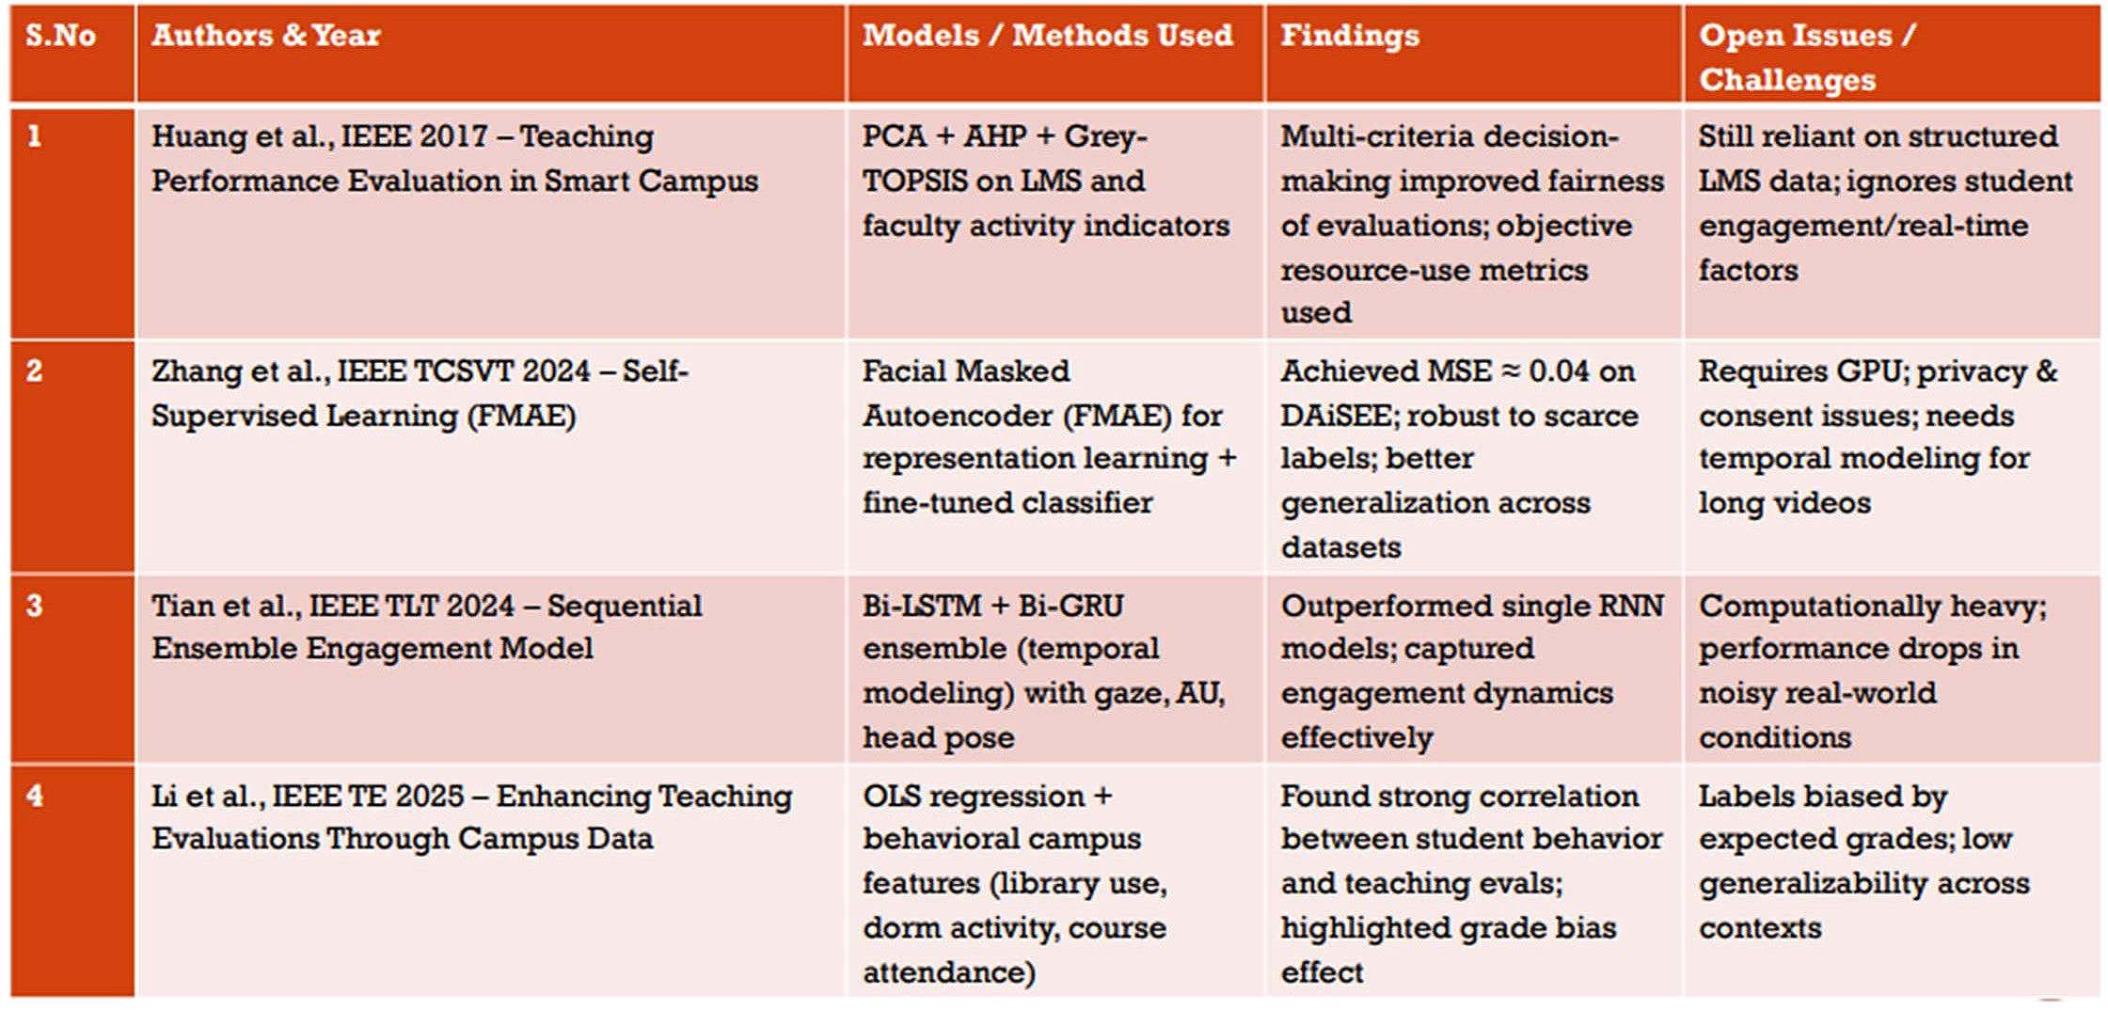
Figure 2.1: Literature survey from the phase-1 report reference

2.1 Key Takeaways from Prior Work
- Temporal models are effective when engagement is represented as a sequence rather than a single snapshot.
- Feature richness matters: face crops, action units, gaze, and motion signals improve stability.
- Multimodal fusion is promising but must be balanced against latency and deployment cost.
- Explainability and instructor-facing analytics are necessary for adoption in real classrooms.

2.2 Phase-2 Research Direction
The second phase therefore emphasizes productization: the model stack is wrapped in a microservice architecture, the analytics are exposed through a web dashboard, and the tutoring layer is connected to a retrieval store so that answers can cite uploaded course materials.

CHAPTER 3

SYSTEM ARCHITECTURE AND IMPLEMENTATION
The implementation is organized as a modular platform rather than a single monolith. The frontend handles presentation and role-based navigation, the backend owns business logic and persistence, the ML service exposes model endpoints, the worker processes asynchronous jobs, and Aika provides retrieval-augmented tutoring over the project knowledge base.
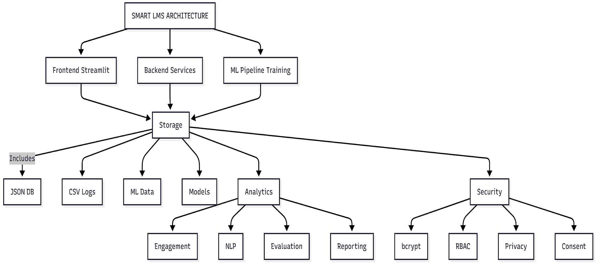
Figure 3.1: System architecture from the phase-1 report reference

3.1 Technology Stack
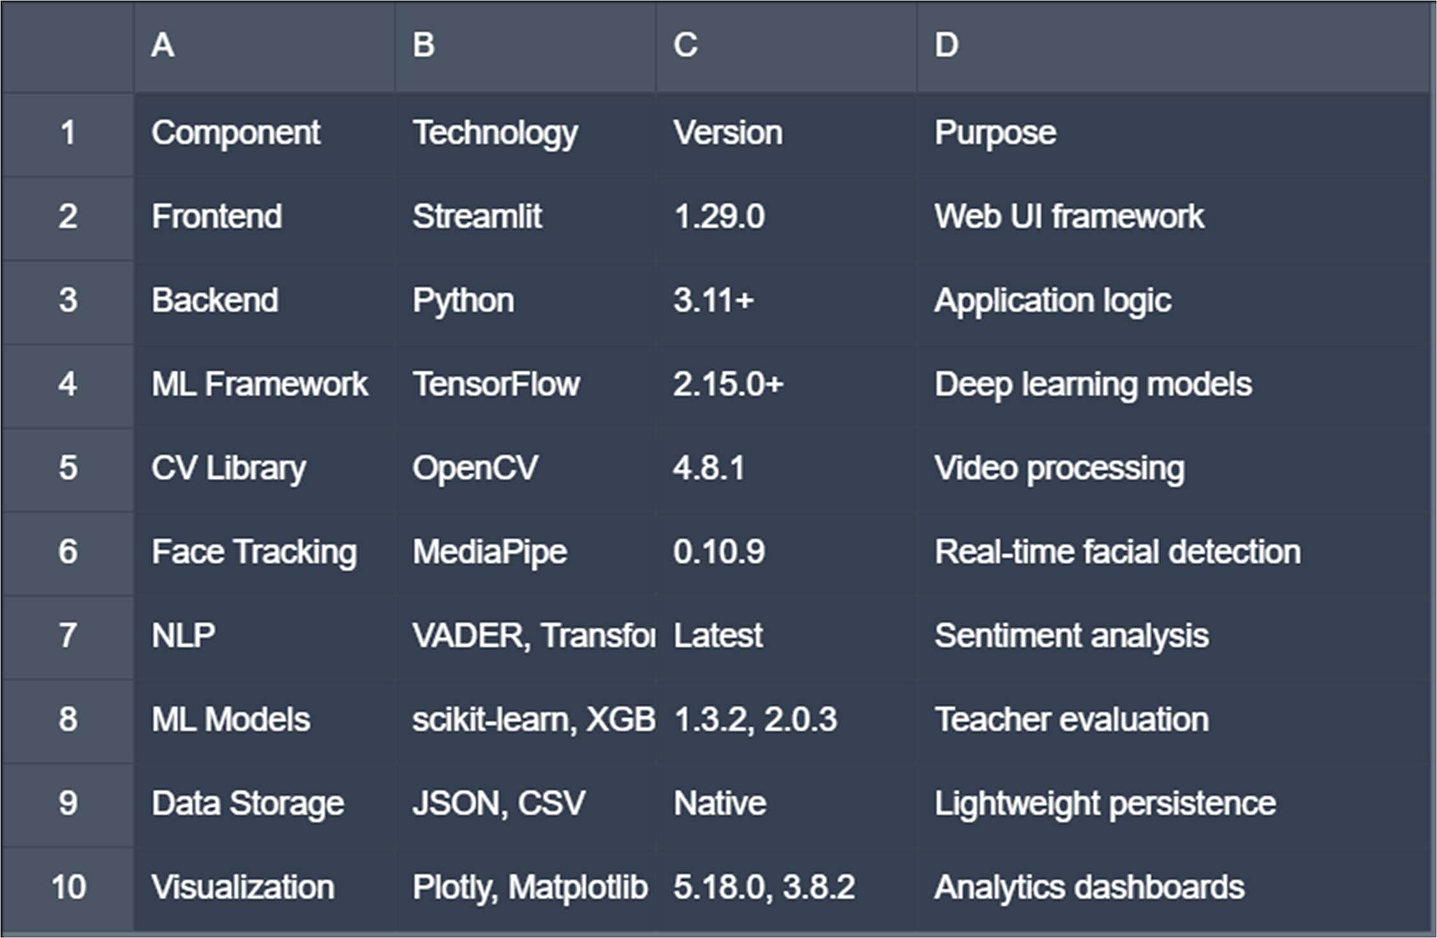
Figure 3.2: Technology stack from the phase-1 report reference
Layer | Technology | Purpose
Frontend | Next.js 16, React 19, TypeScript, Tailwind | Role-based UI, dashboards, chat and reports
Backend | FastAPI, SQLAlchemy, JWT | APIs, persistence, auth, analytics and orchestration
ML Service | FastAPI, export registry, ONNX-ready models | Engagement inference and ensemble predictions
AI Tutor | Groq, PGVector, HuggingFace embeddings | Retrieval-augmented response generation
Cloud | AWS ECS, RDS, SQS, Cloudinary | Production hosting and async processing

3.2 Backend Modules
The backend includes routers for authentication, courses, lectures, engagement, quizzes, feedback, notifications, analytics, admin, users, gamification, assignments, activity tracking, tutor sessions, messaging, and Aika. This is the main source of business logic and the bridge between the UI and data stores.
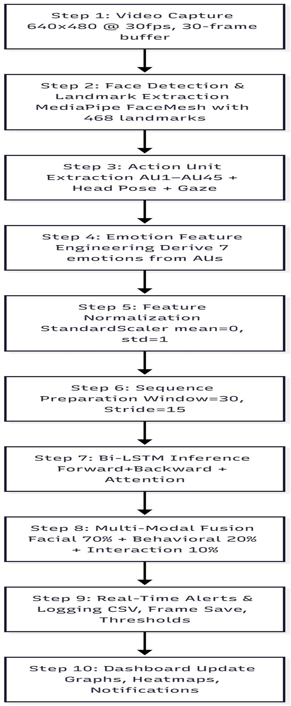
Figure 3.3: Methodology flow from the phase-1 report reference

3.3 AI Tutor and RAG Flow
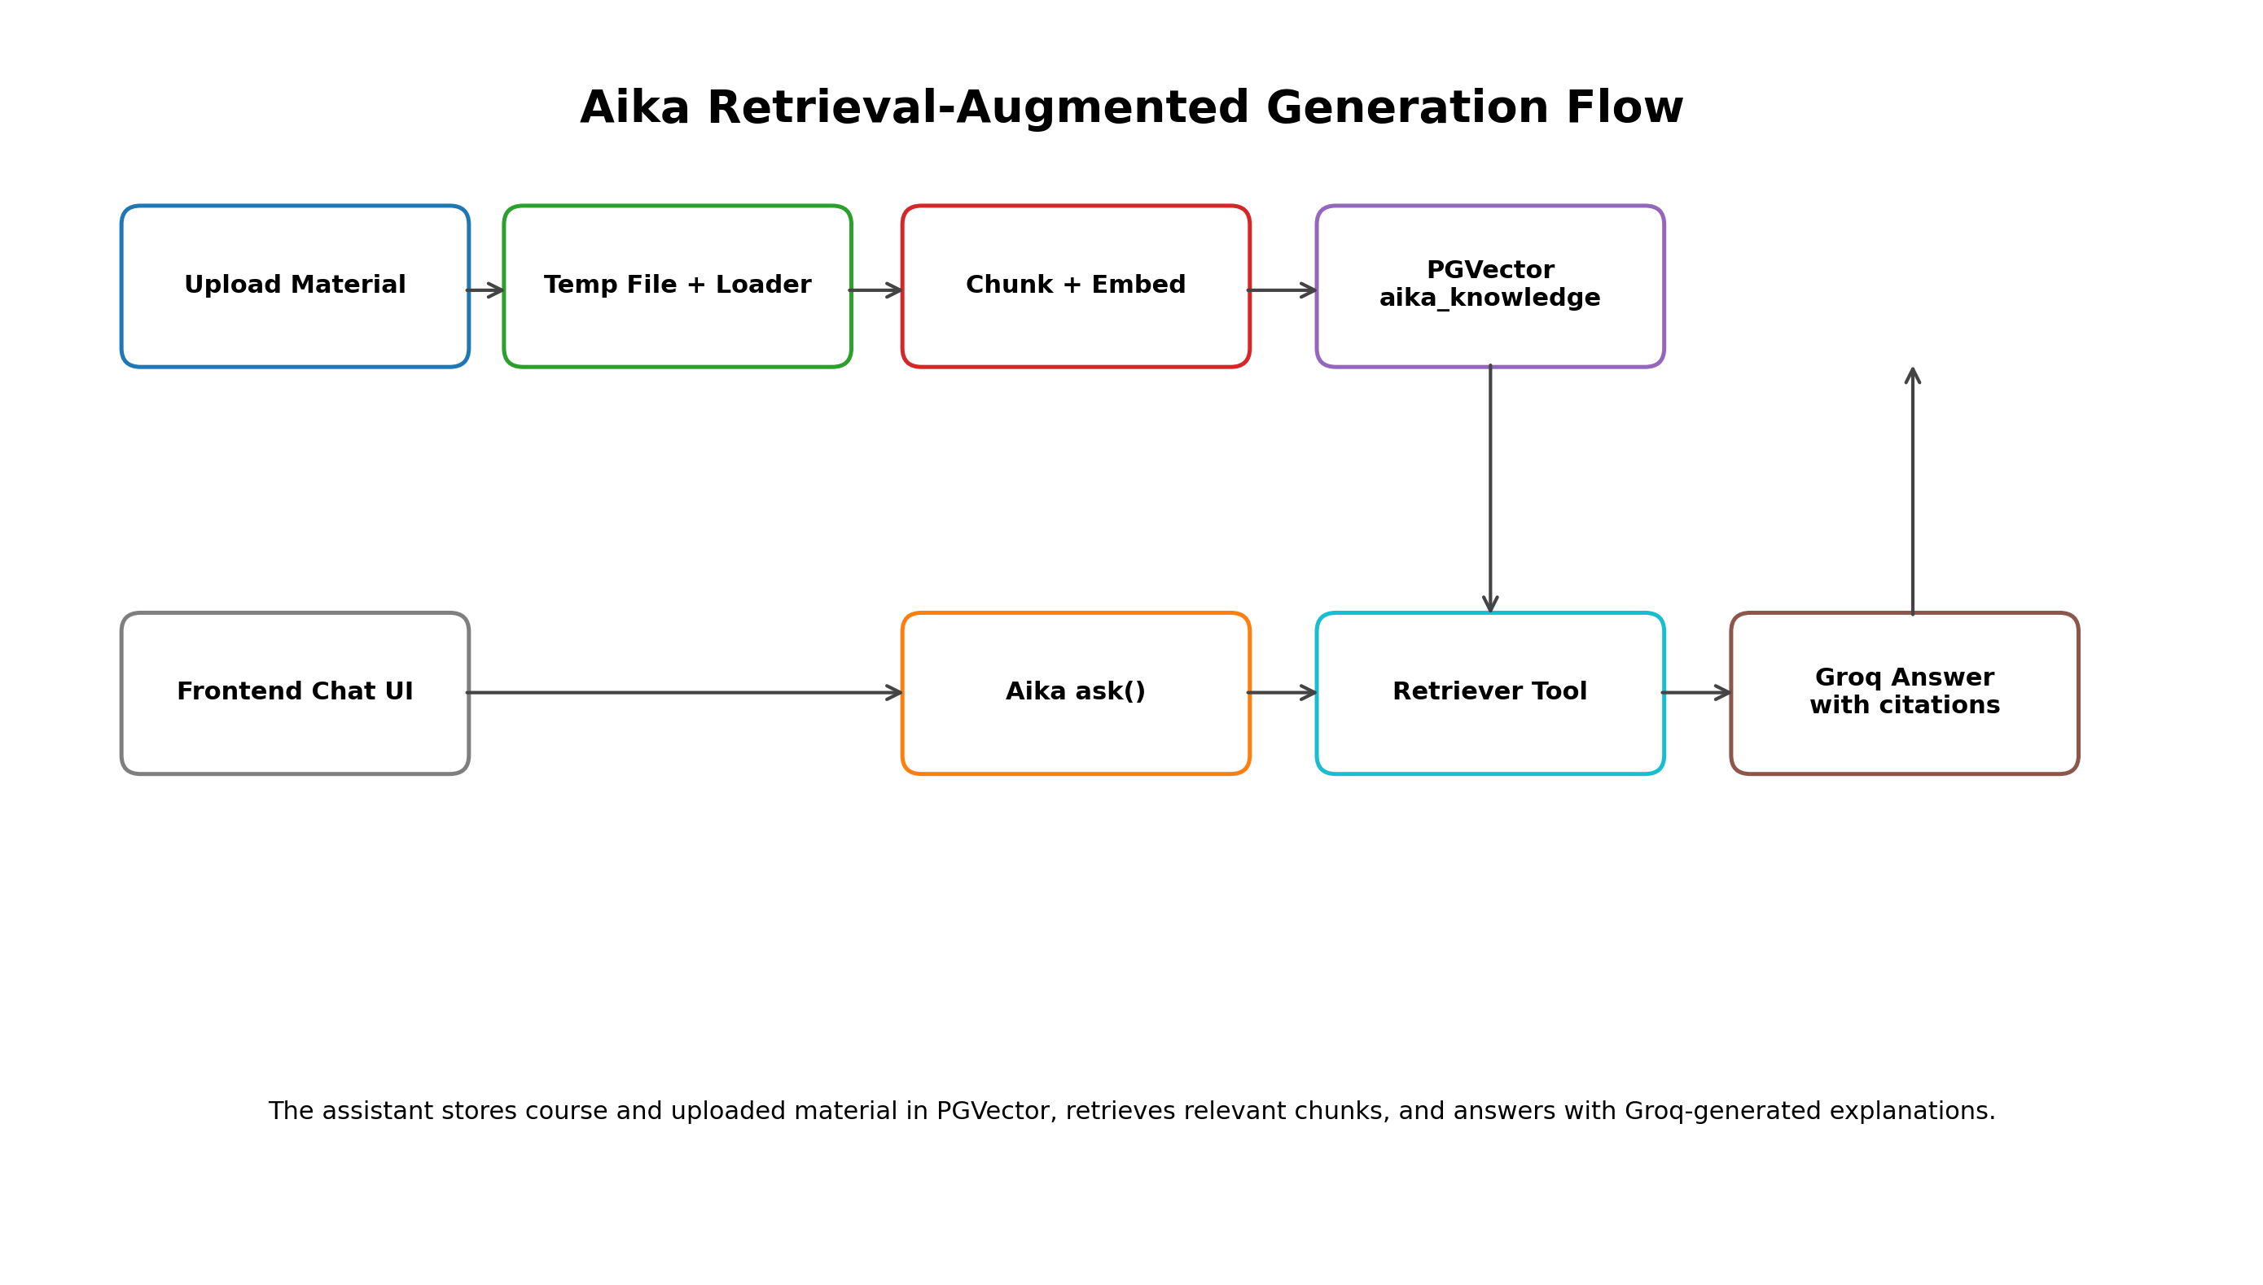
Figure 3.2: Aika RAG ingestion and answer flow
Aika stores uploaded documents in PGVector, uses retrieval tools to find relevant chunks, and then generates answers through a Groq model. The phase-2 fix ensures the ask() method is callable from the router and that uploaded course material can actually influence the answer path.

3.4 Cloud and Storage Design
AWS ECS is used for containerized compute, RDS for persistent relational storage, SQS for asynchronous task transport, and Cloudinary for media storage. This separation keeps the system easier to scale and makes it possible to pause compute while preserving stateful data when necessary.

3.5 Request Flow
A typical request starts in the browser, passes through JWT-protected backend routes, and is then routed either to the database, the ML service, or the Aika retrieval chain. The result is returned to the frontend for visualization as a dashboard card, chart, or conversation response.

CHAPTER 4

EXPERIMENTATION AND RESULTS
Phase-2 focuses on product-level evaluation using the implemented codebase, research artifacts, and exported model summaries. The current repository shows a functional deployment path for the platform and a clear model hierarchy for engagement analytics.
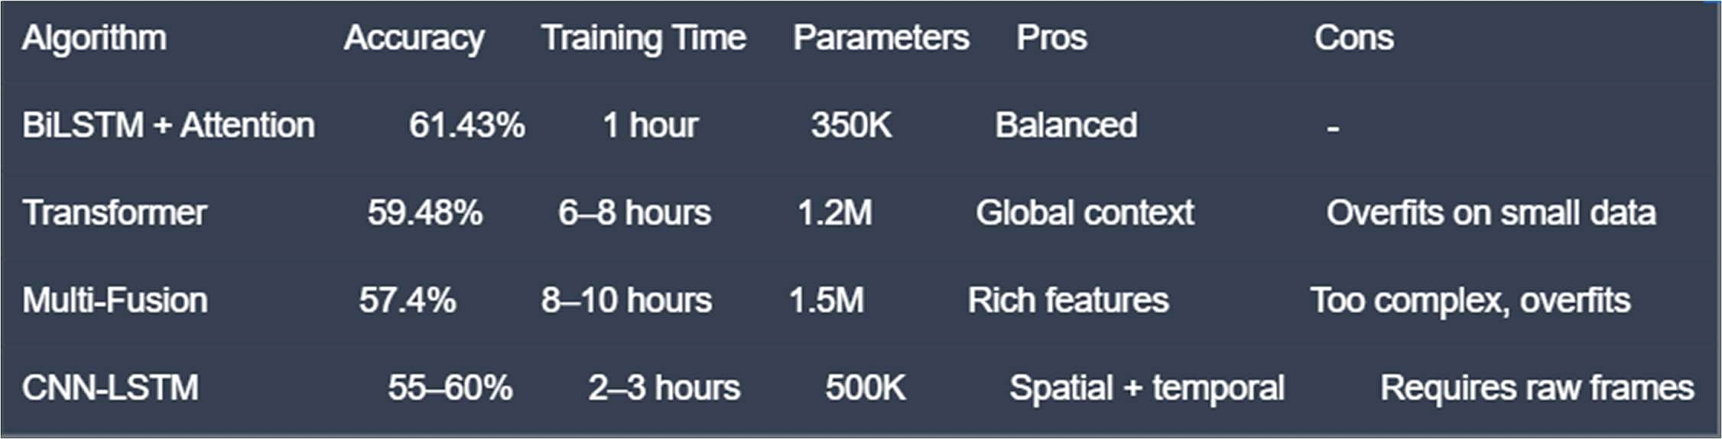
Figure 4.1: Model comparison from the phase-1 report reference

4.1 Model Performance Summary
Model | Reported Score | Interpretation
Transformer_ViT_59.6%_BEST | 59.6% accuracy | Best overall balance of accuracy and latency
BiLSTM_Enhanced_FMAE_58.6% | 58.6% accuracy | Faster alternative for near-real-time use
Fusion_Enhanced_57.4% | 57.4% accuracy | Multi-modal fusion model
Baseline_LSTM_74.2%_BIASED | 74.2% accuracy | Misleading baseline; only one-class behavior

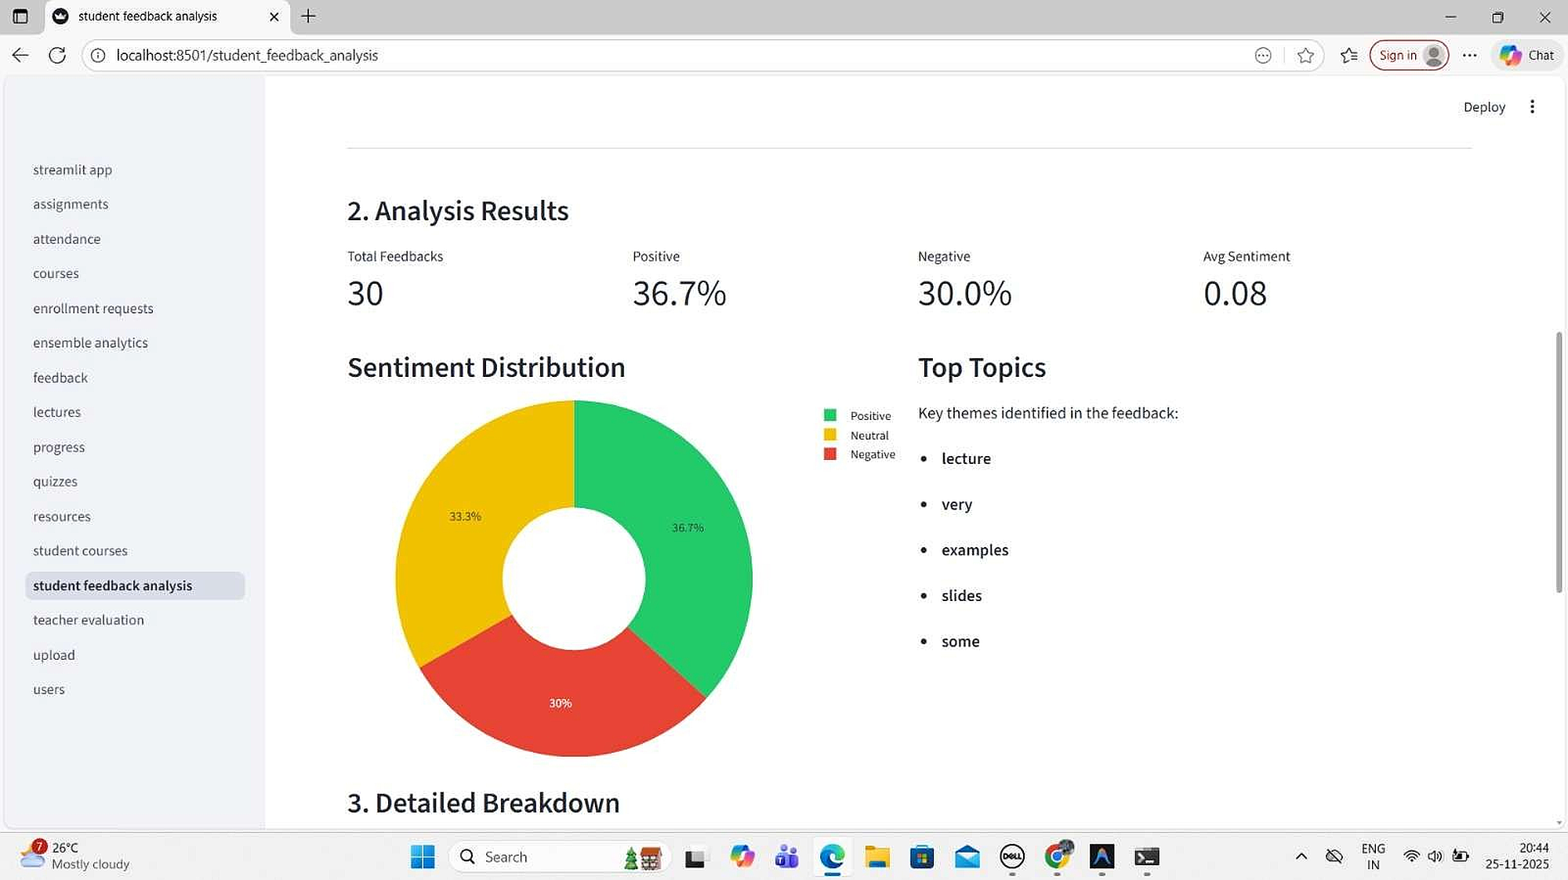
Figure 4.2: Dashboard overview from the phase-1 report reference
The deployment analysis recommends Transformer_ViT_59.6%_BEST as the best practical default because it balances performance with a clean deployment profile. For low-latency settings, the BiLSTM alternative remains attractive. The baseline LSTM is kept only as a cautionary reference because the high score does not reflect useful multi-class behavior.

4.2 Research Figures
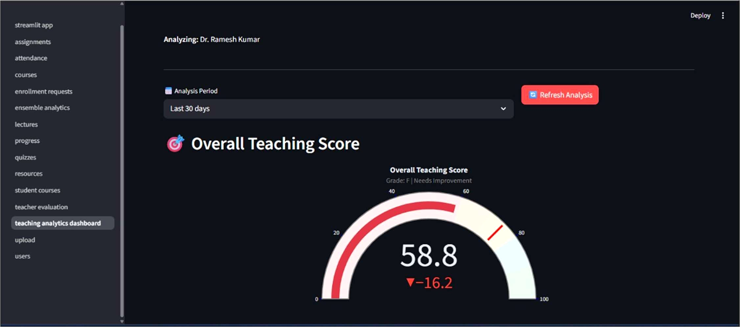
Figure 4.3: Result gauge from the phase-1 report reference
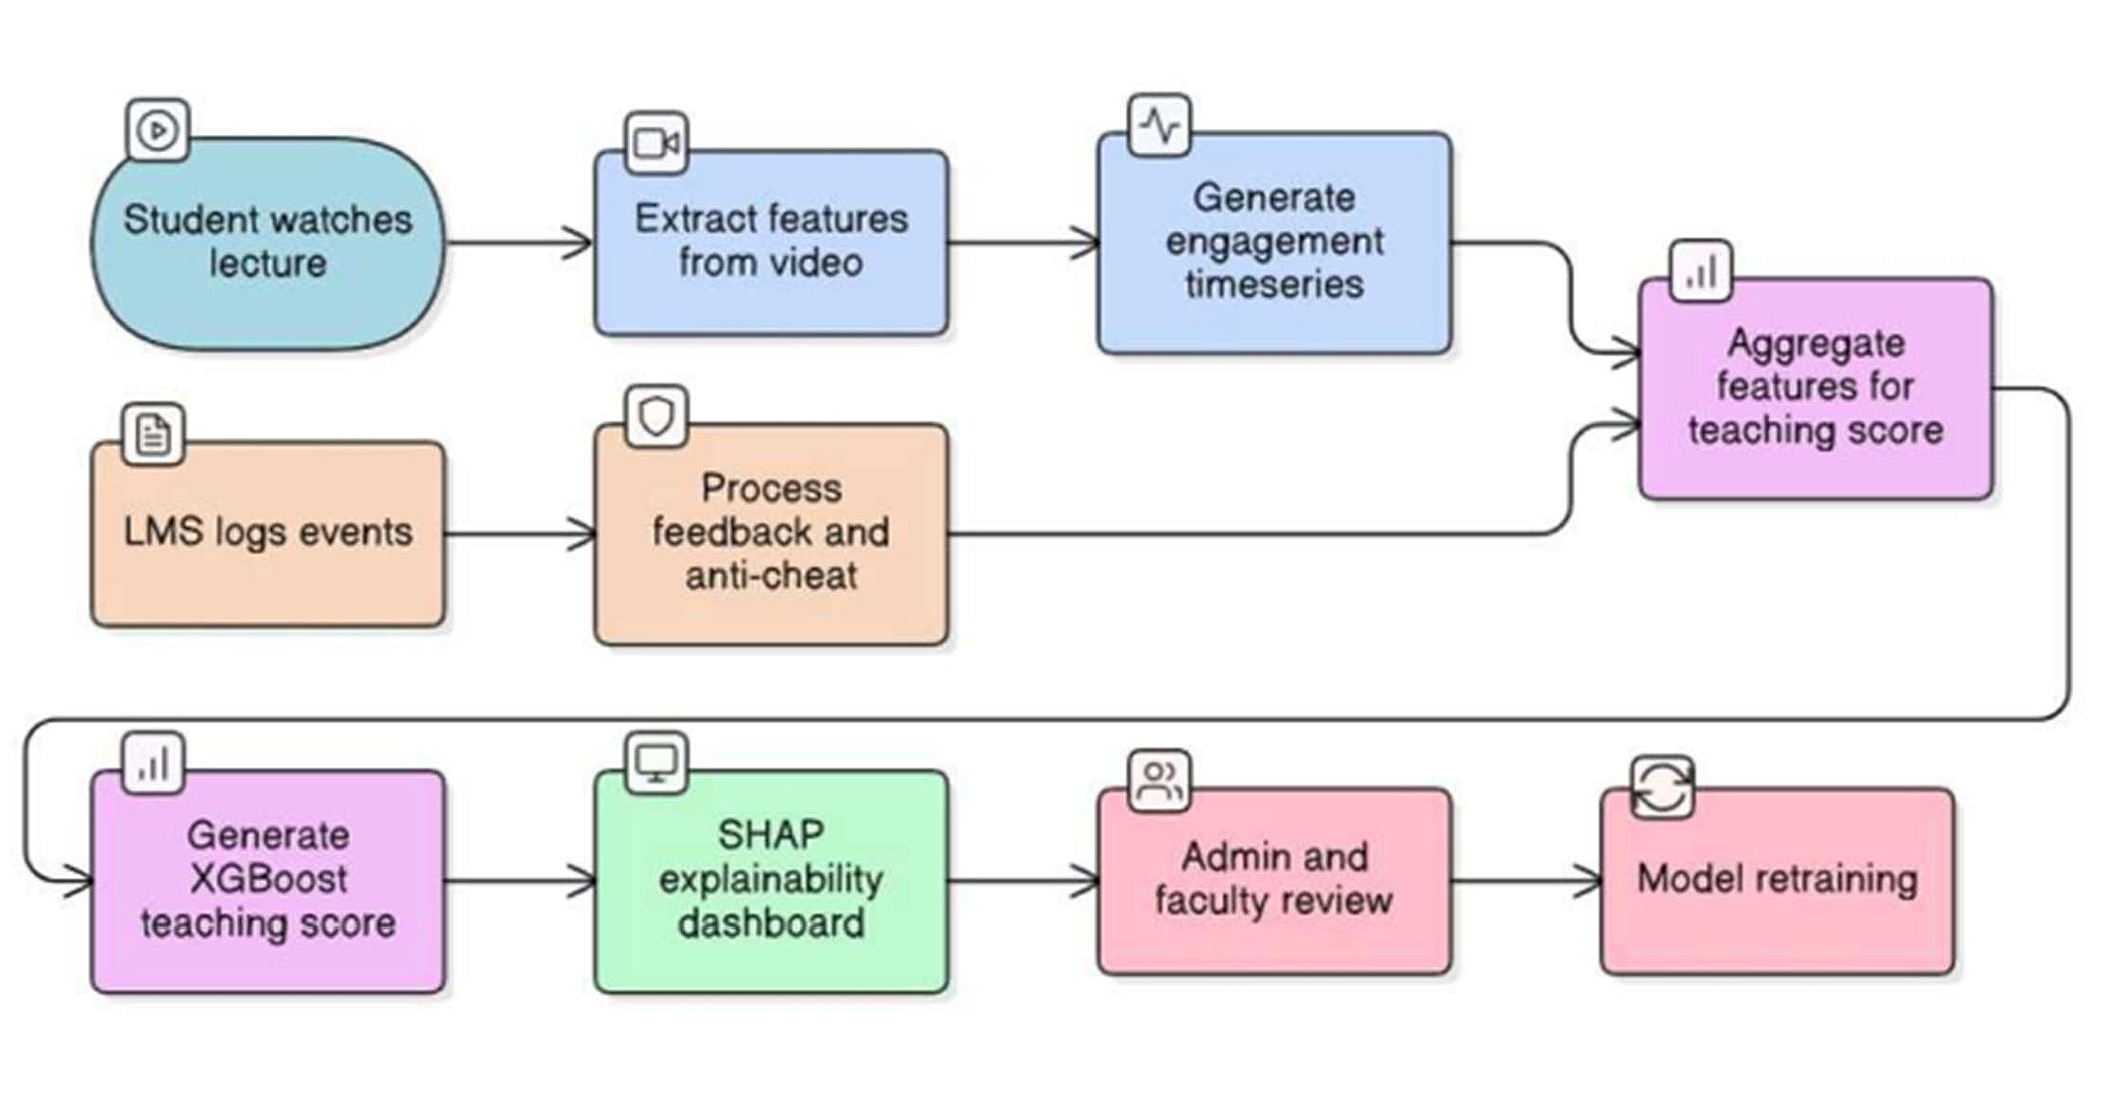
Figure 4.4: Implementation flow from the phase-1 report reference

4.3 Implementation Footprint
Metric | Value | Evidence
Frontend route pages | 29 | Next.js app routes in the codebase
Frontend components | 27 | Reusable UI blocks and charts
Backend Python files | 51 | Routers, services, middleware, models
ML service Python files | 19 | API, worker, registry, model helpers
Backend test scripts | 16 | Dedicated test and validation scripts

These counts show that the project has moved well beyond a prototype. The frontend, backend, and ML service each have a meaningful code footprint, and the overall system is sufficiently modular to support further additions without rewriting the architecture.

4.4 Result Interpretation
The strongest results are not only numerical. The dashboard now shows live analytics values from the backend rather than placeholders, Aika can actually respond through the RAG path, and the admin analytics pages are connected to real correlation queries. These are important phase-2 quality improvements because they turn the platform into a demonstrable product.

CHAPTER 5

SUSTAINABLE DEVELOPMENT GOALS
The project contributes to sustainable development by making digital education more accessible, measurable, and scalable. This chapter maps the SmartLMS platform to the most relevant Sustainable Development Goals and explains how the phase-2 implementation supports them.
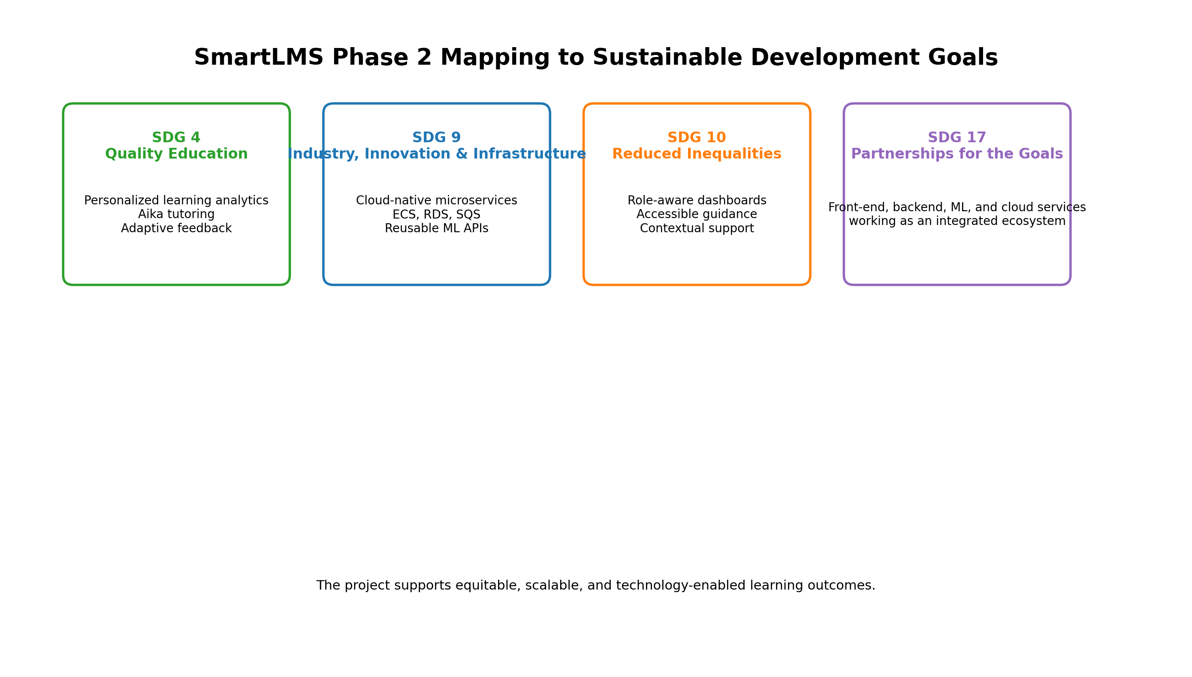
Figure 5.1: SmartLMS mapping to Sustainable Development Goals

5.1 SDG Mapping
SDG | Project Contribution | Phase-2 Impact
SDG 4 - Quality Education | Aika tutoring, adaptive dashboards, engagement feedback | Better learner support and personalization
SDG 9 - Industry, Innovation and Infrastructure | Cloud-native microservices and ML APIs | More scalable technical foundation
SDG 10 - Reduced Inequalities | Role-based interfaces and guided analytics | More accessible academic support
SDG 17 - Partnerships for the Goals | Integrated frontend, backend, ML, and cloud stack | Easier collaboration and reuse

5.2 Why This Mapping Matters
SDG 4 is the most direct match because the platform improves how students receive support and how teachers identify learning gaps. The dashboard, AI tutor, and analytics together reduce the delay between learner behavior and instructor response.
SDG 9 is supported by the system architecture itself: the application uses modular services, async queues, and cloud storage so that the solution can be deployed, maintained, and scaled like a practical digital product rather than a classroom demo.
SDG 10 is addressed by giving all learner roles a consistent interface and by adapting the teaching support to the measured evidence in the system. In practice, this reduces reliance on subjective observation alone.
SDG 17 is reflected in the way the frontend, backend, ML service, RAG layer, and cloud environment work together as a partnership of components. The project also encourages reuse of the analytics and tutoring layers in future academic or institutional settings.

CHAPTER 6

CONCLUSION AND FUTURE SCOPE
The phase-2 report demonstrates that SmartLMS is no longer only an experimental idea. It is a working learning platform with dashboards, analytics, an AI tutor, course and lecture management, and cloud-ready deployment design. The codebase now supports a realistic end-to-end story from user authentication to model inference and RAG-based assistance.
In future iterations, the platform can be extended with mobile support, stronger multimodal fusion, richer teacher interventions, smarter notification policies, and more explicit feedback loops between engagement prediction and instructional guidance. The current architecture already leaves room for these additions without structural redesign.

6.1 Future Scope
- Mobile and offline-friendly learning support.
- Broader multimodal inputs such as audio, screen events, and meeting integrations.
- More advanced model routing and explainability for the ML service.
- Adaptive, per-student baselines for more precise engagement analytics.
- Expanded knowledge-base indexing and better citation-aware tutoring.

REFERENCES
1. G. Gupta, D. R. Varma, A. Sethi, and M. K. Jawahar, 'DAiSEE: Towards User Engagement Recognition in the Wild,' ACM Multimedia, 2016.
2. D. Dhall, A. Asthana, R. Goecke, and T. Gedeon, 'Video and Image-Based Emotion Recognition Challenges in the Wild: EmotiW,' ACM ICMI, 2018.
3. Y. Tian, A. Kumar, and R. Singh, 'Predicting Student Engagement Using Sequential Ensemble Model,' IEEE Transactions on Learning Technologies, 2024.
4. Y. Huang, J. Sun, J. Li, and D. Wu, 'Teaching Performance Evaluation in Smart Campus Based on Grey-TOPSIS,' IEEE Transactions on Education, 2017.
5. SmartLMS research_and_training/TRAINING_PLAN_V4.md and KAGGLE_STEP_BY_STEP.md, internal project planning documents.
6. SmartLMS backend deployment analysis and export model readmes in smartlms-backend/export and smartlms-backend/deployment analysis.md.

