Lab Week 1B: HTML Introduction

Hello and welcome to the first week Lab (1B) for Web Application Development 1. In this lab you will follow up on the content introduced in the previous lecture. You will have a closer look at IP Addresses and Domain names and find your internal & external IP address. You will also learn how to resolve IP addresses from Domain Names manually and will create your first basic HTML Website.

Note: You might work through this lab before the end of three hours. If that is the case, it is highly recommended that you look at the recommended reading/viewing materials section on GCU learn in week one.

Software Requirements
This lab requires you to have a computer, running one of the main operating systems (Windows, MacOS, Linux). As this module is Web Application Development, it is also necessary that you have several browsers at your disposal. The lab exercises will show examples with Firefox; However, you can also make use of Chrome, Edge or Safari but the instructions on how to open the developer tools for example will differ and are not included in this lab document.

Additionally, you should also have a code editor installed. Popular options here include Visual Studio Code, Notepad++ or Sublime text. As you’ll be writing HTML, it would also be beneficial if your editor supports the HTML-Tag syntax. Visual Studio Code and Sublime Text automatically write the closing tags once you create the opening one. For Notepad++ follow the instructions here.

Task 1: IP Addresses
- Find out your IP Address.
Depending on your operating system there are different ways to find out what IP address your device has been assigned. The most reliable way is to do it through the command line as user interfaces change.

a. MAC/LINUX
Open up the terminal on your Mac or Linux machine. Usually, you’ll find this in the applications. You will probably have used this in the previous, Fundamentals of Computing module. Once you have opened this application you are in your operating systems command line.

In the terminal type in:
ifconfig
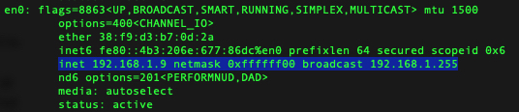
The output should look similar to the following:
Most of the time your Ip address will be in the eth0 or en0 interface which
determine your network adapter.

b. Windows
On a windows machine, press the start button to open the menu, and then search for cmd. Click on it and this should open the command line.

In the command line type in:
ipconfig
The output here should look similar to the following:

If you are connected to your home/work network via WiFi or Ethernet cable you will most likely have an IP within the ranges :

10.0.0.0 - 10.255.255.255 (10/8 prefix)
172.16.0.0 - 172.31.255.255 (172.16/12 prefix)
192.168.0.0 - 192.168.255.255 (192.168/16 prefix)

If your IP address falls within that range, you are connected to a private network. This range of IP addresses is not routed onto the internet and no traffic from the internet can be sent to them directly. As with addresses on the internet, those private IP addresses within the same network should be unique and cannot be repeated.
Your internet router uses NAT (network address translation) to allow you to send and receive data from servers on the internet. More information about NAT can be found here.
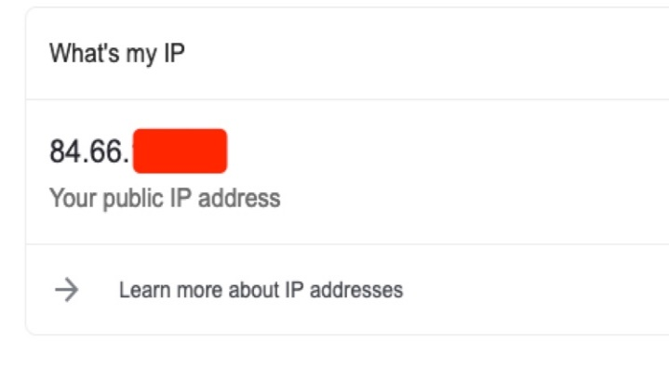
The internet router in your network is the device that is assigned an external (public) IP. To find out what your external IP is you can type “what is my ip” into the search provider of your choice (Google, Bing or DuckDuckGo).
The address which is shown there is the one the web servers send their responses to in regard to your request. You can also usually see who your provider (ISP) is and your IP location.

- Seach https://whatismyipaddress.com/ to find your IP and see the difference between IPv6 and IPv4 with other IP information (including ISP, City, Region, etc).

Remember: Every time you visit a website your IP address is transmitted to the server. A lot of web servers keep automatic logs of who visited what page to analyse web site traffic.

Task 2: Domain Name Resolution

In this task you will be working with DNS to translate URLs into IP addresses and vice versa.
You will need your command line window or your terminal again.

- First, we are going to try to find the IP address for www.gcu.ac.uk.
To do this type:

nslookup www.gcu.ac.uk

(this works on Windows/Mac/Linux, ns here means name server)

Your output will look similar to this:
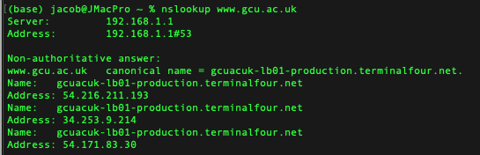

Here we can see that the DNS server 192.168.1.1 gave us the non-authoritative answer with three different IP addresses. Sometimes, the DNS server will be shown as other name, which means you are using another modern router (like the BT Hub) within the local network. The figure below shows a case that the DNS server is bthub.hom. If you’d like to confirm, you could continue and try manually looking up the IP of the server’s name.

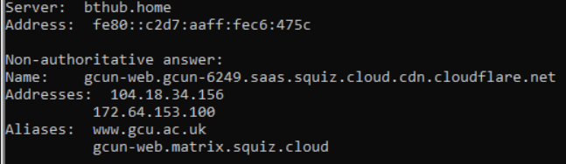

nslookup bthub.home

- Take one result of the Addresses/Aliases after performing the nslookup and copy that into a browsers address bar. After hitting enter you will see that this forwards you to the actual www.gcu.ac.uk website3.

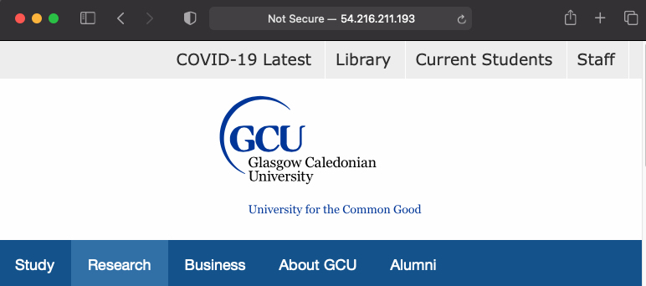

Task 3: HTTP Headers

As you recall from the lecture, HTTP (Hyper Text Transfer Protocol) is the main protocol for client-server communication in the web. In this task you will examine the content of the HTTP headers to observe what is being transmitted.
For this exercise you will need to use the Firefox browser.

- Open the browser, and navigate to https://www.gcu.ac.uk

- Right click anywhere inside the website and select inspect element.

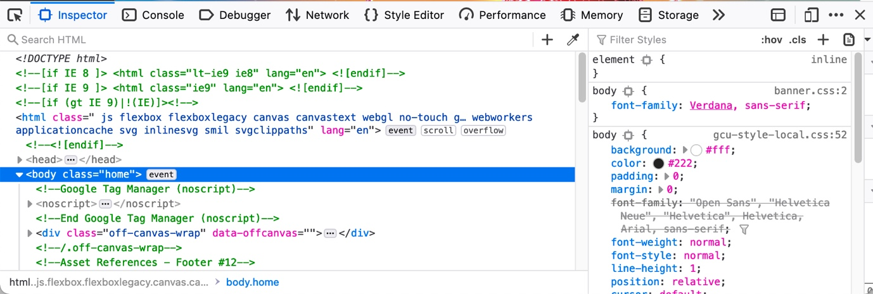
- This will open the developer console, which is shown in the figure below:

- On the left side of the developer console, you can see the HTML source code. You can scroll through this to see the HTML source code for a complex web application.

- In the open developer menu, click on the Network tab.

- Now, refresh the whole web page. You should now see content appear in the developer tools, which shows all the network requests that have been carried out upon you refreshing the website. Change the filter from All to HTML. This now shows all the requests for HTML files. Select the request for the domain www.gcu.ac.uk. The right-hand side of the developer tools should now look like this:

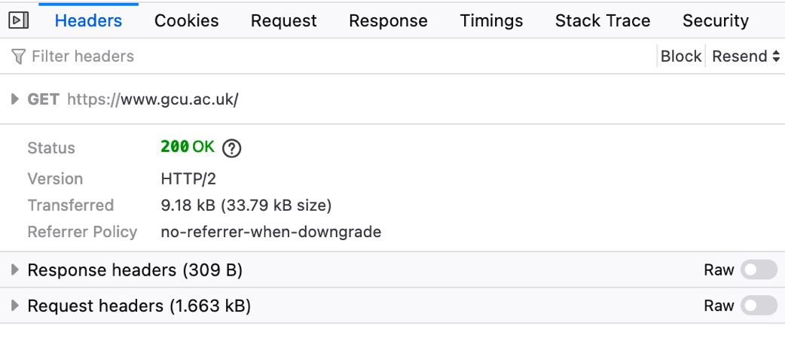

- Examine the content for the request and response headers. Here you can see the content headers for what your browser has requested from this site and the responses from the GCU website. You can tell by examining the server value in the response header, what kind of webserver and operating system the server hosting the GCU site is using. Additionally, if you look at the request header, User-Agent section you can see what information your browser sends when making a web request. This usually includes your browser and its version and operating your system.

- As a last step switch from the Headers tab, on the right-hand side, to the Response tab. By clicking on preview, you can now see the bare HTML site that has been sent to your browser, without any external resources that have been loaded.

Task 4: Your First HTML Page

In this task you will create your first web page.

The steps are as follows:
- To start, create a new folder, lab1, in the directory of your choice.
- Open your preferred code editor. Create a new file with the filename: index.html and save it in the lab1 folder.
In Visual Studio Code this workflow goes as follows:
- Open VSCode
- Click File->New File
- Click File->Save As
- Select the lab1 folder
- Enter index.html
- Click save
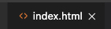
- Now your code editor should display an empty file titled index.html. We can now start writing html.

- Start off with the doctype declaration for HTML5.

<!DOCTYPE html>

The doctype tells the browsers the version and type of your page and ensures it is rendered correctly.

- In the next step, we add the HTML tag and save the file.

<html lang=”en”>
</html>

The lang=”en” statement in your <html> tag is an attribute, which we will cover in the next lecture. This attribute is used to assist search engines and web crawlers by informing them what language your site is in. For example, you may have seen browsers suggesting automatic translation; This is because the language of the HTML page does not match the one set in your browser.

- Now, open the file in your browser. You can do this by navigating to the folder you created and double clicking the index.html file. Your default browser should open with the file. What do you see?

… If you did everything correct you should see nothing. As you only have created the base structure for a HTML page without any content.

- Nested within the open and close <html> tags you can now add the head and body tags.

<head>
</head>
<body>
</body>

- At the moment you still only have an empty page without content. Include the following content within your page.

Glasgow Caledonian University is a distinctive,
inclusive and forward-looking university that is committed to its social mission to promote the common good.

The address is as follows:
Glasgow Caledonian University
Cowcaddens Road
Glasgow
G4 0BA
Scotland, UK

Remember: Content should be enclosed by the <body> tags and not by the <head> tags. Whilst the browser will still render text within the <head> tags this is not common style and should be avoided.

- Save the file again and reopen it in your browser. You should now see the text which you have included. However, it does not appear the same way you saved it in the editor, with line breaks after each line. This is because in HTML you need to manually define when you want to produce a line break. Expand your code with line breaks (<br> tags) so that when you open it in the browser it appears as shown above.

- Your first page now has some content. However, if you look at the website in the browser, your site does not have a title as shown in the tab. Add a sensible title to your first page using the <title> tag (such as Glasgow Caledonian University). Within this link you can find more information about this tag. If you do not recall where to put the title tag, read through the definition in this link.

- After saving and refreshing your browser window you’ll now see your defined title in the tab header.

- Now, let’s add some more styling to your site. Add the following code above your content from point 8).

<h1> Glasgow Caledonian University </h1>
<hr>
The <h1> tag creates a heading, whereas the <hr> tag creates a horizontal line. Save your html file and open it in your browser.

- It should now look similar to the figure below:

At the top you can see the title and the lines are separated correctly.

- As a last step you are going to add an incorrect html tag to your html <body>. Chose any random sequence of characters and include them under the <hr> such as:

<abcdefghijkl>

Save the site, refresh your browser. As you will see if you use Chrome, Firefox or Safari, the incorrect tag will not be displayed.

Extra Task – Familiarize yourself with your Editor of Choice

Throughout this module you will write quite a lot of code. Be it HTML, CSS or JavaScript.
Editors can be an immense help in writing the code, they can assist with syntax highlighting, intelligent and automatic completion of code blocks, integrated version control or aids that help you rewrite your code.

The following tasks have only been tested to work with the Visual Studio Code editor. If you use any other editor, there is a high chance, that they have those functions too. Try to find your code editor’s documentation and see if there is an equivalent shortcut.

Copy and paste the following code into a new html file called practice.html:

<!DOCTYPE html>
<html lang="en">

<head>
<title>Document</title>
</head>

<body>
<ul id="test">
<li>Item 1</li>
<li>Item 2</li>
<li>Item 3</li>
</ul>
</body>

</html>

(The HTML elements that you do not know until now (<li> and <ul> will be explained in the next class).
Before elaborating on basic navigation, it might be useful to know the shortcut to auto-format and indent your code. Some programming languages such as Python enforce this, in others it just helps readability.
Visual Studio Code has an automatic shortcut for this. Select all lines of code (CTRL+A or CMD+A) and then press CTRL+K followed by CTRL+F (Mac users press CMD+K and CMD+F). As you will see, the code is now much easier to read and has been automatically structured.
In IntelliJ it is CTRL + A followed by CTRL + ALT + L.

As with any editor, you can use the arrow keys to navigate one character to the left or right, or one line upwards and downwards. However, you can also select or move multiple lines just using keyboard shortcuts:
- Select the whole line <li>Item 2</li>. (You can select the whole line by triple-clicking on it).
- Whilst holding the Shift key, press the ⇧ or ⇩ key. As you will see this selects all code above or below the line that you are currently at. Use this shortcut to select the lines with Item 2 and Item 3.
- Another useful shortcut is to move whole lines of code instead of following the usual Cut and Paste routine. To do this (whilst having selected the two lines of code as mentioned before) hold the Alt key and press the ⇧ or ⇩ key. This moves the parts of code that you have selected up or down within the editor. For example, you could use this to re-sort items in a list without the need to touch the mouse at all.

Another useful shortcut is to open the “search-box” within an editor to find bits of code. This is often used when you have quite a lot of code written and do not want to scroll through the whole document. It also contains a text-replace function. In our example, you are going to replace the part <ul id="test"> with <ul id="my list">.
- Open the search function within Visual Studio Code with the keyboard shortcut CTRL+F (Mac users press CMD+F).
- Now, type in the text that you want to search for: id="test”. You will see that the relevant code has automatically been highlighted.
- Assume you want to rename this id, you can then use the replace function. Press CTRL+H (Mac users press CMD+H) to open this (whilst the search box is still open). In the new field, type in id="my list" followed by pressing enter. This will automatically replace your search selection. You may see how this can be useful without tediously manually selecting content and replacing it.

The last useful shortcut that will be introduced within this lab is the selection of multiple items. This is useful if you want to rename variables or other pieces of the code without the need to pull up the refactor function of the editor.
- Let’s say you want to rename the Items within your list. Click on the word “Item” (without selecting the number).
- Once this is highlighted you can select the various instances of this selected word. For this, use the shortcut CTRL+D (Mac users press CMD+H). Press this shortcut multiple times, until you have selected all items. Then delete the selection and replace the word “Item” with the word “Option”. As you can see, you are now inserting text at multiple places within the document simultaneously.

This extra-part of the lab exercise was used to show you some various, useful keyboard shortcuts with the VS Code editor. As this is not an exhaustive list, it is very useful to familiarize yourself with the other shortcuts as it will make writing and editing code much easier:
- https://code.visualstudio.com/shortcuts/keyboard-shortcuts-windows.pdf
- https://code.visualstudio.com/shortcuts/keyboard-shortcuts-macos.pdf

Summary
In this lab you will have learned how to display your internal and external IP addresses as well as how to perform a DNS lookup to find the IP address when you have an URL. In addition, you also examined the content that is transferred through HTTP headers and will have successfully built your first web site.

Q&A

- Why it shows error 1003 after I try to access the GCU IP address?

The error you're encountering happens because Cloudflare blocks direct IP access to websites behind its network. Cloudflare acts as an intermediary between visitors and the website’s server, and it enforces strict Host header validation for security purposes.

When you enter an IP address directly into the browser (which is what happens when you perform an nslookup and use that IP), it sends the request directly to the server’s IP without providing the required domain information. Cloudflare identifies this as a potential security risk and denies access with the message "Direct IP access not allowed."

- What is the difference between addresses and aliases after I nslookup www.gcu.ac.uk

Addresses: These are the actual IP addresses associated with the domain or hostname. In our case, the IPs are part of Cloudflare's content delivery network (CDN) that handles traffic for the domain.

Aliases: These are alternative domain names or hostnames that point to the same resource. In our case, www.gcu.ac.uk and gcun-web.matrix.squiz.cloud are different names (aliases) that both refer to the same underlying resource (the website).

- Why I cannot use my online tools like whatismyipaddress.com to check my IPv6 address but can only see the IPv4?

- Your ISP might not support IPv6: If your Internet Service Provider (ISP) (e.g. BT/EE) doesn't provide IPv6, only IPv4 will be detected.
- Router or device configuration: Even if your ISP supports IPv6, your router or device may not be configured to use it. Some routers have IPv6 disabled by default.
- Network preference: Many networks still prioritize IPv4 over IPv6. If your connection defaults to IPv4, online tools will show that instead of IPv6.
- Tool limitations: Some websites may be better at detecting IPv4 and might not always display IPv6 information, even if you have it enabled.

- If I type the IP address of my school's computer into my web browser while at home? What will happen?

Most schools protect their internal networks with firewalls, which block incoming connections from outside the school network. In this case, you'll likely see a message indicating that the connection was refused or timed out. In addition, If the computer at school is not running a web server (like Apache, Nginx, or IIS), there won’t be anything to display in the browser, and you might receive a message like "This site can’t be reached." If the school computer is running a web server and it’s publicly accessible, you may see a webpage hosted on that computer. However, this is rare without specific configurations to allow external access.

- Any other resource I can use to improve my web development skills?

Here is the link to to TheOdinProject:
https://www.theodinproject.com/paths/foundations/courses/foundations

More info on private IP ranges here: https://tools.ietf.org/html/rfc1918
Non-authoritative means that the DNS server that responded is not the authoritative (primary) source of the DNS record but that they hold a cached copy of it. 3Typing the IP address sometimes directly doesn't work because of virtual hosting, CDN behaviour, SSL certificates, and server configurations that rely on the domain name to properly handle web requests.

