**Basic Ract application development**

**React.js** is a JavaScript library for building user interfaces, particularly for single-page .Here are the basic steps to install React.js and create a simple React application:

**Node.js and npm Installation:**

React requires Node.js and npm (Node Package Manager) for development.

You can download and install them from the official website: Node.js.

**Create a React App:**

Once Node.js and npm are installed, you can create a new React app using the create-react-app command. Open your terminal or command prompt and run the following command:

**npx create-react-app my-react-app**

**or**

**npm create-react-app my-react-app**

**npm install react-router-dom@6**

**Navigate to Your App:**

Change into the newly created app directory:

**cd my-react-app**

**. Start the Development Server:**

**npm start**

This will start the development server and open your React app in a new browser window. The default URL is usually <http://localhost:3000>.

**Create pages inside src folder**

Open the src folder in your code editor (e.g., Visual Studio Code) and start editing the src/pages to make changes to your React app.

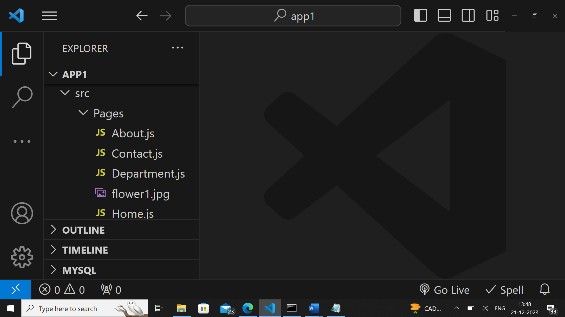

**Home page**

const Home=()=>{

return(

<>

<h>React JS</h>

<p>Welocme to React js.React js is ,Javascript framework.It is SPA</p>

</>

);

};

export default Home;

**About page**

const About=()=>{

return(

<>

<h>welcome to About page</h>

<table>

<tr><th>S NO</th><th>Name</th></tr>

<tr><td>123</td><td>Kamal</td></tr>

<tr><td>556</td><td>Vimal</td></tr>

</table>

</>

);

};

export default About;

**Department page**

import React from "react";

const Department=()=>{

return(

<>

<ol>

<li>CSE</li>

<li>Mechanical</li>

<li>ECE</li>

</ol>

</>

);

};

export default Department;

**Contact page**

import React from "react";

import pic from "./flower1.jpg";

const Contactt=()=>{

return(

<>

<h>welcome to About page</h><br />

<img src={pic}/>

</>

);

};

export default Contactt;

**App page default page inside src folder**

import React from 'react';

import { Link, Route, BrowserRouter as Router, Routes } from 'react-router-dom';

import About from './Pages/About';

import Contact from './Pages/Contact';

import Department from './Pages/Department';

import Home from './Pages/Home';

const App = () => {

return (

<Router>

<nav>

<ul>

<li>

<Link to="/">Home</Link>

</li>

<li>

<Link to="/about">About</Link>

</li>

<li>

<Link to="/contact">Contact</Link>

</li>

<li>

<Link to="/department">Department</Link>

</li>

</ul>

</nav>

<Routes>

<Route path="/" element={<Home />} />

<Route path="/about" element={<About />} />

<Route path="/contact" element={<Contact />} />

<Route path="/department" element={<Department />}/>

</Routes>

</Router>

);

};

export default App;

**Home page output**

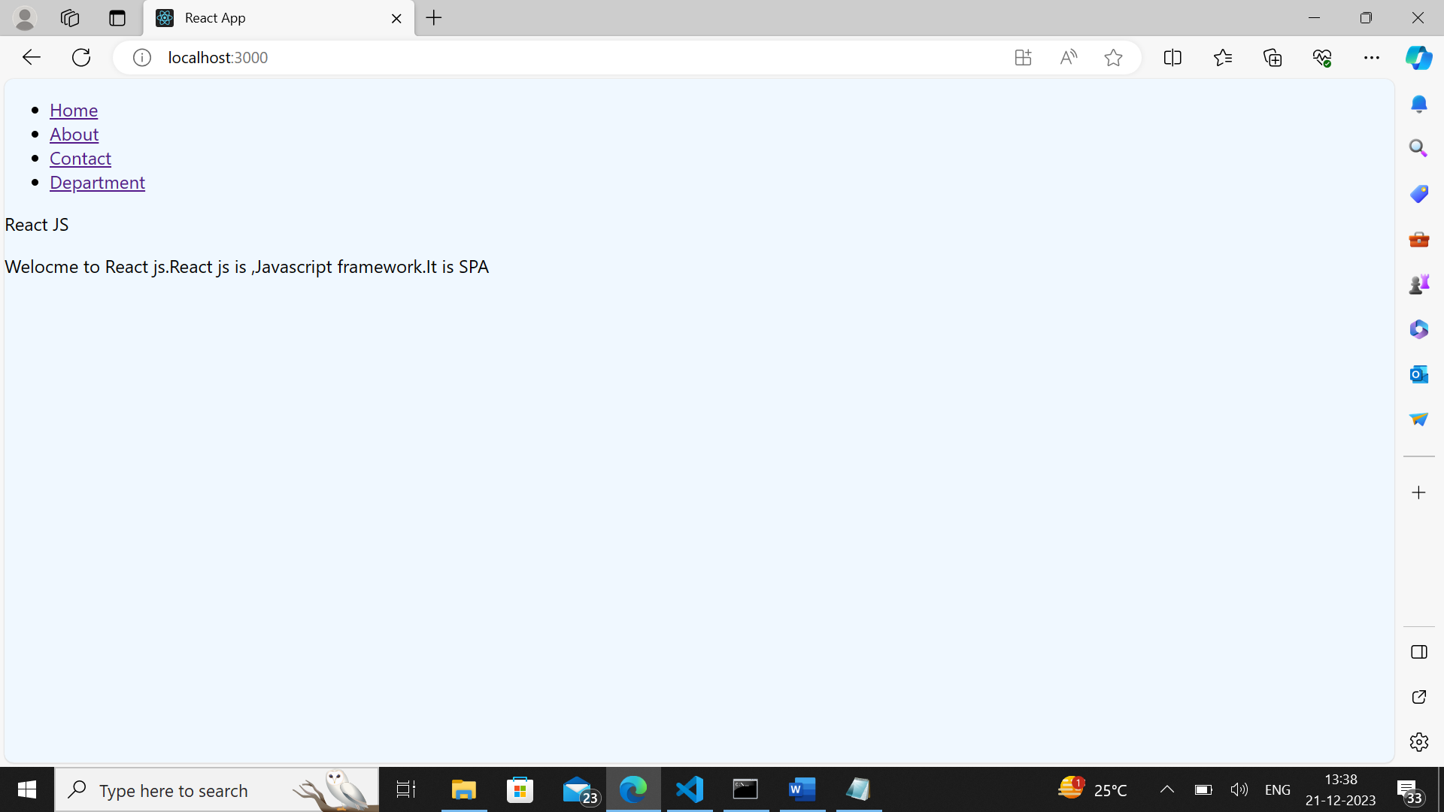

**About page output**

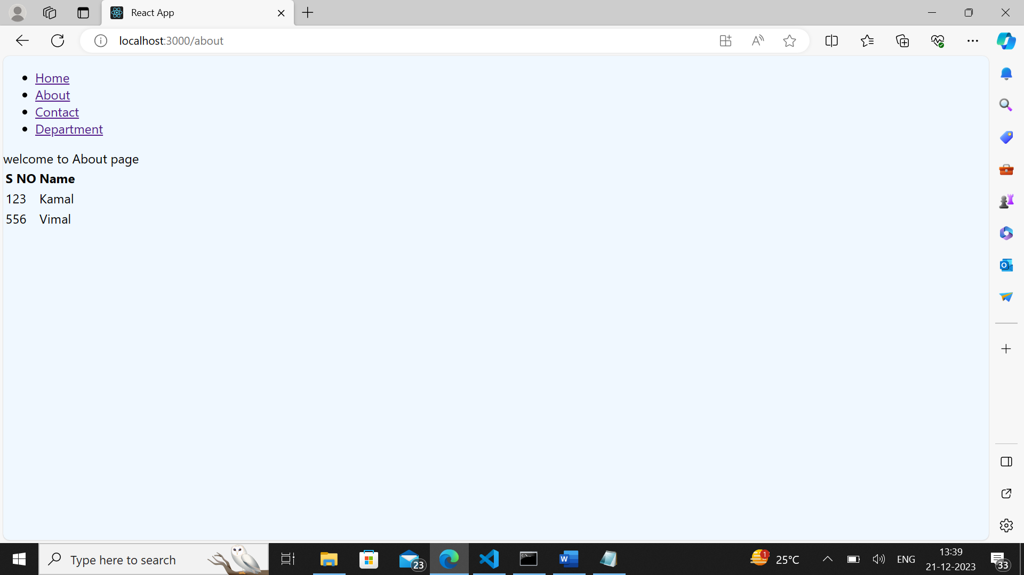

**Contact page output**

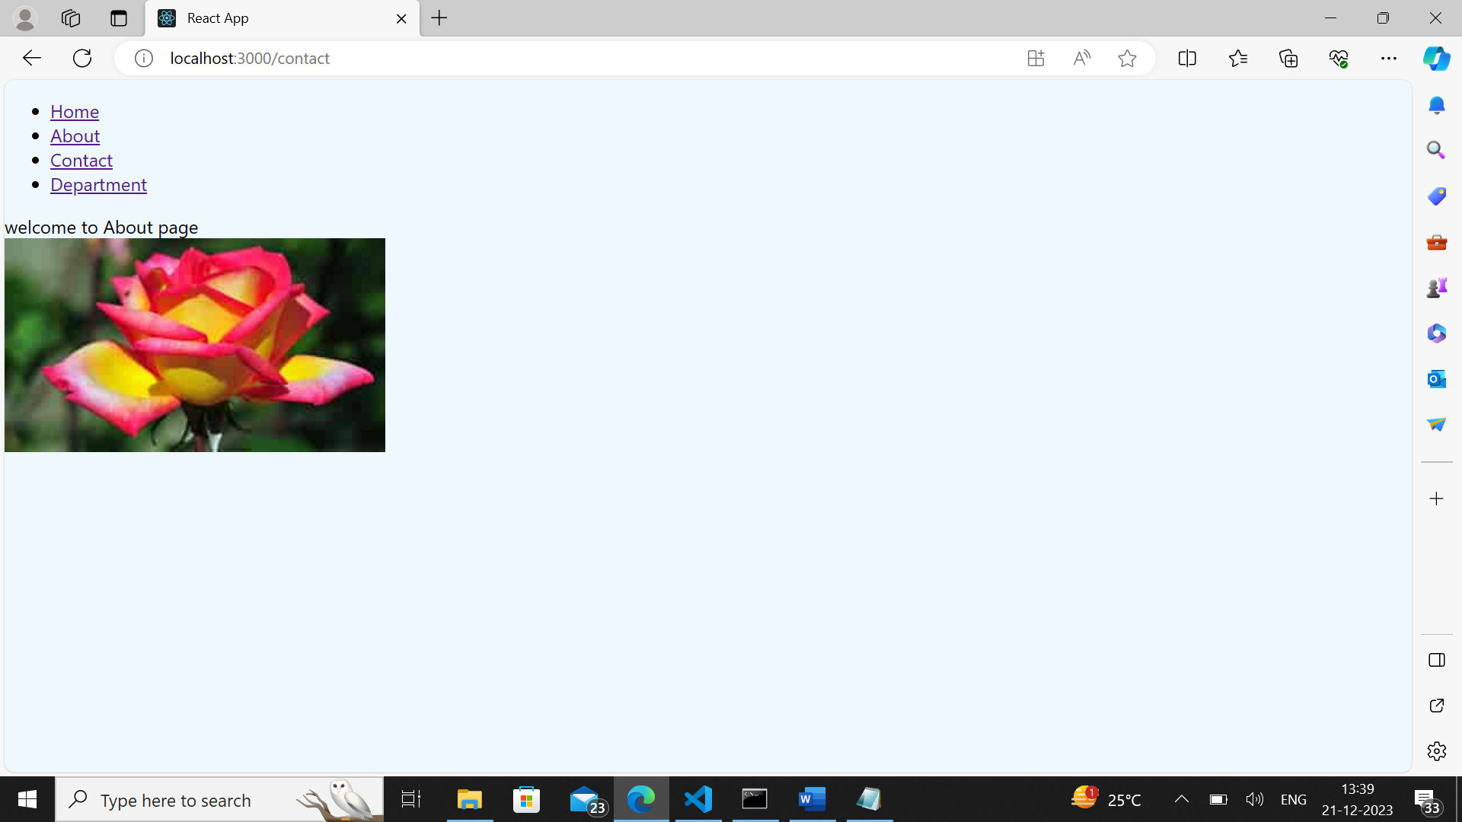

**Department page output**

