**6. E-ticketing**

**Class Diagram**

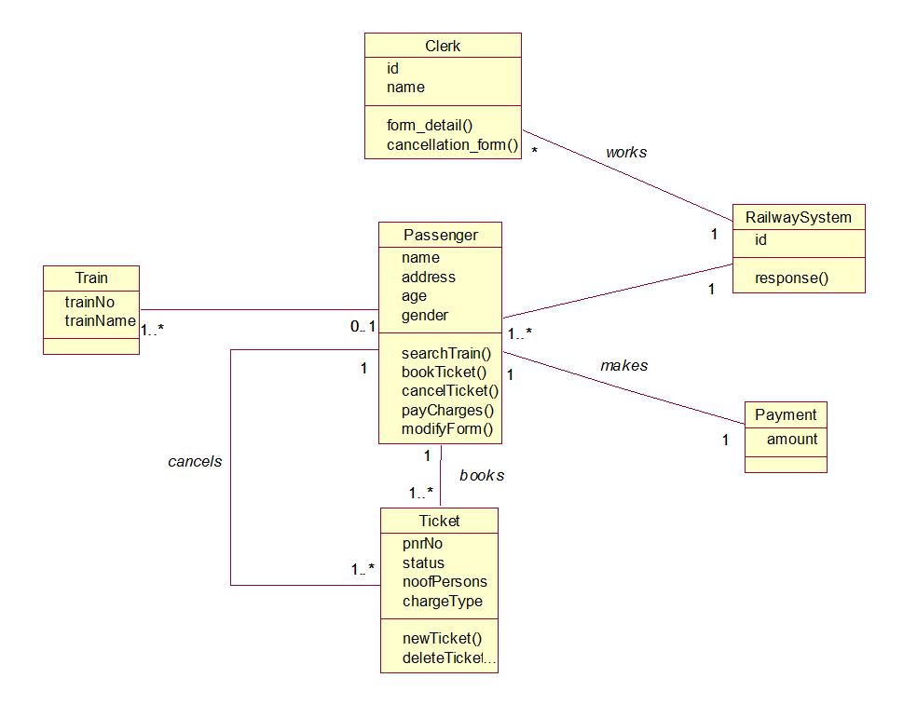

**Use Case Diagram**

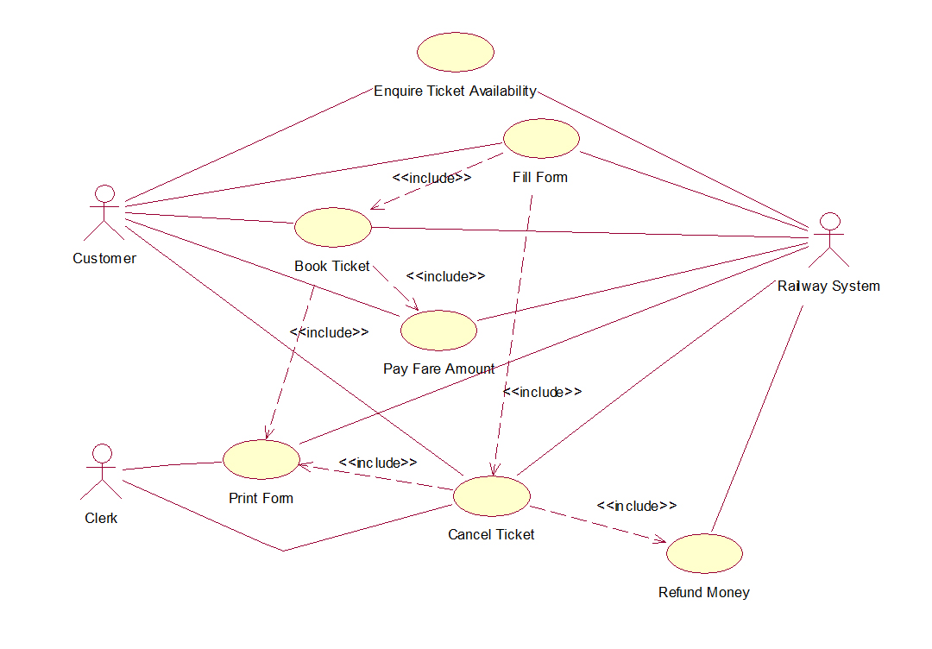

**Sequence Diagram**

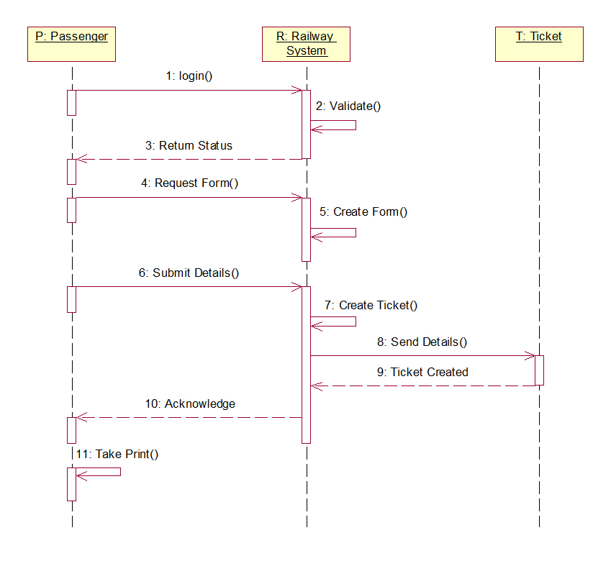

**Collaboration Diagram**

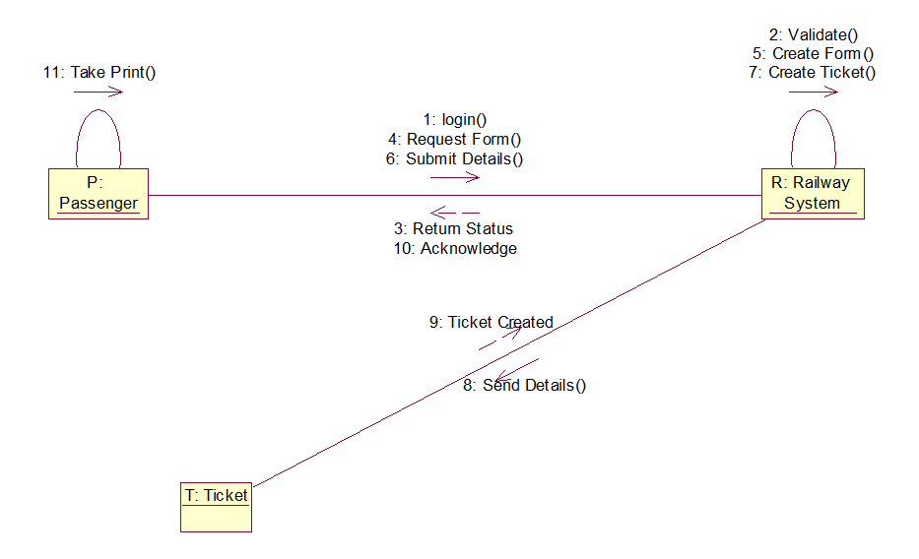

**State Chart Diagram**

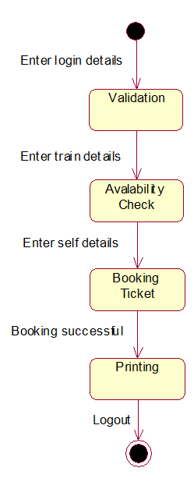

**Activity Diagram**

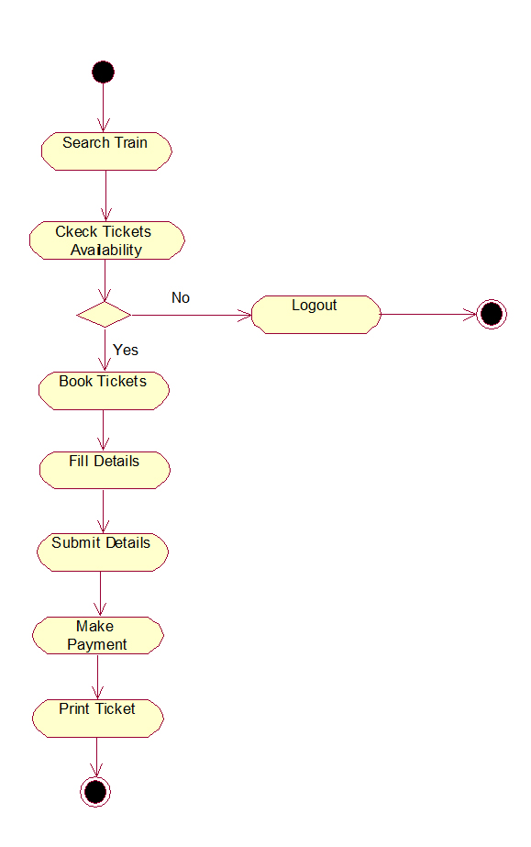

**Component Diagram**

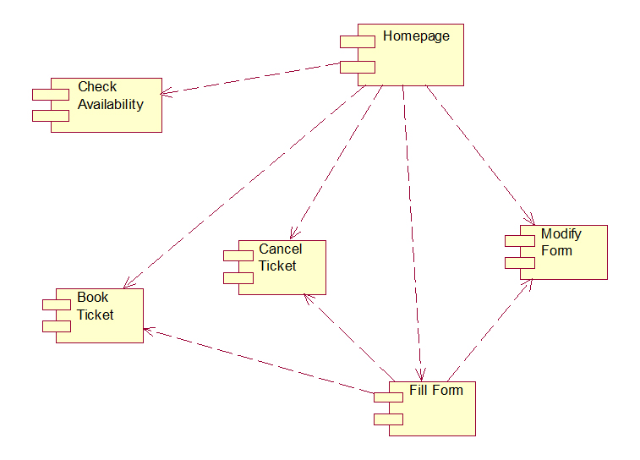

**Deployment Diagram**

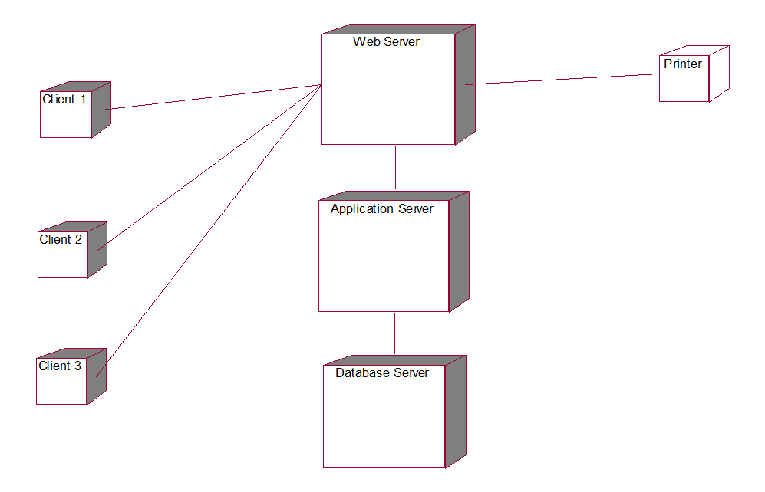

**Experiment -5**

**Online Course Reservation System**

**Class Diagram**

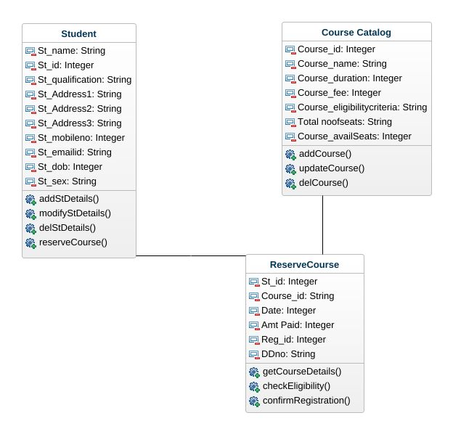

**Use Case Diagram**

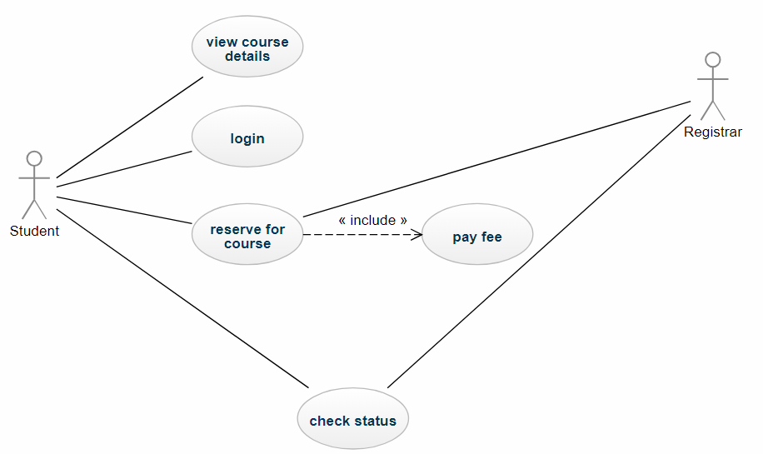

**Sequence Diagram**

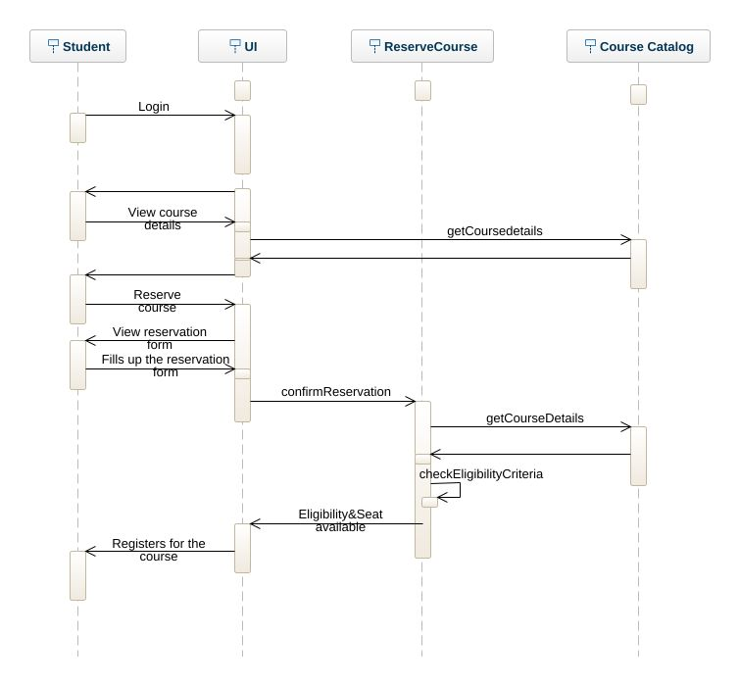

**State Diagram**

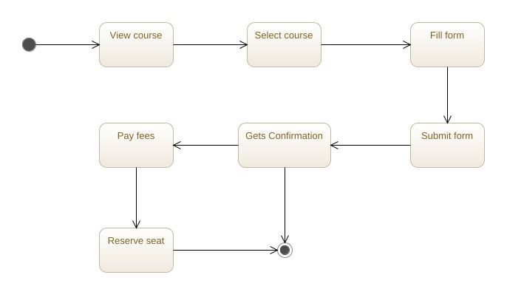

**Activity Diagram**

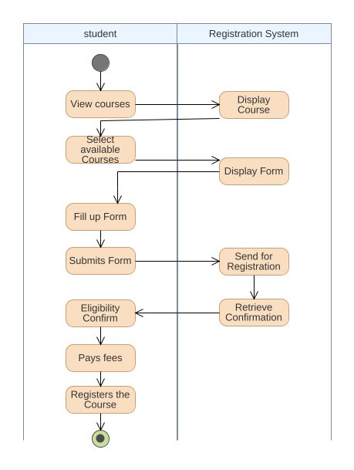

**Collaboration Diagram**

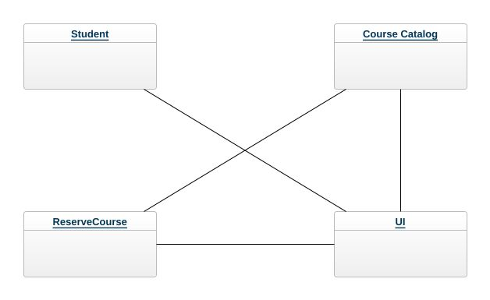

**Component Diagram**

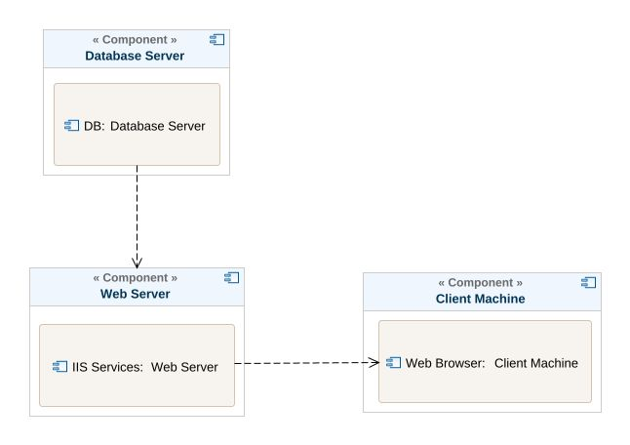

**Deployment Diagram**

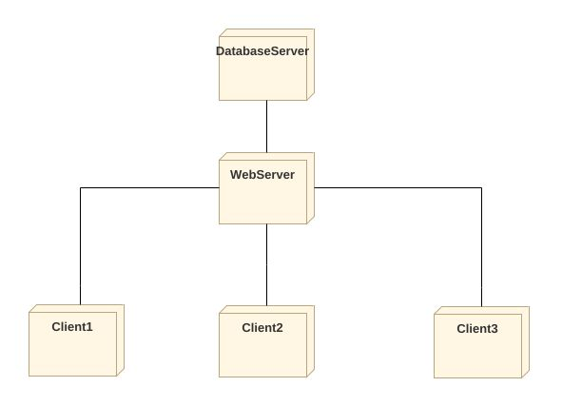

**Experiment 7**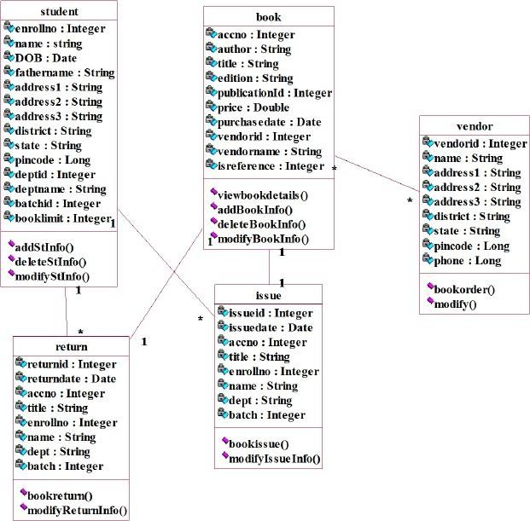

Use Case Diagram

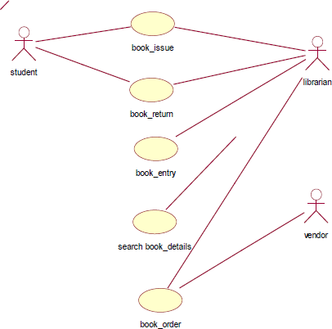

Sequence Diagram

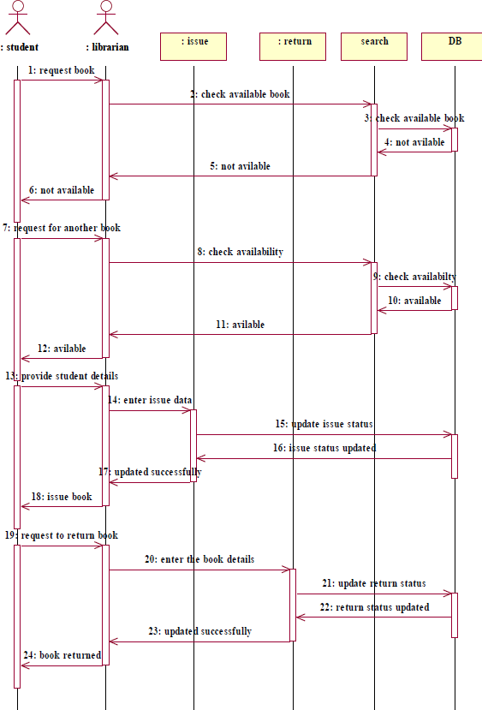

**Statechart Diagram**

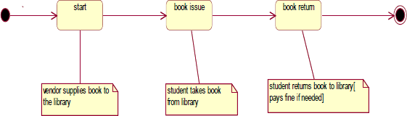

Deployment Diagram

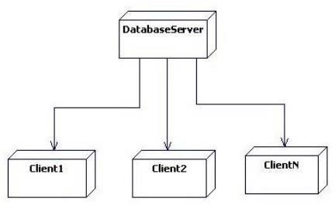

### Activity Diagram for Book Bank System [borrow book]

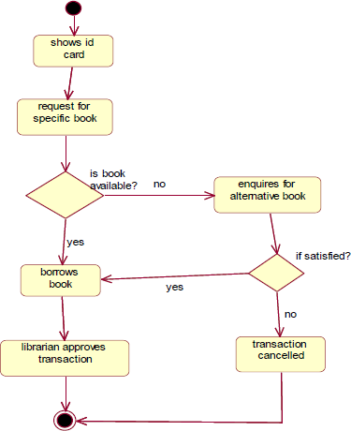

**Activity Diagram for Book Bank System [order book]**

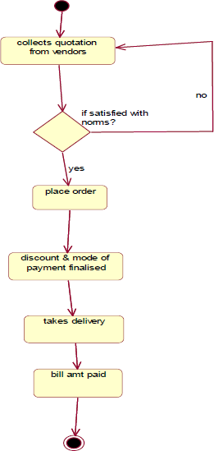

**Activity Diagram for Book Bank System [Return book]**

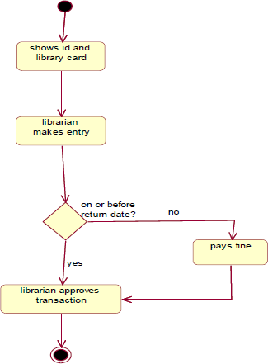

**Collaboration Diagram For Book Issue & Return**

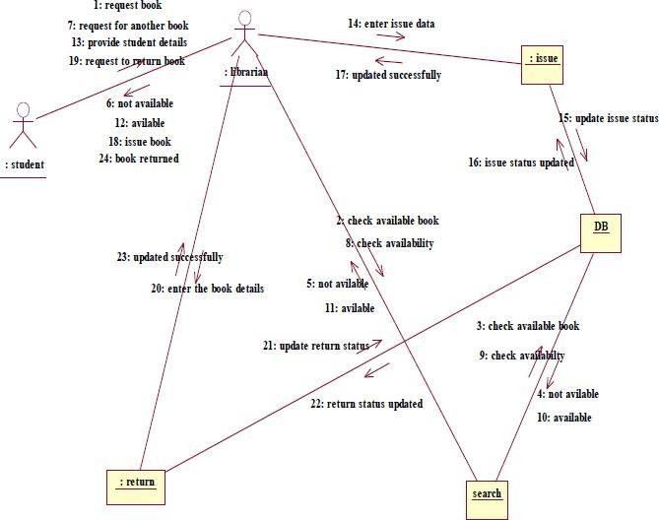

**Experiment-1**

**Name of the Experiment:** Develop a problem statement and project plan drafting.

**Aim:** Deﬁne the problem statement and usage of planning software to draft a project plan.

**Prepare a problem Statement:**

1. The problem statement is the initial starting point for a project.

1. It is a basically a one to three page statement that everyone on the project agrees with that describes what will be done at high level.
2. The problem statement is intended for broad audience and should be return in non-technical terms.
3. It helps the non-technical or technical personal communication by providing a description of a problem.
4. It doesn’t describe the solution to the problem
5. It doesn’t describe the solution requirement engineering is the problem state described by the problem
6. It may give an overview of existing system along with the broad expectations from new system.
7. The ﬁrst phase of requirements engineering begins with the help of customer and existing system processes from here begins the preparation of the problem statements.
8. So basically a problem statement describes what need to be done without describing how.

**Deﬁnition of Project**

The purpose of the software project planning is to establish responsible plans for performing the software engineering and for managing the software project software project planning involved developing estimates for the work to be performed establishing necessary commitments and designating the plan to perform work to be performed establishing necessary commitments and deﬁning the plan to perform work.

The purpose of the project plan is to document all managerial aspects of a project that required to execute it successfully with in its constraints. If some aspects are deﬁned in separate plans the project plan should refer to this document. Project planning and subsequently report progress with in the project environment.

Software project planning is tasks which is performed before project production of software starts. It is there for the software production but involves no concrete activity that has only direct connection with software production rather it is a set of multiple process which facilitates software production project planning may include the following.

**Scope management and Goals**

It deﬁnes the scope of project this include all activities process need to be done in order to make deliverable software project. Scope management is essential because it creates boundaries of project estimation may involve project by clearly deﬁning what would be done in project to contain the limited and quantiﬁable task which can be easily done in project and what would not be done. This makes project to contain limited and quantiﬁable tasks which can easily documented and it turn avoids cost and time over run.

**Project Estimation**

For an eﬀective management accurate estimation of various measures is must with correct estimation manages can manage and control project more eﬀectively project estimation may involve the following.

|  |  |
| --- | --- |
| **1.** | **Software Size Estimation** |
|  | Software size may be estimated either in terms of KLDC (Kilo Line of Code) |

or by calculating number of functions points in the software lines of code depend upon coding practices and functional points. Vary according to user or software requirement.

**2. Eﬀort Estimation**

The manager estimates eﬀorts in terms of personal requirements and developers required to produce the software for eﬀort estimation of software size should be known. This can either be desired by managers. Experienced organizations historical by data or software size can be converted in to the eﬀorts by using some standard formula.

**3. Time Estimation**

Once size and eﬀort are estimated the time required to produce software can be estimated over eﬀorts required is segregated into sub categories. As per requirements speciﬁcations and interdependency of various components of software. Software tasks are divided into smaller task activities or events by work. Breakthrough structure (WBS). The tasks are scheduled on day to day basic on calendar months the some of the time required to complete all the tasks in hours of days is the total time invested to complete the project.

**4. Cost Estimation**

This might be considered as the most diﬃcult of all because it depends on more elements than any of the previous once. For estimating projects cost it is required to consider size of software.

* Software Quality
* Hardware
* Additional Software or tools Licences etc.
* Skilled personal with task-Speciﬁc Skills
* Travel Involved
* Communication
* Training and Support.

**5.Project Scheduling**

In a Project refers to row map of all activities to be done with speciﬁed order and within time slot allotted to each activity project manager’s tent to deﬁne various tasks and project milestone and arrange them keeping various factors in mind. They look for tasks lie in critical path in schedule which necessary to complete in speciﬁc manner and strictly with in time allocated. Arrangement of tasks which lies out of critical path are less likely to impact overall schedule to project per scheduling per project it is necessary to

* Breakdown project tasks into smaller manageable forms.
* Find out various tasks and Correlate them.
* Estimate time frame required for each tasks.
  + Divide time into work units.
  + Assign adequate number of work units per each task.

Experiment 2 Name of the experiment = Software requirement Speciﬁcation

Aim: To know the concepts of currents project and deﬁne SPS according 10 SDLC

Software Requirement Speciﬁcation:

A Software requirement speciﬁcation CSRS) is a complete description of the behaviour of the system to be developed. It includes a set of w will have the Software Use cases au known as functional requirements are required. In addition to use cases the SRS also contour non- functional (or supplementary) requirement Non- functional requirements, quality standards, or design. Constraints)

Requirement analyse in system engineering and software engineering, encompasses then tasks that into needs or conditions to meet go for a new determining OT altered product tasking account of possibly conﬂicting requirement analysis is critical 10 the Success of a development project. requirement must be actionable, measurable, testable, related to identiﬁed business needs opportunities and deﬁned to a line of delay Suﬃcient for system design requirements analyses. includes the types of activity.

eﬀecting Requirements:

The task d Communicating with the customers and users to determine what the requirements au also called requirement gathering.

Analysing Requirements:

Determining whether the stated requirements are unclear, incomplete, ambiguous or contradictory and then resolving those issues.

Recording Requirements:

Requirements might be documented in various forms.. such as natural -language document use cases or process speciﬁcation

Requirement's analysis can be a long, arduous process during which many delicate psychological stills are involves New system change to identity all the Stakeholders, take into account all their needs and ensure they understand implications of new systems Analysis can empty several technique include prototyping and use cases, where necessary, the analyst will employ combination of these methods to establish exact requirements of stake So that system say to help engineers to identity exact problem behind development of software and ﬁnd Exact requirements for development.

Table of Content

1.Introduction- I

1.1 purpose-1

1.2Document Conventions -1

1.3Intended Audience and reading suggestions-1

1.4 Product scope- I

1.5 Referenas- I

Overall Description- 2

2.1 Product perspective-2

2.2 Product functions- 2

2.3 user classes and characteristics -2

2.4Operating environments -2

2.5 Design and implementation Constraints- 2

2.6 User documentation- 2.

2.7 Assumptions and dependencies- 3

3.External Interface requirement- 3

3.1 userf interfaces-3

3.2 Hardware interfaces -3

3.3 Software interfaces- 3

3.4 Communication interfaces -3

4.System Feauture -4

4.1 system feautures -4

4.2 system feauture-2(and soon)4

5. Other non-functional requirements -4

5.1 performing Requirements-4

5.2 Safety Requirements -5

5.3 security requirements-5

5.4Software quantity attributes- 5

5.5Business rules- 5

6. Other requirements

Introduction:

Purpose:

< Identify the product whose software requirements are speciﬁed in this document, including the revision or release number, Describe the scope of the product that is caused by this. SRS describes only part of the System or a Single Subsystem>

Document Conventions:

<Describe that’s any standards of typographical conventions were followed when writing this SRS, Such as fonts of highlighting that have speciﬁed signiﬁcant. For example state whether priorities for high-level requirements au assumed to be inherited by detailed requirements of whether every requirements or whether every Statement is to have its own priority.

Intended Audience and Reading Suggestions:

-> Describe the diﬀerent types of reacts that the documents intended for such as developers Project manager marketing Staﬀ users, teachers, a sequence for reading document beginning with overview sections and proceeding through sections that are the most pertinent to each read type

Product scope:

provide Short description of software being speciﬁed and Its purpose, including relevant beneﬁts, objectives goals, Relate Software to corporate goals or business strategies If a separate vision and scope document is available refer to it rather that duplicating Contents have.

Reference:

List any this SRS other documents or web addresses to which refers. There may include user interface style guides, contracts, standards and safe document provide enough reference, including title version no date and source or location.

Product perspective:

Describe the context and origin of product being speciﬁed in SRS for example, state whether this product is follower member of a product family, a replacement for Certain existing systems or a new, self-contained product A simple diagram that occurs and major components of overall system, subsystem inter connections and external interfaces can be helpful.

Product functions:

< summarise major functions product that must perform must let user perform details Null be provided in section 3, only a high level summary is needed here.

A picture of major groups, of related requirements and how they relate, such as top line data ﬂow diagram or object class diagram is often eﬀecting.

user classes and characteristics:

< identify various user classes that you anticipate will use this of use subset of product functions used, technical expertise security or privilege levels, educational Cent or experience · Distinguish more important user classes for this product from those who are less important safety.

Operating environment:

Describe environment on which software will operate, including the hard work platform, operating system and Versions and any other Software Components of applications With which it must peacefully coexist.

User documentation:

List the user any assumed factor that could aﬀect requirements stated in SRS These could include third party around commercial components that you use issues around the development or operating environment or constraints. identify any dependences the project has a Components that external factors; such as Software intend to reuse from the another project, unless they are already documented else where.

Hardware Interface:

Describe logical and physical characteristics of each interface between software product and hardware components of system. This may include supported device types, nature of data and Control interaction between Software and

hardware and communication protocols to be used>

Software interface:

<Describe Connection between the product and other speciﬁcation Software components including database, operating Systems, tools, libraries and Integrated. Commercial Component Identity the data items or messages coming into the system and going out and describe purpose of each It the data sharing mechanism must be implemented in a speciﬁc way. Specify this as an implementation Constraint > .

Communication into faces:

describes the requirement associated with any functions required by this product including, communication browser network error Server Communications. Protocols, electronic forms Specify any communication security. encryption issue, data transfer rates synchronization mechanisms>.

System Feature:

<Don't usually say I system feature I", state feature name in just few words >

Description and priority. Provide short description of feature and indicate whether it is of high medium of low quality and priority.

4.1.2 Stimulate response Sequences:

List the sequences of user actions and system.

responses that stimulate behaviour deﬁned for the feature

4.1.3Functional requirements:

It there is performance requirements for project under various Circumstances, state them here. and explain this ratio to help developers understand intent and make Suitable design choice you may need. to State requirements for individual functional requirements or features >

Software quality Attributes:

< specify any additional quality characteristics. for product that will be important to either customers. or developer some oral availability, adaptability, portability, reliability testability and clarify the relative preferences for various of warnings attributes , such as case of use cases of warnings.

EXPERIMENT-3:

Preparation of Software Conﬁguration management and risk management related documents

Conﬁguration management is a process of tracking and controlling the changes in software in terms of requirements design function and development of products The process of identifying and deﬁning the items through out this life cycle recording and reporting status of items and change requests, verifying the completeness. and Correctness of items.

Generally once the SRS is ﬁnalized there is less Chance baseline of requirement of charges from user.

Baseline:

A phase of SDLC is assumed one if it base line is it is a measurement that deﬁnes completeness of a phase. A phase is baseline when all activities pertaining to it ﬁnished and well documented If it was not the ﬁnal phase, its output would be used in next immediate phase.

Conﬁguration management is a discipline of organization administration , which take care of occurrence of any change after a phase is base lined, CM keeps check on any changes in software.

Change Control :

Change control is function of conﬁguration. management which ensures is software system. that all changes made in software system.

Identiﬁcation

A change request arrives from either. Internal or external source, when change requests is identiﬁed formally it is properly documented.

Validation

Validity of the change request is checked and its handling procedure is conﬁrmed.

Analysers

The impact of change request is analysed in. terms of schedule, car and required terms Of schedule ,cost and required eﬀorts. overall impact of prospective change on systems is analysed.

control

It the prospective change either impact to entities in systems of it is unavoidable. it is mandatory to take a approval of high authorities. before change is incorporated into the system. It is decided if the Change is worth incorporation or not change request refused formally

Execution

It the previous phase determines to execute. The Change requests, this phase actions take in appropriate to execute the change does through revision if necessary.

Close request

The change is veriﬁed for correct implementations merging with just of the system. This newly and incorporated changes in software is documented properly. and requests Formally being closed.

Risk management Process

There are following activities involved in risk management process:

Identiﬁcation –

Make note of all possible risks which may occur in the project

Categorize:

categorize known risks into high, medium. and low risk intensity as per this possible impact project ·

Manage

Analyze the possible probability of occurrence attempt 10 minimize this side eﬀects monitor closely mentor The potential risks and this early Symptoms Also monitor the eﬀect of steps taken to mitigate or avoid them.

4 Speciﬁc Requirement

4.1 System Requirement-

The requirement deﬁnition is concerned with the analysis of the an existing system with the aim of determining structuring the requirement of the proposed systems. It is achieved with the aid of user requirement

4.2 Requirement Speciﬁcation

Requirement speciﬁcation a complete description of the behaviour of system to be a developed and may set of un cases that describe interactions the users will have with the software. In addition it also contain non-functional requirements impose constraints. on the design or implementation

4.3 Functional Requirements.

Functional requirements deﬁne the speciﬁc fun that the system performs. alone with The data operatinal on by the function The functional requirements are presented in scenarios that depict an operational System from the perspective of its end users Included on more associated.

4.4 Non-Functional Requirements.

Non-functional requirements address aspects of the system other than These aspects the speciﬁc function it performs. include system performance, costs, and search.

General system characteristics as reliability, security and Portability The non- functional requirements also actress. aspects of the system development process and operational personal. It includes the following.

The functional other requirement

Data base: The system must be able to use several data formats according to the data formats that are provided by the databases of diﬀerent users The all information should have in the database

**architecture of the Proposed System.**

This process support existing infrastructure requirement and provides speciﬁc recommendations for hardware and network Solutions band on existing infrastructure based on existing and projected user needs Application requirements data" resources and people within an organization are all important in determining the optimum hardware solution.

**The functional model of the systems.**

UML use can program of the bus reservation system is Shawn in the diagram below. In this ﬁgure, details of the various participants are also detailed!

**4.7 The functional Model of the system**

UML use case diagram of the bus reservation system is shown in the diagram below In this ﬁgure details various participants are also detailed.

**4.8 user Activities**

The most common activities Carried out illustrated below by

* The most common activities carried out by user are illustrated below

The user can search for seal on the proposed system

* The user can print receipt on the system as evidence payment.

**4.9 Administer Activities**

The most common activities carried out by administrator are illustrated below.

* The administrator will verify the registered user and allow them to login the system

*The administrator give acknowledge to any payment user made on the system..

**4.10 Data ﬂow diagram**

Data ﬂow diagram is used to the ﬂow of data from external entities into the system. It used to represent of the online bus reservation System The data ﬂow diagram of the au pictorial online bus diagram course Or graphical representation reservation System. The dataﬂow. all the processer and data storage CUL

**5. Results and discussions**

"The proposed bus reservation system was developed using extensible Hypertext Mark up Language CKHINALLY PHP Hypertext and preprocessor (PHP), structure query language tray Ajax, CSS, and Javascript. The relational database was adopted because Therefore, establishing a relational. Database management system is a great way to increase data information.

**6 Conclusion**

Now days, bus agencies are taking important role in transportation and to make reservation reliable they need that a strong system they faster and will make reservation easier, safer This project designed to meet requirements of a be reservation easier, faster and safer. This Project designed to meet requirements of bus reservation System It has been developed in AHTML, PHP.COS, JAVA SCRIPT and database has been built in mysql. By using this application the company can provide reservation Services and information to their customers without limited of oﬃcer howes or man power.