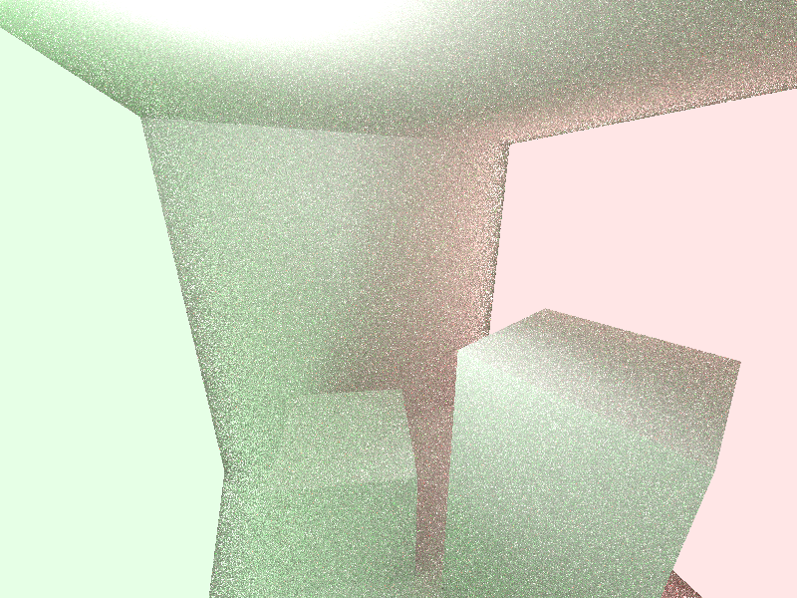

Cornell. 8 bounces with Russian Roulette (50% chance to terminate before every extra bounce after 8 bounces). Left and right walls emits light (green and red respectively). Every point takes the light sample of the light which has the biggest sent emission (emission \* area / distance ^ 2).

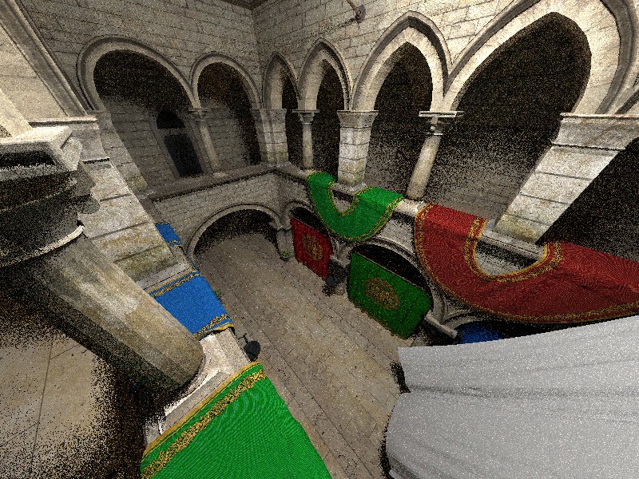

Crytek Sponza. 8 bounces with Russian Roulette (50% chance to terminate before every extra bounce after 8 bounces).