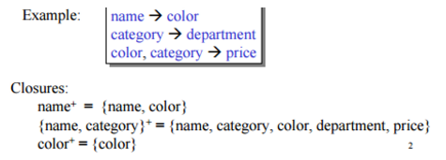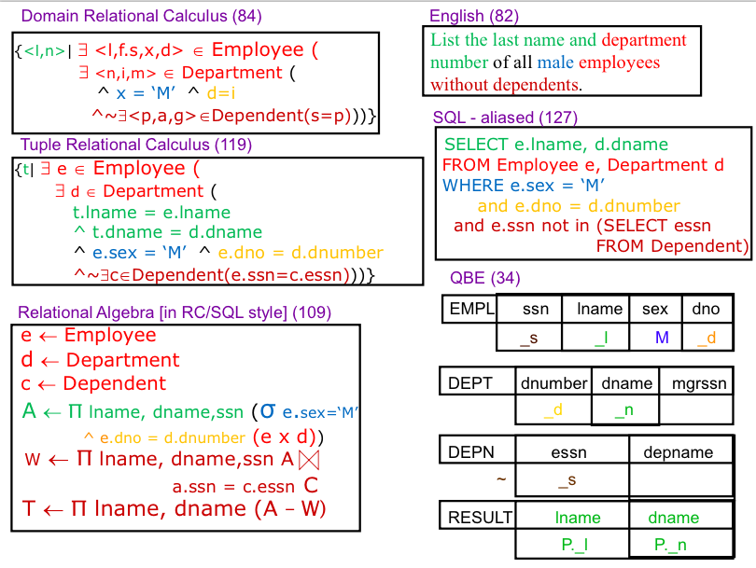**Closures**

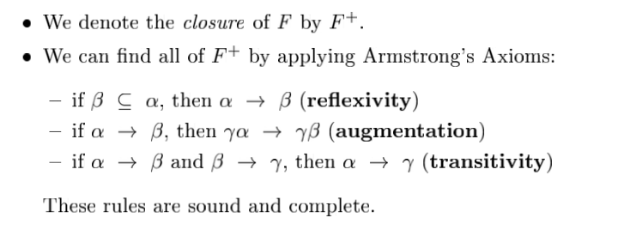**Canonical Cover** – the most bare combination of Functional Dependences

**Super Key**- a set of one or more attributes that allow us to uniquely identify a tuple.

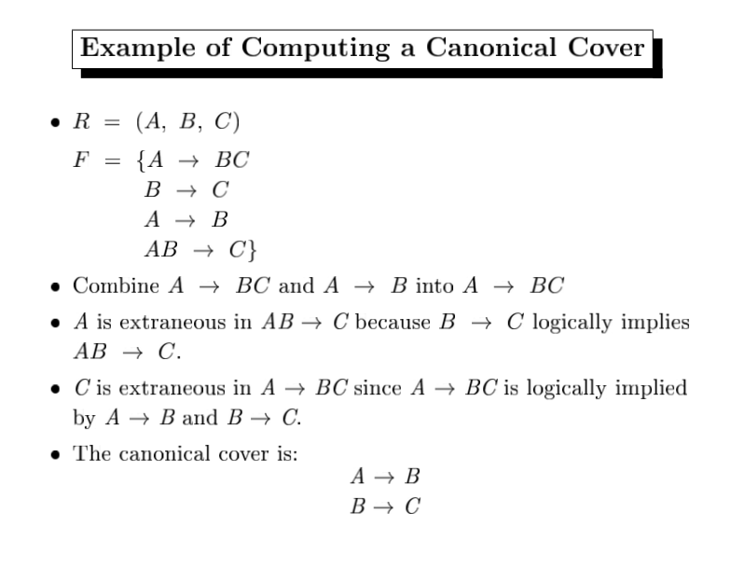**Primary Key** - The chosen key, only one per table.

**Candidate Key** - Superkeys for which there is no proper subset that is a superkey.

**Foreign Key** - Keys used to define relationships between tables (also called Referential Integrity) Usually is a primary key in one table and then a foreign key in the other.

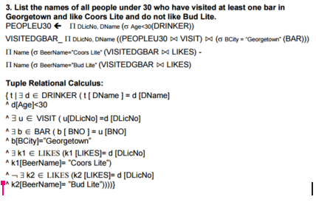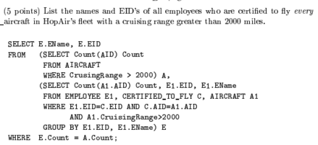

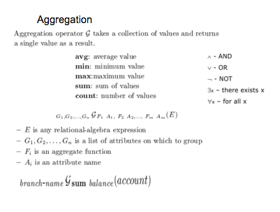

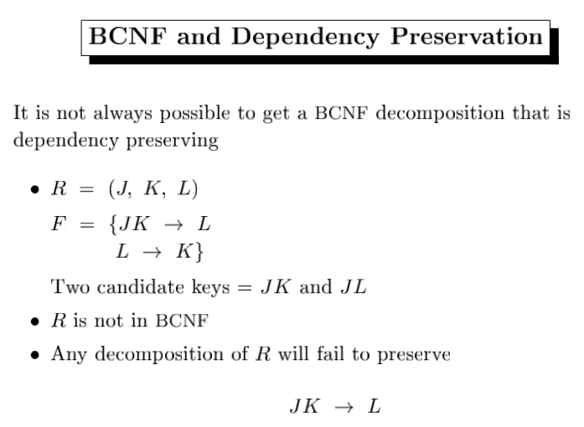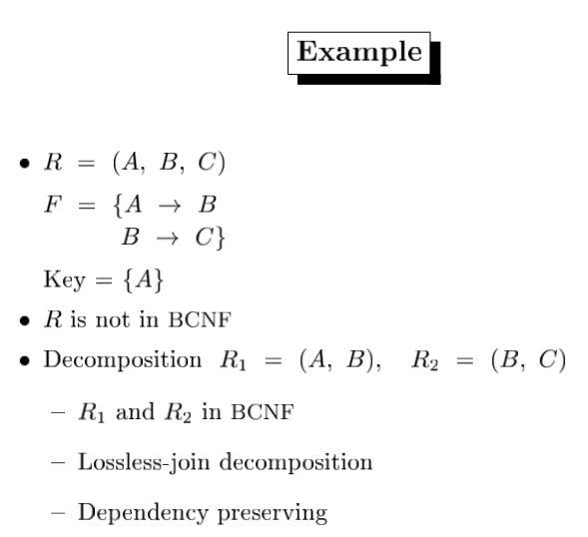**BCNF**

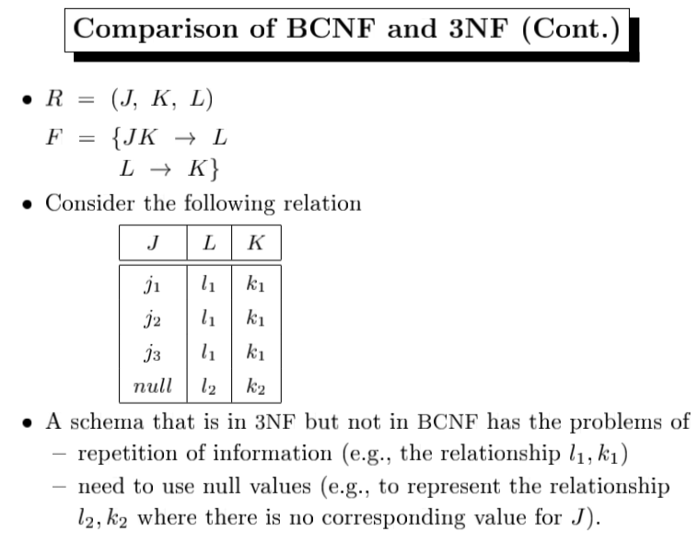**3NF**

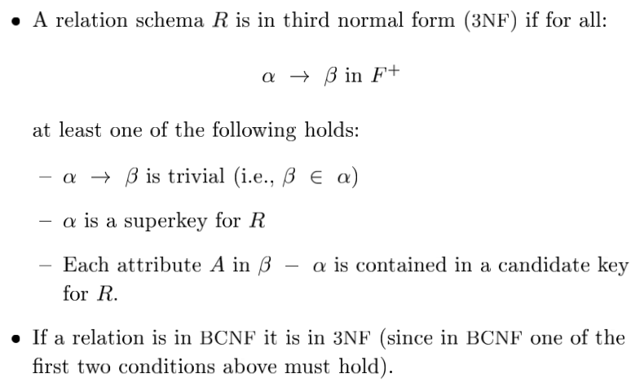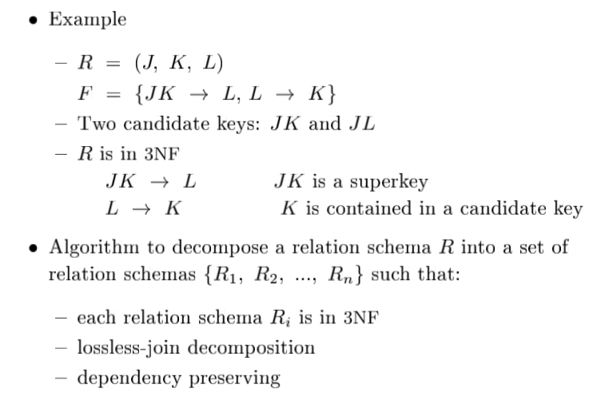

**List the name and age of drinker that likes the fewest number of different beers but likes at least one beer.**

//s = select, p = rename

NumBeersLiked <- DLicNoGCOUNT-DISTINCT(BeerName) (Likes)

MinBeersLiked <- Gmin(NumBeers)(sNumBeers > 0 (pBeersLiked(DLicNo, NumBeers)(NumBeersLiked))

MinDrinker <- pt1(DLicNo, NumBeers) (NumBeersLiked) |x| pt2(NumBeers)(MinBeersLiked)

Result <- πDName, Age (DRINKER |x|DLicNo = DLicNo MinDrinker)