CAMBRIDGE A LEVEL ECONOMICS 9708 | SYLLABUS 9.1.1

The multiplier
  - Student handout · concept, calculation and national income
STUDENT | CLASS | DATE

TWO-LESSON DESTINATION Explain the multiplier process, calculate the multiplier in four economy models, derive marginal propensities from data, and connect an injection to equilibrium national income.

By the end, I can ...
 | OUTCOME | MY START
 | EXPLAIN | show how an injection creates repeated rounds of income and spending
 | CALCULATE | use k = 1/MPW and ΔY = k × ΔJ accurately
 | INTERPRET | distinguish average from marginal propensities and use data
 | APPLY | connect the multiplier to aggregate expenditure, AD and exam questions

Use the first column as a progress check: tick it when you can demonstrate the outcome without notes.

Lesson map
1 | BUILD THE IDEA | Circular flow → injection → repeated spending
2 | SELECT THE MODEL | Identify the marginal leakages in MPW
3 | CALCULATE | Find k, then find the final change in income
4 | APPLY | Use diagrams, data and Cambridge-style questions

LESSON 1 | CONCEPT AND FORMULAE

1. Why can £100m create more than £100m of GDP?
Scenario. The government commissions a new rail link. Firms receive new orders; workers and suppliers receive income; they spend part of that extra income.
Predict the final rise in national income. What information would you need?

2. Injections enlarge the flow; leakages reduce it
INJECTIONS (J) | LEAKAGES / WITHDRAWALS (W)
Investment (I)  Government spending (G)  Exports (X) | Saving (S)  Taxation (T)  Imports (M)

EQUILIBRIUM The circular flow is in equilibrium when planned injections equal planned leakages: J = W.

Quick check
CHANGE | INJECTION OR LEAKAGE? | LIKELY EFFECT ON THE FLOW
Exports rise
Saving rises
Government spending falls
Imports fall

In one sentence, explain why a leakage makes the circular flow smaller.

LESSON 1 | THE PROCESS

3. One injection creates repeated spending rounds
1 | INJECTION | New autonomous spending enters the circular flow.
2 | INCOME | The payment becomes income for firms, workers and suppliers.
3 | RE-SPENDING | Part of the extra income is spent again; the rest leaks out.
4 | NEW EQUILIBRIUM | Rounds become smaller until extra leakages equal the injection.

DEFINITION The multiplier is the process by which an initial change in autonomous spending causes a larger final change in national income.

Spending-round calculation: MPC = 0.75
Assume a closed economy with no government and an initial investment of £100m. Complete the missing figures.
ROUND | EXTRA INCOME (£m) | RE-SPENT: 75% (£m) | LEAKS: 25% (£m)
0: initial injection | 100.00 | 75.00 | 25.00
1 | 75.00 | 56.25 | 18.75
2 | 56.25
3 |  | 31.64 | 10.55
4 | 31.64

The total converges to £400m. Explain why the rounds do not continue adding £75m each time.

Core formula
MULTIPLIER k = final change in national income ÷ initial change in injection = ΔY / ΔJ

Interpretation check: k = 2.5 means each £1 injection creates £2.50 of national income; larger marginal leakages reduce k.

LESSON 1 | PROPENSITIES AND FORMULA SELECTION

4. Average uses totals; marginal uses changes
FLOW | AVERAGE PROPENSITY | MARGINAL PROPENSITY
Consumption | APC = C / Y | MPC = ΔC / ΔY
Saving | APS = S / Y | MPS = ΔS / ΔY
Imports | APM = M / Y | MPM = ΔM / ΔY
Tax | ART = T / Y | MRT = ΔT / ΔY

MEMORY CUE A = all income (totals). M = movement in income (changes). For the multiplier, marginal behaviour matters.

5. Four economy models, one rule
GENERAL RULE Step 1: identify the leakages. Step 2: add their marginal propensities. Step 3: invert the sum. k = 1 / MPW

ECONOMY MODEL | LEAKAGES IN MPW | MULTIPLIER FORMULA
Closed, no government | S | k = 1 / MPS = 1 / (1 - MPC)
Closed, with government | S + T | k = 1 / (MPS + MRT)
Open, no government | S + M | k = 1 / (MPS + MPM)
Open, with government | S + T + M | k = 1 / (MPS + MRT + MPM)

Why must you identify the economy model before selecting a formula? In your answer, explain why MPC is not included in MPW and state the MPW-k relationship.

LESSON 1 | WORKED METHOD AND INDEPENDENT PRACTICE

6. Worked example: open economy with government
GIVEN | MPS = 0.20 · MPM = 0.10 · MRT = 0.10 · Exports rise by £80m
1 Find MPW | 0.20 + 0.10 + 0.10 = 0.40
2 Find k | k = 1 / 0.40 = 2.5
3 Find ΔY | ΔY = 2.5 × £80m = £200m
INTERPRET | Every £1 of new exports creates £2.50 of national income.

7. Your turn: calculate before you compare
ITEM | TASK
Q1 | Open, no government: MPS = 1/6 and MPM = 1/3. Find MPW and k.
Q2 | Closed, no government: initial Y = $5,000m, MPS = 0.20 and investment rises by $1,000m. Find k and ΔY.
Q3 | Open, with government: MPS = 0.20, MPM = 0.30 and MRT = 0.30. Find MPW and k.

Show MPW before k. Give an economic interpretation for one answer.

Exit ticket
- Define the multiplier in one precise sentence.
- Explain why larger leakages make the multiplier smaller.
- MPS = 0.15, MPM = 0.20 and MRT = 0.15. Calculate k.

LESSON 2 | CALCULATIONS AND NATIONAL INCOME

8. Retrieval: last lesson
RECALL | CALCULATE
Define k.  Write the general MPW formula.  Name the three leakages in an open economy with government.  State the relationship between leakages and k. | MPS = 0.10  MPM = 0.20  MRT = 0.20  Find MPW and k.

9. Find marginal propensities from data
METHOD Find each change first. Then divide each flow change by ΔY. Do not divide the second row's levels by 1,200.

Y | C (domestic) | S | M | T
1,000 | 800 | 100 | 50 | 50
1,200 | 940 | 120 | 70 | 70

MEASURE | CHANGE | CALCULATION | VALUE
MPC |  | ΔC / ΔY
MPS |  | ΔS / ΔY
MPM |  | ΔM / ΔY
MRT |  | ΔT / ΔY
MPW and k |  | MPS + MPM + MRT; then 1/MPW

Check: in this simplified allocation, MPC + MPS + MPM + MRT should equal 1. Explain why.

LESSON 2 | CALCULATION PATHWAY

10. How to choose and use the formula
1 | MODEL | Closed or open? Government or no government?
2 | LEAKAGES | Write MPW using the relevant S, T and M propensities.
3 | MULTIPLIER | Calculate k = 1 / MPW.
4 | INCOME | Calculate ΔY = k × ΔJ and include units.
5 | CHECK | A larger MPW should give a smaller k.

Examples
A CLOSED, NO GOVERNMENT | B OPEN, WITH GOVERNMENT
MPS = 0.25; investment rises by £60m.  k = 1/0.25 = 4  ΔY = 4 × £60m = £240m | MPS = 0.20; MPM = 0.15; MRT = 0.15; G rises by £90m.  MPW = 0.50; k = 2  ΔY = 2 × £90m = £180m

11. Work backwards: reconstruct the total change
In a closed economy with no government, investment rises by £400m and induced consumption rises by £1,200m.
1 INJECTION | 2 INDUCED C | 3 TOTAL ΔY | 4 MULTIPLIER
£400m | + £1,200m | = ________ | k = ________

Then find MPS = 1/k and MPC = 1 - MPS. Explain why induced consumption is added to the injection.

LESSON 2 | EQUILIBRIUM AND AGGREGATE DEMAND

12. Equilibrium returns when J = W
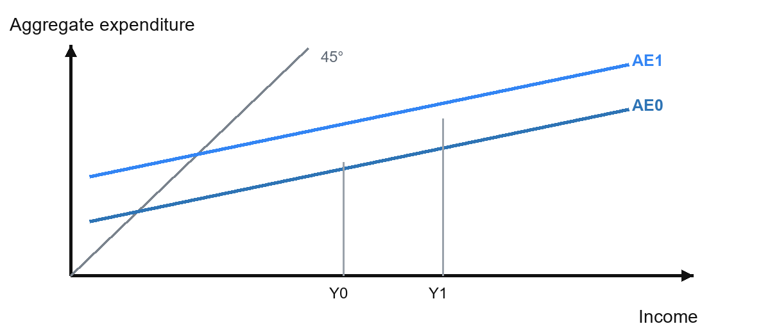
Annotate the autonomous injection, multiplied ΔY and the two equilibria.
EXAM TRAP Aggregate expenditure is plotted against income. Aggregate demand is plotted against the price level.

13. Each spending round shifts AD again
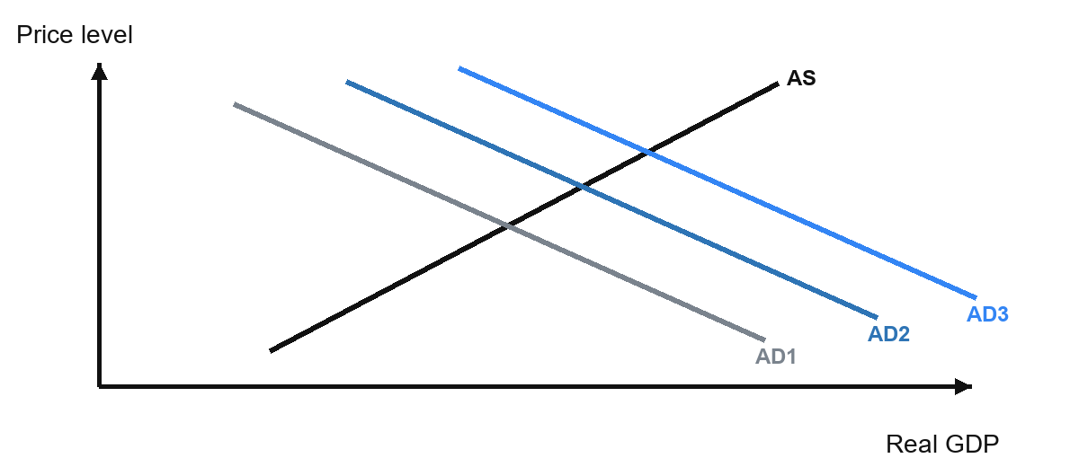
Annotate the injection, induced consumption, and final output/price outcome.
EVALUATION The real-output/inflation split depends on spare capacity and the shape of AS.

EXAM PRACTICE | PAST-PAPER CONCEPTS

14. Cambridge-style multiple choice: concepts and propensities
INSTRUCTIONS Choose one answer. Then justify it using a definition, formula or logical chain. Answers are on the final page.

Q1 9708/32/M/J/25 Q15
An initial injection into the circular flow of income causes a much larger increase in GDP. What does this define?
A autonomous investment | B demand-pull inflation
C the accelerator principle | D the national income multiplier

Answer: ____ Justification:

Q2 9708/32/F/M/26 Q15
An estimate of the consumption function is C = 10 000 + 0.8Y. Which conclusion can be drawn?
A The average propensity to consume is constant. | B The average propensity to consume increases as income increases.
C The average propensity to consume is always equal to the marginal propensity to consume. | D The average propensity to consume is always greater than the marginal propensity to consume.

Answer: ____ Justification:

Q3 9708/31/M/J/26 Q16
What would increase the value of the multiplier?
A a decrease in the marginal propensity to consume | B a decrease in the marginal rate of tax
C an increase in the marginal propensity to import | D an increase in the marginal propensity to save

Answer: ____ Justification:

EXAM PRACTICE | CALCULATIONS AND TRADE

15. Cambridge-style multiple choice: calculations
Q4 9708/32/F/M/21 Q24
In a closed economy, MPS = 0.1 and MRT = 0.1. What will be the increase in national income if there is an injection of $100 million?
A $1000 million | B $500 million
C $100 million | D $80 million

Answer: ____ Working / justification:

Q5 9708/31/O/N/22 Q26
MPC = 0.2, MPS = 0.3, MRT = 0.3 and MPM = 0.2. What is the most likely consequence of a $1000m rise in government expenditure?
A Import expenditure rises by $200m. | B Import expenditure rises by $1000m.
C Tax revenues rise by $75m. | D Tax revenues rise by $375m.

Answer: ____ Working / justification:

Q6 9708/31/O/N/23 Q17
What might decrease if a closed economy with a government sector decides to allow international trade?
A components of aggregate expenditure | B number of injections into the circular flow
C number of leakages from the circular flow | D value of the economy's multiplier

Answer: ____ Working / justification:

CALCULATION DISCIPLINE Write MPW first, then k, then ΔY. If the question asks about tax revenue or imports, apply the relevant marginal propensity to the final ΔY.

EXAM PRACTICE | APPLICATION AND ASSESSMENT

16. Structured response: Ghana multiplier chain
9708/41/O/N/24 Q1(b) [4]
Explain how the extraction of natural resources in Ghana will 'create further employment in other sectors through the multiplier effect'. [4]
MARK TARGET | WHAT YOUR CHAIN MUST DO
2 marks: knowledge | Define the multiplier and identify an initial injection / new income.
2 marks: application | Use Ghana, resource extraction, re-spending, other sectors and employment.

Write your four-mark response.

17. Teacher-created assessment
An open economy with government has MPS = 0.10, MPM = 0.20 and MRT = 0.20. Exports rise by £120m.
PART | TASK | WORKING / ANSWER
a | Calculate MPW.
b | Calculate the multiplier.
c | Calculate the final change in national income.
d | Explain one reason why the rise in real GDP may be smaller than your answer to c.

SUCCESS CRITERIA Show each stage, include units, and separate the simplified income calculation from the real-output evaluation.

REVIEW | COMPLETE AFTER BOTH LESSONS

18. Core Lessons 1-2: process, size and outcome
PROCESS | SIZE | OUTCOME
Injection → income → re-spending → smaller rounds → new equilibrium | k = 1/MPW  More S, T or M → smaller k | ΔY = k × ΔJ  Real output vs inflation depends on AS

Final challenge: MPW = 0.50 and the injection is £120m. Find k and ΔY, then interpret k.

Self-check answers
PAUSE Complete the tasks before using this section. Cover it or remove this page if your teacher asks.

Lesson 1 practice
Q1 MPW = 1/2, k = 2. Q2 k = 5, ΔY = $5,000m. Q3 MPW = 0.80, k = 1.25. Exit ticket Q3: MPW = 0.50, k = 2.
Lesson 2 retrieval
MPW = 0.10 + 0.20 + 0.20 = 0.50; k = 2.
Data task
ΔY = 200; ΔC = 140, so MPC = 0.70; MPS = 0.10; MPM = 0.10; MRT = 0.10; MPW = 0.30; k = 3.33.
Work backwards
Total ΔY = £1,600m; k = 4; MPS = 0.25; MPC = 0.75.
Past-paper MCQs
Q1 D. Q2 D. Q3 B. Q4 B. Q5 D. Q6 D.
Teacher assessment
a MPW = 0.50. b k = 2. c ΔY = £240m. d For example, limited spare capacity may cause part of the rise in nominal income to appear as inflation rather than real output.
Final challenge
k = 2; ΔY = £240m. Interpretation: each £1 injection generates £2 of national income.
Four-mark Ghana chain
Natural-resource extraction is an injection that creates jobs and incomes in Ghana. Workers and firms spend part of the extra income on goods and services in other sectors. Those firms then gain revenue, employ more workers and generate further income and spending. This repeated process creates a larger final rise in employment and national income.

