LESSON 1 How the multiplier works
Follow the sequence, add annotations, and complete the calculations as the lesson develops.
Name | Class | Date

BY THE END I can trace repeated spending rounds, distinguish injections from withdrawals, and calculate a simple multiplier.

1 STARTER: WHAT HAPPENS AFTER THE FIRST INJECTION?

The government pays £100 million to build a railway. Identify two groups that receive income next, then predict what happens to total national income.
________________________________________________________________________________
________________________________________________________________________________

2 THE CIRCULAR FLOW

Injections: add spending | Withdrawals (leakages): reduce re-spending
Investment (I) • Government spending (G) • Exports (X) | Saving (S) • Taxation (T) • Imports (M)

CORE CHAIN Initial injection → higher income → induced consumption → more income → repeated rounds → new equilibrium national income.

3 SPENDING ROUNDS WHEN MPC = 0.75

Round | New income (£m) | Consumption passed on (£m) | Withdrawal (£m)
Initial injection | 100.00 | 75.00 | 25.00
2 | 75.00 | ________ | ________
3 | ________ | ________ | ________
4 | ________ | ________ | ________
What happens to each new round? | ________________ | Why? | ________________

DEFINITION The multiplier is the process by which an initial change in autonomous spending causes a larger final change in national income.

FORMULA k = change in national income ÷ change in injection | k = ΔY ÷ ΔJ

LESSON 1 Choose the formula and apply it
Use marginal—not average—propensities in multiplier calculations.
4 AVERAGE AND MARGINAL PROPENSITIES

Measure | Meaning | Formula
APC / APS / APM / ART | Share of total income used | total amount ÷ total income
MPC / MPS / MPM / MRT | Share of an extra £1 of income | change in amount ÷ change in income

IDENTITY For each extra £1 of income: MPC + MPS = 1 (closed, no government). More generally: MPC + MPS + MRT + MPM = 1.

5 FOUR MODELS

Economy | Withdrawals included | Multiplier
Closed, no government | Saving | k = 1/MPS = 1/(1 − MPC)
Closed, with government | Saving + taxation | k = 1/(MPS + MRT)
Open, no government | Saving + imports | k = 1/(MPS + MPM)
Open, with government | Saving + taxation + imports | k = 1/(MPS + MRT + MPM)

6 GUIDED EXAMPLE

QUESTION In an open economy with government, MPS = 0.20, MPM = 0.10 and MRT = 0.10. Exports rise by £80 million.

Step | Set-up | Your calculation
1 Total marginal withdrawals | MPW = MPS + MPM + MRT | MPW = __________
2 Multiplier | k = 1 ÷ MPW | k = __________
3 Change in national income | ΔY = k × ΔJ | ΔY = £__________m
4 Interpretation | A £1 rise in exports causes… | ________________________________

7 TRY THESE AS YOUR TEACHER REVEALS EACH STEP

Question | Model / formula | k | ΔY
A Closed, no government: MPS = 0.25; investment rises by £60m. | ________________ | ______ | £______m
B Open, no government: MPC = 0.70, MPM = 0.10; exports rise by £40m. | ________________ | ______ | £______m
C Open, with government: MPS = 0.10, MRT = 0.20, MPM = 0.20; G rises by £50m. | ________________ | ______ | £______m

LESSON 2 Derive the multiplier from data
Calculate changes first; then select the withdrawals that match the economy.
1 RETRIEVAL

Complete | Complete
Injection: I, G or X? __________ | Withdrawal: S, T or M? __________
k = ΔY ÷ ________ | ΔY = ________ × ΔJ

2 CALCULATE MARGINAL PROPENSITIES FROM THE DATA

£m | Initial | New | Change
National income (Y) | 1,000 | 1,200 | ________
Domestic consumption (C) | 800 | 940 | ________
Saving (S) | 100 | 120 | ________
Imports (M) | 50 | 70 | ________
Taxation (T) | 50 | 70 | ________

MPC = ΔC/ΔY | MPS = ΔS/ΔY | MPM = ΔM/ΔY | MRT = ΔT/ΔY
________ | ________ | ________ | ________
Check: MPC + MPS + MPM + MRT = | ________________ | MPW = MPS + MPM + MRT = | ________________
Multiplier: k = 1/MPW = | ________________ | Expected relationship: k is | greater than / equal to / less than 1

3 A RELIABLE FOUR-STEP METHOD

1 | Identify the economy | Closed or open? Government or no government?
2 | Add relevant marginal withdrawals | MPW = MPS + MRT + MPM, as appropriate
3 | Calculate the multiplier | k = 1 ÷ MPW
4 | Apply it to the injection | ΔY = k × ΔJ; include units and direction

4 WORK BACKWARDS

SCENARIO An autonomous injection of £400 million eventually raises national income by £1,200 million.

Find k | Find MPW | If there is no government and no foreign trade, find MPC
k = ΔY/ΔJ = __________ | MPW = 1/k = __________ | MPS = __________ so MPC = __________

LESSON 2 Show the multiplier and explain it
Connect repeated expenditure to equilibrium income, aggregate demand, and exam responses.
5 DIAGRAM ANNOTATION

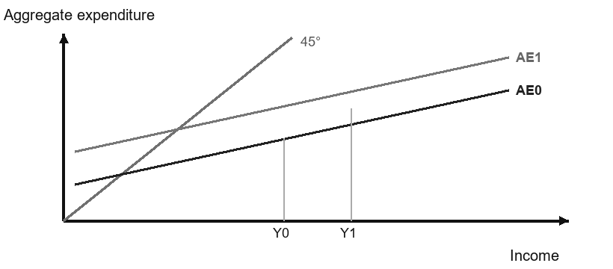 | 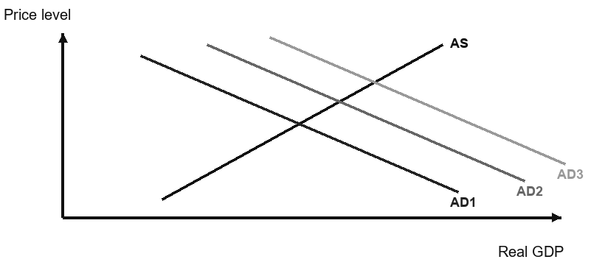
AE model: circle both equilibria. Label the initial vertical shift ΔJ and the larger horizontal change ΔY. | AD–AS model: add arrows for the first and later rounds. Mark where spare capacity begins to run out.

LINK The initial injection shifts AE or AD first. Induced consumption creates further shifts, so the final increase in real output can exceed the first injection.

6 QUICK EXAM CHECKS

Task | Working / response
1 Define the multiplier in one precise sentence. [2] | ________________________________________________________
2 MPW = 0.50 and autonomous spending rises by £120m. Calculate k and ΔY. [3] | k = ________ ΔY = £________m
3 Give one reason why real GDP may rise by less than the multiplier calculation predicts. [2] | ________________________________________________________

7 FOUR-MARK APPLICATION

Explain how the extraction of natural resources in Ghana will create further employment in other sectors through the multiplier effect. [4]
________________________________________________________________________________
________________________________________________________________________________
________________________________________________________________________________
________________________________________________________________________________

STRUCTURE Start with the injection and direct jobs → show higher household income and consumption → identify demand and employment in other sectors → note repeated, diminishing rounds.

Final check: Underline the causal links in your response and circle the point where you applied the context of Ghana.
________________________________________________________________________________

