Force Field Excluder Tutorial

Introduction

Force field excluders allow you to specify areas of a level which are not influenced by a force field for example if a tornado passes over a house, the interior of the house can be marked by an excluder to prevent the tornado from blowing around the objects inside the house.

Tutorial – Step 1 – Create the force field excluder brush

First specify a builder brush in the shape and position you want the force exclude volume. Then right click the special brush icon and select “RB_ForceFieldExcludeVolume”.

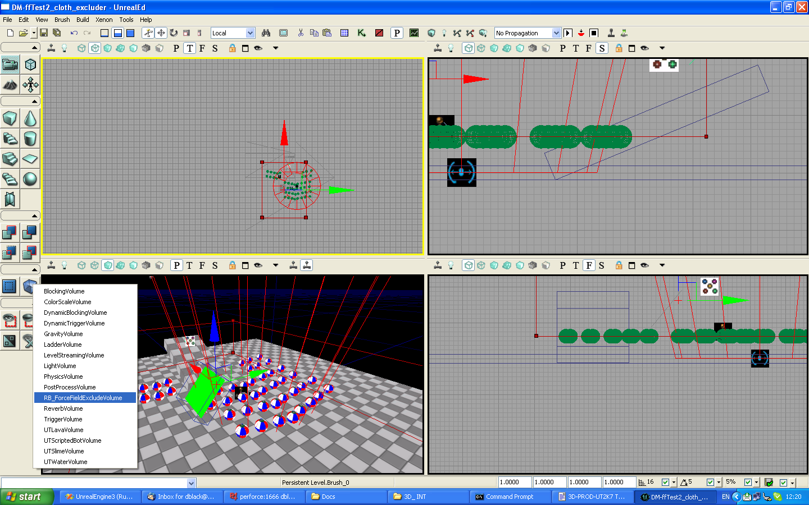
Tutorial – Step 2 – Set the force field channel

Next we can select the force field channel for the excluder. Right click the force field excluder brush we just created and open the properties. Under the RB_ForceFieldExcludeVolume heading the property is “ForceFieldChannel” we set this to a number which associates it with the force field. Ie there is a matching ForceFieldChannel property in the force field. When these numbers are the same the excluder is considered by the force field.
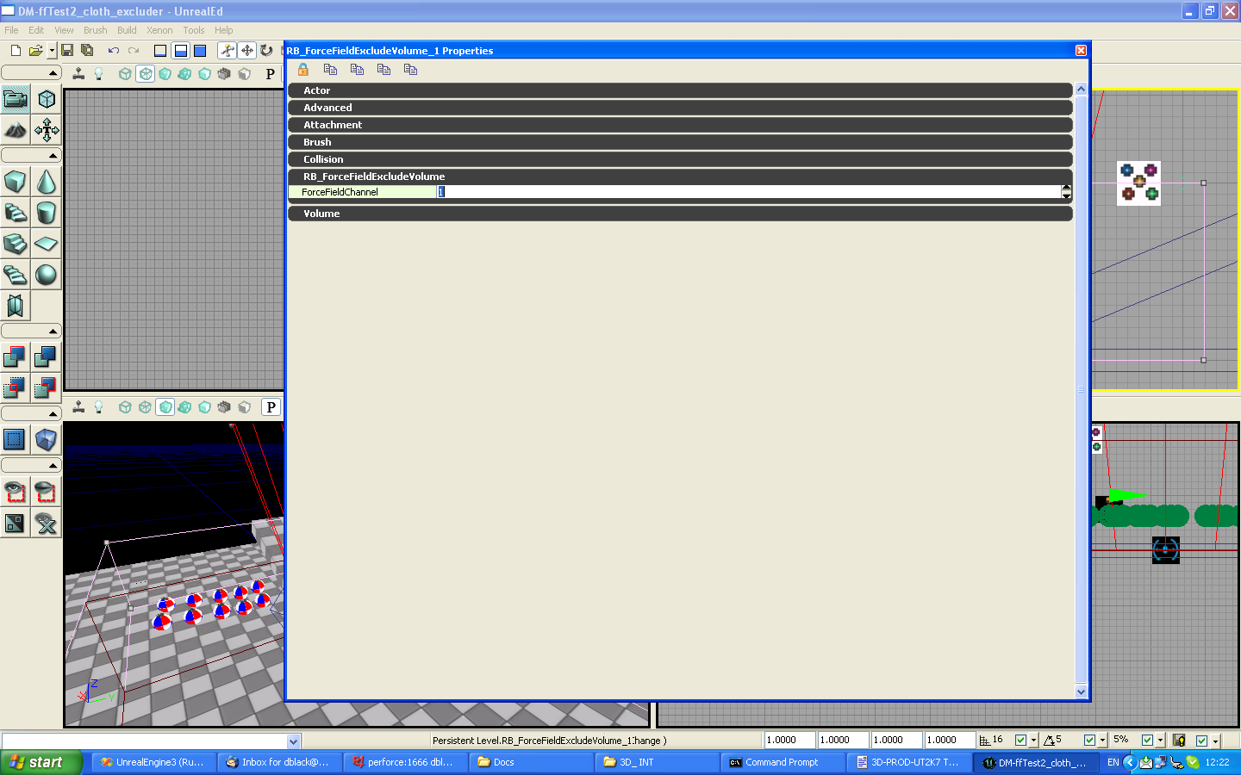
In this way we could have a force field exclude volume around a building, which prevents the tornado from moving objects inside. But then have another force field inside the building(eg for a broken pipe) with a different channel id.

