# TASK 1.1

1. The Stock table was created from the Transactions table with all columns removed except the StockItemID column (PK) and the StockItemName column. It is a dimension table.

The Date was created as a rolling calendar that updates daily with the Date (PK), Year, Months and Days column. It is a dimension table.

1. The relationship between the Cities and Transactions table is a one to many relationship with the PostalCityID column as the primary key in the Cities table and a foreign key in the Transactions table.

The relationship between the Customers and Transactions table is a one to many relationship with the CustomerID column as the primary key in the Cities table and a foreign key in the Transactions table.

The relationship between the Date and Transactions table is a one to many relationship with the Date column as the primary key in the Cities table and TransactionDate as a foreign key in the Transactions table.

The relationship between the Stock and Transactions table is a one to many relationship with the StockItemID column as the primary key in the Cities table and a foreign key in the Transactions table.

1. The LocationHierarchy column was built into the Cities table. The hierarchy consists of the column – Region, Subregion, Continent, CountryName, StateProvinceName, CityName, Location

# TASK 1.2

a)

|  |  |  |  |  |  |
| --- | --- | --- | --- | --- | --- |
| **Table Name** | **No of Rows** | **Facts or Dimensions** | **List of Columns** | **Hierarchy Names** | **Columns included in the hierarchy** |
| Stock | 227 | Dimension | StockItemID **(PK)**  StockItemName | - | - |
| Date | 4,345 | Dimension | Date **(PK)**  Month  Year  Day | - | - |
| Customers | 663 | Dimension | CustomerID **(PK)**  CustomerName  PhoneNumber  DeliveryAddressLine  DeliveryPostalCode **(FK)**  PostalCityID **(FK)** | - | - |
| Cities | 655 | Dimension | PostalCityID **(PK)**  CityName  StateProvinceName  CountryName  Continent  SalesTerritory  Region  Subregion  Location  Latitude  Longitude  LastRecordedPopulation | LocationHierarchy | Region  Subregion  Continent  CountryName  StateProvinceName  CityName  Location |
| Transaction | 228,265 | Fact | CustomerTransactionID **(PK)**  CustomerID **(FK)**  TransactionDate  SalesPersonName  StockItemID **(FK)**  Quantity  UnitPrice  AmountExcludingTax  TaxAmount  TransactionAmount  PostalCityID **(FK)** | - | - |

b)

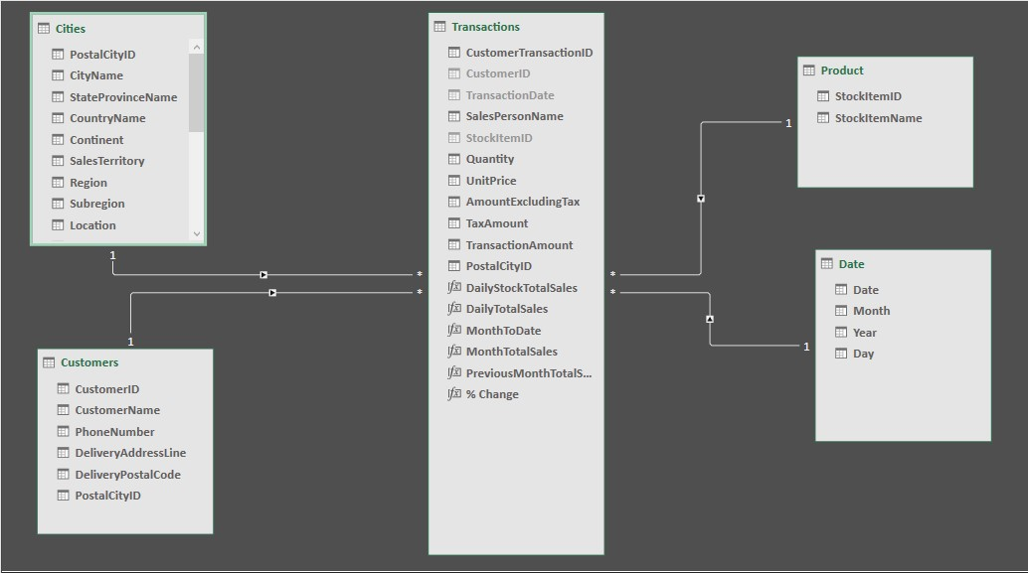

c)

PIVOT TABLE 1

# DailyStockTotalSales

Top ranked products in terms of total sales amount

=CALCULATE(SUM(Transactions[TransactionAmount]),DISTINCT(Transactions[StockItemName]))

PIVOT TABLE 2

# MonthToDate

Month to date running total

=TOTALMTD(SUM(Transactions[TransactionAmount]),'Date'[TransactionDate])

# DailyTotalSales

Daily Total Sales

=CALCULATE(SUM(Transactions[TransactionAmount]),DISTINCT(Transactions[TransactionDate]))

PIVOT TABLE 3

# MonthTotalSales

Corresponding total sales

=CALCULATE(SUM(Transactions[TransactionAmount]),FILTER(Transactions,MONTH(Transactions[TransactionDate])))

# PreviousMonthTotalSales

Last (previous) month total sales

=CALCULATE(SUM(Transactions[TransactionAmount]),PREVIOUSMONTH('Date'[TransactionDate]))

# % Change

Percentage change in total sales from month to month

=CALCULATE([MonthTotalSales]-[PreviousMonthTotalSales])/([PreviousMonthTotalSales])

d)

PIVOT TABLE 1

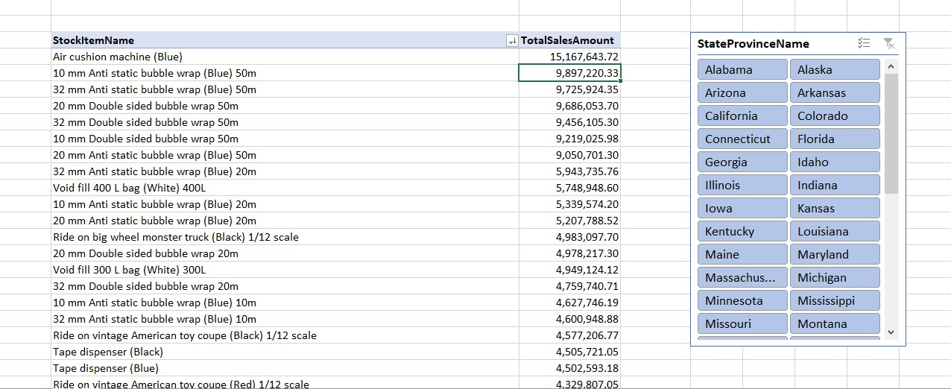

PIVOT TABLE 2

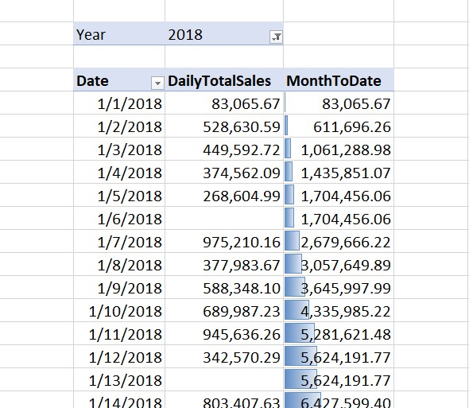

PIVOT TABLE 3

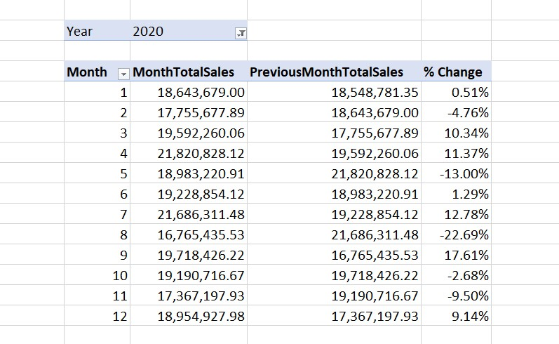

e)