GTX OSV
WORK INSTRUCTION

Toshiba HDD Vendor Test
Drive detection, diagnostic dump collection, and log handling

Document field | Value
Document ID | WI-GTXE-TOSHIBA-HDD
Revision | Draft 01
Prepared from | GTXE-Toshiba HDD Vendor SOP
Original SOP prepared by | Eduardo Trujillo
Effective date | To be assigned
Owner / approver | To be assigned

PURPOSE Provide a repeatable method to install Toshiba hard drives in the JBOD, run the Toshiba test script, identify PASS/FAIL results, and locate output logs.

Source basis: GTXE-Toshiba HDD Vendor SOP-190826-153209.pdf, pages 1-3.

1. Document Control
Role | Name | Date / Signature
Author / preparer | ________________________ | ________________________
Technical reviewer | ________________________ | ________________________
Quality / operations approval | ________________________ | ________________________

2. Scope
This work instruction applies to the GTX OSV Toshiba HDD vendor test process using the designated blade, JBOD, rack manager, Toshiba TSBDRV software, and the toshiba_test.sh script.

3. Responsibilities
Role | Responsibility
Technician | Follow the sequence, verify power state, install drives, run the script, and record the outcome.
Reviewer / lead | Confirm failed drives and log locations are documented before disposition.

4. Required Access and Equipment
- Rack manager access at 192.168.0.124
- Target test blade ID for rack-manager power control
- Blade #19 access at 192.168.0.167 through MobaXterm
- JBOD enclosure
- Toshiba hard drives to be tested
- Toshiba TSBDRV tools and test script installed on the blade

5. Key Paths and Commands
Item | Value
Rack manager | 192.168.0.124
Test blade | Blade #19, 192.168.0.167
Script folder | /opt/toshiba/tsbdrv/scripts/
Test command | ./toshiba_test.sh
Output log root | /home/Logs
Vendor tool logs | /var/log/toshiba/tsbdrv/

6. Work Procedure

6.1 Power Down and Install Drives
1 | Shut down the blade from the rack manager  Connect to rack manager 192.168.0.124 and run: set manager port off -i<blade id>  Verification: The rack manager reports that the selected blade port is off.

2 | Verify equipment is powered off  Confirm both the blade and JBOD are powered off before opening the enclosure.  Verification: No blade or JBOD power activity is present.

3 | Install Toshiba hard drives  Open the JBOD and insert the Toshiba hard drives into the approved drive positions.  Verification: Each drive is fully seated.

4 | Close the JBOD  Close and secure the JBOD after all drives are installed.  Verification: The enclosure is fully closed before power-on.

5 | Power on the blade  From rack manager 192.168.0.124, run: set manager port on -i<blade id>  Verification: The selected blade powers on normally.

Source procedure reference
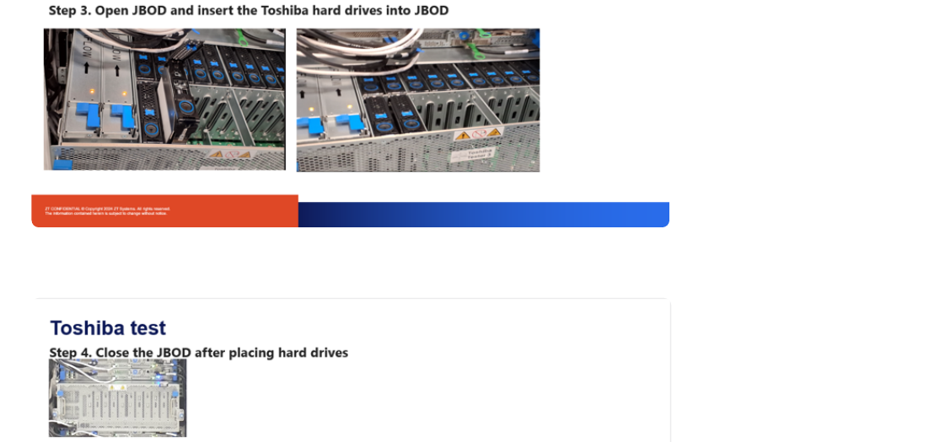

6.2 Access the Blade and Run the Test
6 | Connect to blade #19  Use MobaXterm to access blade #19 at 192.168.0.167. Log in with the approved credentials.  Verification: A terminal prompt is available on the blade.

7 | Run the Toshiba test script  Change to the script directory and execute the test commands shown below.  Verification: The script begins drive detection and log collection.

cd /opt/toshiba/tsbdrv/scripts/
./toshiba_test.sh

What the Script Does
- Checks whether Toshiba drives are detected.
- Reads and displays device serial numbers.
- Creates a folder for each hard drive under /home/Logs.
- Runs the TSBDRV devdump command for each detected drive.
- Generates and moves each drive output file into its corresponding serial-number folder.
DO NOT INTERRUPT Wait until each devdump operation finishes and the script returns a PASS or FAIL result. Interrupting the process may leave incomplete output.

Command and terminal output reference
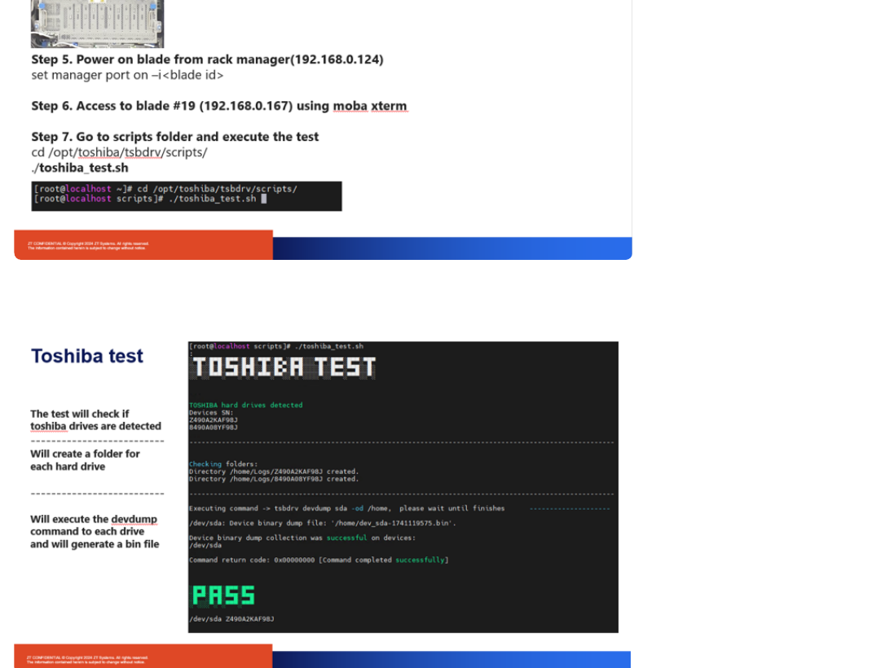

7. Interpret Results
Result | Indication | Required action
PASS | The device binary dump collection completed successfully and the command return code is 0x00000000. | Record the drive serial number and confirm its file is present in /home/Logs/<serial number>/.
FAIL | The dump collection failed for a device. The example SOP shows code 0x80007200 and TSBERR114: SCSI Log Sense command failed. | Record the failed device and serial number. Preserve the generated drive file and review the TSBDRV log path displayed by the command.

7.1 Log Locations
- /home/Logs/<drive serial number>/ for the drive-specific output file.
- /var/log/toshiba/tsbdrv/ for detailed TSBDRV logs when the tool reports an error.
NOTE The source SOP states that a log is generated even when dump collection fails. Confirm the script moves the available output into the drive serial-number folder.

Failure and log-movement reference
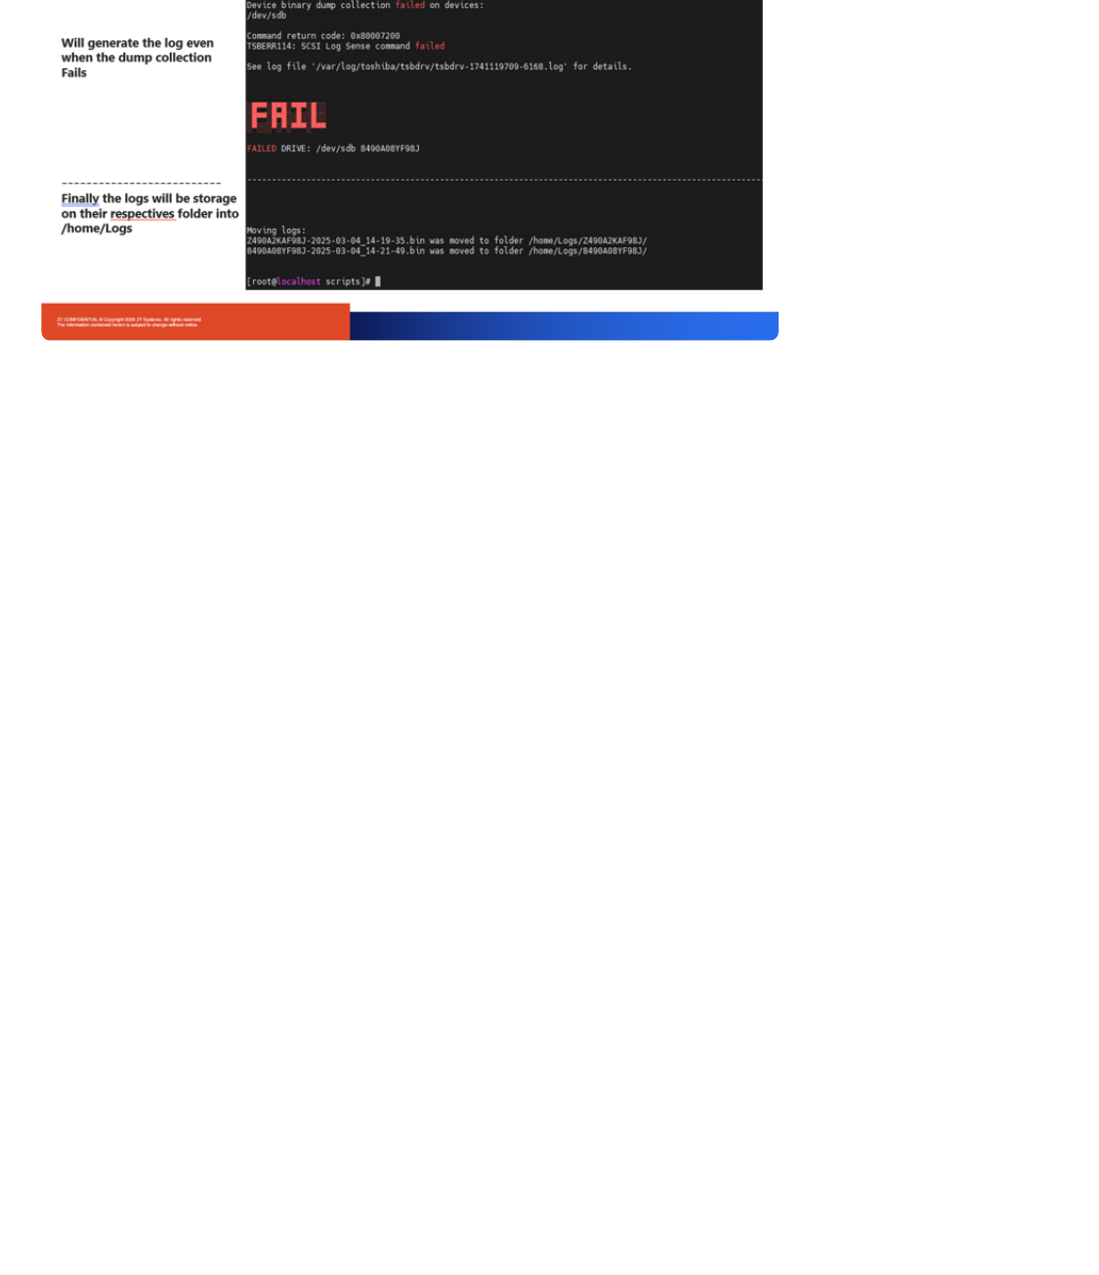

8. Completion Checklist
Done | Verification item | Notes / evidence
☐ | Correct blade ID was used for power control.
☐ | Blade and JBOD were off before opening the JBOD.
☐ | All Toshiba drives were fully seated and the JBOD was closed.
☐ | Blade #19 at 192.168.0.167 was accessed successfully.
☐ | The test was launched from /opt/toshiba/tsbdrv/scripts/.
☐ | PASS/FAIL was recorded for every detected drive.
☐ | Each drive serial-number folder was checked under /home/Logs.
☐ | Any failed-drive TSBDRV log path was captured for review.

9. Test Record
Field | Entry
Date / time
Technician
Blade ID
Number of drives
Drive serial numbers
PASS count
FAIL count
Log location / ticket

FINAL CHECK Do not remove or reconfigure drives until the required logs and serial-number results have been verified and recorded.

