This is the data file:

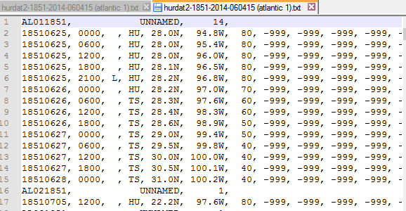

Once loaded into memory, it has a nice structure:

hurricane {

code: AL011851,

name: UNNAMED,

time-data: [

{

date: 1851/06/25,

time: 0600,

location,

max-wind-speed,

min-central-pressure,

wind-radii

},

…

]

}

But we aren’t going to load the entire thing into data. We will use a provider object.

hurricaneData = {

…

}

Provide list of atlantic hurricanes since 2005:

list = from(hurricaneData).where(year >= 2005);

HurricaneList(list).show()

Interactive toggle display of individual hurricanes

HurricaneList(list).enableToggle((item, toggle) => { item.setDisplay(toggle); });

Filter list by all/year/individual/top5or10-max-wind-speed

filter = all | year = 2005 | max-wind-speed in top5or10

filteredList = from(hurricaneData).where(filter)

Order hurricanes by time/name/max-wind-speed

filteredList = filteredList.order(time/name/max-wind-speed)

Hurricanes should be seen on map as path

HurricaneMap.show(filteredList);

Show hurricane positions on day

day = selectDay();

HurricaneMap.setDay(day);

Pick hurricane season and playback

HurricaneMap.playback(from, to);

Overview graph showing number of hurricanes/year since 2005

HurricaneCountGraph.show(from(hurricaneData).where(year >= 2005));

