As expected, the inequality measured as gini decreses as the the income of the bottom 40% of the population growths faster than the countries average.

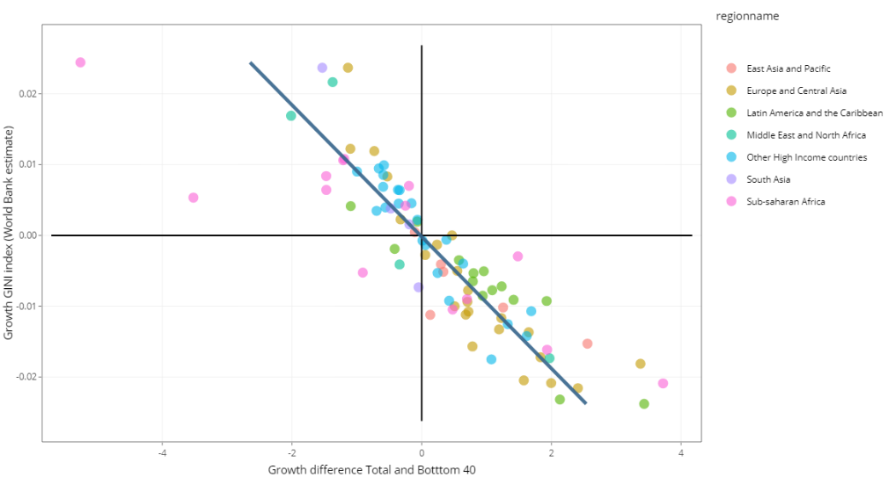

However, the regional perspective is not always as clear. The case of Sub-Saharan Africa is particularly intriguing. In this region, not only the relationship between the growth of the bottom 40 and the GINI is not as clear, but also contains the most outliers. Benin is an interesting case, with both the largest increase inequality measured as GINI and with the largest difference between the average and the bottom 40. Besides Benin, other SSA countries dynamics are captivating, for example Namibia has a reduction on inequality while the bottom growth is lower than the average. Is also important to notice that that in this region, most of the countries have increases in inequity and low growth of the bottom during the span of time analysed.

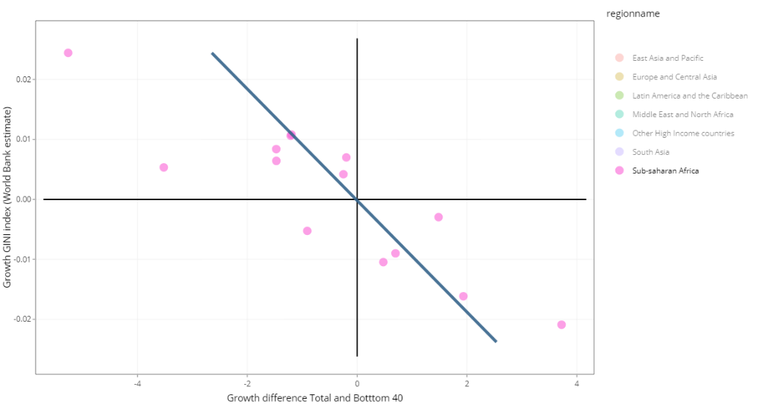

South Asia is a region that should raise awareness as well. Particularly Pakistan, with a very large growth in inequality accompanied by a moderately slow growth of the bottom compared to the mean. Similarly to Pakistan, Egypt and Iran, in the Middle East and North Africa region have a large increase in inequality and slow growth of the bottoms welfare.

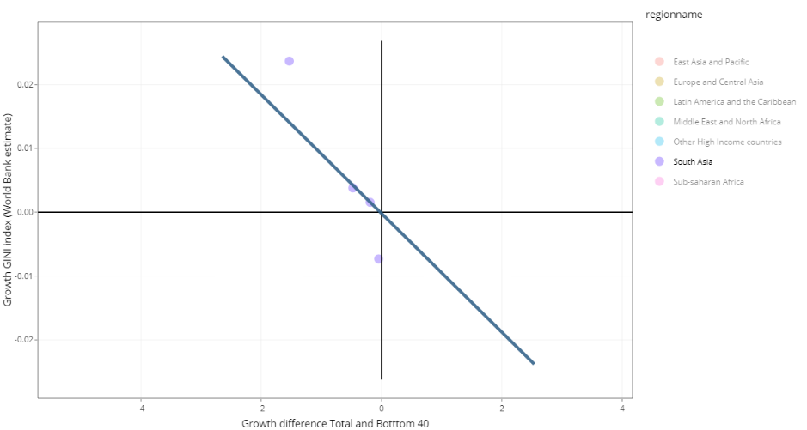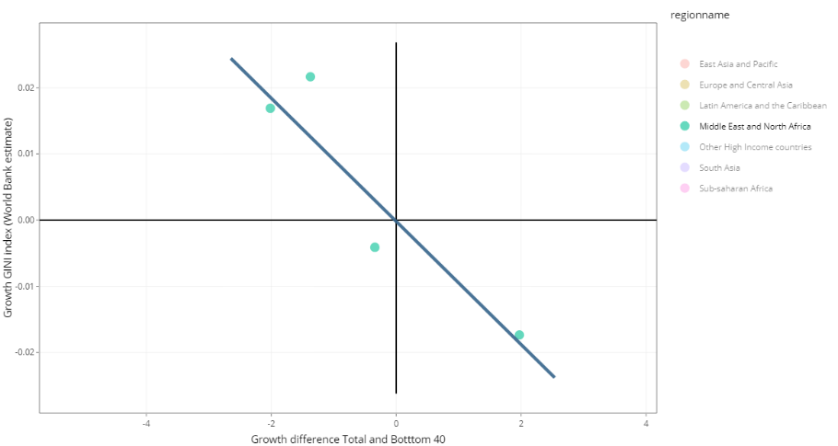

On the Brightside, most countries of the regions of East Asia and Pacific, and Latin America and the Caribbean have achieved reductions in poverty and a faster growth of income/consumption of the bottom 40% of the population. However, three large countries Brazil, Argentina and Vietnam are worth watching as are the only ones, with data, experiencing an increase in inequality.

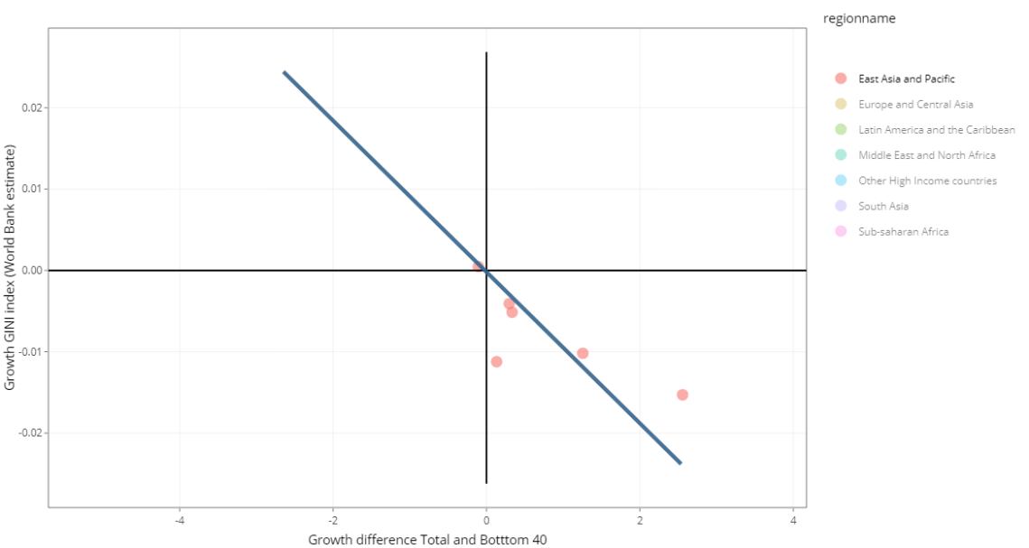

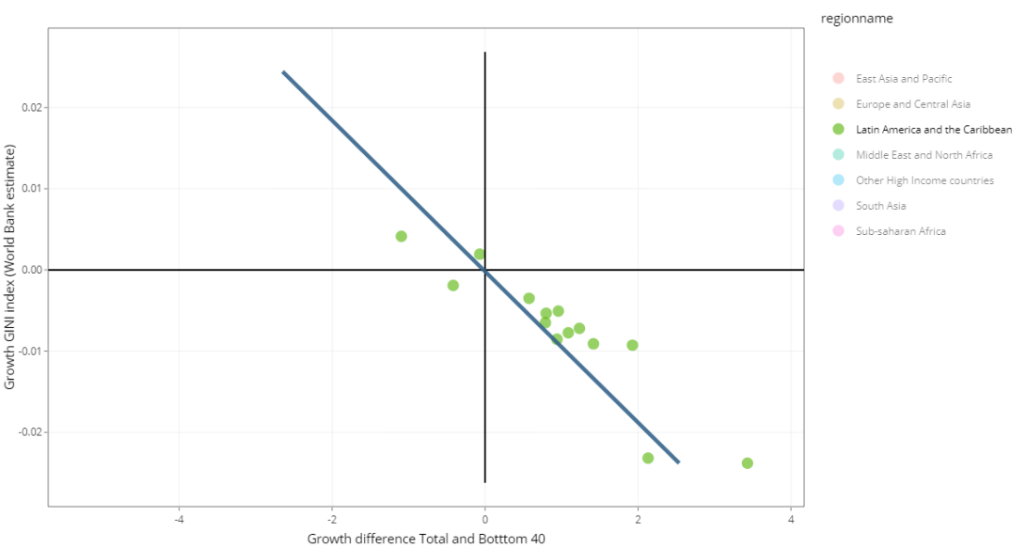

In Europe and Central Asia, we found an overall good performance. However, some of the lower income countries on the region increased their inequality, this is the case of Armenia, Latvia and Ukraine. Kosovo is an important case to follow as despite a moderate faster growth of the bottom’s welfare, the inequality remains unchanged.

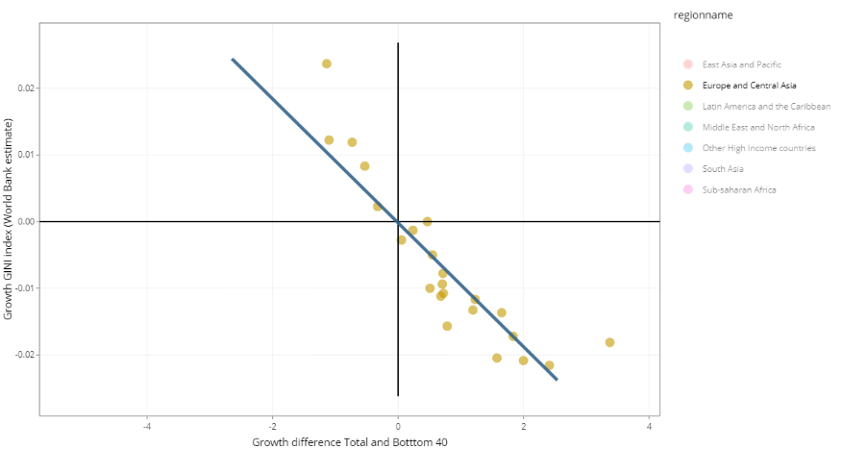

Finally, concerning high income countries, a trend of lower growth of the bottom’s income seems to be widespread. Even if less worrying that in other regions, is worth watching, as long-time champions on low inequality as Norway, Sweden or Germany are increasing inequality.

