SIT323 Practical Software Development

PEOJECT 02 cROZZLE GAME

yibing xie----Student ID:214049532

2016

# Contents

Contents 1

Introduction 2

Project Task 4

Section 1 – test 01 4

● a snapshot of your GUI, and 4

● the saved crozzle TXT file. 4

Section 2 – test 02 5

● a snapshot of your GUI, and 5

● the saved crozzle TXT file. 5

Section 3 – test 03 7

● a snapshot of your GUI, and 7

● the saved crozzle TXT file. 7

Appendix 9

# Introduction

This project is Assignment Task 02, coding for SIT323 Practical Software Develop of Deakin University. Based on Task 01. That developed using c# and developing environment is Microsoft Visual Studio 2015. The major propose is:

1. Read a Crozzle and Configuration TXT file
2. Automatically create a new crozzle.
3. Computing and display the score of a new crozzle.
4. Correctly create a crozzle based on wordlist which in Crozzle.TXT file.
5. Saving a TXT file which is your crozzle answer.
6. Create a crozzle and get score as higher as I can.
7. New Crozzle must meet the requirements

Basically, this project develop from my project 01, same structure and using same function to check validation of crozzle. To be honest, this project quite difficult, if we want to get high marks. A plenty of details need to be considered. Logic needs to be fairly clear. Because of the result of program crash may have lot. One of the most commonly encountered problems is program going to Infinite loop then program stop. Of course, this is occur at a later stage, when I tried to insert second GROUP. In addition, at first stage, the problems are more focused on the algorithm. Reasonably insert words, selected best position for each different Level. Also, drawing on the teacher’s ideas, on EASY, MEDIUM AND HARD method choice different sorting to insert word. At last, Regrettably, I have not successfully completed recursion of Greedy algorithm. So processing bar becomes insignificant. Furthermore, during my algorithm, all testing must in 30 seconds, so 3 mins countdown timer also not coding. The following parts, I will generally introduce my project working step.

From the code compiler point of view, during project 02 based on project 01, I code over 20 lists to contain data, which convenient to invoke data. Compare to project 01, I coding more function, which all just for one propose. Between procedures is more of each other calls, not write in single function.

For algorithm part, Logic is actually very simple. Select the optimal words. The location is selected randomly. The Horizontal and vertical are selected randomly. All the words cross each other. Function will check insert word validations every times.

For Displaying part (figure 01), have 4 areas group. Crozzle is web browser controller for display Crozzle game by HTML based on data table. Word List area will display every word which will be used in crozzle. The middle area consist two parts, Point and Buttons. Point will dynamically generated total score result and processing time. Buttons, Open Crozzle File and Open Configuration File, will open file dialog, which will loading file and start processing some functions. The Create Crozzle will start to create Crozzle. And Save Crozzle also will open file dialog to save TXT file. Also, this TXT file can be using to Project 01 to testing validation.

I set up regular expressions. Which will using on check input data validation. Also, I have a class which for translate Data table to HTML.

In addition, during my setting. Position list well contain almost important information. Which means I need to filter the data. I using Lambda searching repeat items, then separate into different list for me to choose from.

**Note:**

1. **First Step must Open Test Crozzle, then open Test Configuration**
2. **Second Step Must Create Crozle.**
3. **Last Step is Save Crozzle.**

**LogFile will contain error messages.**

# Project Task

## Section 1 – test 01

## a snapshot of your GUI, and

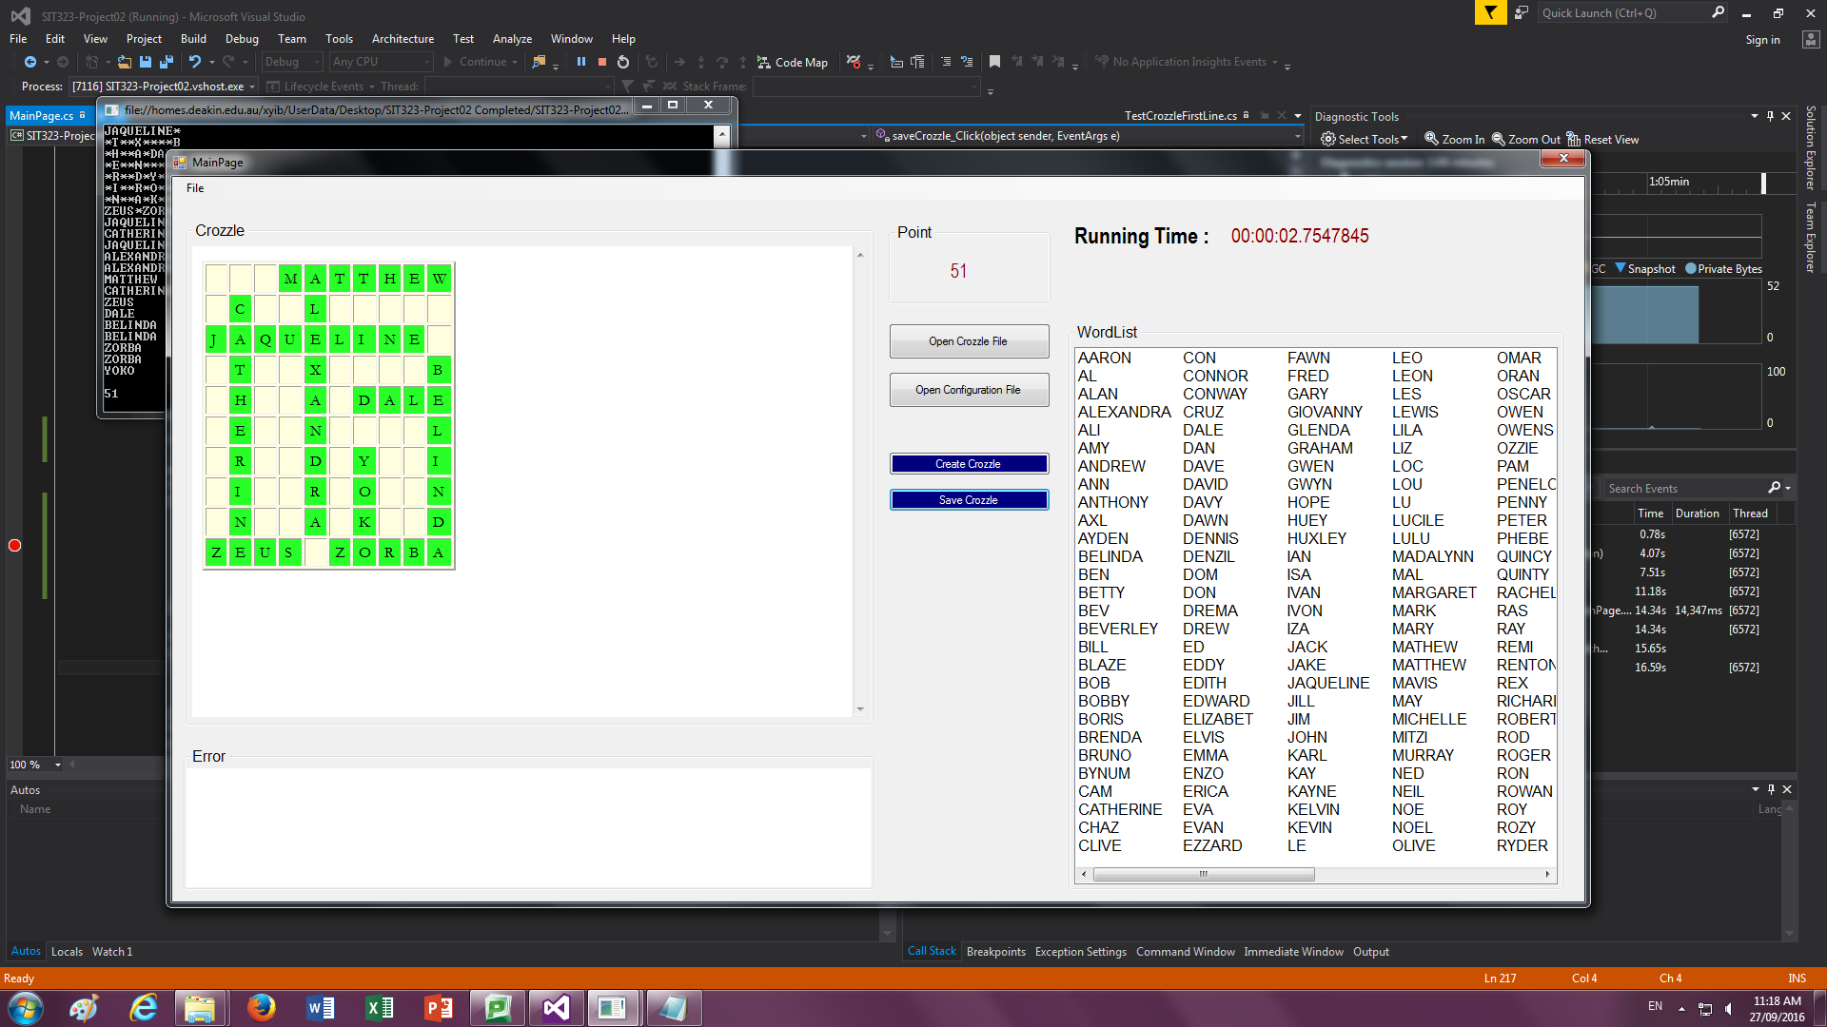

## the saved crozzle TXT file.

EASY,200,10,10,0,0

AARON,AL,ALAN,ALEXANDRA,ALI,AMY,ANDREW,ANN,ANTHONY,AXL,AYDEN,BELINDA,BEN,BETTY,BEV,BEVERLEY,BILL,BLAZE,BOB,BOBBY,BORIS,BRENDA,BRUNO,BYNUM,CAM,CATHERINE,CHAZ,CLIVE,CON,CONNOR,CONWAY,CRUZ,DALE,DAN,DAVE,DAVID,DAVY,DAWN,DENNIS,DENZIL,DOM,DON,DREMA,DREW,ED,EDDY,EDITH,EDWARD,ELIZABET,ELVIS,EMMA,ENZO,ERICA,EVA,EVAN,EZZARD,FAWN,FRED,GARY,GIOVANNY,GLENDA,GRAHAM,GWEN,GWYN,HOPE,HUEY,HUXLEY,IAN,ISA,IVAN,IVON,IZA,JACK,JAKE,JAQUELINE,JILL,JIM,JOHN,KARL,KAY,KAYNE,KELVIN,KEVIN,LE,LEO,LEON,LES,LEWIS,LILA,LIZ,LOC,LOU,LU,LUCILE,LULU,MADALYNN,MAL,MARGARET,MARK,MARY,MATHEW,MATTHEW,MAVIS,MAY,MICHELLE,MITZI,MURRAY,NED,NEIL,NOE,NOEL,OLIVE,OMAR,ORAN,OSCAR,OWEN,OWENS,OZZIE,PAM,PENELOPE,PENNY,PETER,PHEBE,QUINCY,QUINTY,RACHELLE,RAS,RAY,REMI,RENTON,REX,RICHARD,ROBERT,ROD,ROGER,RON,ROWAN,ROY,ROZY,RYDER,SALLY,SAM,SARAH,SHELDON,SPENCER,STEPHEN,STEVE,STEVEN,SUE,SUZY,SYLVIA,TAMMY,TEDDY,TERRY,TIMOTHY,TOBY,TODD,TOM,TRACEY,TREVOR,TY,TYRIANNE,VELVET,VERA,VERN,VIC,VICK,VICKY,VICTOR,WADE,WALLY,WALT,WENDY,WES,WESLEY,WHITNEY,WILL,WILLY,WILMA,WYNNIE,XAVIER,XENA,XIA,XIANG,YEE,YOEL,YOKO,YOLANDA,YOSEF,ZACH,ZACK,ZARA,ZELDA,ZENA,ZETA,ZEUS,ZILI,ZOLA,ZORBA,ZUZANNY

HORIZONTAL,3,1,JAQUELINE

HORIZONTAL,1,4,MATTHEW

HORIZONTAL,10,1,ZEUS

HORIZONTAL,5,7,DALE

HORIZONTAL,10,6,ZORBA

VERTICAL,2,2,CATHERINE

VERTICAL,1,5,ALEXANDRA

VERTICAL,4,10,BELINDA

VERTICAL,7,7,YOKO

## Section 2 – test 02

## a snapshot of your GUI, and

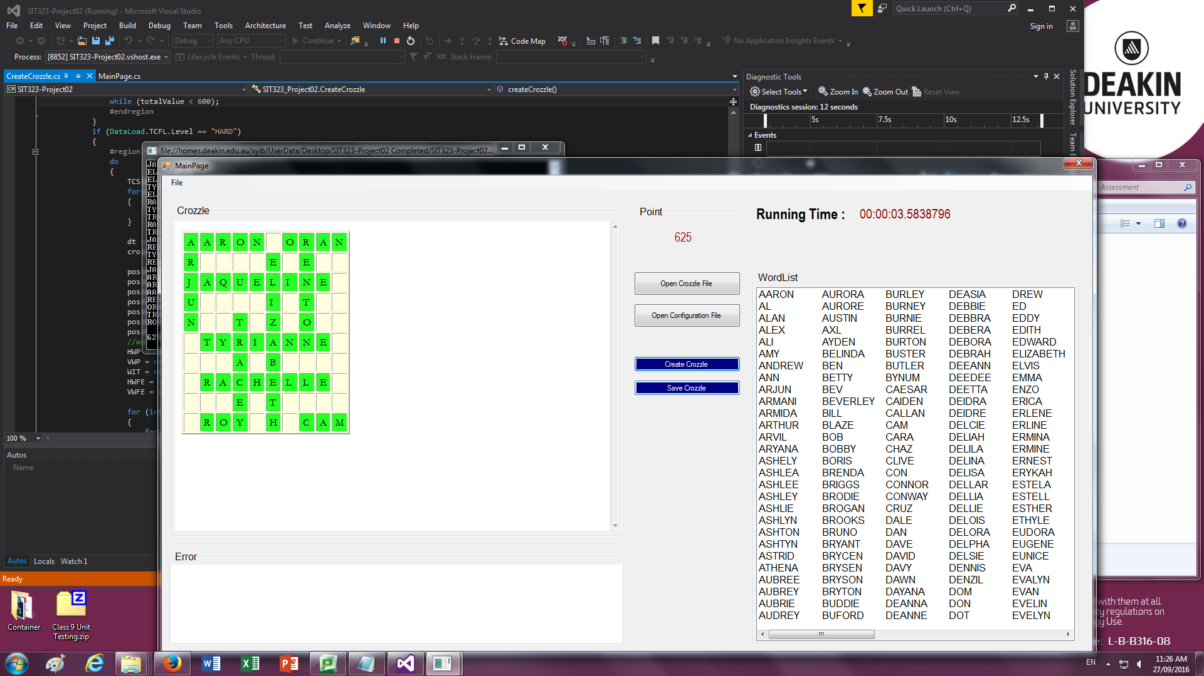

## the saved crozzle TXT file.

MEDIUM,300,10,10,0,0

AARON,AL,ALAN,ALEX,ALI,AMY,ANDREW,ANN,ARJUN,ARMANI,ARMIDA,ARTHUR,ARVIL,ARYANA,ASHELY,ASHLEA,ASHLEE,ASHLEY,ASHLIE,ASHLYN,ASHTON,ASHTYN,ASTRID,ATHENA,AUBREE,AUBREY,AUBRIE,AUDREY,AURORA,AURORE,AUSTIN,AXL,AYDEN,BELINDA,BEN,BETTY,BEV,BEVERLEY,BILL,BLAZE,BOB,BOBBY,BORIS,BRENDA,BRIGGS,BRODIE,BROGAN,BROOKS,BRUNO,BRYANT,BRYCEN,BRYSEN,BRYSON,BRYTON,BUDDIE,BUFORD,BURLEY,BURNEY,BURNIE,BURREL,BURTON,BUSTER,BUTLER,BYNUM,CAESAR,CAIDEN,CALLAN,CAM,CARA,CHAZ,CLIVE,CON,CONNOR,CONWAY,CRUZ,DALE,DAN,DAVE,DAVID,DAVY,DAWN,DAYANA,DEANNA,DEANNE,DEASIA,DEBBIE,DEBBRA,DEBERA,DEBORA,DEBRAH,DEEANN,DEEDEE,DEETTA,DEIDRA,DEIDRE,DELCIE,DELIAH,DELILA,DELINA,DELISA,DELLAR,DELLIA,DELLIE,DELOIS,DELORA,DELPHA,DELSIE,DENNIS,DENZIL,DOM,DON,DOT,DREW,ED,EDDY,EDITH,EDWARD,ELIZABETH,ELVIS,EMMA,ENZO,ERICA,ERLENE,ERLINE,ERMINA,ERMINE,ERNEST,ERYKAH,ESTELA,ESTELL,ESTHER,ETHYLE,EUDORA,EUGENE,EUNICE,EVA,EVALYN,EVAN,EVELIN,EVELYN,EVERLY,EVETTE,EVONNE,EZZARD,FALLON,FANNIE,FANNYE,FARRAH,FATIMA,FAWN,FELICE,FELIPA,FINLEY,FRED,GARY,GIOVANNY,GLENDA,GRAHAM,GWEN,GWYN,HARVY,HOWARD,HUXLEY,IAN,IVA,IVAN,IVON,IZA,JACK,JAKE,JAQUELINE,JILL,JO,JUDY,KARL,KAY,KAYLAH,KAYLAN,KAYLEE,KAYLEN,KAYNE,KELVIN,KEVIN,LE,LEO,LEON,LES,LEWIS,LILA,LIZ,LOC,LOU,LU,LUCILE,LULU,MADALYNN,MAL,MARGARET,MARK,MARY,MATHEW,MATTHEW,MAVIS,MAY,MICHELLE,MITZI,MURRAY,NAOMI,NED,NOE,NOEL,OLIVE,OMAR,ORAN,OSCAR,OWEN,OWENS,OZZIE,PAM,PENELOPE,PENNY,PETER,PHEBE,QUINCY,QUINTY,RACHELLE,RAE,RAY,REMY,RENTON,REX,RICHARD,ROBERT,ROD,ROGER,RON,ROWAN,ROY,ROZY,RYLEY,SALLY,SAM,SARAH,SHELDON,SOPHIE,STEPHEN,STEVE,STEVEN,SUE,SUZY,SYLVIA,TAMMY,TED,TERRY,TIMOTHY,TOBY,TODD,TOM,TRACEY,TREVOR,TY,TYRIANNE,VELVET,VERA,VELDA,VIC,VICK,VICKY,VICTOR,WADE,WALLY,WALT,WENDY,WES,WESLEY,WHITNEY,WILL,WILLY,WILMA,WYNNIE,XAVIER,XENA,XIA,XIANG,YEE,YOEL,YOKO,YOLANDA,YORK,ZACH,ZACK,ZARA,ZELIA,ZENA,ZETA,ZEUS,ZILI,ZOLA,ZORBA,ZUZANNY

HORIZONTAL,3,1,JAQUELINE

HORIZONTAL,6,2,TYRIANNE

HORIZONTAL,8,2,RACHELLE

HORIZONTAL,1,1,AARON

HORIZONTAL,1,7,ORAN

HORIZONTAL,10,2,ROY

HORIZONTAL,10,8,CAM

VERTICAL,2,6,ELIZABETH

VERTICAL,5,4,TRACEY

VERTICAL,1,8,RENTON

VERTICAL,1,1,ARJUN

## Section 3 – test 03

## a snapshot of your GUI, and

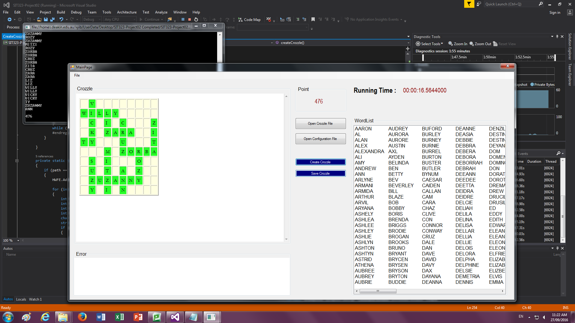

## the saved crozzle TXT file.

HARD,400,10,10,0,0

AARON,AL,ALAN,ALEX,ALEXANDRA,ALI,AMY,ANDREW,ANN,ARLYNE,ARMANI,ARMIDA,ARTHUR,ARVIL,ARYANA,ASHELY,ASHLEA,ASHLEE,ASHLEY,ASHLIE,ASHLYN,ASHTON,ASHTYN,ASTRID,ATHENA,AUBREE,AUBREY,AUBRIE,AUDREY,AURORA,AURORE,AUSTIN,AXL,AYDEN,BELINDA,BEN,BETTY,BEV,BEVERLEY,BILL,BLAZE,BOB,BOBBY,BORIS,BRENDA,BRIGGS,BRODIE,BROGAN,BROOKS,BRUNO,BRYANT,BRYCEN,BRYSEN,BRYSON,BRYTON,BUDDIE,BUFORD,BURLEY,BURNEY,BURNIE,BURREL,BURTON,BUSTER,BUTLER,BYNUM,CAESAR,CAIDEN,CALLAN,CAM,CARA,CHAZ,CLIVE,CON,CONNOR,CONWAY,CRUZ,DALE,DAN,DAVE,DAVID,DAVY,DAX,DAYANA,DEANNA,DEANNE,DEASIA,DEBBIE,DEBBRA,DEBERA,DEBORA,DEBORRAH,DEBRAH,DEEANN,DEEDEE,DEETTA,DEIDRA,DEIDRE,DELCIE,DELIAH,DELILA,DELINA,DELISA,DELLAR,DELLIA,DELLIE,DELOIS,DELORA,DELPHA,DELPHINE,DELSIE,DEMETRIA,DENNIS,DENZIL,DESTINEE,DESTINEY,DEYANIRA,DOM,DOMENICA,DOMINQUE,DON,DORATHEA,DOROTHEA,DREMA,DREW,DRUCILLA,DRUSILLA,ED,EDDY,EDITH,EDWARD,ELEANORA,ELEANORE,ELEONORA,ELEONORE,ELFRIEDA,ELIZABET,ELIZABETH,ELIZBETH,ELVIS,EMMA,EMMALINE,EMMALYNN,EMMELINE,ENZO,ERICA,ERLENE,ERLINE,ERMINA,ERMINE,ERNEST,ERYKAH,ESTEFANI,ESTEFANY,ESTELA,ESTELL,ESTHER,ESTRELLA,ETHELENE,ETHYLE,EUDORA,EUGENE,EUNICE,EUPHEMIA,EVA,EVALYN,EVAN,EVE,EVELYN,EVERLY,EVETTE,EVONNE,EZZARD,FALLON,FANNIE,FANNYE,FARRAH,FATIMA,FAWN,FELICE,FELICITY,FELIPA,FERNANDA,FILOMENA,FINLEY,FRED,GARY,GIOVANNY,GLENDA,GRAHAM,GWEN,GWYN,HARRISON,HARTWELL,HARVY,HERSCHEL,HERSHELL,HEZEKIAH,HILLIARD,HOWARD,HUMBERTO,HUMPHREY,HUXLEY,IAN,IGNATIUS,IMMANUEL,ISA,IVAN,IVON,IZA,JACK,JAKE,JAMARCUS,JAMARION,JAQUELINE,JEDEDIAH,JEDIDIAH,JEFFEREY,JENNIFER,JENNINGS,JERAMIAH,JEREMIAH,JERIMIAH,JERMAINE,JILL,JIM,JOHATHAN,JOHN,JOHNPAUL,JONATHAN,JONATHON,JOSELUIS,JOSEPHUS,KARL,KATHLEEN,KAY,KAYLAH,KAYLAN,KAYLEE,KAYLEN,KAYNE,KELVIN,KENDRICK,KENYATTA,KEVIN,KEYSHAWN,LE,LEO,LEON,LES,LEW,LEWIS,LIZ,LOC,LOU,LU,LUCILE,LULU,MADALYNN,MAL,MARGARET,MARIANNA,MARIANNE,MARIBETH,MARICELA,MARIETTA,MARILYNN,MARISELA,MARJORIE,MARK,MARLEIGH,MARQUITA,MARY,MARYANNE,MARYBETH,MARYJANE,MATHEW,MATHILDA,MATHILDE,MATTHEW,MAVIS,MAY,MAYBELLE,MCKENZIE,MCKINLEY,MECHELLE,MELISSIA,MELLISSA,MERCEDES,MEREDITH,MERRILEE,MICHAELA,MICHAELE,MICHELLE,MIGDALIA,MILAGROS,MINERVIA,MISSOURI,MITZI,MURRAY,NANNETTE,NAOMI,NATHALIA,NATHALIE,NEIL,NICHELLE,NICHOLAS,NOE,NOEL,OLIVE,OMAR,ORAN,OSCAR,OWEN,OWENS,OZZIE,PAM,PATIENCE,PATRICIA,PAULETTA,PENELOPE,PENNY,PETER,PHEBE,QUINCY,QUINTY,RACHELLE,RAS,RAY,REMI,RENTON,REX,RICHARD,ROBERT,ROD,ROGER,RON,ROWAN,ROY,ROZY,RYDER,SALLY,SAM,SARAH,SHELDON,SOPHIE,STEPHEN,STEVE,STEVEN,SUE,SUZY,SYLVIA,TAMMY,TED,TERRY,TEX,TOBY,TODD,TOM,TRACEY,TREVOR,TY,TYRIANNE,VELVET,VERA,VERN,VIC,VICK,VICKY,VICTOR,WADE,WALLY,WALT,WENDY,WES,WESLEY,WHITNEY,WILL,WILLY,WILMA,WYNNIE,XAVIER,XENA,XIA,XIANG,YEE,YOEL,YOKO,YOLANDA,YORK,ZACH,ZACK,ZARA,ZED,ZENA,ZETA,ZITA,ZILI,ZOLA,ZORBA,ZUZANNY

HORIZONTAL,9,2,ZUZANNY

HORIZONTAL,6,6,ZORBA

HORIZONTAL,4,4,ZARA

HORIZONTAL,2,1,WILLY

HORIZONTAL,5,1,TY

VERTICAL,7,2,SUZY

VERTICAL,6,8,ROZY

VERTICAL,6,4,MITZI

VERTICAL,3,6,CRUZ

VERTICAL,3,10,ZITA

VERTICAL,2,4,LIZ

VERTICAL,1,2,VICKY

VERTICAL,8,6,ANN

# Appendix

#### Introduction

Figure01

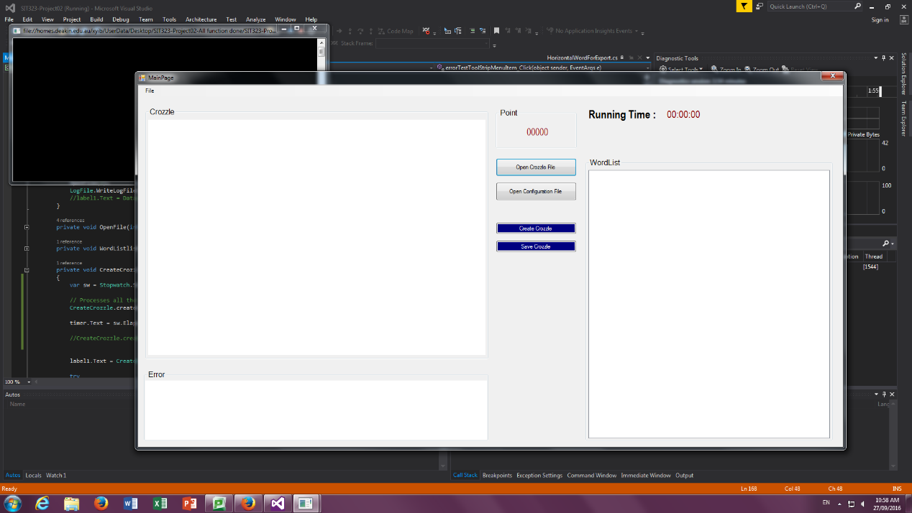

#### Section 1

#### the crozzle TXT file

EASY,200,10,10,0,0

AARON,AL,ALAN,ALEXANDRA,ALI,AMY,ANDREW,ANN,ANTHONY,AXL,AYDEN,BELINDA,BEN,BETTY,BEV,BEVERLEY,BILL,BLAZE,BOB,BOBBY,BORIS,BRENDA,BRUNO,BYNUM,CAM,CATHERINE,CHAZ,CLIVE,CON,CONNOR,CONWAY,CRUZ,DALE,DAN,DAVE,DAVID,DAVY,DAWN,DENNIS,DENZIL,DOM,DON,DREMA,DREW,ED,EDDY,EDITH,EDWARD,ELIZABET,ELVIS,EMMA,ENZO,ERICA,EVA,EVAN,EZZARD,FAWN,FRED,GARY,GIOVANNY,GLENDA,GRAHAM,GWEN,GWYN,HOPE,HUEY,HUXLEY,IAN,ISA,IVAN,IVON,IZA,JACK,JAKE,JAQUELINE,JILL,JIM,JOHN,KARL,KAY,KAYNE,KELVIN,KEVIN,LE,LEO,LEON,LES,LEWIS,LILA,LIZ,LOC,LOU,LU,LUCILE,LULU,MADALYNN,MAL,MARGARET,MARK,MARY,MATHEW,MATTHEW,MAVIS,MAY,MICHELLE,MITZI,MURRAY,NED,NEIL,NOE,NOEL,OLIVE,OMAR,ORAN,OSCAR,OWEN,OWENS,OZZIE,PAM,PENELOPE,PENNY,PETER,PHEBE,QUINCY,QUINTY,RACHELLE,RAS,RAY,REMI,RENTON,REX,RICHARD,ROBERT,ROD,ROGER,RON,ROWAN,ROY,ROZY,RYDER,SALLY,SAM,SARAH,SHELDON,SPENCER,STEPHEN,STEVE,STEVEN,SUE,SUZY,SYLVIA,TAMMY,TEDDY,TERRY,TIMOTHY,TOBY,TODD,TOM,TRACEY,TREVOR,TY,TYRIANNE,VELVET,VERA,VERN,VIC,VICK,VICKY,VICTOR,WADE,WALLY,WALT,WENDY,WES,WESLEY,WHITNEY,WILL,WILLY,WILMA,WYNNIE,XAVIER,XENA,XIA,XIANG,YEE,YOEL,YOKO,YOLANDA,YOSEF,ZACH,ZACK,ZARA,ZELDA,ZENA,ZETA,ZEUS,ZILI,ZOLA,ZORBA,ZUZANNY

#### the configuration TXT file

GROUPSPERCROZZLELIMIT=1000

POINTSPERWORD=0

INTERSECTING:A=1

INTERSECTING:B=1

INTERSECTING:C=1

INTERSECTING:D=1

INTERSECTING:E=1

INTERSECTING:F=1

INTERSECTING:G=1

INTERSECTING:H=1

INTERSECTING:I=1

INTERSECTING:J=1

INTERSECTING:K=1

INTERSECTING:L=1

INTERSECTING:M=1

INTERSECTING:N=1

INTERSECTING:O=1

INTERSECTING:P=1

INTERSECTING:Q=1

INTERSECTING:R=1

INTERSECTING:S=1

INTERSECTING:T=1

INTERSECTING:U=1

INTERSECTING:V=1

INTERSECTING:W=1

INTERSECTING:X=1

INTERSECTING:Y=1

INTERSECTING:Z=1

NONINTERSECTING:A=1

NONINTERSECTING:B=1

NONINTERSECTING:C=1

NONINTERSECTING:D=1

NONINTERSECTING:E=1

NONINTERSECTING:F=1

NONINTERSECTING:G=1

NONINTERSECTING:H=1

NONINTERSECTING:I=1

NONINTERSECTING:J=1

NONINTERSECTING:K=1

NONINTERSECTING:L=1

NONINTERSECTING:M=1

NONINTERSECTING:N=1

NONINTERSECTING:O=1

NONINTERSECTING:P=1

NONINTERSECTING:Q=1

NONINTERSECTING:R=1

NONINTERSECTING:S=1

NONINTERSECTING:T=1

NONINTERSECTING:U=1

NONINTERSECTING:V=1

NONINTERSECTING:W=1

NONINTERSECTING:X=1

NONINTERSECTING:Y=1

NONINTERSECTING:Z=1

#### Section 2

#### the crozzle TXT file

MEDIUM,300,10,10,0,0

AARON,AL,ALAN,ALEX,ALI,AMY,ANDREW,ANN,ARJUN,ARMANI,ARMIDA,ARTHUR,ARVIL,ARYANA,ASHELY,ASHLEA,ASHLEE,ASHLEY,ASHLIE,ASHLYN,ASHTON,ASHTYN,ASTRID,ATHENA,AUBREE,AUBREY,AUBRIE,AUDREY,AURORA,AURORE,AUSTIN,AXL,AYDEN,BELINDA,BEN,BETTY,BEV,BEVERLEY,BILL,BLAZE,BOB,BOBBY,BORIS,BRENDA,BRIGGS,BRODIE,BROGAN,BROOKS,BRUNO,BRYANT,BRYCEN,BRYSEN,BRYSON,BRYTON,BUDDIE,BUFORD,BURLEY,BURNEY,BURNIE,BURREL,BURTON,BUSTER,BUTLER,BYNUM,CAESAR,CAIDEN,CALLAN,CAM,CARA,CHAZ,CLIVE,CON,CONNOR,CONWAY,CRUZ,DALE,DAN,DAVE,DAVID,DAVY,DAWN,DAYANA,DEANNA,DEANNE,DEASIA,DEBBIE,DEBBRA,DEBERA,DEBORA,DEBRAH,DEEANN,DEEDEE,DEETTA,DEIDRA,DEIDRE,DELCIE,DELIAH,DELILA,DELINA,DELISA,DELLAR,DELLIA,DELLIE,DELOIS,DELORA,DELPHA,DELSIE,DENNIS,DENZIL,DOM,DON,DOT,DREW,ED,EDDY,EDITH,EDWARD,ELIZABETH,ELVIS,EMMA,ENZO,ERICA,ERLENE,ERLINE,ERMINA,ERMINE,ERNEST,ERYKAH,ESTELA,ESTELL,ESTHER,ETHYLE,EUDORA,EUGENE,EUNICE,EVA,EVALYN,EVAN,EVELIN,EVELYN,EVERLY,EVETTE,EVONNE,EZZARD,FALLON,FANNIE,FANNYE,FARRAH,FATIMA,FAWN,FELICE,FELIPA,FINLEY,FRED,GARY,GIOVANNY,GLENDA,GRAHAM,GWEN,GWYN,HARVY,HOWARD,HUXLEY,IAN,IVA,IVAN,IVON,IZA,JACK,JAKE,JAQUELINE,JILL,JO,JUDY,KARL,KAY,KAYLAH,KAYLAN,KAYLEE,KAYLEN,KAYNE,KELVIN,KEVIN,LE,LEO,LEON,LES,LEWIS,LILA,LIZ,LOC,LOU,LU,LUCILE,LULU,MADALYNN,MAL,MARGARET,MARK,MARY,MATHEW,MATTHEW,MAVIS,MAY,MICHELLE,MITZI,MURRAY,NAOMI,NED,NOE,NOEL,OLIVE,OMAR,ORAN,OSCAR,OWEN,OWENS,OZZIE,PAM,PENELOPE,PENNY,PETER,PHEBE,QUINCY,QUINTY,RACHELLE,RAE,RAY,REMY,RENTON,REX,RICHARD,ROBERT,ROD,ROGER,RON,ROWAN,ROY,ROZY,RYLEY,SALLY,SAM,SARAH,SHELDON,SOPHIE,STEPHEN,STEVE,STEVEN,SUE,SUZY,SYLVIA,TAMMY,TED,TERRY,TIMOTHY,TOBY,TODD,TOM,TRACEY,TREVOR,TY,TYRIANNE,VELVET,VERA,VELDA,VIC,VICK,VICKY,VICTOR,WADE,WALLY,WALT,WENDY,WES,WESLEY,WHITNEY,WILL,WILLY,WILMA,WYNNIE,XAVIER,XENA,XIA,XIANG,YEE,YOEL,YOKO,YOLANDA,YORK,ZACH,ZACK,ZARA,ZELIA,ZENA,ZETA,ZEUS,ZILI,ZOLA,ZORBA,ZUZANNY

#### the configuration TXT file

GROUPSPERCROZZLELIMIT=1000

POINTSPERWORD=0

INTERSECTING:A=1

INTERSECTING:B=2

INTERSECTING:C=3

INTERSECTING:D=4

INTERSECTING:E=5

INTERSECTING:F=6

INTERSECTING:G=7

INTERSECTING:H=8

INTERSECTING:I=9

INTERSECTING:J=10

INTERSECTING:K=11

INTERSECTING:L=12

INTERSECTING:M=13

INTERSECTING:N=14

INTERSECTING:O=15

INTERSECTING:P=16

INTERSECTING:Q=17

INTERSECTING:R=18

INTERSECTING:S=19

INTERSECTING:T=20

INTERSECTING:U=21

INTERSECTING:V=22

INTERSECTING:W=23

INTERSECTING:X=24

INTERSECTING:Y=25

INTERSECTING:Z=26

NONINTERSECTING:A=1

NONINTERSECTING:B=2

NONINTERSECTING:C=3

NONINTERSECTING:D=4

NONINTERSECTING:E=5

NONINTERSECTING:F=6

NONINTERSECTING:G=7

NONINTERSECTING:H=8

NONINTERSECTING:I=9

NONINTERSECTING:J=10

NONINTERSECTING:K=11

NONINTERSECTING:L=12

NONINTERSECTING:M=13

NONINTERSECTING:N=14

NONINTERSECTING:O=15

NONINTERSECTING:P=16

NONINTERSECTING:Q=17

NONINTERSECTING:R=18

NONINTERSECTING:S=19

NONINTERSECTING:T=20

NONINTERSECTING:U=21

NONINTERSECTING:V=22

NONINTERSECTING:W=23

NONINTERSECTING:X=24

NONINTERSECTING:Y=25

NONINTERSECTING:Z=26

#### Section 3C:\Users\Randy\Desktop\SIT323-Project02 Completed\crozzleTXT and Image\SIT323-TEST01.pngC:\Users\Randy\Desktop\SIT323-Project02 Completed\crozzleTXT and Image\SIT323-TEST01.png

#### the crozzle TXT file

HARD,400,10,10,0,0

AARON,AL,ALAN,ALEX,ALEXANDRA,ALI,AMY,ANDREW,ANN,ARLYNE,ARMANI,ARMIDA,ARTHUR,ARVIL,ARYANA,ASHELY,ASHLEA,ASHLEE,ASHLEY,ASHLIE,ASHLYN,ASHTON,ASHTYN,ASTRID,ATHENA,AUBREE,AUBREY,AUBRIE,AUDREY,AURORA,AURORE,AUSTIN,AXL,AYDEN,BELINDA,BEN,BETTY,BEV,BEVERLEY,BILL,BLAZE,BOB,BOBBY,BORIS,BRENDA,BRIGGS,BRODIE,BROGAN,BROOKS,BRUNO,BRYANT,BRYCEN,BRYSEN,BRYSON,BRYTON,BUDDIE,BUFORD,BURLEY,BURNEY,BURNIE,BURREL,BURTON,BUSTER,BUTLER,BYNUM,CAESAR,CAIDEN,CALLAN,CAM,CARA,CHAZ,CLIVE,CON,CONNOR,CONWAY,CRUZ,DALE,DAN,DAVE,DAVID,DAVY,DAX,DAYANA,DEANNA,DEANNE,DEASIA,DEBBIE,DEBBRA,DEBERA,DEBORA,DEBORRAH,DEBRAH,DEEANN,DEEDEE,DEETTA,DEIDRA,DEIDRE,DELCIE,DELIAH,DELILA,DELINA,DELISA,DELLAR,DELLIA,DELLIE,DELOIS,DELORA,DELPHA,DELPHINE,DELSIE,DEMETRIA,DENNIS,DENZIL,DESTINEE,DESTINEY,DEYANIRA,DOM,DOMENICA,DOMINQUE,DON,DORATHEA,DOROTHEA,DREMA,DREW,DRUCILLA,DRUSILLA,ED,EDDY,EDITH,EDWARD,ELEANORA,ELEANORE,ELEONORA,ELEONORE,ELFRIEDA,ELIZABET,ELIZABETH,ELIZBETH,ELVIS,EMMA,EMMALINE,EMMALYNN,EMMELINE,ENZO,ERICA,ERLENE,ERLINE,ERMINA,ERMINE,ERNEST,ERYKAH,ESTEFANI,ESTEFANY,ESTELA,ESTELL,ESTHER,ESTRELLA,ETHELENE,ETHYLE,EUDORA,EUGENE,EUNICE,EUPHEMIA,EVA,EVALYN,EVAN,EVE,EVELYN,EVERLY,EVETTE,EVONNE,EZZARD,FALLON,FANNIE,FANNYE,FARRAH,FATIMA,FAWN,FELICE,FELICITY,FELIPA,FERNANDA,FILOMENA,FINLEY,FRED,GARY,GIOVANNY,GLENDA,GRAHAM,GWEN,GWYN,HARRISON,HARTWELL,HARVY,HERSCHEL,HERSHELL,HEZEKIAH,HILLIARD,HOWARD,HUMBERTO,HUMPHREY,HUXLEY,IAN,IGNATIUS,IMMANUEL,ISA,IVAN,IVON,IZA,JACK,JAKE,JAMARCUS,JAMARION,JAQUELINE,JEDEDIAH,JEDIDIAH,JEFFEREY,JENNIFER,JENNINGS,JERAMIAH,JEREMIAH,JERIMIAH,JERMAINE,JILL,JIM,JOHATHAN,JOHN,JOHNPAUL,JONATHAN,JONATHON,JOSELUIS,JOSEPHUS,KARL,KATHLEEN,KAY,KAYLAH,KAYLAN,KAYLEE,KAYLEN,KAYNE,KELVIN,KENDRICK,KENYATTA,KEVIN,KEYSHAWN,LE,LEO,LEON,LES,LEW,LEWIS,LIZ,LOC,LOU,LU,LUCILE,LULU,MADALYNN,MAL,MARGARET,MARIANNA,MARIANNE,MARIBETH,MARICELA,MARIETTA,MARILYNN,MARISELA,MARJORIE,MARK,MARLEIGH,MARQUITA,MARY,MARYANNE,MARYBETH,MARYJANE,MATHEW,MATHILDA,MATHILDE,MATTHEW,MAVIS,MAY,MAYBELLE,MCKENZIE,MCKINLEY,MECHELLE,MELISSIA,MELLISSA,MERCEDES,MEREDITH,MERRILEE,MICHAELA,MICHAELE,MICHELLE,MIGDALIA,MILAGROS,MINERVIA,MISSOURI,MITZI,MURRAY,NANNETTE,NAOMI,NATHALIA,NATHALIE,NEIL,NICHELLE,NICHOLAS,NOE,NOEL,OLIVE,OMAR,ORAN,OSCAR,OWEN,OWENS,OZZIE,PAM,PATIENCE,PATRICIA,PAULETTA,PENELOPE,PENNY,PETER,PHEBE,QUINCY,QUINTY,RACHELLE,RAS,RAY,REMI,RENTON,REX,RICHARD,ROBERT,ROD,ROGER,RON,ROWAN,ROY,ROZY,RYDER,SALLY,SAM,SARAH,SHELDON,SOPHIE,STEPHEN,STEVE,STEVEN,SUE,SUZY,SYLVIA,TAMMY,TED,TERRY,TEX,TOBY,TODD,TOM,TRACEY,TREVOR,TY,TYRIANNE,VELVET,VERA,VERN,VIC,VICK,VICKY,VICTOR,WADE,WALLY,WALT,WENDY,WES,WESLEY,WHITNEY,WILL,WILLY,WILMA,WYNNIE,XAVIER,XENA,XIA,XIANG,YEE,YOEL,YOKO,YOLANDA,YORK,ZACH,ZACK,ZARA,ZED,ZENA,ZETA,ZITA,ZILI,ZOLA,ZORBA,ZUZANNY

#### the configuration TXT fileC:\Users\Randy\Desktop\SIT323-Project02 Completed\crozzleTXT and Image\SIT323-F1.png

GROUPSPERCROZZLELIMIT=1

POINTSPERWORD=10

INTERSECTING:A=1

INTERSECTING:B=2

INTERSECTING:C=2

INTERSECTING:D=2

INTERSECTING:E=1

INTERSECTING:F=2

INTERSECTING:G=2

INTERSECTING:H=2

INTERSECTING:I=1

INTERSECTING:J=4

INTERSECTING:K=4

INTERSECTING:L=4

INTERSECTING:M=4

INTERSECTING:N=4

INTERSECTING:O=1

INTERSECTING:P=8

INTERSECTING:Q=8

INTERSECTING:R=8

INTERSECTING:S=8

INTERSECTING:T=8

INTERSECTING:U=1

INTERSECTING:V=16

INTERSECTING:W=16

INTERSECTING:X=32

INTERSECTING:Y=32

INTERSECTING:Z=64

NONINTERSECTING:A=0

NONINTERSECTING:B=0

NONINTERSECTING:C=0

NONINTERSECTING:D=0

NONINTERSECTING:E=0

NONINTERSECTING:F=0

NONINTERSECTING:G=0

NONINTERSECTING:H=0

NONINTERSECTING:I=0

NONINTERSECTING:J=0

NONINTERSECTING:K=0

NONINTERSECTING:L=0

NONINTERSECTING:M=0

NONINTERSECTING:N=0

NONINTERSECTING:O=0

NONINTERSECTING:P=0

NONINTERSECTING:Q=0

NONINTERSECTING:R=0

NONINTERSECTING:S=0

NONINTERSECTING:T=0

NONINTERSECTING:U=0

NONINTERSECTING:V=0

NONINTERSECTING:W=0

NONINTERSECTING:X=0

NONINTERSECTING:Y=0

NONINTERSECTING:Z=0