Plaid

OVERVIEW

Plaid is a financial infrastructure provider that makes it easy to access high-quality transaction data, validate account ownership, and mitigate risks in a user-friendly way.
Develop the future of financial services Plaid enables applications to connect with users bank accounts.

Features

- Integrate Plaid with Odoo
- Import your Bank Statements Automatically or Manually using Plaid.
- Update Your Bank Credentials Using Plaid.
- Synchronize Bank Statements From Invoicing Dashboard of Odoo.
- Use Multiple Plaid Environment Like, SandBox - Use test credentials and account data to build out and test your Plaid integration, Development - Test your Plaid integration with real credentials and account data for up to 100 Items, Production - Connect unlimited bank accounts and access our full range of products; all requests are billed.

How to Configure Plaid Account in Odoo

To start using Plaid, you must first sign up for an account.

Click here to get started!

Enter Plaid Account Credentials into Invoicing Configuration
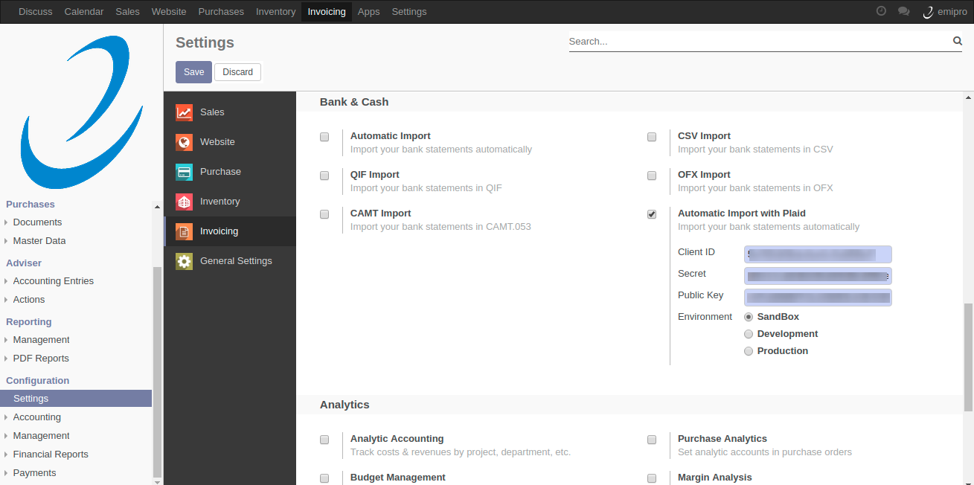

Configure Plaid Bank Account into Accounting Journals
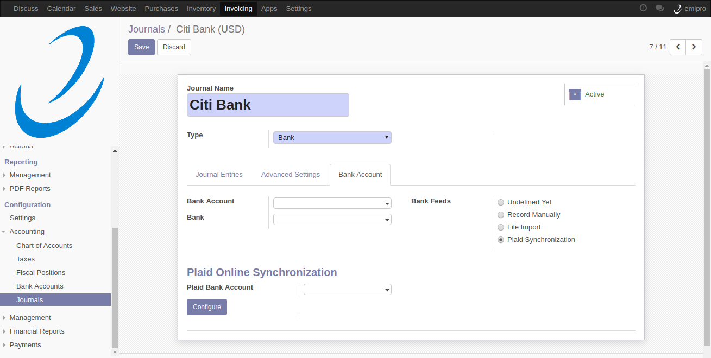

Link Bank Account to Odoo
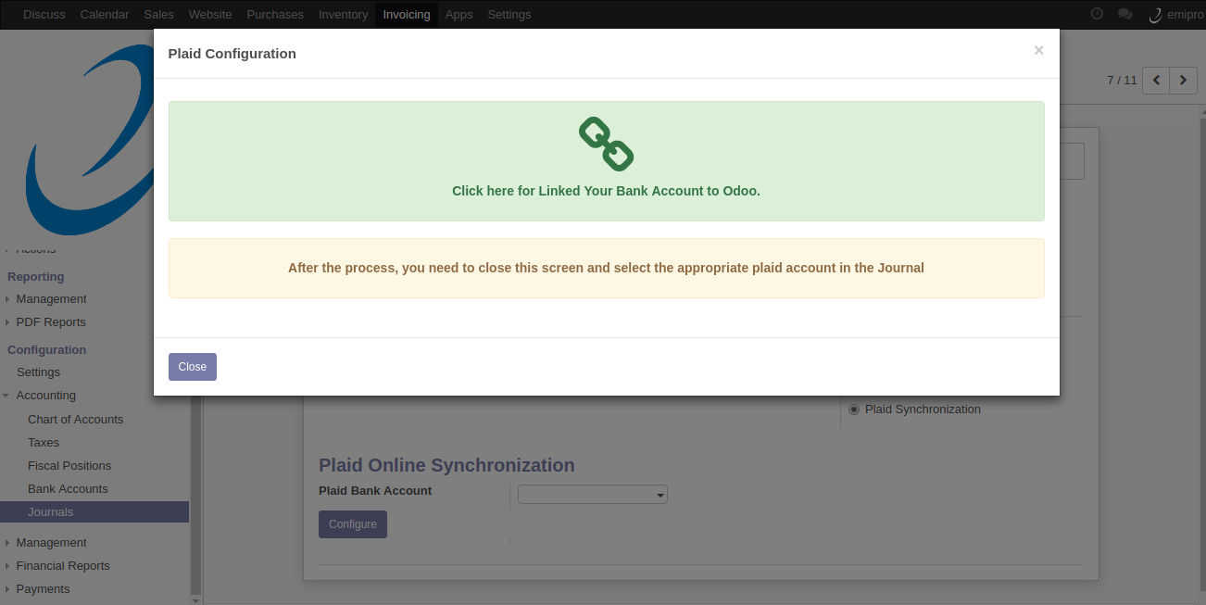

Quick Integration with Plaid
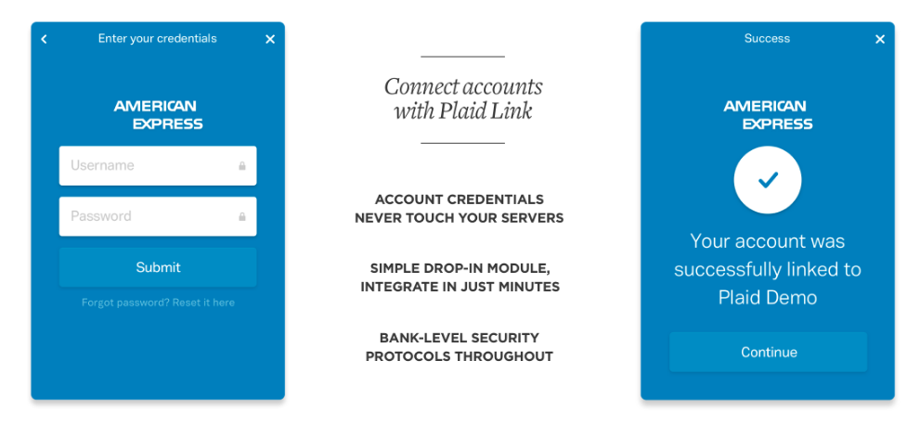
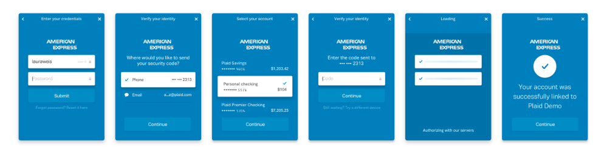

select the appropriate plaid account in the Journal
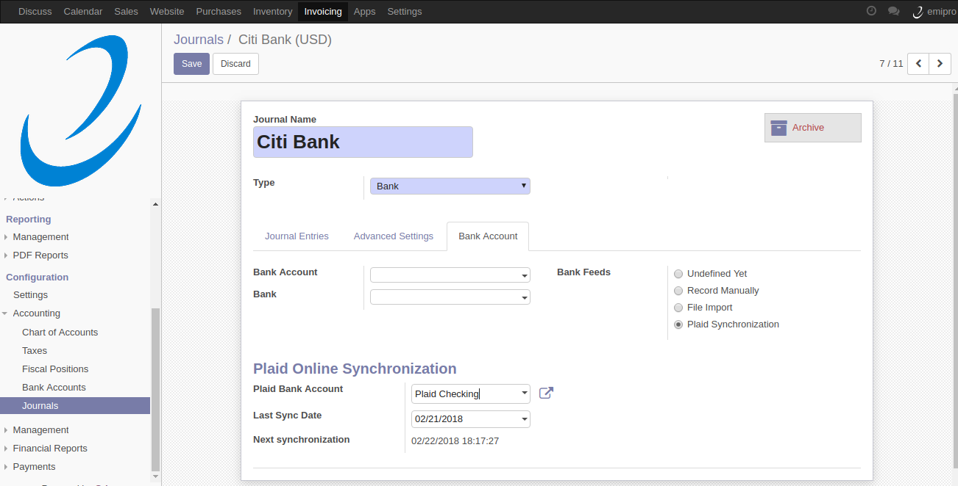

Sync Manually from Invoicing Dashboard
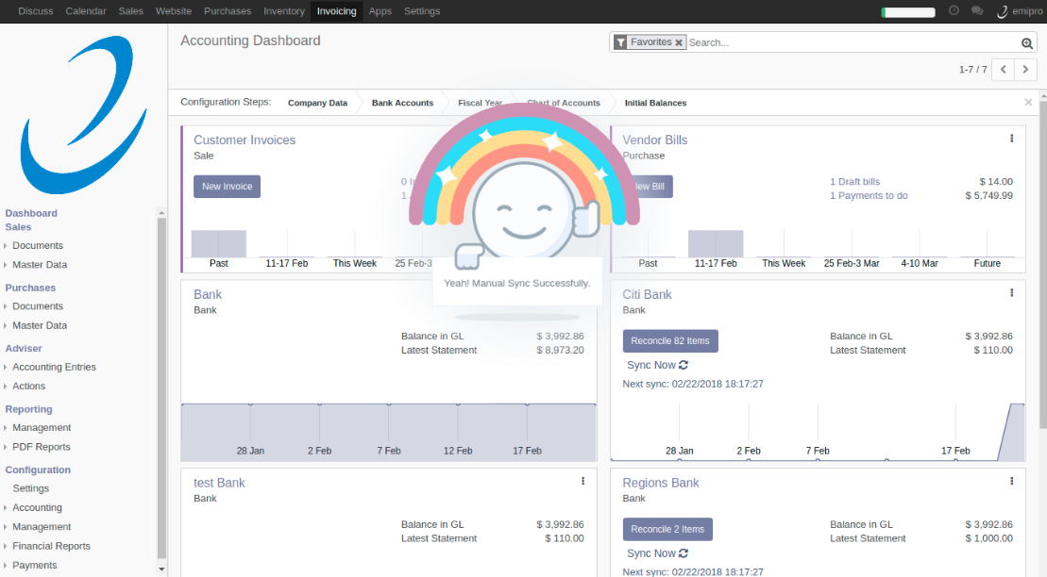

Sync Manually from Plaid Bank Account
