12.6 This
My objective here is to understand fully how ‘this’ is implemented in Jlox.

Page 208
Running the code sample at the top of page 208.
1 class Cake {
2 taste() {
3 var adjective = “delicious”;
4 print “The “ + this.flavor + “ cake is “ + adjective + “!”;
5 }
6 }
7 var cake = Cake();
8 cake.flavor = “German Chocolate”;
9 cake.taste();

line 1 through 5 – OK, stepped through it once.
Back to line 2 to look at LoxFunction made for taste(). Looking for its closure
Interpreter visitClassStmt() … walking the class’s methods and creating LoxFunctions.
LoxFunction(method, environment) .. environment here is the global environment
Within LoxFunction instance, this is its closure, closure points to global – matches top sketch on page 208

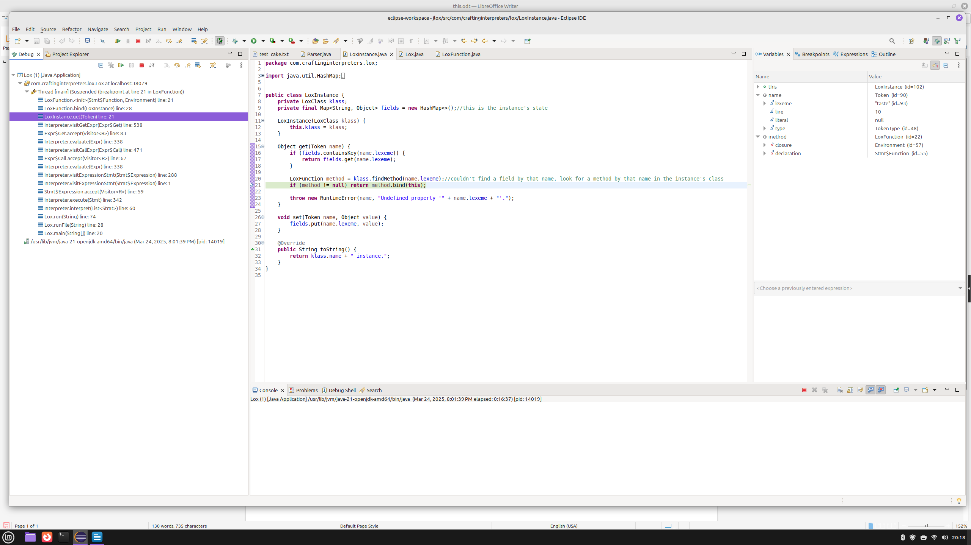
Wasn’t a field, it’s a method. findMethod() got that LoxFunction.
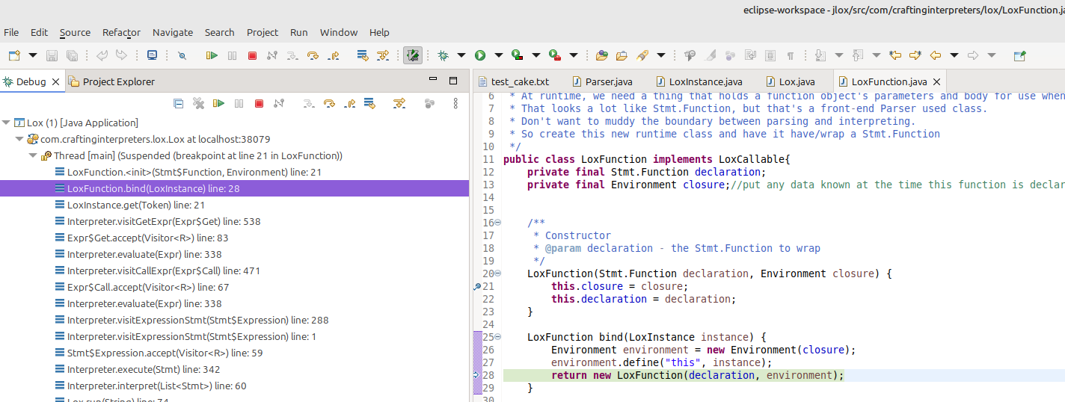
bind() does what is shown in the bottom sketch on page 208: create a new inner environment with the LoxFunction’s closure as its parent. Bind “this” to the LoxInstance in that new inner environment. Create a new, “clone”, LoxFunction whose closure is this new inner environment where “this” is bound. That “clone” LoxFunction is the one returned. So that when that taste() LoxFunction is called later, its body’s environment has that inner environment as it’s parent, the environment with ‘this’ in it. When this.flavor is used in the print statement, ‘this’ can be found by walking up the environment chain from the body.
At executeBlock(List<Stmt> statements, Environment environment), environment passed in is the one with ‘this’ bound in it.

