# OpenH264 Memory Scan

Table of Contents

OpenH264 Memory Scan 1

1. UBSan check 2

Introduction 2

2. ASan check 4

Introduction 4

3. Low memory check 6

4. MSan Check 8

Introduction 8

5. Valgrind 11

# UBSan check

**Overall memory check:**

<https://clang.llvm.org/docs/index.html>

**UBSan:**

<https://clang.llvm.org/docs/UndefinedBehaviorSanitizer.html>

**Jenkins job:**

<http://10.140.198.27:8080/view/Robustness_test/job/Openh264_MemCheck_UBSAN/configure>

**UBSan**

## [Introduction](https://clang.llvm.org/docs/UndefinedBehaviorSanitizer.html#id1)

UndefinedBehaviorSanitizer (UBSan) is a fast undefined behavior detector. UBSan modifies the program at compile-time to catch various kinds of undefined behavior during program execution, for example:

* Using misaligned or null pointer
* Signed integer overflow
* Conversion to, from, or between floating-point types which would overflow the destination

See the full list of available [**checks**](https://clang.llvm.org/docs/UndefinedBehaviorSanitizer.html#ubsan-checks) below.

UBSan has an optional run-time library which provides better error reporting. The checks have small runtime cost and no impact on address space layout or ABI.

**Error output:**

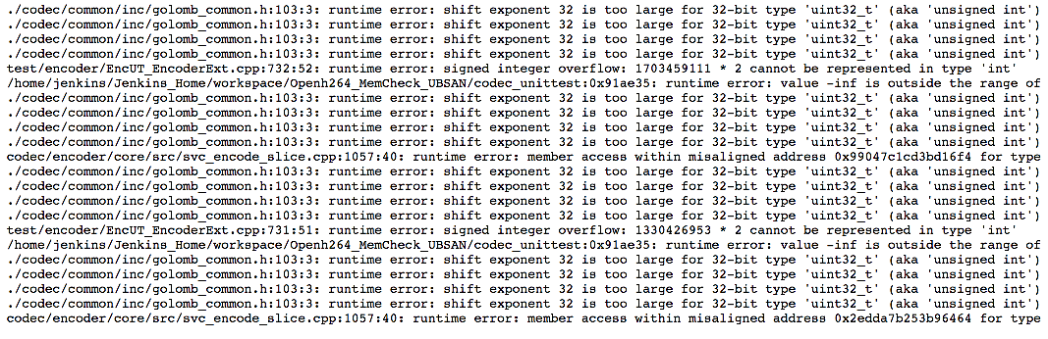

**Scripts:**

#!/bin/bash

set -x

#vBitPath="/home/jenkins/avc_bits/from_Github"

vOut="OutputUBSAN.txt"

vKey="anitizer|runtime error|egmentation|== Warning|== Error"

vErr="Error.txt"

vMail="Mail.txt"

aECMode=(0 7) # Error Concealment mode, please refer to openh264 api code

vNum=0

function GenerateExe() {

echo "Current EC mode is $1"

sed -i "/int32_t iErrorConMethod/c int32_t iErrorConMethod = $1;" codec/console/dec/src/h264dec.cpp

make clean >> /dev/null

make 1>>/dev/null

}

function RunAllTest() {

for vFile in `find ${vBitPath} -name "*.*264"`

do

echo "Testing Sequence is: "$vFile >>$vOut

./h264dec $vFile ./test.yuv 1>>$vOut 2>>$vOut

rm -f ./test.yuv

vNum=`expr $vNum + 1`

done

}

echo "Clean the status files:"

rm -f $vOut && rm -f $vErr && rm -f $vMail

echo "Build Name: ${parent_project}#${parent_build_number}-${NODE_NAME}" >> $vMail

export CC="clang -fsanitize=undefined -fno-sanitize=vptr"

export CXX="clang++ -fsanitize=undefined -fno-sanitize=vptr"

export LD="clang++"

export LDFLAGS="-fsanitize=undefined"

if [ ! -d "./gtest" ]; then

echo "Prepare the gtest code:" >> $vOut

make gtest-bootstrap

fi

sed -i 's/\/\/#define NO_DELAY_DECODING/#define NO_DELAY_DECODING/' codec/console/dec/src/h264dec.cpp

for vECMode in ${aECMode[@]}

do

echo "EC Mode == $vECMode" >> $vOut

vNum=0

GenerateExe $vECMode

./codec_unittest 1>>$vOut 2>>$vOut

RunAllTest $vBitPath

done

grep -E "$vKey" $vOut >> $vErr

if [ -s $vErr ]

then

echo "The listed error occur. Please check it." >> $vMail

cat $vErr >> $vMail

else

echo "No error found in this Test. Good luck." >> $vMail

fi

exit 0

# ASan check

**ASan:**

<https://clang.llvm.org/docs/AddressSanitizer.html>

**Jenkins job:**

<http://10.140.198.27:8080/view/Robustness_test/job/Openh264_MemCheck_ASAN/>

## [Introduction](https://clang.llvm.org/docs/AddressSanitizer.html#id1)

AddressSanitizer is a fast memory error detector. It consists of a compiler instrumentation module and a run-time library. The tool can detect the following types of bugs:

* Out-of-bounds accesses to heap, stack and globals
* Use-after-free
* Use-after-return (runtime flag ASAN_OPTIONS=detect_stack_use_after_return=1)
* Use-after-scope (clang flag -fsanitize-address-use-after-scope)
* Double-free, invalid free
* Memory leaks (experimental)

Typical slowdown introduced by AddressSanitizer is **2x**.

**Scripts:**

#!/bin/bash

set -x

vOut="OutputASAN.txt"

vKey="anitizer|runtime error|egmentation|== Waring|== Error"

vErr="Error.txt" && vMail="Mail.txt"

aECMode=(0 7) # Error Concealment mode, please refer to openh264 api code

vNum=0

function GenerateExe() {

echo "Current EC mode is $1"

sed -i "/int32_t iErrorConMethod/c int32_t iErrorConMethod = $1;" codec/console/dec/src/h264dec.cpp

make clean >> /dev/null

make USE_ASAN=Yes 1>>/dev/null

}

function RunAllTest() {

for vFile in `find ${vBitPath} -name "*.*264"`

do

echo "Testing Sequence is: "$vFile >>$vOut

./h264dec $vFile ./test.yuv 1>>$vOut 2>>$vOut

rm -f ./test.yuv

vNum=`expr $vNum + 1`

done

}

echo "Clean the status files:"

rm -f $vOut && rm -f $vErr && rm -f $vMail

export CC="clang"

export CXX="clang++"

if [ ! -d "./gtest" ]; then

echo "Prepare the gtest code:" >> $vOut

make gtest-bootstrap

fi

#echo "First test the delay mode:" >> $vOut

#for vECMode in ${aECMode[@]}

#do

# echo "EC Mode == $vECMode" >> $vOut

# vNum=0

# GenerateExe $vECMode

# ./codec_unittest 1>>$vOut 2>>$vOut

# RunAllTest $vBitPath

#done

echo "Second test the no-delay mode:" >> $vOut

sed -i 's/\/\/#define NO_DELAY_DECODING/#define NO_DELAY_DECODING/' codec/console/dec/src/h264dec.cpp

for vECMode in ${aECMode[@]}

do

echo "EC Mode == $vECMode" >> $vOut

vNum=0

GenerateExe $vECMode

./codec_unittest 1>>$vOut 2>>$vOut

RunAllTest $vBitPath

done

grep -E "$vKey" $vOut >> $vErr

if [ -s $vErr ] ; then

echo "The listed error occur. Please check it." >> $vMail

cat $vErr >> $vMail

else

echo "No error found in this Test. Good luck." >> $vMail

fi

exit 0

# Low memory check

<http://10.140.198.27:8080/view/Robustness_test/job/Openh264_MemCheck_LowMemory/>

**Tools:**

**ulimit:** User limits - limit the use of system-wide resources.

<https://ss64.com/bash/ulimit.html>

Syntax

ulimit [-acdfHlmnpsStuv] [limit]

Options

-S Change and report the soft limit associated with a resource.

-H Change and report the hard limit associated with a resource.

-a All current limits are reported.

-c The maximum size of core files created.

-d The maximum size of a process's data segment.

-f The maximum size of files created by the shell(default option)

-l The maximum size that can be locked into memory.

-m The maximum resident set size.

-n The maximum number of open file descriptors.

-p The pipe buffer size.

-s The maximum stack size.

-t The maximum amount of cpu time in seconds.

-u The maximum number of processes available to a single user.

-v The maximum amount of virtual memory available to the process.

**Run on:**

**ubuntu-64bits-hf-CodeNomicon**

**ErrorOutput (Example):**

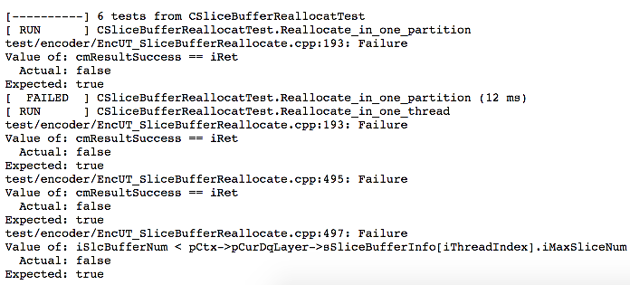

**Script:**

#!/bin/bash

set -x

# Print some enviornment information

echo ${WORKSPACE}

echo `ifconfig | grep "inet addr"`

echo `nasm -v`

# The test script body

vErr="Error.txt"

aMemorySize=(163840 81920 40960 10240)

export CC="clang"

export CXX="clang++"

if [ ! -d "./gtest" ]

then

echo "Prepare the gtest code:" >> $vOut

make gtest-bootstrap

fi

make clean >>/dev/null

make 1>>/dev/null

rm -f $vErr

# The common unlimited case

echo "The common case: " >> $vErr

ulimit -m unlimited -v unlimited

./codec_unittest args >> $vErr

if [ $? -eq 139 ]; then

echo "It crashed!"

exit 1

fi

# The lower memory case

for vMemorySize in ${aMemorySize[@]}

do

rm $vErr #delete the error file for each passed case

echo "The memory size is: " $vMemorySize >> $vErr

ulimit -m $vMemorySize -v $vMemorySize

./codec_unittest args >> $vErr

if [ $? -eq 139 ]

then

echo "It crashed!"

exit 1

fi

done

rm $vErr # delete the error file when success

exit 0

# MSan Check

MSan: <https://clang.llvm.org/docs/MemorySanitizer.html>

Jenkins job: <http://10.140.198.27:8080/view/Robustness_test/job/Openh264_MemCheck_MSAN/>

## [Introduction](https://clang.llvm.org/docs/MemorySanitizer.html#id1)

MemorySanitizer is a detector of uninitialized reads. It consists of a compiler instrumentation module and a run-time library.

Typical slowdown introduced by MemorySanitizer is **3x**.

**Script:**

########### This job can't work well now, Memory SAN output warning information ############

########### Don't the reasons, the Clang version? or the source code? ############

########### Some warnings reported from the gtest framework, it sounds bad ############

#!/bin/bash

set -x

# Print some enviornment information

echo ${WORKSPACE}

echo `ifconfig | grep "inet addr"`

echo `nasm -v`

echo `gcc -v`

# The test script body

#vBitPath="/home/jenkins/avc_bits/from_Github"

vOut="OutputMSAN.txt"

vKey="anitizer|runtime error|egmentation|== Warning|== Error"

vErr="Error.txt"

vMail="Mail.txt"

aECMode=(0 7) # Error Concealment mode, please refer to openh264 api code

vNum=0

function GenerateExe() {

echo "Current EC mode is $1"

sed -i "/int32_t iErrorConMethod/c int32_t iErrorConMethod = $1;" codec/console/dec/src/h264dec.cpp

make clean >> /dev/null

make 1>>/dev/null

}

function RunAllTest() {

for vFile in `find ${vBitPath} -name "*.*264"`

do

echo "Testing Sequence is: "$vFile >>$vOut

./h264dec $vFile ./test.yuv 1>>$vOut 2>>$vOut

rm -f ./test.yuv

vNum=`expr $vNum + 1`

done

}

echo "Clean the status files:"

rm -f $vOut

rm -f $vErr

rm -f $vMail

CFLAGS +=

export CC="clang -fno-omit-frame-pointer -fsanitize=memory -fno-optimize-sibling-calls -fsanitize-memory-track-origins -g -fstack-protector-all -D_FORTIFY_SOURCE=2"

export CXX="clang++ -fno-omit-frame-pointer -fsanitize=memory -fno-optimize-sibling-calls -fsanitize-memory-track-origins -g -fstack-protector-all -D_FORTIFY_SOURCE=2"

export LD="clang++"

export LDFLAGS="-fsanitize=memory"

if [ ! -d "./gtest" ]

then

echo "Prepare the gtest code:" >> $vOut

make gtest-bootstrap

fi

#echo "First test the delay mode:" >> $vOut

#for vECMode in ${aECMode[@]}

#do

# echo "EC Mode == $vECMode" >> $vOut

# vNum=0

# GenerateExe $vECMode

# ./codec_unittest 1>>$vOut 2>>$vOut

# RunAllTest $vBitPath

#done

echo "Second test the no-delay mode:" >> $vOut

sed -i 's/\/\/#define NO_DELAY_DECODING/#define NO_DELAY_DECODING/' codec/console/dec/src/h264dec.cpp

for vECMode in ${aECMode[@]}

do

echo "EC Mode == $vECMode" >> $vOut

vNum=0

GenerateExe $vECMode

./codec_unittest 1>>$vOut 2>>$vOut

RunAllTest $vBitPath

done

grep -E "$vKey" $vOut >> $vErr

if [ -s $vErr ]

then

echo "The listed error occur. Please check it." >> $vMail

cat $vErr >> $vMail

else

echo "No error found in this Test. Good luck." >> $vMail

fi

exit 0

# Valgrind

**Valgrind:**

<http://valgrind.org/>

**Jenkins job:**

<http://10.140.198.27:8080/view/Robustness_test/job/Openh264_MemCheck_Valgrind/>

**About valgrind:**

Valgrind is an instrumentation framework for building dynamic analysis tools. There are Valgrind tools that can automatically detect many memory management and threading bugs, and profile your programs in detail. You can also use Valgrind to build new tools.

The Valgrind distribution currently includes six production-quality tools: a memory error detector, two thread error detectors, a cache and branch-prediction profiler, a call-graph generating cache and branch-prediction profiler, and a heap profiler. It also includes three experimental tools: a stack/global array overrun detector, a second heap profiler that examines how heap blocks are used, and a SimPoint basic block vector generator. It runs on the following platforms: X86/Linux, AMD64/Linux, ARM/Linux, ARM64/Linux, PPC32/Linux, PPC64/Linux, PPC64LE/Linux, S390X/Linux, MIPS32/Linux, MIPS64/Linux, TILEGX/Linux, X86/Solaris, AMD64/Solaris, ARM/Android (2.3.x and later), ARM64/Android, X86/Android (4.0 and later), MIPS32/Android, X86/Darwin and AMD64/Darwin (Mac OS X 10.10, with initial support for 10.11).

Valgrind is [Open Source](http://www.opensource.org/) / [Free Software](http://www.gnu.org/philosophy/free-sw.html), and is freely available under the [GNU General Public License, version 2](http://www.gnu.org/licenses/gpl-2.0.html).

**Script:**

#!/bin/bash

set -x

vOut="OutputValgrind.txt"

vKey="anitizer|runtime error|egmentation|== Warning|== Error"

vErr="Error.txt"

vMail="Mail.txt"

aECMode=(0 7) # Error Concealment mode, please refer to openh264 api code

vNum=0

function GenerateExe() {

echo "Current EC mode is $1"

sed -i "/int32_t iErrorConMethod/c int32_t iErrorConMethod = $1;" codec/console/dec/src/h264dec.cpp

make clean >> /dev/null

make 1>>/dev/null

}

function RunAllTest() {

for vFile in `find ${vBitPath} -name "*.*264"`

do

echo "Testing Sequence is: "$vFile >>$vOut

valgrind ./h264dec $vFile ./test.yuv 1>>$vOut 2>>$vOut

rm -f ./test.yuv

vNum=`expr $vNum + 1`

done

}

echo "Clean the status files:"

rm -f $vOut && rm -f $vErr && rm -f $vMail

if [ ! -d "./gtest" ]

then

echo "Prepare the gtest code:" >> $vOut

make gtest-bootstrap

fi

echo "Second test the no-delay mode:" >> $vOut

sed -i 's/\/\/#define NO_DELAY_DECODING/#define NO_DELAY_DECODING/' codec/console/dec/src/h264dec.cpp

for vECMode in ${aECMode[@]}

do

echo "EC Mode == $vECMode" >> $vOut

vNum=0

GenerateExe $vECMode

valgrind ./codec_unittest 1>>$vOut 2>>$vOut

RunAllTest $vBitPath

done

grep -E "$vKey" $vOut >> $vErr

if [ -s $vErr ]

then

echo "The listed error occur. Please check it." >> $vMail

cat $vErr >> $vMail

else

echo "No error found in this Test. Good luck." >> $vMail

fi

exit 0