**Project 3 Part 3 (full recursive approach O(nlog^2n))**

Name: Randy Period: 5

Date: 11/8/22

Is your lab name l033?(lowercase L followed by digits 033) Yes

Did you created a class to store a point? Yes

Did you use a vector to store the points you generated? Yes

Did you use at least one iterator to traverse the vector you created (optional)? No

Did you sort using the sort method offered by C++? Yes

Does your main has the part1 commented out? Yes

Does your main contain only 3 calls of: part0(), part2() and part3() (NO part1!!)? Yes

(in main you may also have the part to display results for the 2 methods and then also in the txt file)

Obs: the part1 and part2 may have a return type like the time it took to complete the algorithm, the minimum distance, the points for the minimum distance, or you may create global variables for these.

1. **Paste here a clear picture of the graph that compares the running times of the “initial recursive” algorithm and “full recursive” algorithm versus number of points. (use 2 different colors for the 2 graphs, colors that can be visible even if you print in black and white). Each point on this graph should be an average of several runs for that size:**

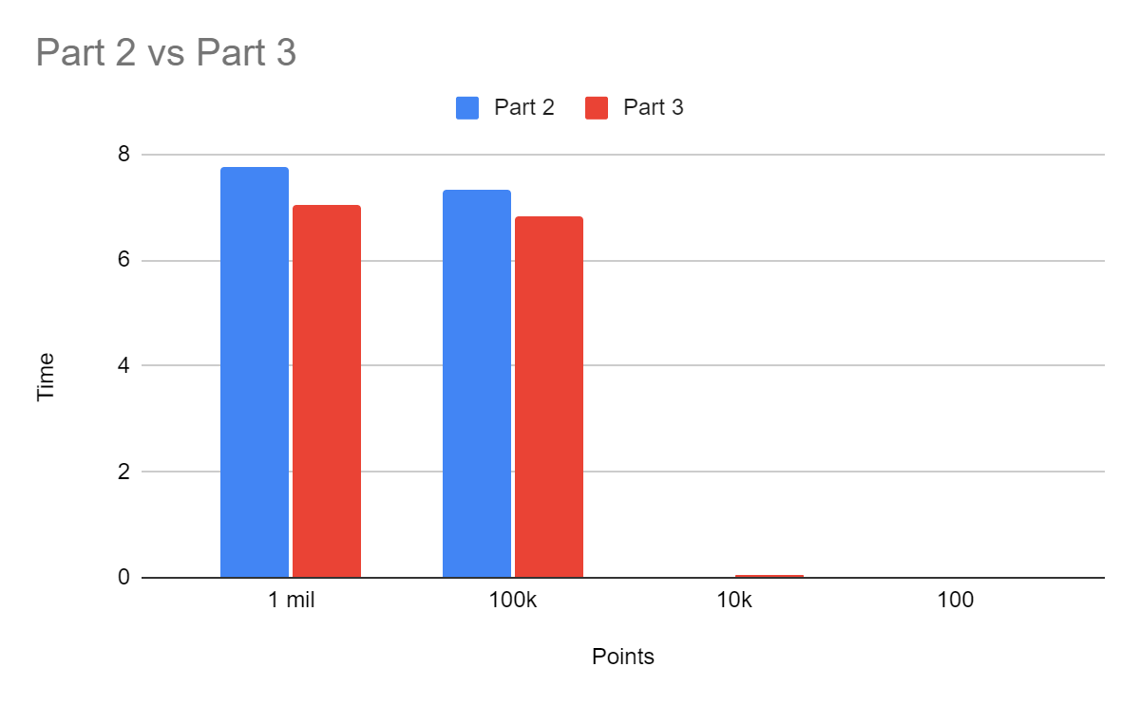

1. **Paste here the content of the results.txt when you run your lab on the content of the file points10k.txt and points100k.dat**

**For 10k:**

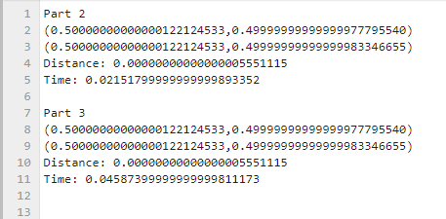

**For 100k:**

