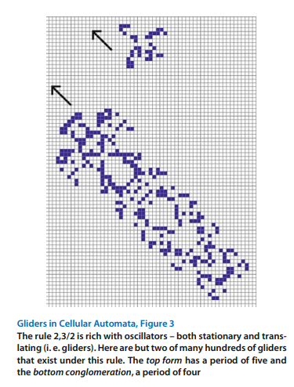Widespread popular interest of CA was created when John Conway’s “game of life” cellular automaton was initially revealed to the public in a 1970 Scientific American article (https://www.ibiblio.org/lifepatterns/october1970.html). The single feature of his game that probably caused this intensive interest was undoubtedly the discovery of “gliders” (translating oscillators that move across the grid of a CA). Not surprisingly, gliders are present in many other cellular automata rules.

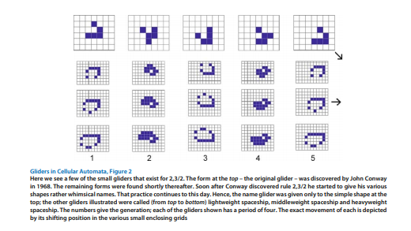

In Figs. 2 and 3 we show several oscillators that move across the grid as they change from generation to generation. Such forms are called translating oscillators, or more commonly, gliders. Conway’s rule popularized the term glider; in fact a flurry of activity began during which a great many shapes were discovered and exploited. Most translating oscillators were given names other than the simple moniker glider – there were “lightweight spaceships”, “puffer trains”, etc. For this article, we shall call all translating oscillators “gliders”.

Of course rule 2,3/3 is not the only CA rule. Configurations under some rules always die out, and other rules lead to explosive growth. (We say that rules with expansive growth are unstable). We can easily find gliders for many unstable rules; for example Fig. 4 illustrates some simple constructs for rule 2/2.

Hence we shall only look at gliders for rules that stabilize (i. e. exhibit bounded growth) and eventually yield only zero or more oscillators. We call such rules GL (game of life) rules. Stability can be a rather murky concept, since there may be some carefully constructed forms within a GL rule that grow without bounds. Typically, such forms would never appear in random configurations**.** Hence, we shall informally define a GL rule as follows:

1. All neighbors must be touching the candidate cell and all are treated the same (a Moore neighborhood).
2. there must exist at least one translating oscillator (a glider).
3. Random configurations must eventually stabilize.

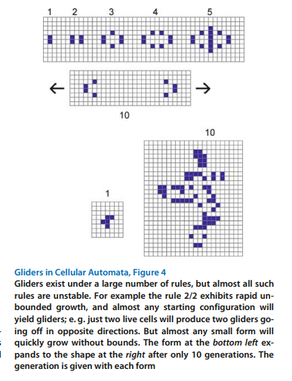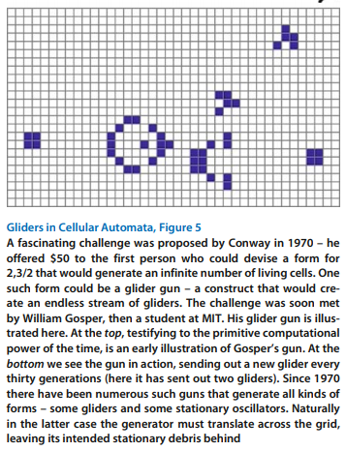file:///sC:/Users/randy/Downloads/Bays2009_ReferenceWorkEntry_GlidersInCellularAutomata.pdf