

Faculty of Science

**Course**: CSCI 4110U: Advanced Computer Graphics

**Lab Assignment:** 1

**Topic:** Hierarchical Modelling

## Overview

In this lab, you will create a more complex model using a simple model: a cube. The code to draw a single, transformed, cube is provided. You are expected to make modifications to this program to make it draw a hand shape.

## Instructions

First, you should download the base project. All of the base projects will be put into a single GitHub repository, which may not have all base projects at the time of your laboratory. Additional base projects may be added later, but the base project for this lab is already there. The location of the repository is given, below:

* <https://github.com/randyfortier/CSCI4110U_Labs>

This project draws a red cube, although it has been transformed so that it doesn’t look like a perfect cube. This red shape will be the palm of the hand. Included in the base project is an unimplemented method, called drawFinger(). Your main draw function will call this drawFinger() method 5 times, once for each finger. In the drawFinger() method, you will call drawCube() to draw three more boxes to make up each finger. The result should look like Figure 1.

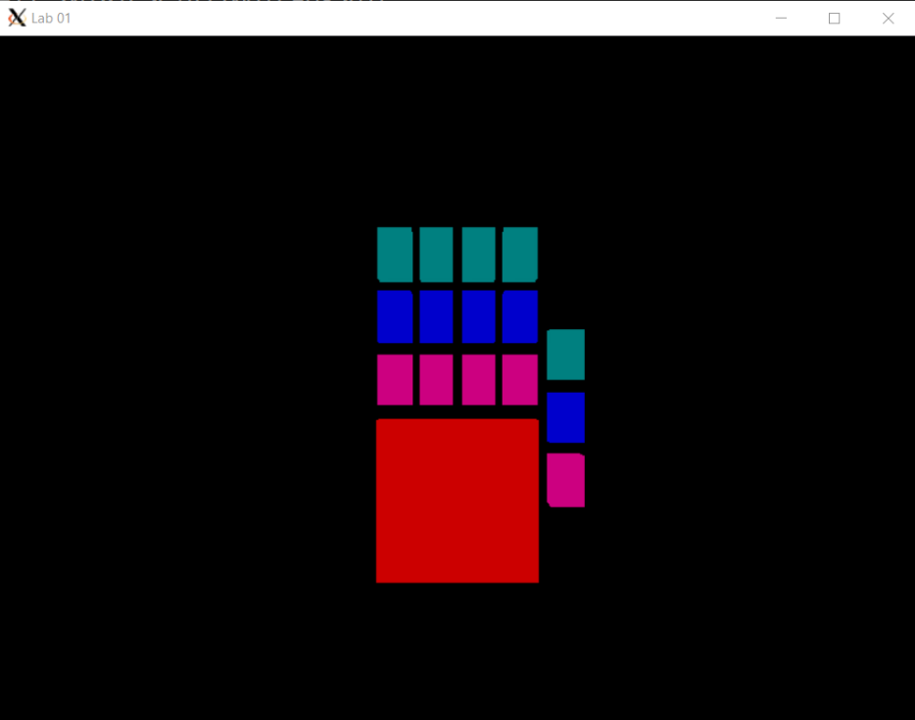

*Figure 1 – the output of the final version of the program*

## Lab Report

To demonstrate to the lab instructor your completion of this laboratory assignment, merely show them the modified OpenGL program.