

Faculty of Science

**Course**: CSCI 4110U: Advanced Computer Graphics

**Lab Assignment:** 2

**Topic:** Parametric Primitives

## Overview

In this lab, you will create the geometry for a primitive 3D shape: a cylinder. The code to generate a sphere, write it to an .OBJ file, and display the .OBJ file is provided. You are expected to make modifications to this program to make it draw a cylinder. The loading and drawing code should remain unchanged.

## Instructions

First, you should download the base project from the repository is given, below:

* <https://github.com/randyfortier/CSCI4110U_Labs>

Drawing a sphere is a bit more complicated than drawing a cylinder. Essentially, drawing a cylinder centred around generating a circle. You can do this by looping over the angle (ϴ) to create each point in the circle. The parametric equations for a 2D circle are below:

$$x=r ∙cos{θ}$$

$$y=r ∙sin{θ}$$

For each circle point (x,y), you will create two vertices (one at the top of the cylinder, and one at the bottom) at the same (x,y) position (differing only in z). See Figure 1 for details. For each pair of circular vertices (C and D), you will create two triangles (W and X) on the side of the cylinder (along with the previous two points, A and B), and one triangle on each of the top (Y, using point CT) and the bottom (Z, using point CB). The two points CT and CB are the centre points of the top and bottom of the cylinder.

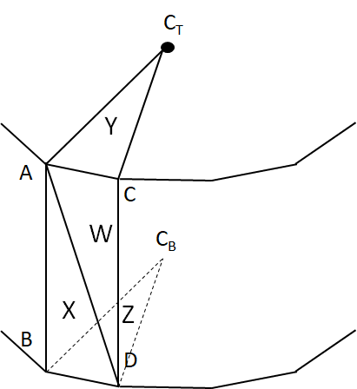

*Figure 1 – the geometry of a single pair of circular vertices*

You are not required to change anything except the geometry creation stage. It is recommended that you create a new class, Cylinder, based on the existing UVSphere class. The final output of the program is shown in Figure 2.

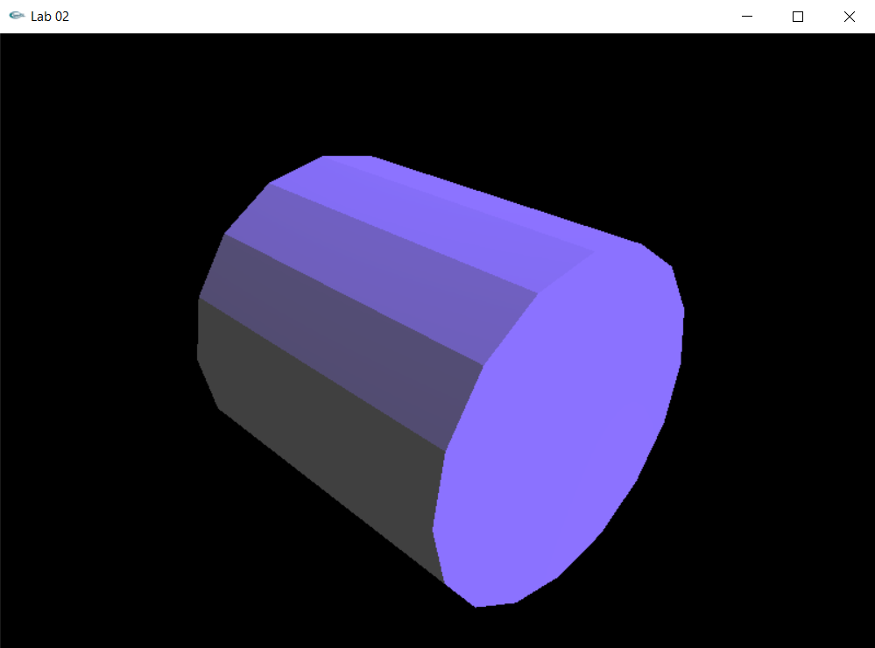

*Figure 2 – the output of the final, modified, version – a cylinder*

## Lab Report

To demonstrate to the lab instructor your completion of this laboratory assignment, merely show them the modified OpenGL program.