

Faculty of Science

**Course**: CSCI 4110U: Advanced Computer Graphics

**Lab Assignment:** 3

**Topic:** Parametrics – Bézier Curves

## Overview

In this lab, you will create the geometry for a 3D cubic Bézier curve. The code to generate a strip of lines (based on hard-coded points), and draw those lines, is provided. You are expected to make modifications to this program to make it draw a cubic Bézier curve.

## Instructions

First, you should download the base project from the repository is given, below:

* <https://github.com/randyfortier/CSCI4110U_Labs>

The parametric equations for a 3D cubic Bézier curve are below:

$$x={(1-t)}^{3}∙p0.x+{\left(1-t\right)}^{2}∙3t∙p1.x+ \left(1-t\right)∙{3t}^{2}∙p2.x+t^{3}∙p3.x$$

$$y={(1-t)}^{3}∙p0.y+{(1-t)}^{2}∙3t∙p1.y+ \left(1-t\right)∙{3t}^{2}∙p2.y+t^{3}∙p3.y$$

$$z={(1-t)}^{3}∙p0.z+{\left(1-t\right)}^{2}∙3t∙p1.z+ \left(1-t\right)∙{3t}^{2}∙p2.z+t^{3}∙p3.z$$

The parameter for these equations, t, will range from 0.0 to 1.0. The smaller the step size, the more points generated and the smoother the curve. In the example where the screenshot is taken, 21 points are used. In these equations p0, p1, p2, and p3 are the four control points. For the purposes of the screenshot, the following control points were used:

glm::vec3 controlPoint1(-2.00f, -1.50f, 2.00f);

glm::vec3 controlPoint2( 2.50f, 2.50f, -0.50f);

glm::vec3 controlPoint3(-1.00f, 1.00f, -2.50f);

glm::vec3 controlPoint4( 2.00f, -2.50f, -0.50f);

The result of this process should look similar to Figure 1.

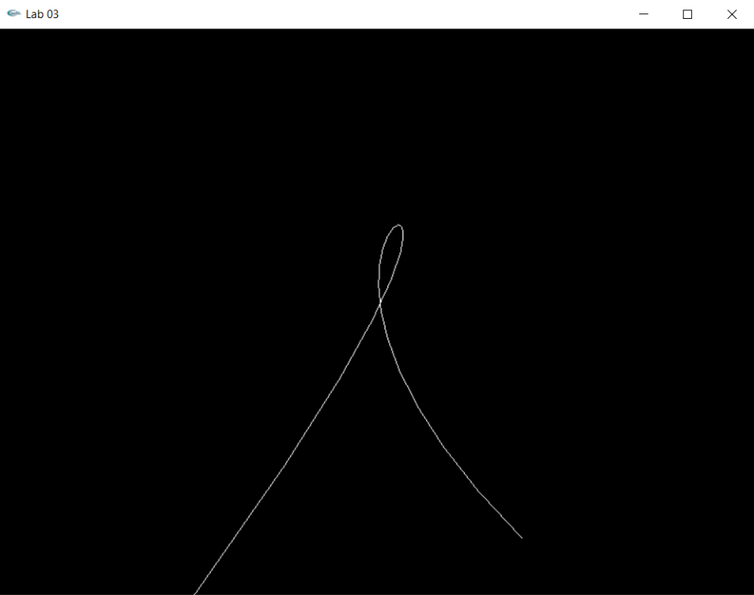

*Figure 1 – the output of the modified program*

## Lab Report

To demonstrate to the lab instructor your completion of this laboratory assignment, merely show them the modified OpenGL program.