

Faculty of Science

**Course**: CSCI 4110U: Advanced Computer Graphics

**Lab Assignment:** 4

**Topic:** Animation - Hierarchical

## Overview

In this lab, you will animate the transforms for a robot body and legs. The code to generate an unanimated robot, is provided. You are expected to make modifications to this program to make it translate and rotate the upper and lower leg parts to show the robot running.

## Instructions

First, you should download the base project from the repository is given, below:

* <https://github.com/randyfortier/CSCI4110U_Labs>

The program will contain arrays of translations and rotations for each of the leg parts:

* Upper right leg
* Lower right leg
* Upper left leg
* Lower left leg

You are not required to do any interpolation between the key frames. Simply hold the same transforms for all of the leg parts until the next frame (wait frame_delay milliseconds between key frames). It is recommended that you use 8 key frames, and work on each frame, one at a time to adjust the movement.

*Note: The animation doesn’t need to be Hollywood quality, but it should resemble a robot running.*

## Need an Extra Challenge?

If you feel like this is too easy for you (e.g. you have some background with OpenGL), you are welcome to try one of these variations (presented in order of difficulty):

1. Include more key frames in order to make the animation look more smooth
2. Use linear interpolation for the tween frames translations and rotations
3. Use linear interpolation for the tween frames for the translations, and quaternion interpolation for the rotations

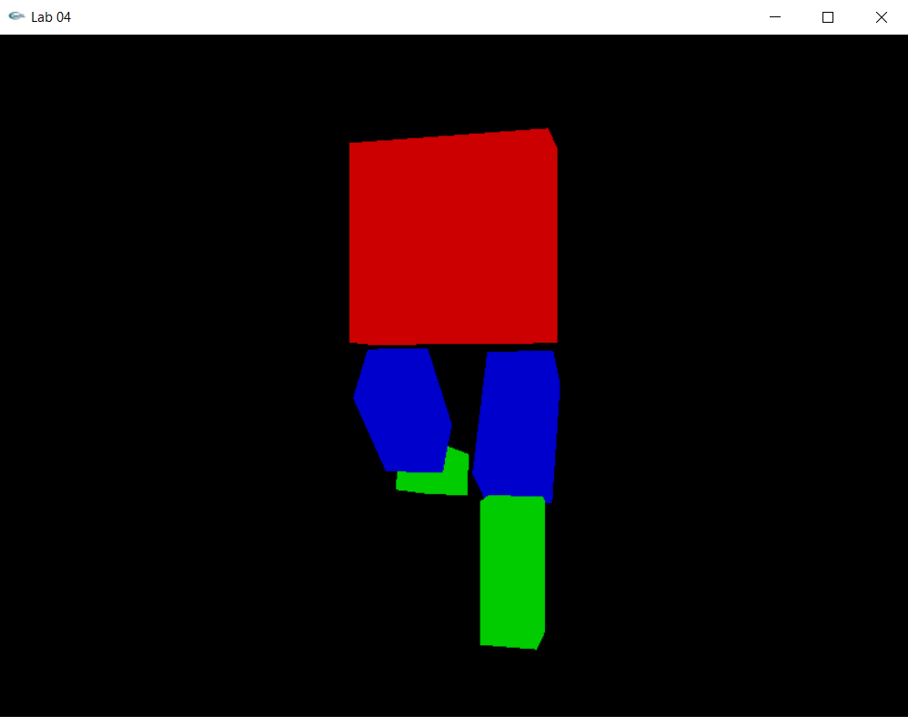

*Figure 1 – the output of the base program*

## Lab Report

To demonstrate to the lab instructor your completion of this laboratory assignment, merely show them the modified OpenGL program.