

Faculty of Science

**Course**: CSCI 2020U: Software Systems Development and Integration

**Lab:** #4

**Topic:** User Interfaces 1

**Overview**

In this lab, you’ll develop a Java program with a user interface, using JavaFX. It is recommended, but not required, that you use IntelliJ for this lab.

**Instructions**

You can use any operating system or environment for this laboratory assignment.

You will create a new directory called lab04. Use the following steps to complete this lab:

1. Create a registration application, that asks the user for the following information:
   * Username (a string)
   * Password (a string)
   * Full name (a string)
   * E-Mail address (a string)
   * Phone number (a string, format: 000-000-0000)
   * Date of birth (a date)
2. Organize the fields for this registration UI into a series of rows, each row having a label, the control most appropriate for that field
3. Include a button, ‘Register’, that when clicked will print all four fields’ values to the console

***Note****: See figure 1 for an example of the final product.*

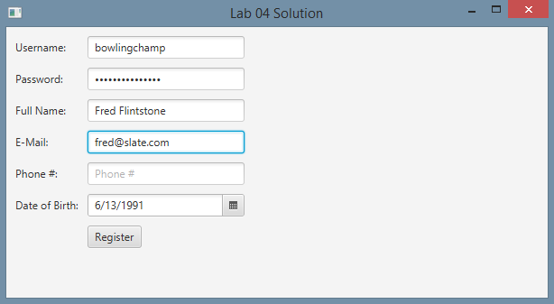

**Figure 1: The running application, showing the registration form**

**Extra Challenge (Optional)**

Try to figure out how to use the Apache Commons Validator, used in an earlier demonstration in the lectures, to validate the E-Mail address. Place an appropriate error message in the error message label, which is a new field to be placed to the right of the E-Mail text field, as shown in figure 2.

**Note**: If you are using IntelliJ Idea for this lab assignment and want to complete the extra challenge, you can easily add any library from the Maven Central repository. To do this, use the following steps:

1. Open up the Project Structure properties using CTRL-ALT-SHIFT-S
2. Click on Libraries
3. Click the + icon to add a new library
4. Select From Maven
5. Enter commons-validator:commons-validator:1.4.1, and click Ok

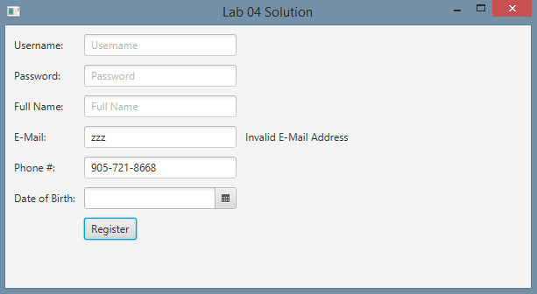

**Figure 2: The application, showing a validation error message for the E-Mail address**

**How to Submit**

Show your running application to the TA to prove that you have finished this lab. The TA can provide oral feedback if you do not receive full marks for any lab assignment, but it is most appropriate to ask the TA for this feedback in a timely fashion (i.e. ask now, not at the end of the term).