

Faculty of Science

**Course**: CSCI 2020U: Software Systems Development and Integration

**Lab:** #6

**Topic:** 2D Graphics

**Overview**

In this lab, you’ll develop a Java program that draws a bar chart and a pie chart, using JavaFX. It is recommended, but not required, that you use IntelliJ for this lab.

**Instructions**

You can use any operating system or environment for this laboratory assignment.

You will create a new directory (or IntelliJ IDEA project) called lab06. The 2D graphics demo might serve as a useful starting point, since this lab is similar. The following code will store the data that you should use for your bar chart:

***Code Listing 1: Sample Data for the Bar Chart***

private static double[] *avgHousingPricesByYear* = {  
 247381.0,264171.4,287715.3,294736.1,

308431.4,322635.9,340253.0,363153.7  
};  
private static double[] *avgCommercialPricesByYear* = {  
 1121585.3,1219479.5,1246354.2,1295364.8,

1335932.6,1472362.0,1583521.9,1613246.3  
};

Create a bar chart of these two arrays, each representing one of the two series in the chart. Show the first series with red rectangles, and the second series as blue rectangles. The height of the largest bar should be the maximum height of the window (minus a little space all around the chart, e.g. 50 pixels), and the rest should be proportionally smaller, based on their value.

For the pie chart, you’ll use the following data:

***Code Listing 2: Sample Data for the Pie Chart***

private static String[] *ageGroups* = {  
 "18-25", "26-35", "36-45", "46-55", "56-65", "65+"  
};  
private static int[] *purchasesByAgeGroup* = {  
 648, 1021, 2453, 3173, 1868, 2247  
};  
private static Color[] *pieColours* = {  
 Color.*AQUA*, Color.*GOLD*, Color.*DARKORANGE*,  
 Color.*DARKSALMON*, Color.*LAWNGREEN*, Color.*PLUM*};

Create a pie chart of the purchasesByAgeGroup array, by drawing a series of arcs. The colour of each arc should correspond to the colour at the same index in the pieColors array.

***Note****: See figure 1 for an example of the final product.*

**Figure 1: The running application, showing the two charts**

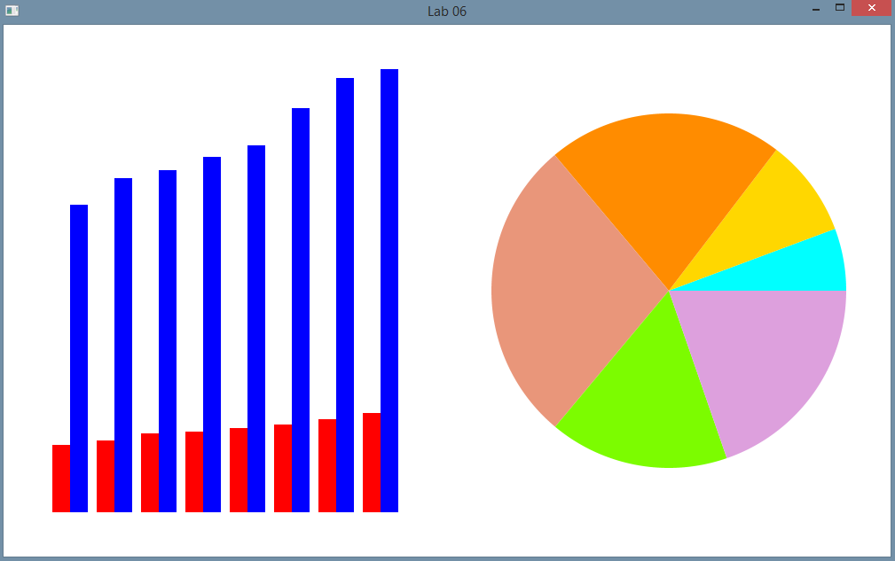

**Extra Challenge (Optional)**

Add an x-axis and y-axis to the bar chart, as well as a legend for the two series. For the pie chart, label each pie slice with the age group and the percentage of purchases. You could also draw an outline around each of the pie slices. The most challenging addition could be to add the ability to *explode* one or more of the pie slices, where if the slices is *exploded*, then it would be offset from the centre of the circle by some number of pixels.

**How to Submit**

Show your running application to the TA to prove that you have finished this lab. The TA can provide oral feedback if you do not receive full marks for any lab assignment, but it is most appropriate to ask the TA for this feedback in a timely fashion (i.e. ask now, not at the end of the term).