

Faculty of Science

**Course**: CSCI 2020U: Software Systems Development and Integration

**Lab:** #7

**Topic:** Loading Files

**Overview**

In this lab, you’ll develop a Java program that loads data from a CSV file and draws a pie chart using the data collected. It is recommended, but not required, that you use IntelliJ for this lab.

**Instructions**

You can use any operating system or environment for this laboratory assignment.

You will create a new directory (or IntelliJ IDEA project) called lab07. The previous 2D graphics lab might serve as a useful starting point, since this lab also draws a pie chart. The colours to be used in that lab will also be the same for this lab.

Load in the contents of the supplied data file (weatherwarnings-2015.csv), which contains a list of weather warnings in the US in 2015. The 6th column contains the type of warning (FLASH FLOOD, SEVERE THUNDERSTORM, SPECIAL MARINE, TORNADO). Count the number of each warning type.

***Hint****: I suggest you use a Map to keep count.*

Create a pie chart of the counts of each warning type. The pie chart should be to the right of the window. In the left of the window should be a simple legend. The warning types, and how many warning types there are, should not be hard coded into your program but taken from the file itself.

***Note****: See figure 1 for an example of the final product.*

**Figure 1: The running application, showing the chart and its legend**

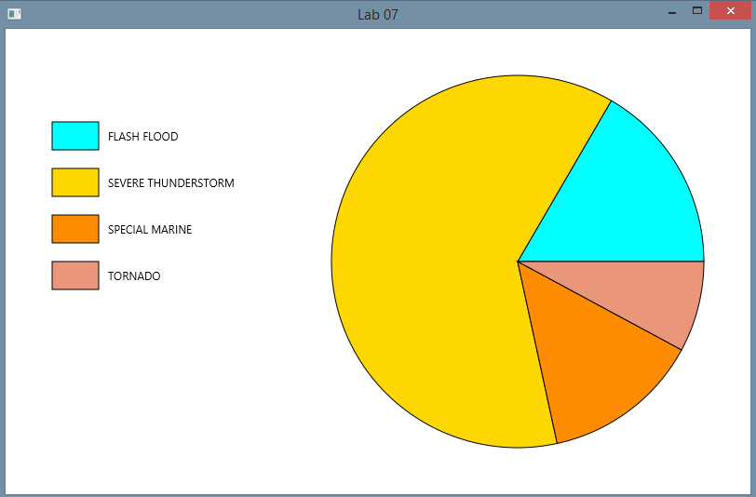

**How to Submit**

Show your running application to the TA to prove that you have finished this lab. The TA can provide oral feedback if you do not receive full marks for any lab assignment, but it is most appropriate to ask the TA for this feedback in a timely fashion (i.e. ask now, not at the end of the term).