

Faculty of Science

**Course**: CSCI 2020U: Software Systems Development and Integration

**Lab:** #8

**Topic:** Loading and saving files

**Overview**

In this lab, you’ll adapt a previous lab (lab 05: with a table user interface that shows student marks), adding the ability to load and save the records from the table. It is recommended, but not required, that you use IntelliJ for this lab.

**Instructions**

You can use any operating system or environment for this laboratory assignment.

You will create a new directory (or IntelliJ IDEA project) called lab08. Lab 05 should be your starting point, will focus on the file operations only. Add the following capabilities to the lab:

1. Ensure that the following menu items are added to the ‘File’ menu:
   * New
   * Open
   * Save
   * Save As
   * Exit
2. Create an instance variable called currentFilename, which stores the currently viewed file’s filename
3. Write a function save() that will pull all data from the TableView’s data structure, and save it to the current filename as a CSV file. This function will save only the following fields:
   * SID
   * Assignments
   * Midterm
   * Final Exam
4. Write a function load() that will load the CSV data (as above) from the current filename, and populate the TableView
5. When the ‘New’ menu item is clicked, you will clear all items from the TableView
6. When the ‘Open’ menu item is clicked, you will show a file chooser , which will do the following when used:
   * Update the currentFilename variable to the user-selected file’s filename
   * Call load()
7. When the ‘Save As’ menu item is clicked, you will show a file chooser (<https://docs.oracle.com/javase/8/javafx/api/javafx/stage/FileChooser.html>) , which will do the following when used:
   * Update the currentFilename variable to the user-selected file’s filename
   * Call save()
8. When the ‘Save’ menu item is clicked, you will call save()
9. When the ‘Exit’ menu item is clicked, you will exit the application

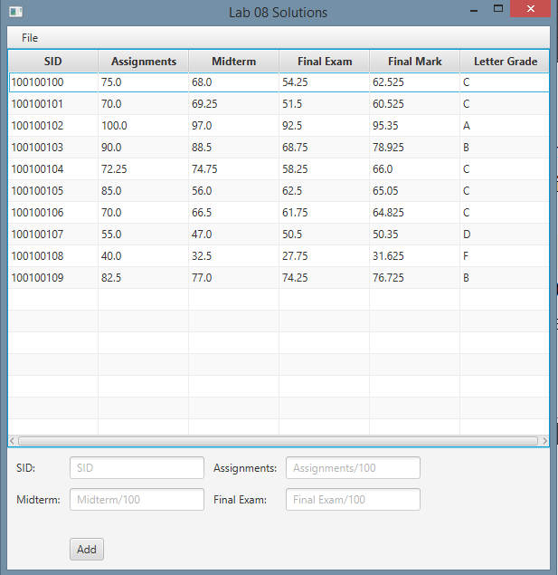

**Figure 1: The application’s sample output**

**How to Submit**

Show your running application to the TA to prove that you have finished this lab. The TA can provide oral feedback if you do not receive full marks for any lab assignment, but it is most appropriate to ask the TA for this feedback in a timely fashion (i.e. ask now, not at the end of the term).