

Faculty of Science

**Course**: CSCI 2020U: Software Systems Development and Integration

**Lab:** #9

**Topic:** Loading web data

**Overview**

In this lab, you’ll write a program to download stock prices from the web (Yahoo Finance), and draw a line chart comparing two stocks.

**Instructions**

You can use any operating system or environment for this laboratory assignment.

You will create a new directory (or IntelliJ IDEA project) called lab09. Perform the following steps:

1. Write a function, downloadStockPrices():
   * This function takes a stock ticker symbol (e.g. GOOG), and downloads historical stock data about that organization from Yahoo Finance
   * The URL you will use will look like this:
     1. http://ichart.finance.yahoo.com/table.csv?s=GOOG&a=1&b=01&c=2010&d=11&e=31&f=2015&g=m
     2. s: stock ticker symbol
     3. a: starting day
     4. b: starting month (0-11)
     5. c: starting year
     6. d: ending day
     7. e: ending month (0-11)
     8. f: ending year
     9. g: period (use ‘m’ for monthly data)
2. Write a function, drawLinePlot():
   * This function takes two lists of floating point values, which are stock closing price values
   * Use 2D graphics to draw the x-axis and y-axis 50 pixels from the left and bottom edge of the window
   * Call plotLine() (below) twice, once for each stock
3. Write a function, plotLine():
   * Use 2D graphics to draw lines between each closing price
     1. Note: You’ll need to adjust for the size of the window, the 50 pixel pad around the outside, and for the inverted y-axis
4. Write some code to call the above functions in order to generate a graph similar to that shown in figure 1 (you can hard code the stock symbols, but I would recommend you try out a few different stocks, for thorough testing)

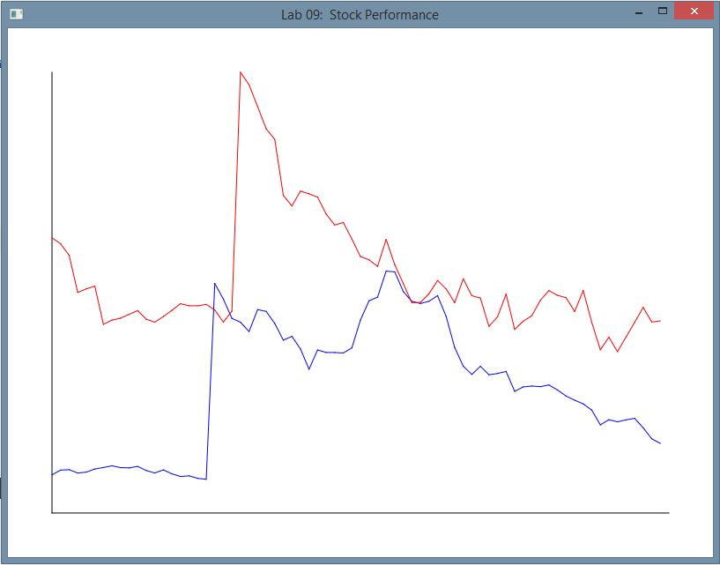

**Figure 1: The application’s sample output comparing Apple (AAPL: red) and Google (GOOG: blue)**

**How to Submit**

Show your running application to the TA to prove that you have finished this lab. The TA can provide oral feedback if you do not receive full marks for any lab assignment, but it is most appropriate to ask the TA for this feedback in a timely fashion (i.e. ask now, not at the end of the term).