2019 CLB & ERA Report Stock Composition Figures

# Introduction

Table 1. Stock Group Definitions

|  |  |
| --- | --- |
| Stock Group | Description |
| ORCST | Oregon Coast |
| CR | Columbia River |
| WACST | Washington Coast |
| PSD | Puget Sound |
| FR-late | Fraser Late |
| FR-early | Fraser Early |
| GS | Georgia Strait |
| WCVI | West Coast Vancouver Island |
| NCBC | North and Central B.C. |
| SEAK | Southeast Alaska |
| NONE ${}^{1}$ | None |
| UNK ${}^{2}$ | Unknown (i.e. Unsampled) |

${}^{1}$ Stock group NONE is comprised of stocks not represented and is contingent on the version of the Chinook Model.

${}^{2}$ UNK is not a stock group per se because it is the unsampled catch. GSI estimates are only available for the portion of the catch sampled for genetics, which may not be the same as the total catch.

## Estimating Stock Composition from the Chinook Model

Estimating stock composition from the Chinook Model is simple. First, the proportion of landed catch by model stock is computed as:

$$P_{F,S,Y}=\frac{Q_{F,S,Y}}{\sum_{S}{Q_{F,S,Y}}}$$

where $Q_{F,S,Y}$ is the model landed catch by fishery $F$, stock $S$, and year $Y$. Second, the landed catch stock composition is computed as:

$$C_{F,S,Y}=C_{F,Y}*P_{F,S,Y}$$

where $C_{F,Y}$ is the reported landed catch by fishery $F$ and year $Y$. Lastly, since the Chinook Model does not account for the Alaska Hatchery Addon, the landed catch stock composition is adjusted by:

$$C_{F,S=AK,Y}=C_{F,S=AK,Y}+A_{F,S=AK,Y}$$

where $A_{F,S=AK,Y}$ is the Alaska Hatchery Addon by fishery $F$ and year $Y$ for only the Alaska Stock Group - $S=AKS$ in clb1804 or $S=NSA$ and $S=SSA$ in Phase 2. The Alaska Hatchery Addon adjustment is necessary so that model-based estimates of landed catch stock composition are comparable to gsi-based estimates.

## Appendix E1–Chinook Model Estimates of landed catch stock composition for Alaska troll with (upper) and without (lower) Alaska hatchery add-on and terminal exclusion, 1979–2016.

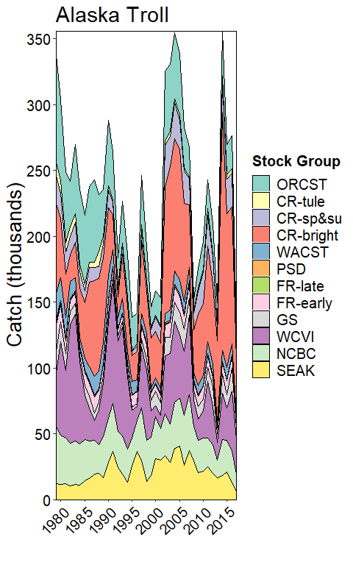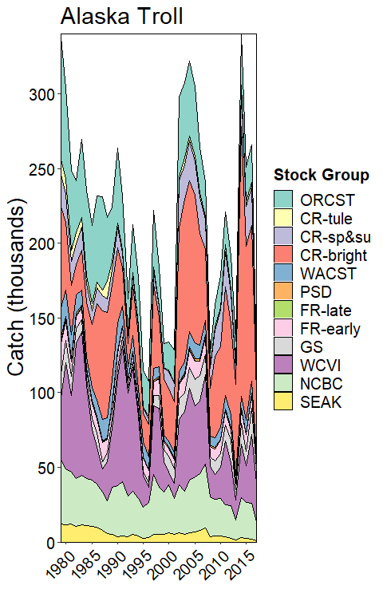

## Appendix E2–Chinook Model Estimates of landed catch stock composition for North British Columbia troll, 1979–2016.

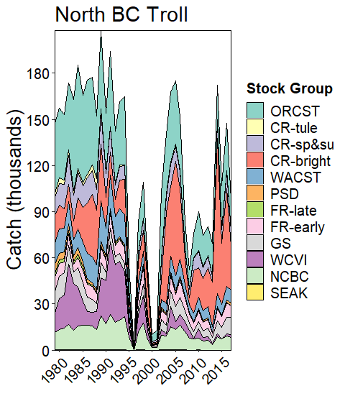

## Appendix E3–Chinook Model Estimates of landed catch stock composition for Central British Columbia troll, 1979–2016.

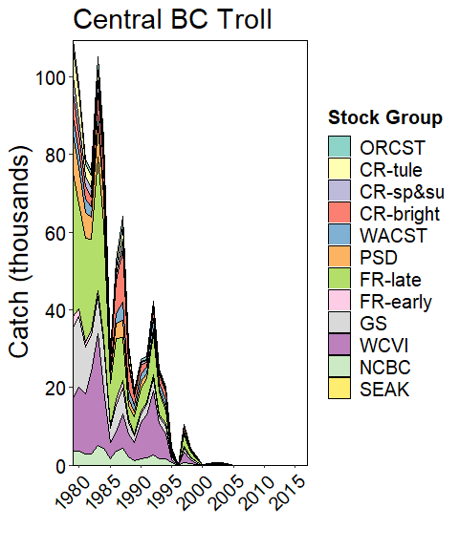

## Appendix E4–Chinook Model Estimates of landed catch stock composition for West Coast Vancouver Island troll, 1979–2016

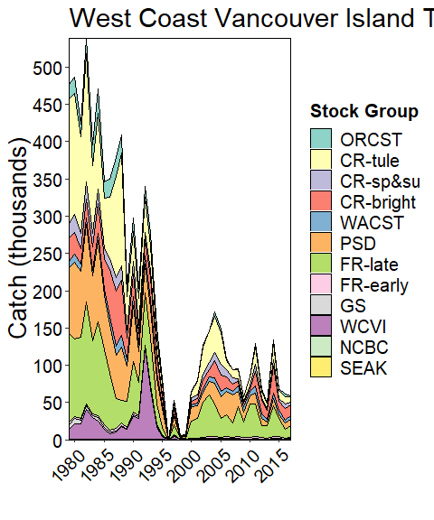

## Appendix E5–Chinook Model Estimates of landed catch stock composition for Washington and Oregon troll, 1979–2016

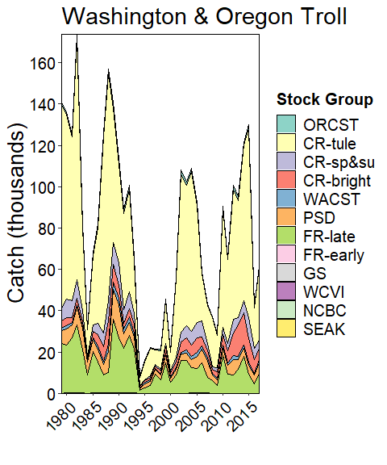

## Appendix E6–Chinook Model Estimates of landed catch stock composition for Strait of Georgia troll, 1979–2016.

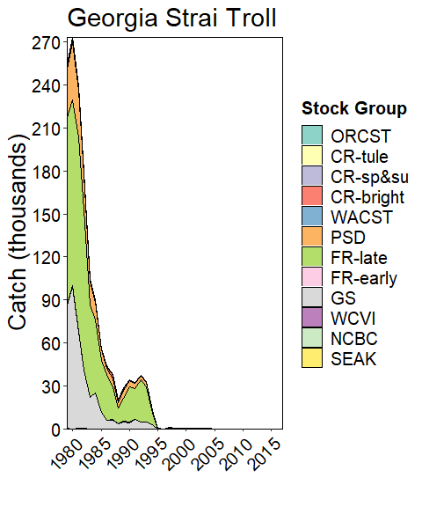

## Appendix E7–Chinook Model Estimates of landed catch stock composition for Alaska net with (upper) and without (lower) hatchery add-on and terminal exclusion, 1979–2016.

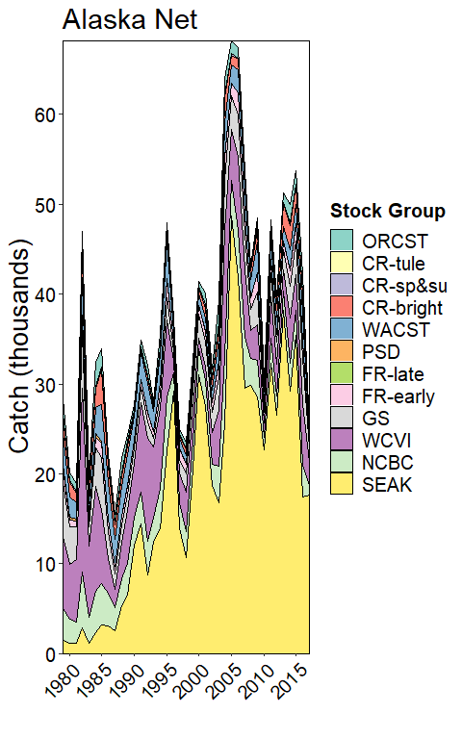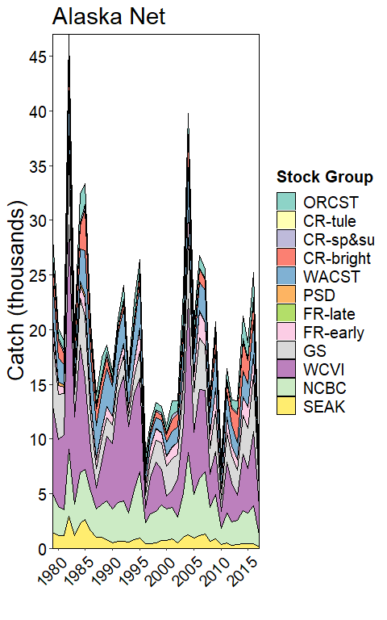

## Appendix E8–Chinook Model Estimates of landed catch stock composition for North British Columbia net, 1979–2016.

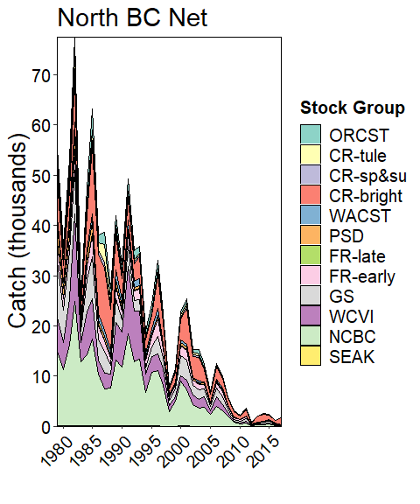

## Appendix E9–Chinook Model Estimates of landed catch stock composition for Central British Columbia net, 1979–2016

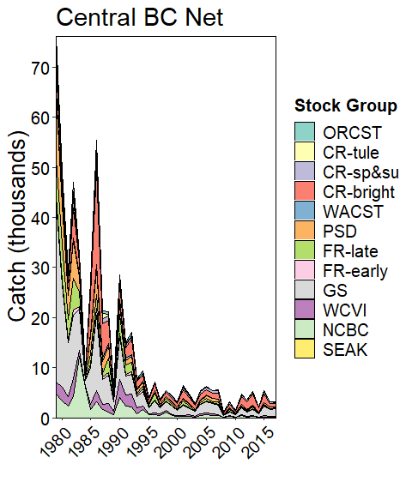

## Appendix E10–Chinook Model Estimates of landed catch stock composition for West Coast Vancouver Island net, 1979–2016

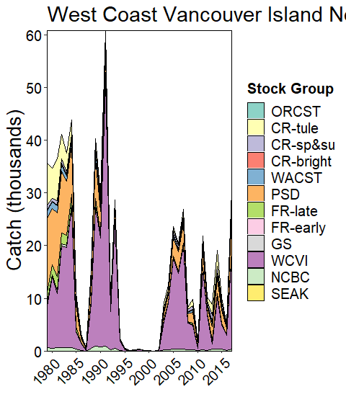

## Appendix E11–Chinook Model Estimates of landed catch stock composition for Strait of Juan de Fuca net, 1979–2016.

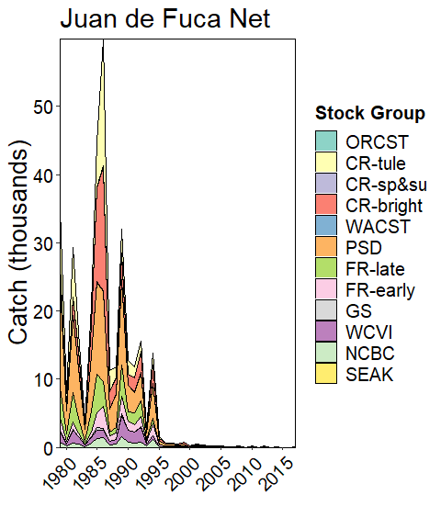

## Appendix E12–Chinook Model Estimates of landed catch stock composition for North Puget Sound net, 1979–2016

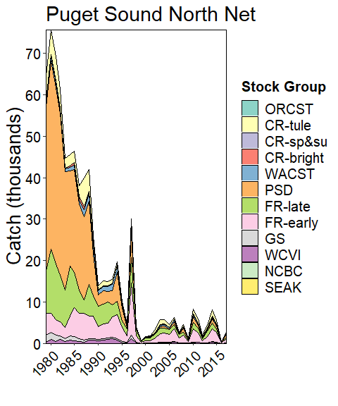

## Appendix E13–Chinook Model Estimates of landed catch stock composition for South Puget Sound net, 1979–2016.

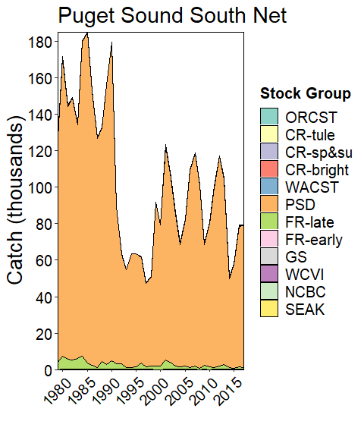

## Appendix E14–Chinook Model Estimates of landed catch stock composition for Washington Coast net, 1979–2016.

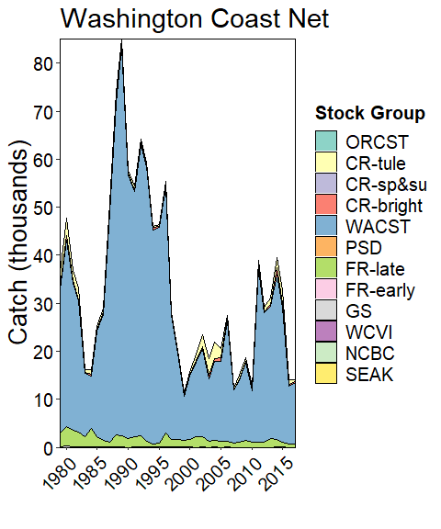

## Appendix E15–Chinook Model Estimates of landed catch stock composition for Columbia River net, 1979–2016.

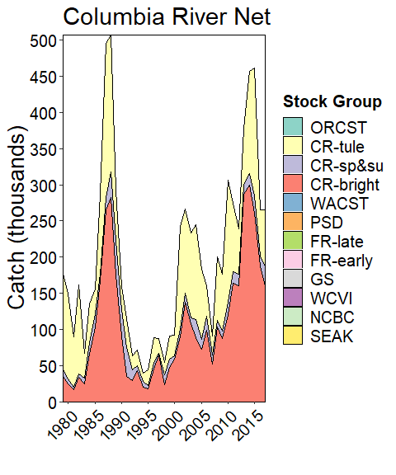

## Appendix E16–Chinook Model Estimates of landed catch stock composition for Johnstone Strait net, 1979–2016.

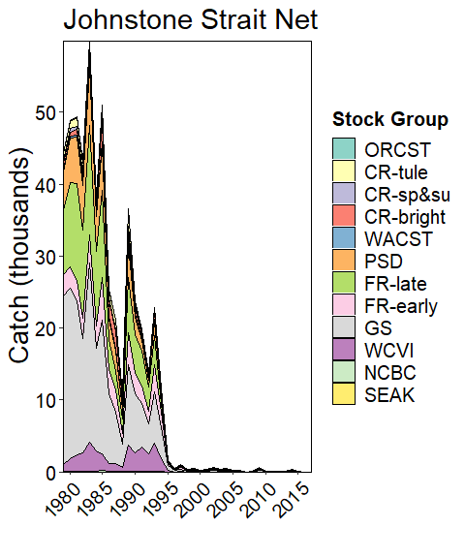

## Appendix E17–Chinook Model Estimates of landed catch stock composition for Fraser River net, 1979–2016.

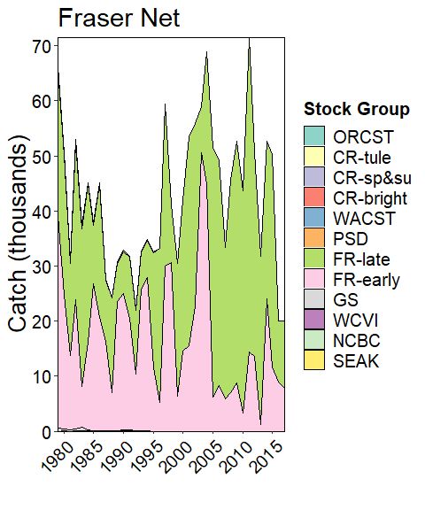

## Appendix E18–Chinook Model Estimates of landed catch stock composition for Alaska sport with (upper) and without (lower) Alaska hatchery add-on and terminal exclusion, 1979–2016.

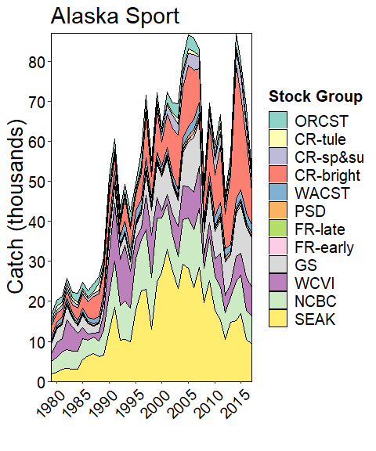

## Appendix E19–Chinook Model Estimates of landed catch stock composition for North and Central British Columbia sport, 1979–2016.

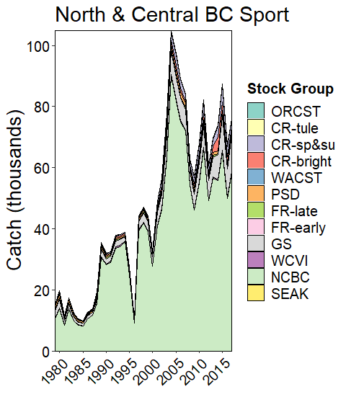

## Appendix E20–Chinook Model Estimates of landed catch stock composition for West Coast Vancouver Island sport, 1979–2016.

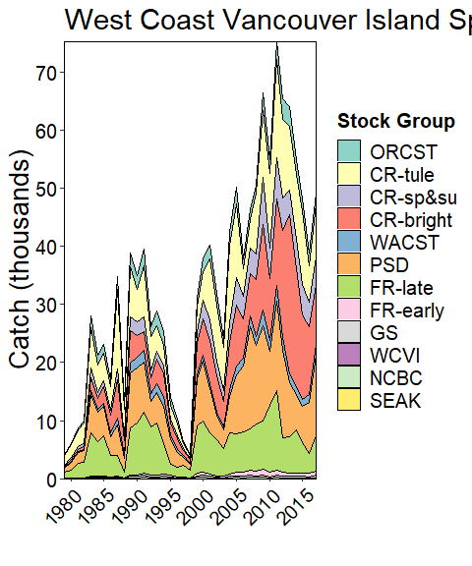

## Appendix E21–Chinook Model Estimates of landed catch stock composition for Washington Ocean sport, 1979–2016.

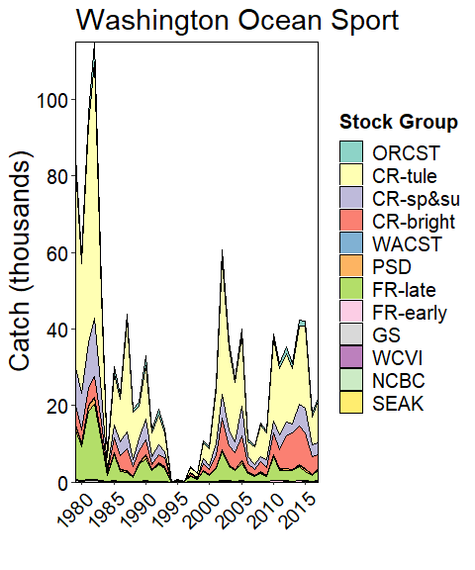

## Appendix E22–Chinook Model Estimates of landed catch stock composition for North Puget Sound sport, 1979–2016.

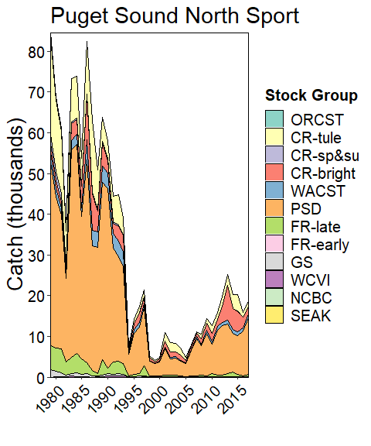

## Appendix E23–Chinook Model Estimates of landed catch stock composition for South Puget Sound sport, 1979–2016.

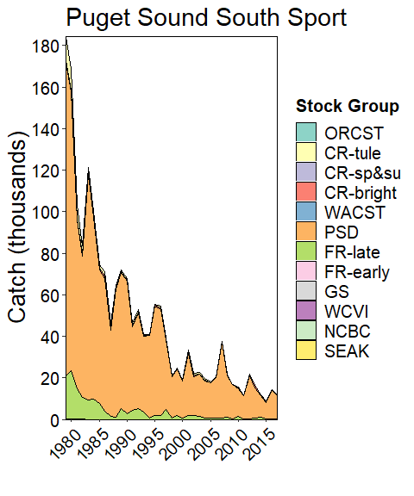

## Appendix E24–Chinook Model Estimates of landed catch stock composition for Strait of Georgia sport, 1979–2016.

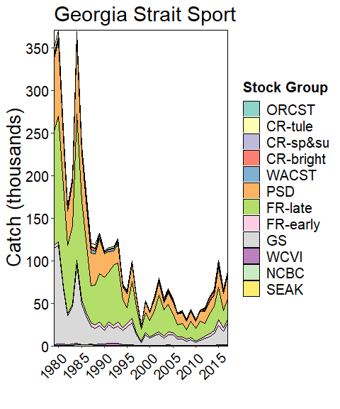

## Appendix E25–Chinook Model Estimates of landed catch stock composition for Terminal sport, 1979–2016.

