Appendix E - Figures of Chinook Model-Generated Stock Composition of Landed Catch for AABM and ISBM Fisheries, 1979-YYYY

Stock composition in the AABM and ISBM fisheries is estimated using the Chinook Model. The proportion of landed catch by model stock is computed:

$$P_{F,S,Y}=\frac{Q_{F,S,Y}}{\sum_{S}{Q_{F,S,Y}}}$$

where $Q_{F,S,Y}$ is model landed catch by fishery $F$, stock $S$, and year $Y$. Landed catch stock composition is computed:

$$C_{F,S,Y}=C_{F,Y}*P_{F,S,Y}$$

where $C_{F,Y}$ is reported landed catch by fishery $F$ and year $Y$. Since the Chinook Model does not include the Alaska Hatchery Addon, reported landed catch stock composition is adjusted:

$$C_{F,S=AK,Y}=C_{F,S=AK,Y}+A_{F,S=AK,Y}$$

where $A_{F,S=AK,Y}$ is the Alaska Hatchery Addon by fishery $F$ and year $Y$ for only the Alaska Stock Group. Results with and without the Alaska Hatchery Addon adjustment are reported. Stock abbreviations in each figure correspond to the following model stocks and aggregations:

|  |  |
| --- | --- |
| Stock Group | Description |
| ORCST | Oregon Coast |
| CR-tule | Columbia River-Fall Tule stocks (Spring Creek, Lower River Hatchery, and Cowlitz Fall) |
| CR-sp&su | Columbia River Spring and Summer stocks (Willamette, Cowlitz Spring, Columbia Summers) |
| CR-bright | Columbia River Fall Bright stocks (Upriver, Mid-Columbia, Lewis River Wild, Lyons Ferry) |
| WACST | Washington Coast |
| PSD | Puget Sound stocks (Nooksack Fall and Spring, Natural Fall Fingerlings, Hatchery Fall Fingerlings, Hatchery Yearlings, Skagit Wild, Stillaguamish Wild, Snohomish Wild) |
| FR-late | Fraser River Late stock |
| FR-early | Fraser River Early stocks |
| GS | Georgia Strait stocks (Upper, Lower Natural, Lower Hatchery) |
| WCVI | West Coast Vancouver Island Stocks (hatchery and natural) |
| NCBC | North Central British Columbia stocks |
| SEAK | Southeast Alaska stocks |

## Appendix E1-Chinook Model Estimates of landed catch stock composition for Alaska troll with (upper) and without (lower) Alaska hatchery add-on and terminal exclusion, 1979-2016.

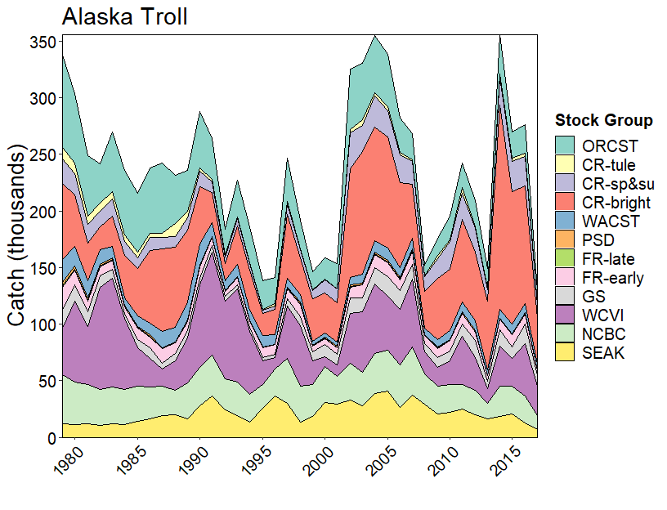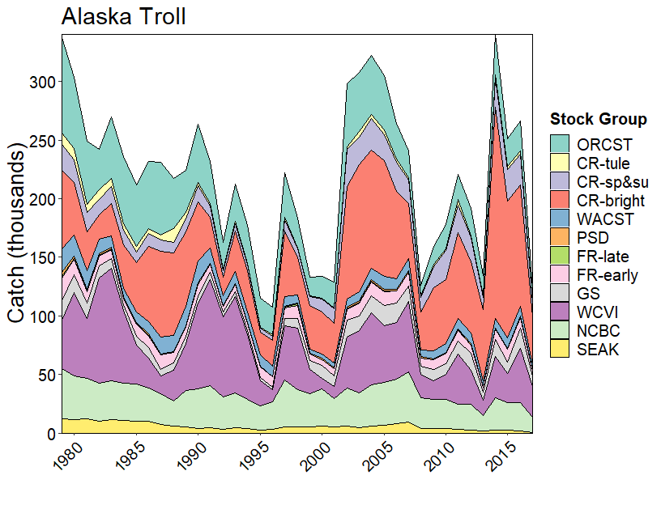

## Appendix E2-Chinook Model Estimates of landed catch stock composition for North British Columbia troll, 1979-2016.

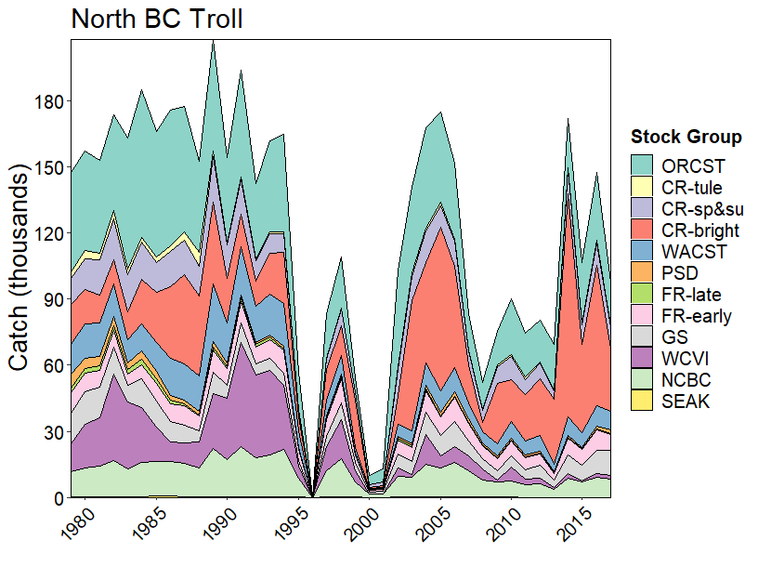

## Appendix E3-Chinook Model Estimates of landed catch stock composition for Central British Columbia troll, 1979-2016.

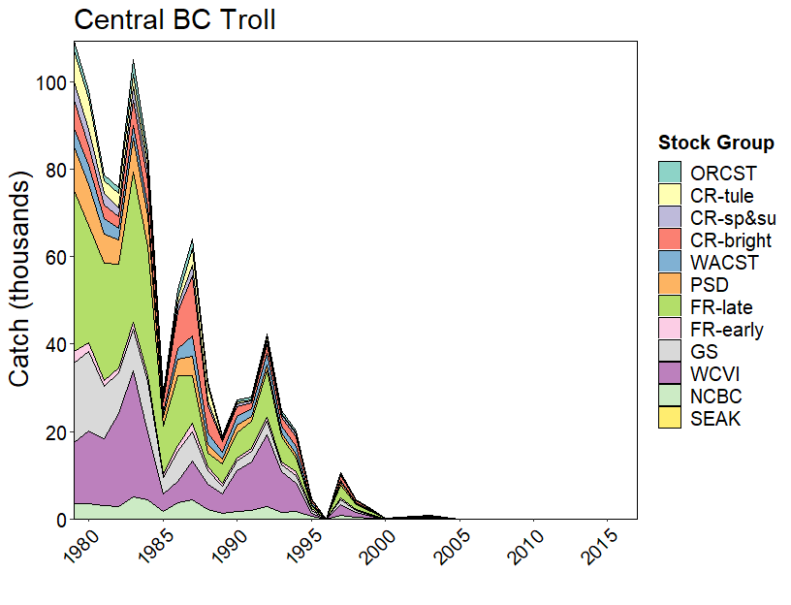

## Appendix E4-Chinook Model Estimates of landed catch stock composition for West Coast Vancouver Island troll, 1979-2016

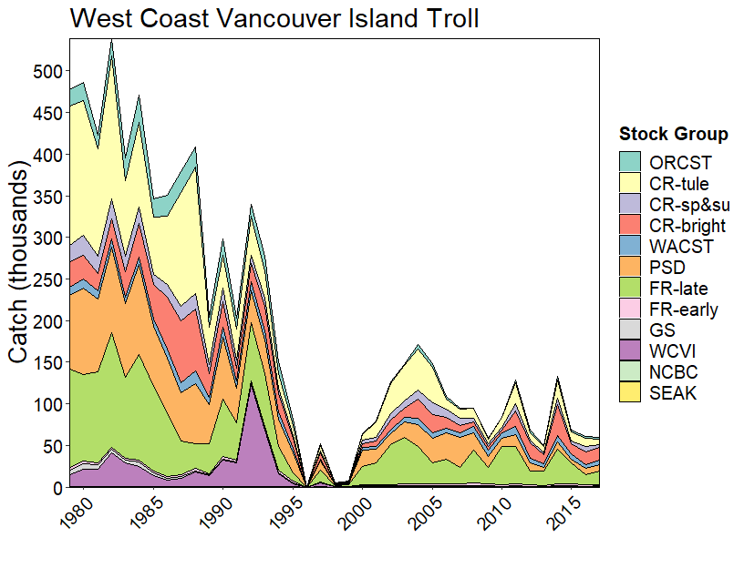

## Appendix E5-Chinook Model Estimates of landed catch stock composition for Washington and Oregon troll, 1979-2016

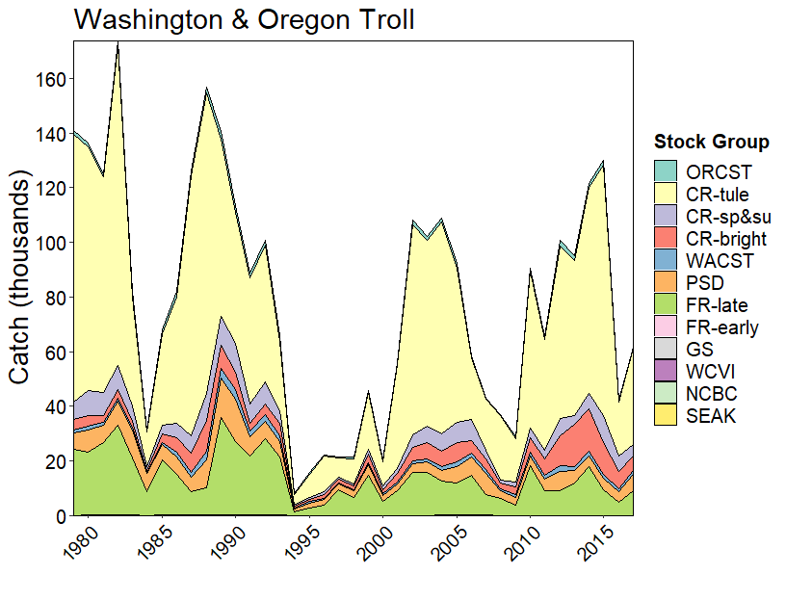

## Appendix E6-Chinook Model Estimates of landed catch stock composition for Strait of Georgia troll, 1979-2016.

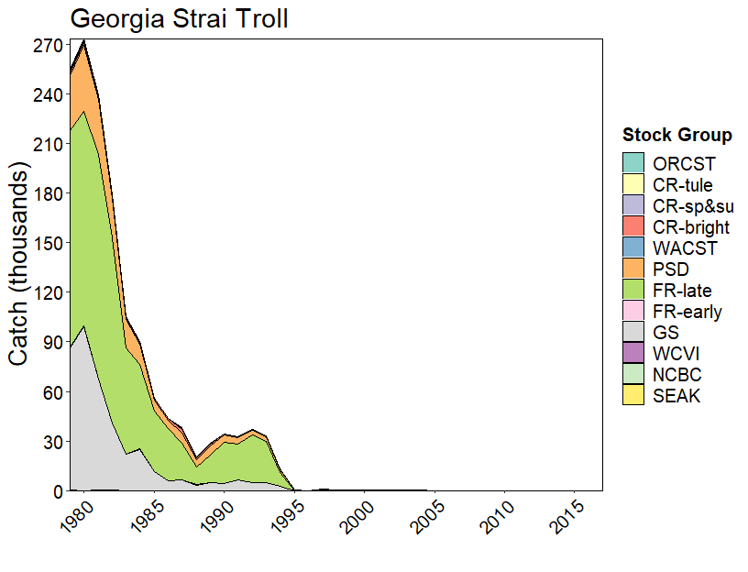

## Appendix E7-Chinook Model Estimates of landed catch stock composition for Alaska net with (upper) and without (lower) hatchery add-on and terminal exclusion, 1979-2016.

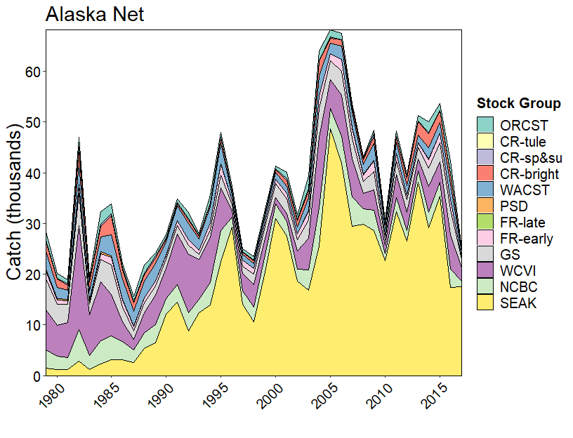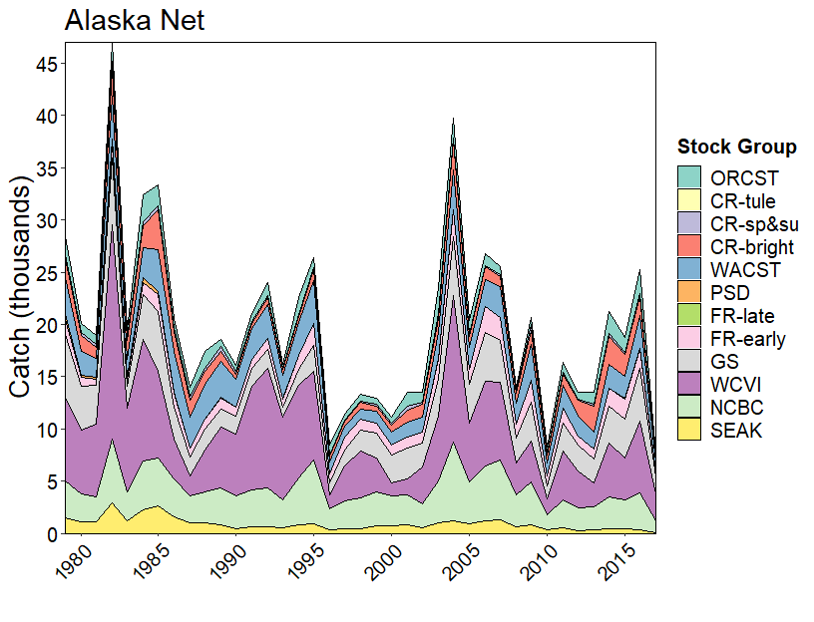

## Appendix E8-Chinook Model Estimates of landed catch stock composition for North British Columbia net, 1979-2016.

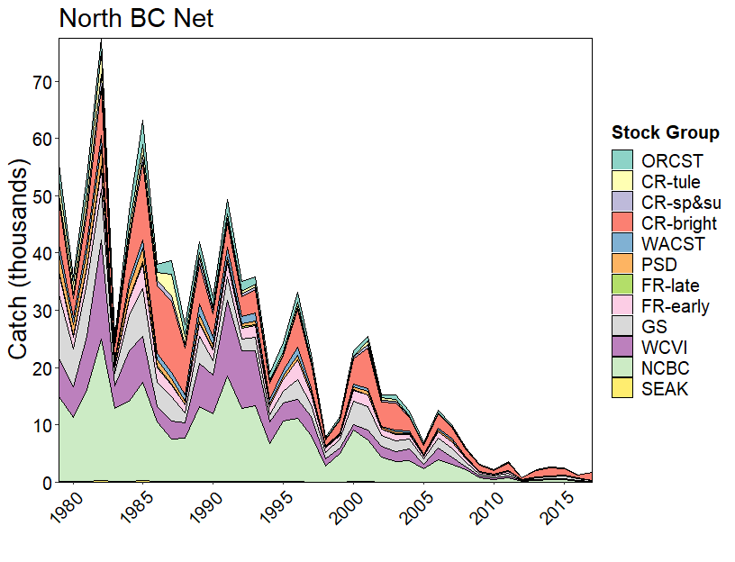

## Appendix E9-Chinook Model Estimates of landed catch stock composition for Central British Columbia net, 1979-2016

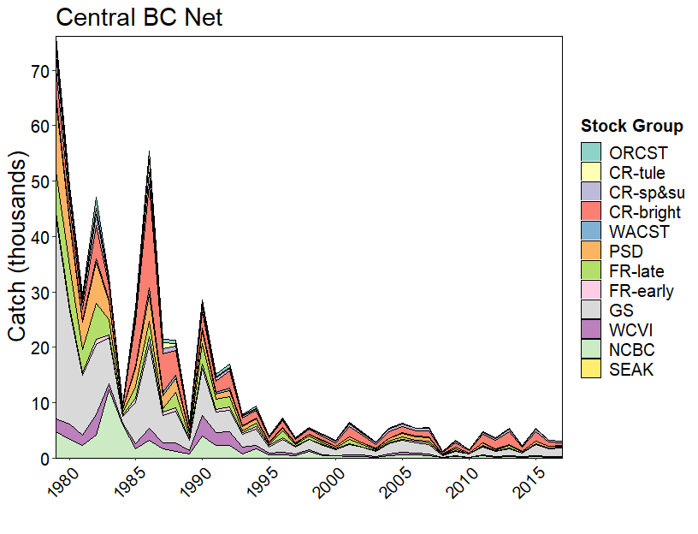

## Appendix E10-Chinook Model Estimates of landed catch stock composition for West Coast Vancouver Island net, 1979-2016

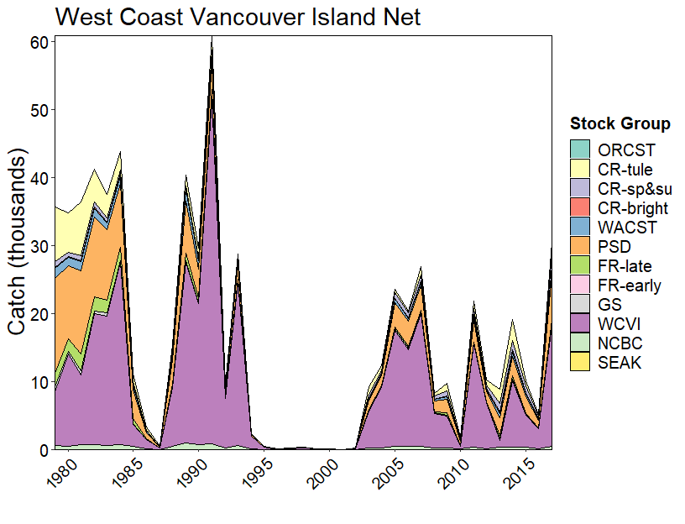

## Appendix E11-Chinook Model Estimates of landed catch stock composition for Strait of Juan de Fuca net, 1979-2016.

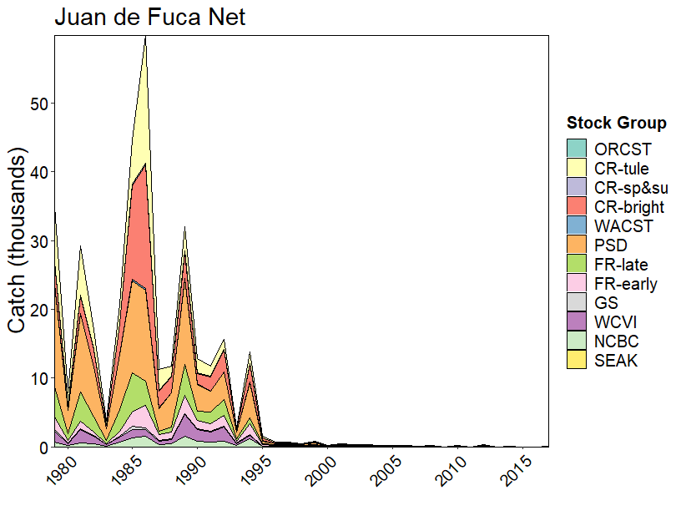

## Appendix E12-Chinook Model Estimates of landed catch stock composition for North Puget Sound net, 1979-2016

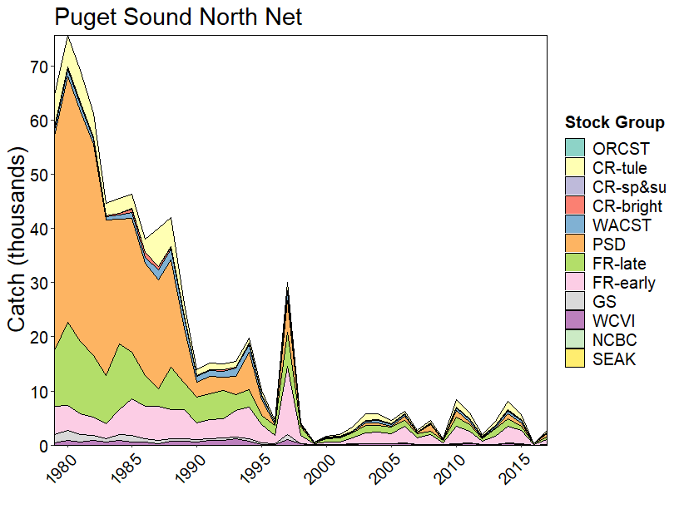

## Appendix E13-Chinook Model Estimates of landed catch stock composition for South Puget Sound net, 1979-2016.

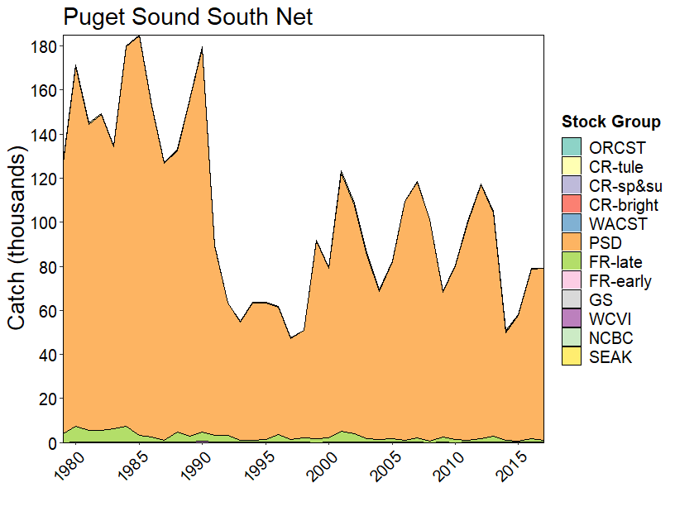

## Appendix E14-Chinook Model Estimates of landed catch stock composition for Washington Coast net, 1979-2016.

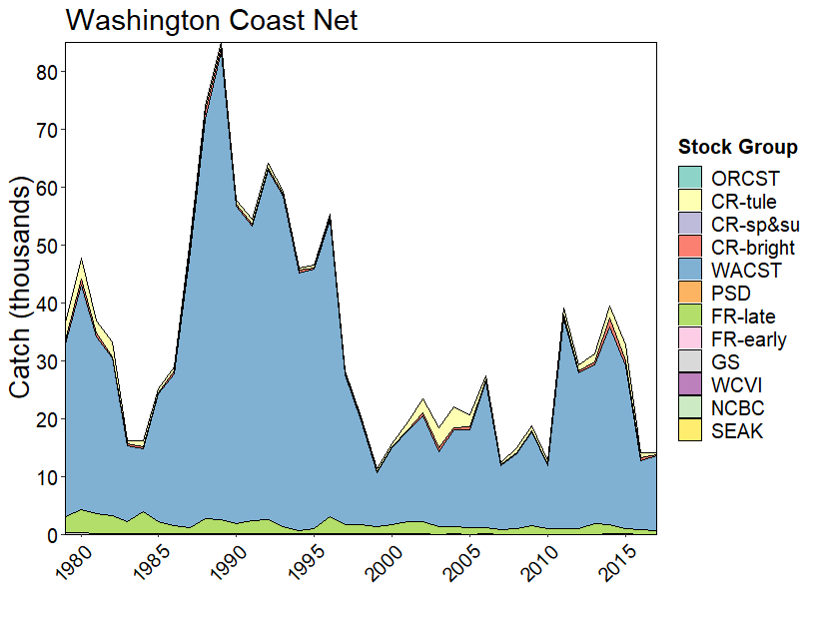

## Appendix E15-Chinook Model Estimates of landed catch stock composition for Columbia River net, 1979-2016.

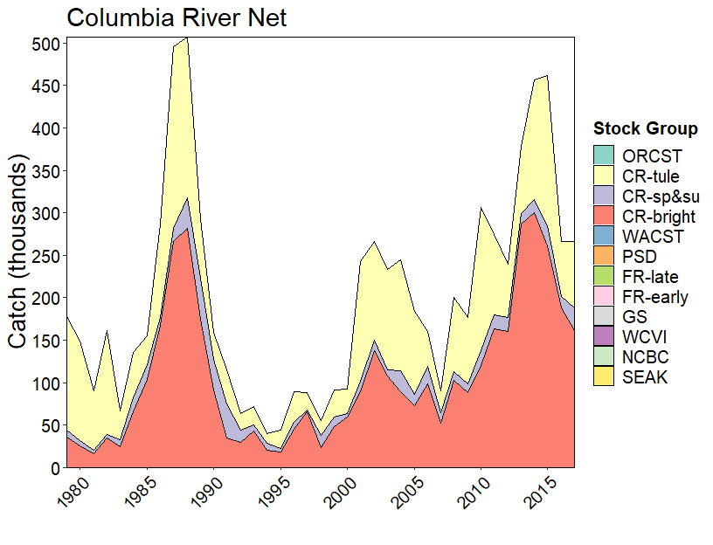

## Appendix E16-Chinook Model Estimates of landed catch stock composition for Johnstone Strait net, 1979-2016.

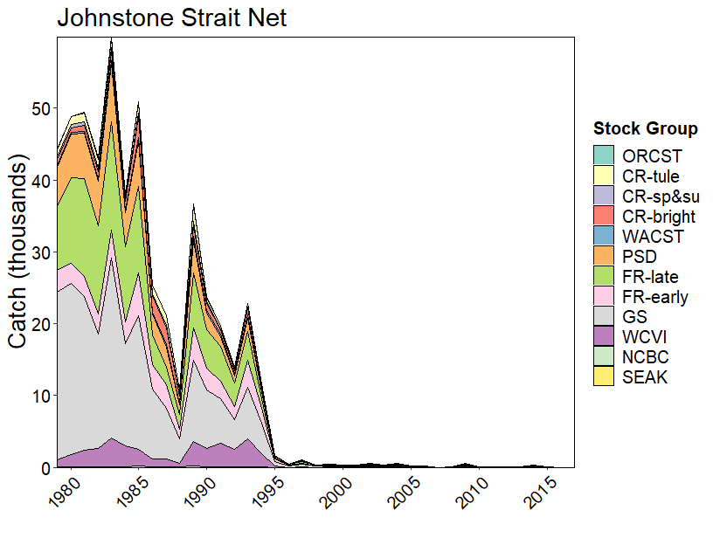

## Appendix E17-Chinook Model Estimates of landed catch stock composition for Fraser River net, 1979-2016.

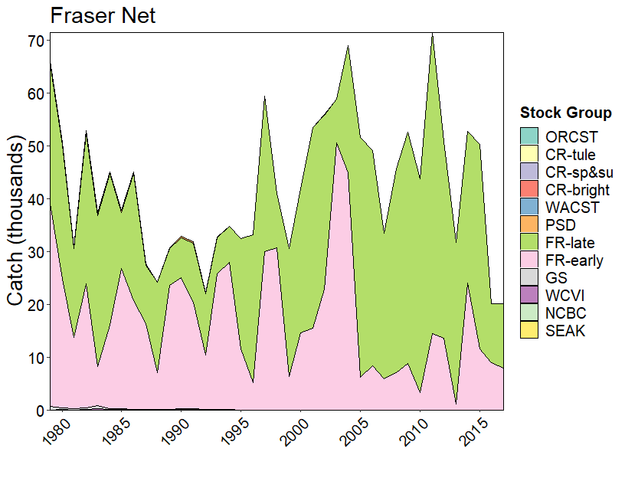

## Appendix E18-Chinook Model Estimates of landed catch stock composition for Alaska sport with (upper) and without (lower) Alaska hatchery add-on and terminal exclusion, 1979-2016.

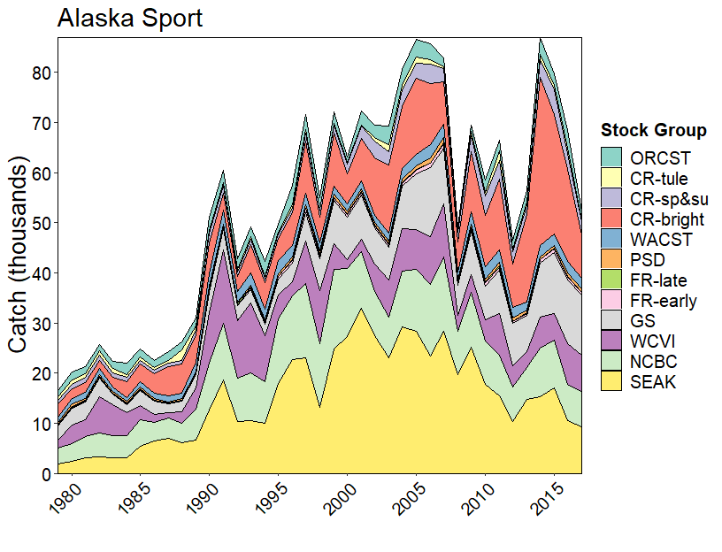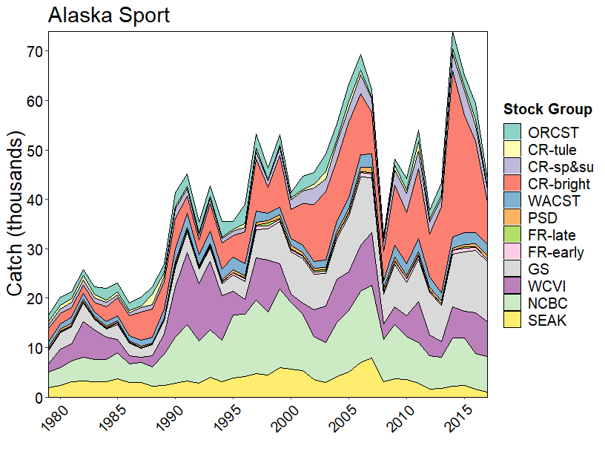

## Appendix E19-Chinook Model Estimates of landed catch stock composition for North and Central British Columbia sport, 1979-2016.

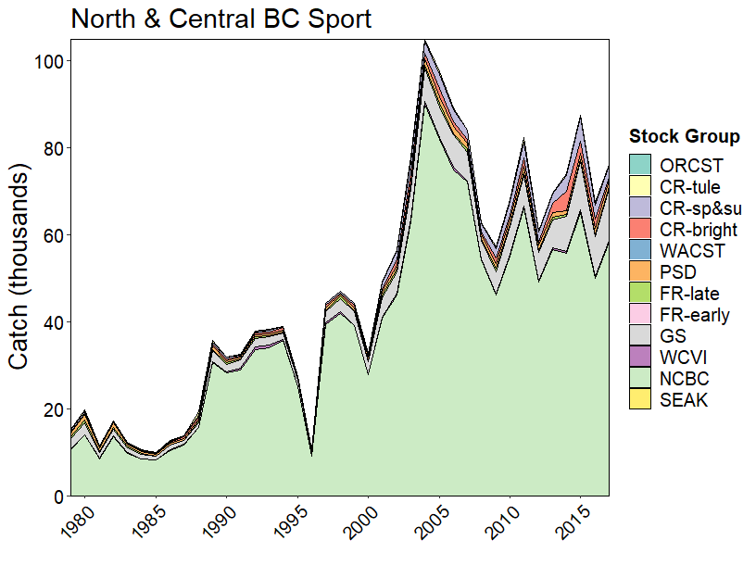

## Appendix E20-Chinook Model Estimates of landed catch stock composition for West Coast Vancouver Island sport, 1979-2016.

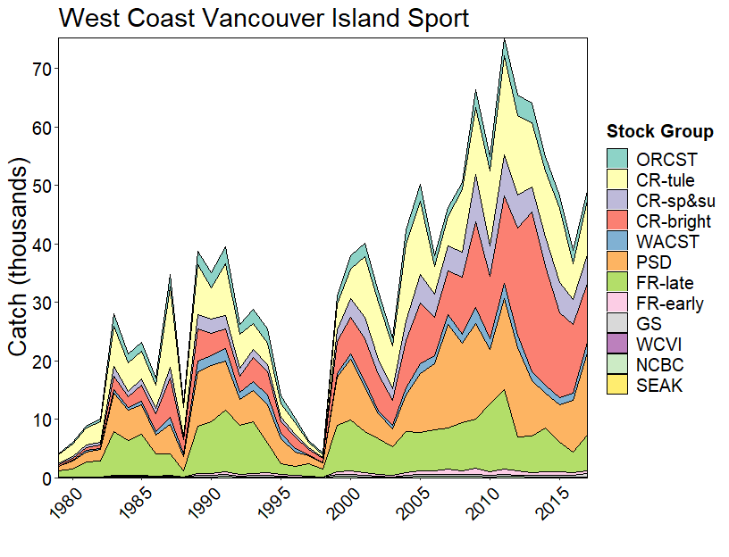

## Appendix E21-Chinook Model Estimates of landed catch stock composition for Washington Ocean sport, 1979-2016.

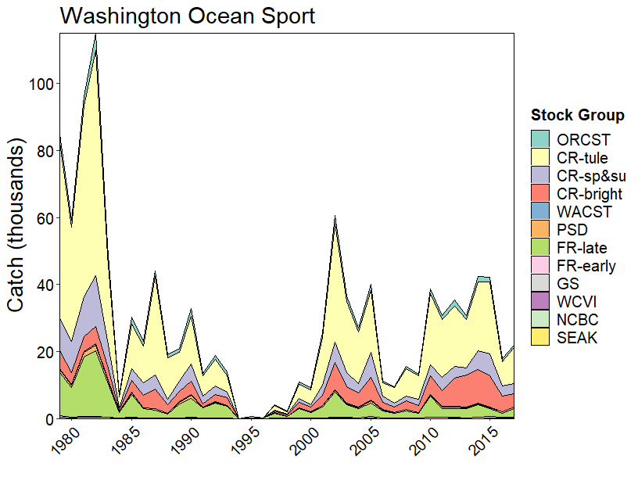

## Appendix E22-Chinook Model Estimates of landed catch stock composition for North Puget Sound sport, 1979-2016.

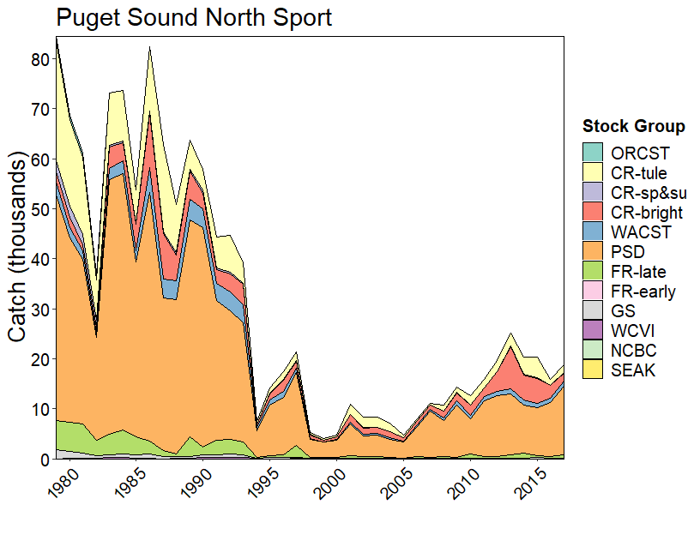

## Appendix E23-Chinook Model Estimates of landed catch stock composition for South Puget Sound sport, 1979-2016.

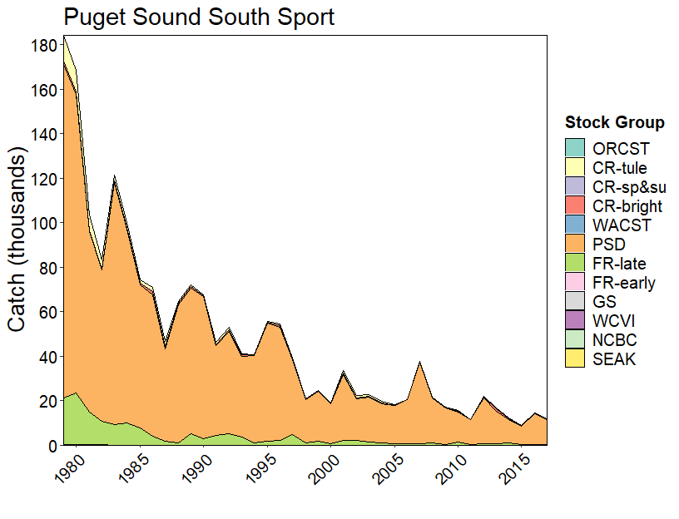

## Appendix E24-Chinook Model Estimates of landed catch stock composition for Strait of Georgia sport, 1979-2016.

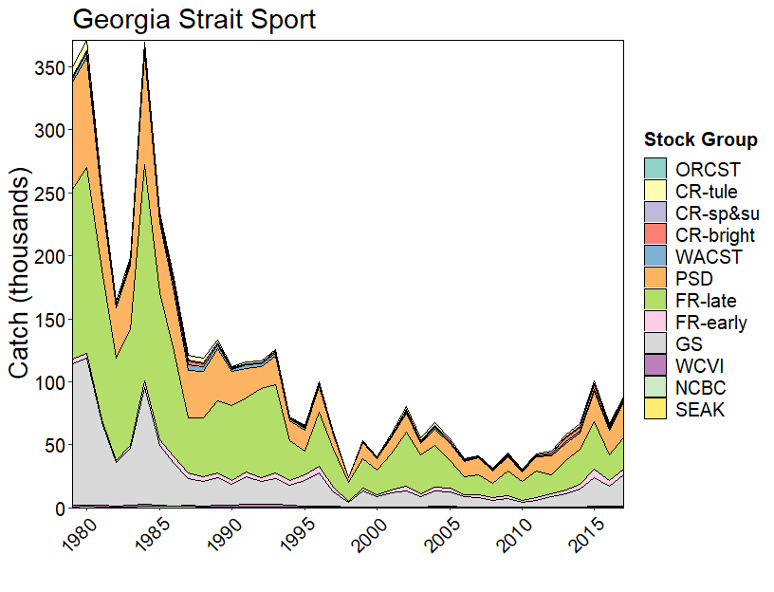

## Appendix E25-Chinook Model Estimates of landed catch stock composition for Terminal sport, 1979-2016.

