Team 20

Georges, Matt, Simone, Sade, DaShaun, Randy

**Design Inspection Defect Log**

**Following lists contains bugs or failed logic found in our code or expected road blocks as we right our program.**

|  |  |
| --- | --- |
| Product | **Resistance Game Design Inspection** |
| Date | September 17 |
| Author | Matt |
| Moderator | Sade |
| Inspectors | Georges, Randy, DaShaun |
| Recorders | Simone |

|  |  |  |  |
| --- | --- | --- | --- |
| Defect # | Description | Severity | How Corrected |
| 0 | Users in Create Game do not go to Game once game is started | 1 | Add websocket event to push players to right place |
| 1 | No team leader is selected at the start of the game, game is hung | 1 | Added line of code to select team leader at the beginning of Create Game |
| 2 | Unregistered users can impact game | 2 | Added defensive protection |
| 3 | While loop in game was inefficient | 3 | Added break, changed boundaries |
| 4 | Player leaving right before game starts can hang up game | 3 | Add automatic error messaging and shutdown of game |

**Code Inspection Defects**

|  |  |
| --- | --- |
| **Product** | **Game module** |
| **Date** | **September 17** |
| **Author** | **Sade and Matt** |

|  |  |  |  |
| --- | --- | --- | --- |
| Defect # | Description | Severity | How Corrected |
| 0 | Redirections called were going through an extra hoop | 3 | Used different redirection using websockets |
| 1 | Websockets checked every instance instead of using predictable logic | 3 | Limited search to places information could only be. |
| 2 | 2 variables server same purpose, mirrors of each other | 3 | Streamlined object characteristics |
| 3 | Game object was not being updated at correct places | 1 | Added calls to object so victories could be alway recorded. |
| 4 | Variables were being referenced before use | 1 | Initialize all variables at beginning |

|  |  |
| --- | --- |
| **Product** | **Join module** |
| **Date** | **September 17** |
| **Author** | **Matt** |

|  |  |  |  |
| --- | --- | --- | --- |
| Defect # | Description | Severity | How Corrected |
| 0 | Game object used primitive way of adding players to the group. | 3 | Used more intelligence, tested the lists for space. Stopped relying on hard counts |
| 1 | User could overload input | 2 | Added restrictions to code. Safety net |

|  |  |
| --- | --- |
| **Product** | **Create Game module** |
| **Date** | **September 17** |
| **Author** | **Sade** |

|  |  |  |  |
| --- | --- | --- | --- |
| Defect # | Description | Severity | How Corrected |
| 0 | Game lobby was not being updated efficiently | 3 | Changed it from constant pulls to event notice. |
| 1 | Players were not getting updated quickly | 3 | Reordered processes |

**Unit Testing Defects**

|  |  |
| --- | --- |
| **Product** | **Game module** |
| **Date** | **September 17** |
| **Author** | **Sade and Matt** |

**Input and Output:**

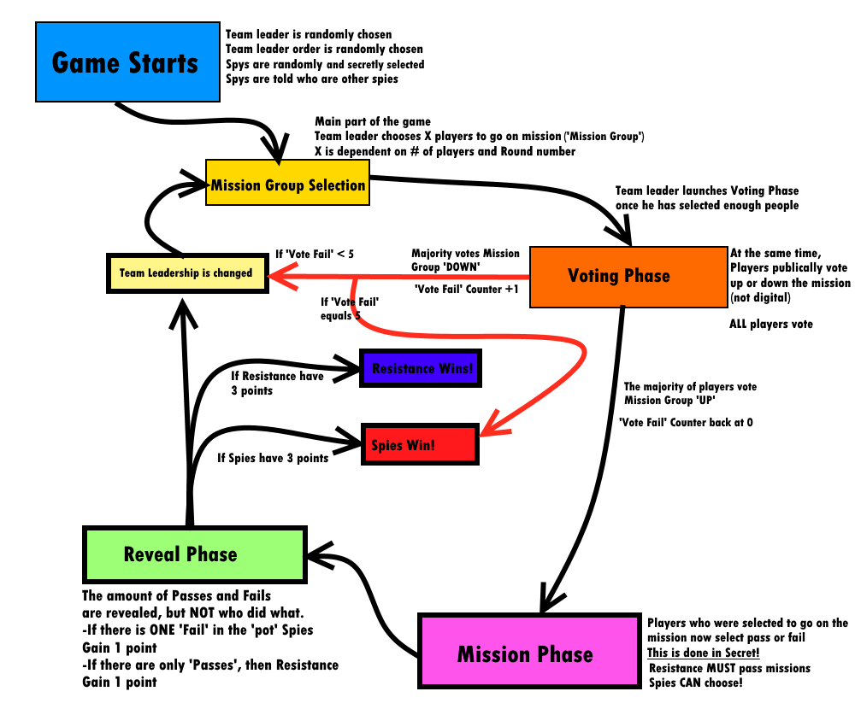

|  |  |  |  |
| --- | --- | --- | --- |
| Defect # | Description | Severity | How Corrected |
| 0 | Game was not changing hands when vote passed down | 2 | Added checks and pass system after failed vote path |
| 1 | Game did not end after 5 consecutive failed votes | 1 | Added forgotten check to redirect to spy win page |
| 2 | Game ended after 5 NON-consecutive failed votes | 2 | Cleared failed vote variable |
| 3 | Game played to the 6th round | 1 | Fixed stop gap on win condition |
| 4 | Team leader was not placed at the bottom of the list | 3 | Fixed sorting bug in reorganization area. |
| 5 | Amount to go on mission never changed after round one | 2 | Added forgotten variable increment |
| 6 | Front facing code did not change after a failed vote | 3 | Rewrote code for updating front end, fixed websocket error |
| 7 | Profile screen does not hide after being summoned | 2 | Fixed event callings for html |
| 8 | Resistance members can fail a mission | 1 | Fixed permissions allowed for Resistance players |

|  |  |
| --- | --- |
| **Product** | **Join module** |
| **Date** | **September 17** |
| **Author** | **Matt** |
| **Input** | **Player inputs game name, presses Join** |
| **Output** | **Redirection to a correct Page or same page if incorrect name** |

|  |  |  |  |
| --- | --- | --- | --- |
| Defect # | Description | Severity | How Corrected |
| 0 | Game crashed when game non-existent | 1 | Catch error and redirect |
| 1 | Capitalization mattered for joining game. | 3 | Lowercased database |
| 2 | Exit button not redirecting back to menu | 3 | Fixed link |
| 1 | Joining game caused error | 1 | Sent user information to game page with it |
| 4 | Inputted game name not calling game | 1 | Fixed request.body var calling in backend |

|  |  |
| --- | --- |
| **Product** | **Create Game module** |
| **Date** | **September 17** |
| **Author** | **Sade** |
| **Input** | **‘Start Game’ by host if 5/5 players** |
| **Output** | **Redirection to Game page once start game is pressed** |

|  |  |  |  |
| --- | --- | --- | --- |
| Defect # | Description | Severity | How Corrected |
| 0 | Players unable to join | 1 | Fixed game creation database post |
| 3 | 6/5 players could join | 1 | Locked down room once full, redirected users back, did not add them to game table |
| 2 | Game cancellation hanging | 3 | Sent update to Game Joiners if game was cancelled |
| 1 | Not all players going to Game screen once starting | 2 | Added redirection websocket listener once they were in the lo3y |

|  |  |
| --- | --- |
| **Product** | **Login module** |
| **Date** | **September 30** |
| **Author** | **Randy** |
| **input** | **Username and password** |
| **Output** | **Redirection to same page if error, profile page if not** |

|  |  |  |  |
| --- | --- | --- | --- |
| Defect # | Description | Severity | How Corrected |
| 0 | Page crashed on load | 1 | Referenced variables that were not established globals |
| 1 | Username was case-sensitive | 3 | Lowered cases for all of the database |
| 2 | Backend could be spammed by large input | 3 | Added text limit checks to front end |

|  |  |
| --- | --- |
| **Product** | **Register module** |
| **Date** | **September 30** |
| **Author** | **Randy** |
| **input** | **Name and password, presses register button** |
| **output** | **Redirection to main page** |

|  |  |  |  |
| --- | --- | --- | --- |
| Defect # | Description | Severity | How Corrected |
| 0 | Username was case-sensitive | 3 | Lowered cases for all of the database |
| 1 | Usernames were not unique | 2 | Cleared DB and added unique check |
| 2 | Backend could be spammed by large input | 3 | Added text limit checks to front end |

|  |  |
| --- | --- |
| **Product** | **Profile module (menu)** |
| **Date** | **September 30** |
| **Author** | **Randy** |
| **input** | **Sign out, create game, join game button** |
| **output** | **Redirection to clicked button** |

|  |  |  |  |
| --- | --- | --- | --- |
| Defect # | Description | Severity | How Corrected |
| 0 | User did not have to be logged in to reach this page | 2 | Added a gate check for users |
| 1 | Page failed to load | 1 | Page called information not available to its scope |