
PEMCU Command
Spec

Revision 0.2

Shanghai Zhaoxin Semiconductor

Revision History
Revision | Date | Document Release | Note
0.1 | 04/13/18 | First version | Justin Wu
0.2 | 04/26/18 | Sencond Version | Jenny Chen
0.3 | 04/27/18 | Update some description for eye monitor part | Chris J.Wang

Command Type

Value | 1 | 2 | 3 | 4 | 5
Command type | Read | Write | Tx_Preset | Cursor | Eye_monitor

Attribute check command

Read Command

Write Command

CMD type: Read/Write

Value: Write data
Address range: 0~3FFFh

BIOS2PEMCU_scratch register for BIOS to PEMCU in CMD cycle:
Bit | 31:5 | 4 | 3:0
Description | Reserved | Value | CMD
CMD:
0 Reserved
1 Read
2 Write
3 Tx_Preset
4. Cursor
5. Eye_monitor
6~F Reserved
Value:
0/1 Write payload.

BIOS2PEMCU_scratch register for BIOS to PEMCU in DATA cycle:
Bit | 31:24 | 23:8 | 7:3 | 2:0
Description | PHYx | Address | Reserved | Bit

Address: 0~3FFF
PHYx: 0 = PHYA, 1 = PHYBC

PEMCU2BIOS_scratch registers for PEMCU to BIOS in Result cycle:
Bit | 31:1 | 0
Description | Reserved | Result

EQ check command

Tx Preset Command
CMD type: Tx_Preset

BIOS2PEMCU_scratch registers for BIOS to PEMCU in CMD cycle:
Bit | 31:4 | 3:0
Description | Reserved | CMD
CMD:
0: Reserved
1: Read
2: Write
3: Tx_Preset
4: Cursor
5. Eye_monitor
6~F Reserved

BIOS2PEMCU_scratch registers for BIOS to PEMCU in DATA cycle:
Bit | 31:8 | 7:0
Description | Reserved | Preset Value

PEMCU2BIOS_scratch registers for PEMCU to BIOS in Result cycle:

Result:
0: Reserved
1: Success
2: Failed
3~0xFF: Reserved

Bit | 31:8 | 7:0
Description | Reserved | Result

PEMCU will update FS/LF to MMIO RxB0~B1.

Address | 0xB1/F1 | 0xB0/F0
Description | LF | FS

Cursor Command
CMD type: Cursor

BIOS2PEMCU_scratch registers for BIOS to PEMCU in CMD cycle:

Bit | 31:16 | 15:8 | 7:4 | 3:0
Description | Reserved | Pre-Cursor | Reserved | CMD

CMD:
0: Reserved
1: Read
2: Write
3: Tx_Preset
4: Cursor
5. Eye_monitor
6~F Reserved

BIOS2PEMCU_scratch registers for BIOS to PEMCU in DATA cycle:
Bit | 31:16 | 15:8 | 7:0
Description | Reserved | Post-Cursor | Cursor

PEMCU2BIOS_scratch registers for PEMCU to BIOS in Result cycle:

Result:
0: Reserved
1: Success
2: Failed
3~0xFF: Reserved

Bit | 31:8 | 7:0
Description | Reserved | Result

Eye Monitor check command
Eye Monitor implementation process has 2 modes:
Mode 1:
For multiple lane port, this mode set ALL_PORT to 1, all Lane of the point must be monitor.
Mode 2:
For multiple lane port, this mode set ALL_PORT to 0 and set the lane number with LANE_SEL[2:0] , which Lane of the point must be monitor

Eye monitor command
CMD type: Eye_monitor

- BIOS2PEMCU_scratch registers 0x9DB~9D8h for BIOS to PEMCU in CMD cycle:
Bit | 31:16 | 15:8 | 7:4 | 3:0
Description | Reserved | Lane Number | Reserved | CMD
- CMD:
0: Reserved
1: Read
2: Write
3: Tx_Preset
4: Cursor
5. Eye_monitor
6~F Reserved

- Lane Number:
2) For mode 2
0~0x07：Lane0~Lane7
0x08~0xFF : Reserverd
3) For mode 1
Reserved

- BIOS2PEMCU_scratch registers 0x9D8~9DBh for BIOS to PEMCU in DATA cycle:
Bit | 31:24 | 23:16 | 15:84 | 7:0
Description | PCIE Port number | *PHYx | EYE ERROR threshold | Eye Monitor Method

- Eye Monitor Method:
0: Reserved
1: Eye monitor implementation process mode 1: by Port
2: Eye monitor implementation process mode 2: by Lane
3: reserved
4~ 0xF: Reserved

- EYE ERROR threshold:
0~ Fh (Standard for pass or fail)

- PHYx: (this field only defined for CHA, CHX002 not used)
0: PHYA
1: PHYB
2: PHYC
others: reserved

- PCIE Port number:
0：PE0
1：PE1
2：PE2
3：PE3
4：PE4
5：PE5
6：PE6
7：PE7
8 : VPI
9~0xFF Reserved

- The Register for PEMCU 0xF8-0xFB for BIOS to PEMCU in DATA cycle

Bit | 31:24 | 23:16 | 15:8 | 7:0
Description | MCU_EQTNVTH_2 | MCU_PH_OS_2 | MCU_EQTNVTH | MCU_PH_OS

- MCU_EQTNVTH_2: Y value----End VR value
0-0x1F :value range
0x20-0x0FF: reserved

- MCU_PH_OS_2: X value-------End PH value
0-0x3F :value range
0x40-0x0FF: reserved

- MCU_EQTNVTH: Y value----Start VR value
0-0x1F :value range
0x20-0x0FF: reserved

- MCU_PH_OS: X value------- Start PH value
0-0x3F :value range
0x40-0x0FF: reserved

- The Register for PEMCU 0xFC-0xFF for BIOS to PEMCU in DATA cycle

Bit | 31:8 | 7:0
Description | Reserved | Scan Time

- Scan Time :
0 - 1Ah: Reserved
1Bh: BERCNTEN assert 130ns
1Ch: BERCNTEN assert 140ns
... …
FEh: BERCNTEN assert 2400ns
FFh: BERCNTEN assert 2410ns
(270ns - 2550ns for one point, 0.553ms-5.23ms for 2048 points)

- PEMCU2BIOS_scratch registers for PEMCU to BIOS in Result cycle:

Result:
0: Reserved
1: Success
2: Failed
3~0xFF: Reserved

Bit | 31:8 | 7:0
Description | Reserved | Result

Make use of DSRAM (CHX002)
In the latest CHX002 PEMCU FW(2018/11/07), we make use of PEMCU’s DSRAM. As figure 4-1 shows, CPU can transmit some command by using the DSRAM range which mapping to System DRAM, also, PEMCU can transmit some debug messages by using this range. This chapter mainly descript the rules of “CPU to PEMCU command”.
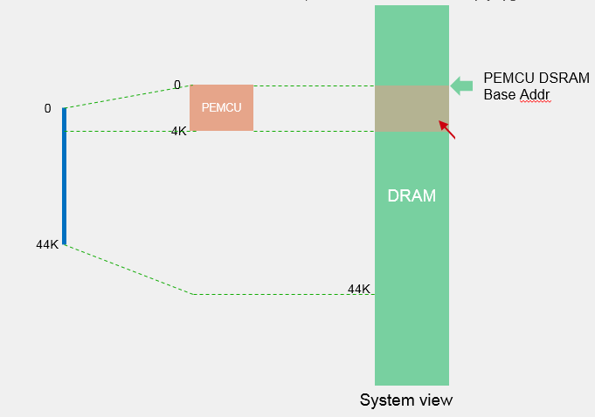
Figure 4-1

Offset Address: 1000h (PEMCU DSRAM Address)
Parameter: Eye Scan Time Default Value: xxh
Bit | Attribute | HW Property | Default | Description | Mnemonic | ChipRev | PwrDm | S | P | E
7:0 | RW | RO | 0 | CPU→PEMCU  Eye scan time  0-1Ah: reserved  1Bh-FFh: eye monitor scan time per point (used by PEMCU)  Here some example for some special valid value:  1Bh(140ns), 72h(1us) , A4h(1.5us), D6h(2us), FFh(2.41us). |  |  | vcc | 72h | x | x

Offset Address: 1001h (PEMCU DSRAM Address)
Parameter: DO EQ Method Default Value: xxh
Bit | Attribute | HW Property | Default | Description | Mnemonic | ChipRev | PwrDm | S | P | E
7:0 | RW | RO | 0 | CPU→PEMCU  DOEQ Method  0: TxEQ, PEMCU execute dynamic auto Tx EQ code in EQ phase3.  1: RxEQ, PEMCU execute dynamic auto Rx EQ code in EQ phase3.  2: Fixed Preset EQ, PEMCU enter command mode in EQ phase3 and adjust specific Preset/Cursor value in this phase. Before enter Gen3 EQ phase3, BIOS/MPT/EFI_ShellTool must delivery command to pemcu to indicate what Preset/Cursor should be used in EQ phase3. The details of command rules pls refer to this document. |  |  | vcc | x | x | x

Offset Address: 1080h (PEMCU DSRAM Address)
Parameter feedback: Eye Scan Time Default Value: xxh
Bit | Attribute | HW Property | Default | Description | Mnemonic | ChipRev | PwrDm | S | P | E
7:0 | RW | RO | 0 | PEMCU→CPU  Eye scan time  0-1Ah: reserved  1Bh-FFh: eye monitor scan time per point (used by PEMCU)  Here some example for some special valid value:  1Bh(140ns), 72h(1us) , A4h(1.5us), D6h(2us), FFh(2.41us).  *PEMCU should read the value in offset 1000h and write back to this position. |  |  | vcc | 72h | x | x

Offset Address: 1081h (PEMCU DSRAM Address)
Parameter feedback: DO EQ Method Default Value: xxh
Bit | Attribute | HW Property | Default | Description | Mnemonic | ChipRev | PwrDm | S | P | E
7:0 | RW | RO | 0 | PEMCU→CPU  DOEQ Method  0: TxEQ, PEMCU execute dynamic auto Tx EQ code in EQ phase3.  1: RxEQ, PEMCU execute dynamic auto Rx EQ code in EQ phase3.  2: Fixed Preset EQ, PEMCU enter command mode in EQ phase3 and adjust specific Preset/Cursor value in this phase. Before enter Gen3 EQ phase3, BIOS/MPT/EFI_ShellTool must delivery command to pemcu to indicate what Preset/Cursor should be used in EQ phase3. The details of command rules pls refer to this document.  *PEMCU should read the value in offset 1001h and write back to this position. |  |  | vcc | x | x | x

